電通二甲微處理器實驗 實驗結報

實驗名稱 | Lab 07 –LCD 顯示器
組別 | 8 | 組員 | 陳冠宇03050052 / 沈揚智03051030

- 實驗目的
使用 Arduino LCD 程式庫, 於 16x2 LCD 顯示器上顯示特 定文字?
1. Arduino 與 LCD 如何接線?
2. 如何使用 LCD library?
3. 如何清除螢幕?
4. 如何顯示文字?
- 實驗步驟
* Arduino 顯示自己的學號及英文姓名
* 使用 PC 串列輸入, 所有 PC 輸入之文字皆顯示在 LCD 螢幕上
- 程式碼
Checkpoint1
#include <LiquidCrystal.h> // include the library code
LiquidCrystal lcd(12, 11, 5, 4, 3, 2); // initialize interface pins
void setup() {
lcd.begin(16, 2); // set up the LCD's number of columns and rows:
lcd.print("hello, world!"); // Print a message to the LCD.
}
void loop() {
// set the cursor to column 0, line 1
// (note: line 1 is the second row, since countingbegins with 0):
lcd.setCursor(0, 1);
lcd.print(millis()/1000); // print the number of secondssince reset:
}
實驗結果與分析
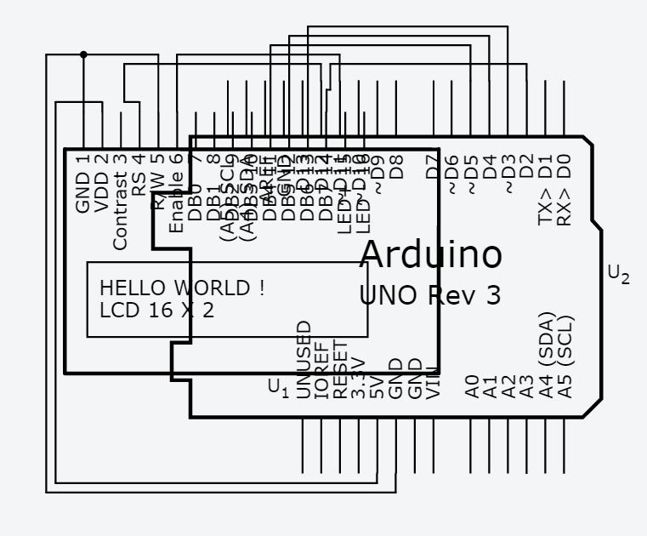
- 心得討論

這次的實驗主要在於如何接好lcd，要小心不能把正負接反，所以一開始就必須要去查詢這塊lcd的型號，不然lcd就會燒壞。

- 程式碼
CHECKPOINT1
#include <LiquidCrystal.h> // include the library code
LiquidCrystal lcd(12, 11, 5, 4, 3, 2); // initialize interface pins
void setup() {
lcd.begin(16, 2); // set up the LCD's number of columns and rows: // Print a message to the LCD.
lcd.print("03051030,03050052");
}
void loop() {
// set the cursor to column 0, line 1
// (note: line 1 is the second row, since countingbegins with 0):
lcd.setCursor(0, 1);
lcd.print("Philip,Alan"); // print the number of secondssince reset:
}

CHECKPOINT2
#include <LiquidCrystal.h> // include the library code
LiquidCrystal lcd(12, 11, 5, 4, 3, 2); // initialize interface pins
char ch;
void setup() {
lcd.begin(16, 2); // set up the LCD's number of columns and rows: // Print a message to the LCD.
lcd.print("03051030,03050052");
lcd.setCursor(0, 1);
lcd.print("Philip,Alan");
Serial.begin(9600);
}
void loop() {
// set the cursor to column 0, line 1
// (note: line 1 is the second row, since countingbegins with 0):
// print the number of secondssince reset:
if(Serial.available()){
lcd.clear();
while(1){
ch=Serial.read();
if(ch=='\r'){
Serial.println();
break;
}
if(ch>0){
Serial.print(ch);
lcd.print(ch);
}
}
}
}

