

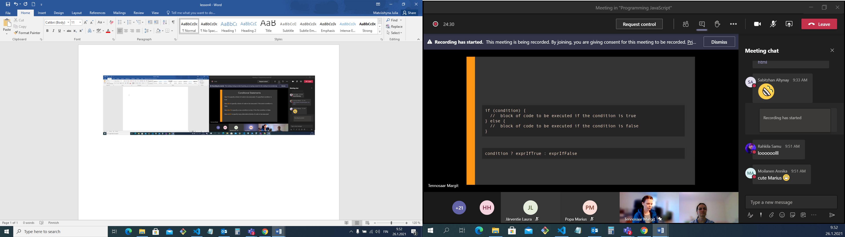

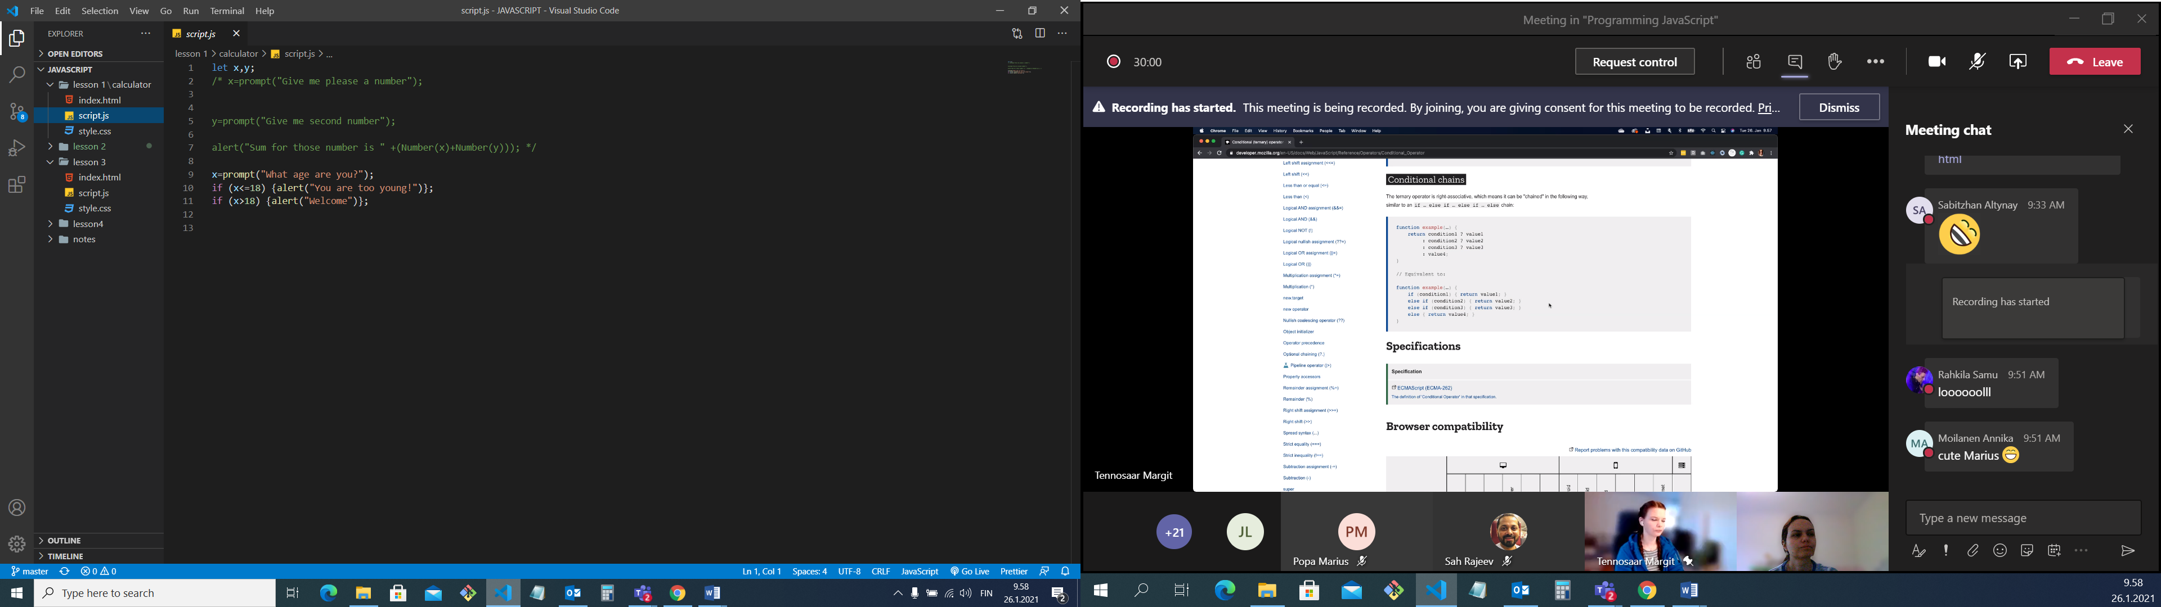

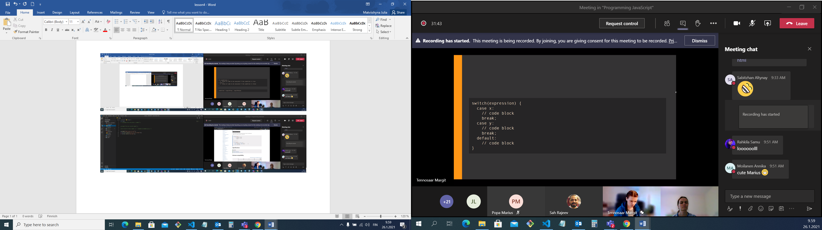

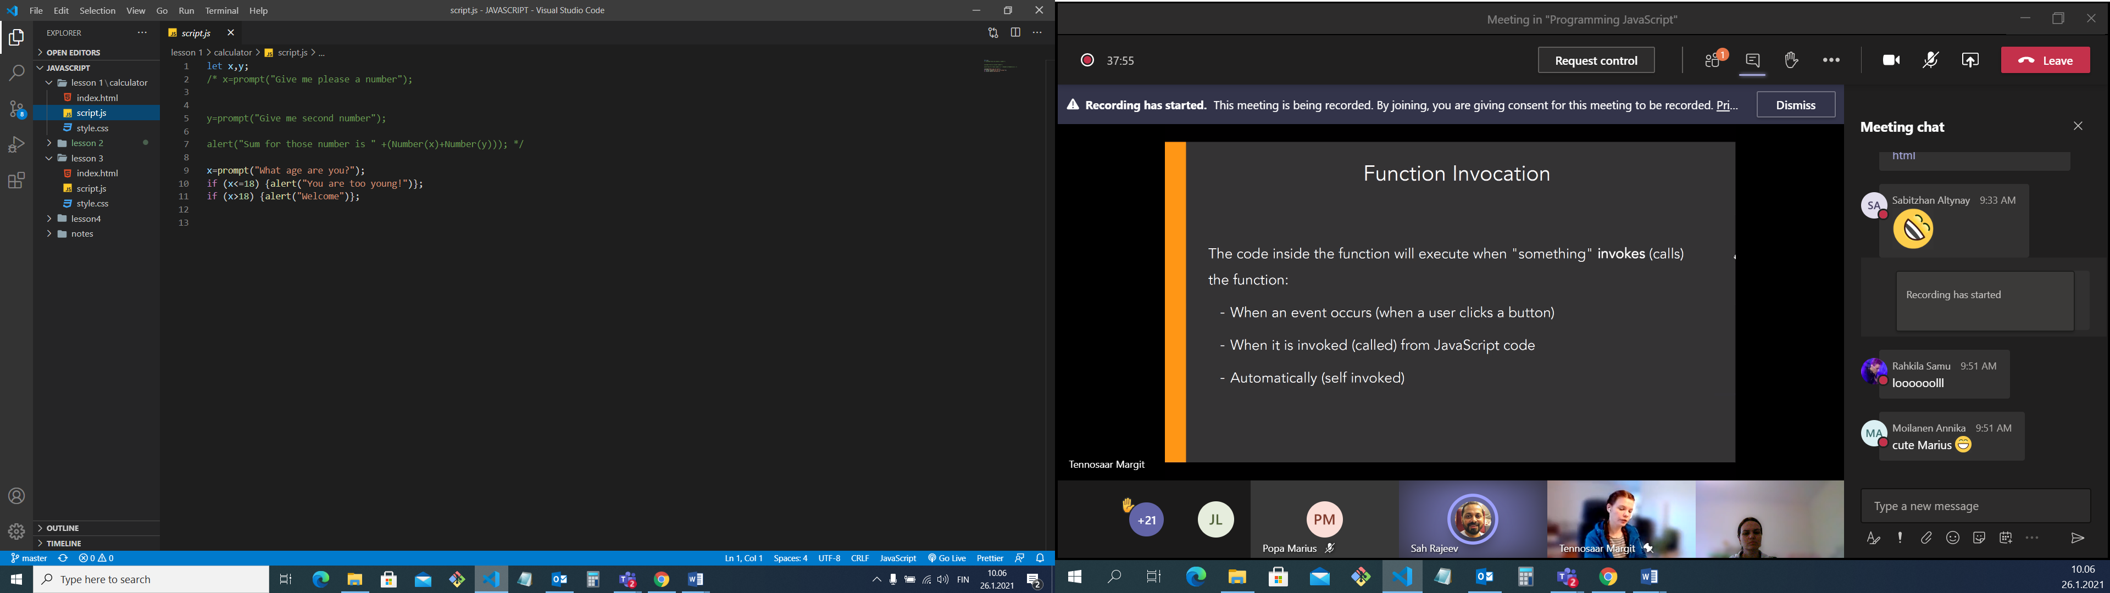

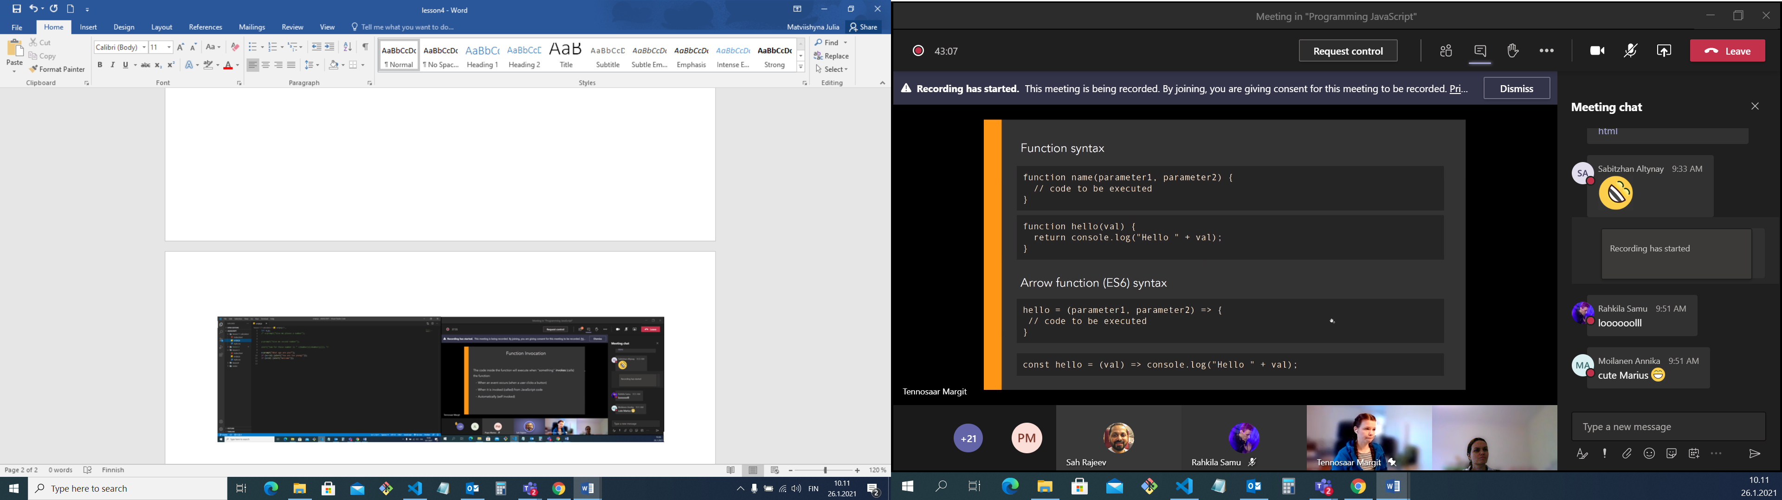

name – your name

parameters to work with – data to work with as many as you need separated with the coma