INTELLIGENT SYSTEMS

(Part One – Software Installation)

Version: 0.1 (20181026T1020)

Author:

Ms Juan Antonio Castro Silva (juan.castro@usco.edu.co)

Ph.D Diego Hernán Peluffo Ordoñez

Objective:

In this short course (tutorial) we are going to build a java web application that uses a python machine learning classification model, using Web Service and Web Sockets.

**Note: This is the first part of the tutorial.**

Software Requirements:

Bellow there is the list of the required software to build and run Intelligent Web Application.

Programming languages:

* Java Development Kit 8 + (JDK)
* Python 3.5 +

Integrated Development Environment (IDE):

* Eclipse 4.9 (Java)
* Spyder IDE (Python)

Web Application Server

* WildFly 14
* Flask Microframework 1.0.2

Databases

* MongoDB (NoSQL)
* PostgreSQL (Object-Relational Database)

# Software Installation:

In this document, you will find the URL, web pages of the required software for this tutorial. The installation process is very simple, the most of the time consisting in unzip a file or click in the next button. If you have problems with the installation process search the web or send me an email explaining your problem (Please begin the the subject with the word YACHAY).

## 1.1 Programming Languages

### 1.1.1 Enterprise Web Programming Language

### **Java Programming Language**

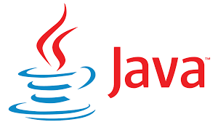Java is a general-purpose [computer-programming language](https://en.wikipedia.org/wiki/Programming_language) that is [concurrent](https://en.wikipedia.org/wiki/Concurrent_computing), [class-based](https://en.wikipedia.org/wiki/Class-based_programming), [object-oriented](https://en.wikipedia.org/wiki/Object-oriented_programming), and specifically designed to have as few implementation dependencies as possible. It is intended to let application developers "[write once, run anywhere](https://en.wikipedia.org/wiki/Write_once,_run_anywhere)" (WORA), meaning that [compiled](https://en.wikipedia.org/wiki/Compiler) Java code can run on all platforms that support Java without the need for recompilation. Java applications are typically compiled to [bytecode](https://en.wikipedia.org/wiki/Java_bytecode) that can run on any [Java virtual machine](https://en.wikipedia.org/wiki/Java_virtual_machine) (JVM) regardless of [computer architecture](https://en.wikipedia.org/wiki/Computer_architecture). As of 2016, Java is one of the most [popular programming languages in use](https://en.wikipedia.org/wiki/Measuring_programming_language_popularity), particularly for client-server web applications, with a reported 9 million developers [1]⁠.

### **Java SE Development Kit 11**

The Java™ Platform, Standard Edition Development Kit (JDK™) is a development environment for building applications, and components using the Java programming language.

The Java SE Development Kit 11 can be installed in different operating systems:

<https://www.oracle.com/technetwork/java/javase/downloads/jdk11-downloads-5066655.html>

### 

### 1.1.2 Machine Learning Programming Language

### Python

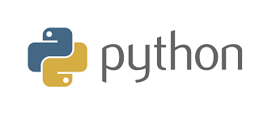Python is an interpreted programming language whose philosophy emphasizes a syntax that favors a readable code.

It is a multi-paradigm programming language, since it supports object orientation, imperative programming and, to a lesser extent, functional programming. It is an interpreted language, it uses dynamic typing and it is multiplatform.

It is managed by the Python Software Foundation. It has an open source license, called the Python Software Foundation License, 3 which is compatible with the GNU General Public License as of version 2.1.1, and incompatible in certain previous versions [2]⁠.

### Python Software Foundation

The mission of the Python Software Foundation is to promote, protect, and advance the Python programming language, and to support and facilitate the growth of a [diverse](https://www.python.org/psf/diversity/) and international community of Python programmers [3]⁠.

### Anaconda Distribution

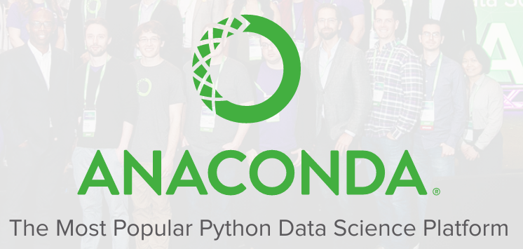Anaconda Distribution 5 is a free, easy-to-install package manager, environment manager and Python distribution with a collection of 1,000+ open source packages with free community support. Anaconda is platform-agnostic, so you can use it whether you are on Windows, macOS or Linux [4]⁠.

With over 6 million users, the open source [Anaconda Distribution](https://www.anaconda.com/distribution/) is the fastest and easiest way to do Python and R data science and machine learning on Linux, Windows, and Mac OS X. It's the industry standard for developing, testing, and training on a single machine [5]⁠.

The Anaconda distribution can be download from the official site:

<https://www.anaconda.com/download/>

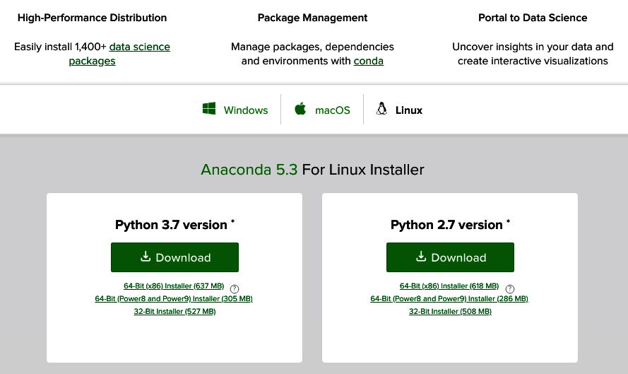Source: https://www.anaconda.com/download/#linux

Choose the **Python 3.7** version installer depending on your operating system (windows, macOS, Linux) and platform (64-Bit or 32-Bit).

Anaconda is one of the most used python distributions, it contains the more important Machine Learning (ML) libraries, and additionally it includes the IDE spyder.

Note: It is possible to develop this tutorial without a specialized IDE such as Spyder.

## 1.2 Integrated Development Environment (IDE)

### 1.2.1 Eclipse

Eclipse is an [integrated development environment](https://en.wikipedia.org/wiki/Integrated_development_environment) (IDE) used in [computer programming](https://en.wikipedia.org/wiki/Computer_programming), and is the most widely used Java IDE. It contains a base [workspace](https://en.wikipedia.org/wiki/Workspace) and an extensible [plug-in](https://en.wikipedia.org/wiki/Plug-in_(computing)) system for customizing the environment. Eclipse is written mostly in [Java](https://en.wikipedia.org/wiki/Java_(programming_language)) and its primary use is for developing Java applications, but it may also be used to develop applications in other [programming languages](https://en.wikipedia.org/wiki/Programming_language) via plug-ins, including [Ada](https://en.wikipedia.org/wiki/Ada_(programming_language)), [ABAP](https://en.wikipedia.org/wiki/ABAP), [C](https://en.wikipedia.org/wiki/C_(programming_language)), [C++](https://en.wikipedia.org/wiki/C%2B%2B), [C#](https://en.wikipedia.org/wiki/C_Sharp_(programming_language)), [COBOL](https://en.wikipedia.org/wiki/COBOL), [D](https://en.wikipedia.org/wiki/D_(programming_language)), [Fortran](https://en.wikipedia.org/wiki/Fortran), [Haskell](https://en.wikipedia.org/wiki/Haskell_(programming_language)), [JavaScript](https://en.wikipedia.org/wiki/JavaScript), [Julia](https://en.wikipedia.org/wiki/Julia_(programming_language)), [Lasso](https://en.wikipedia.org/wiki/Lasso_(programming_language)), [Lua](https://en.wikipedia.org/wiki/Lua_(programming_language)), [NATURAL](https://en.wikipedia.org/wiki/Software_AG), [Perl](https://en.wikipedia.org/wiki/Perl), [PHP](https://en.wikipedia.org/wiki/PHP), [Prolog](https://en.wikipedia.org/wiki/Prolog), [Python](https://en.wikipedia.org/wiki/Python_(programming_language)), [R](https://en.wikipedia.org/wiki/R_(programming_language)), [Ruby](https://en.wikipedia.org/wiki/Ruby_(programming_language)) (including [Ruby on Rails](https://en.wikipedia.org/wiki/Ruby_on_Rails) framework), [Rust](https://en.wikipedia.org/wiki/Rust_(programming_language)), [Scala](https://en.wikipedia.org/wiki/Scala_(programming_language)), [Clojure](https://en.wikipedia.org/wiki/Clojure), [Groovy](https://en.wikipedia.org/wiki/Groovy_(programming_language)), [Scheme](https://en.wikipedia.org/wiki/Scheme_(programming_language)), and [Erlang](https://en.wikipedia.org/wiki/Erlang_(programming_language)). It can also be used to develop documents with [LaTeX](https://en.wikipedia.org/wiki/LaTeX) (via a TeXlipse plug-in) and packages for the software [Mathematica](https://en.wikipedia.org/wiki/Mathematica). Development environments include the Eclipse Java development tools (JDT) for Java and Scala, Eclipse CDT for C/C++, and Eclipse PDT for PHP, among others [6]⁠.

The eclipse IDE can be downloaded from this url:

[https://www.eclipse.org/downloads/packages/](https://www.eclipse.org/downloads/)

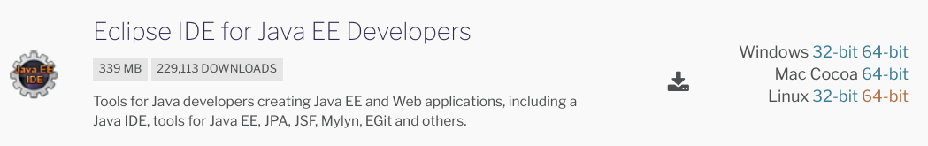You must select the Eclipse IDE for java EE Developers to develop Web applications.

### 1.2.2 Spyder IDE

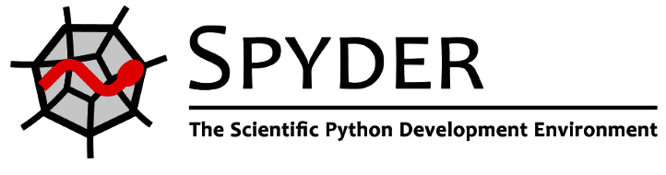Spyder is a powerful scientific environment written in Python, for Python, and designed by and for scientists, engineers and data analysts. It offers a unique combination of the advanced editing, analysis, debugging, and profiling functionality of a comprehensive development tool with the data exploration, interactive execution, deep inspection, and beautiful visualization capabilities of a scientific package [7]⁠.

Beyond its many built-in features, its abilities can be extended even further via its plugin system and API. Furthermore, Spyder can also be used as a PyQt5 extension library, allowing developers to build upon its functionality and embed its components, such as the interactive console, in their own PyQt software.

The Spyder IDE was installed with your the Anaconda distribution. The official web site is:

<https://www.spyder-ide.org/>

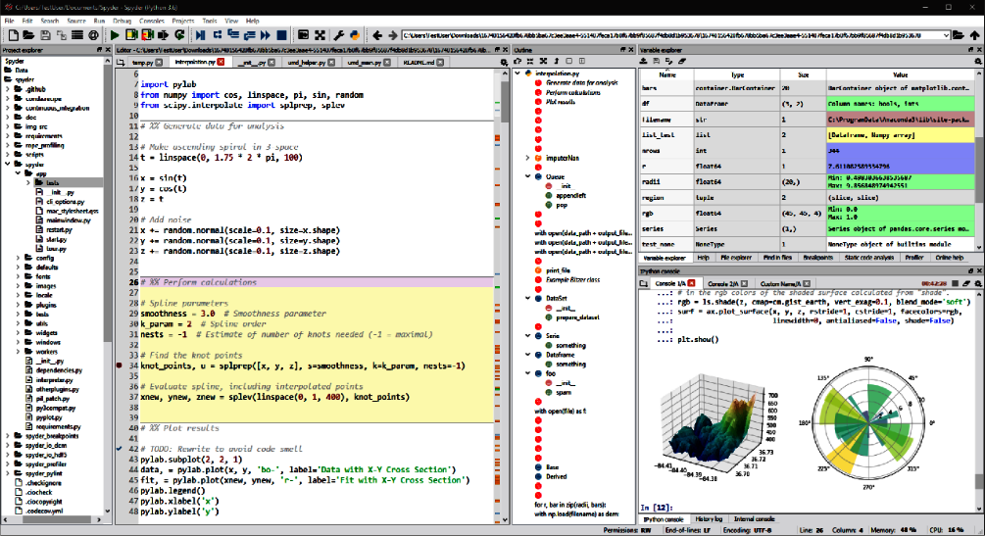

## 1.3 Database

### 1.3.1 NoSQL Database (NO Relational)

### MongoDB

[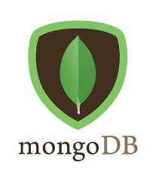MongoDB](https://www.mongodb.com/) is a free and open-source NoSQL document database used commonly in modern web applications [8]⁠.

You can install MongoDB in different operating systems:

<https://docs.mongodb.com/manual/administration/install-community/>

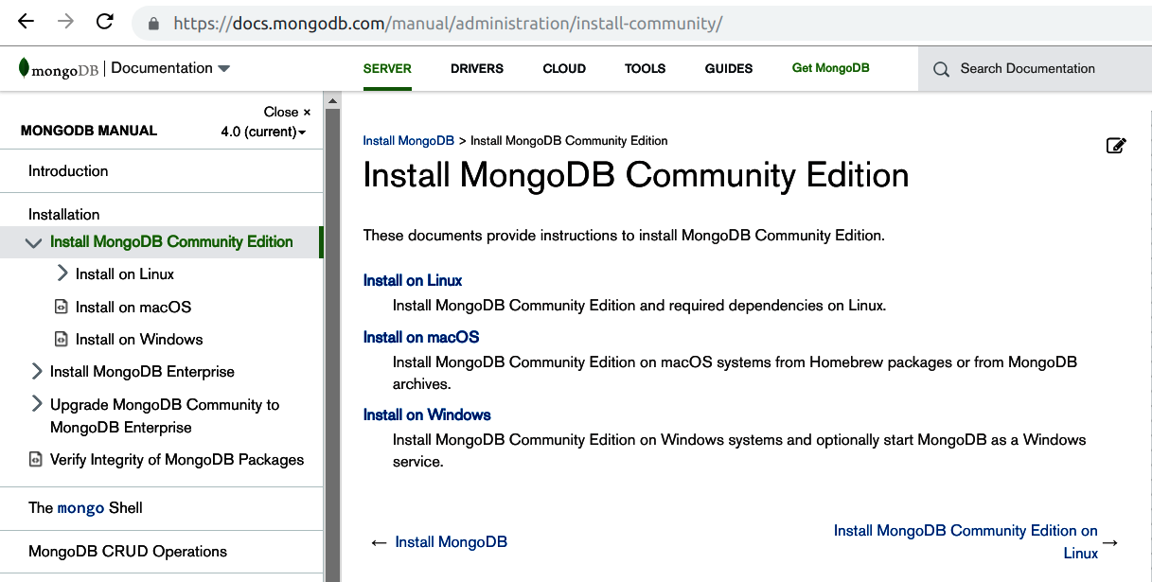

Windows: <https://docs.mongodb.com/manual/tutorial/install-mongodb-on-windows/>

Linux (Ubuntu): <https://docs.mongodb.com/manual/tutorial/install-mongodb-on-ubuntu/>

### 1.3.2 Relational Database (PostgreSQL)

### PostgreSQL

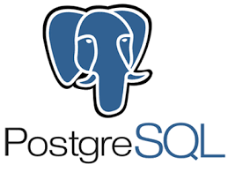PostgreSQL is a powerful, open source object-relational database system with over 30 years of active development that has earned it a strong reputation for reliability, feature robustness, and performance [9]⁠.

Pre-built binary packages are available for a number of different operating systems (Linux, macOS, Windows):

<https://www.postgresql.org/download/>

## 1.4 Web Application Server

### 1.4.1 WildFly (Java)

WildFly is a flexible, lightweight, managed application runtime that helps you build ***amazing*** applications [10]⁠.

**Modern Web**

WildFly supports the latest standards for web development. Web Socket support allows your applications the ability to use optimized custom protocols and full-duplex communication with your backend infrastructure. This is particular useful in communicating with mobile devices.

As web applications have evolved to become more client oriented with rich dynamic JavaScript, data access over the web has become critical. WildFly supports the latest standards for REST based data access, including JAX-RS 2, and JSON-P.

The WildFly server can be downloaded as a zip file format from its web page:

<http://wildfly.org/downloads/>



To install the WildFly web application server, unzip the downloaded file, an rename it as wildfly in lowercase.

### 1.4.2 Flask Microframework (Python)

Flask is a microframework for Python based on Werkzeug, Jinja 2 and good intentions. And before you ask: It's [BSD licensed](http://flask.pocoo.org/docs/license/)! [11]⁠.

The flask microframework can be installed from a terminal with this command:

$ pip install Flask

# REFERENCES

[1] “Java (programming language).” [Online]. Available: https://en.wikipedia.org/wiki/Java_(programming_language). [Accessed: 27-Oct-2018].

[2] “Python.” [Online]. Available: https://es.wikipedia.org/wiki/Python. [Accessed: 27-Oct-2018].

[3] “Python Software Foundation | Python Software Foundation.” [Online]. Available: https://www.python.org/psf/. [Accessed: 27-Oct-2018].

[4] “Anaconda Documentation — Anaconda 2.0 documentation.” [Online]. Available: https://docs.anaconda.com/. [Accessed: 27-Oct-2018].

[5] “What is Anaconda? - Anaconda.” [Online]. Available: https://www.anaconda.com/what-is-anaconda/. [Accessed: 27-Oct-2018].

[6] “Eclipse (software).” [Online]. Available: https://en.wikipedia.org/wiki/Eclipse_(software). [Accessed: 27-Oct-2018].

[7] “Spyder Website.” [Online]. Available: https://www.spyder-ide.org/. [Accessed: 27-Oct-2018].

[8] “How to Install MongoDB on Ubuntu 18.04 | DigitalOcean.” [Online]. Available: https://www.digitalocean.com/community/tutorials/how-to-install-mongodb-on-ubuntu-18-04. [Accessed: 27-Oct-2018].

[9] “PostgreSQL: The world’s most advanced open source database.” [Online]. Available: https://www.postgresql.org/. [Accessed: 27-Oct-2018].

[10] “About · WildFly.” [Online]. Available: http://wildfly.org/about/. [Accessed: 27-Oct-2018

[11] “Welcome | Flask (A Python Microframework).” [Online]. Available: http://flask.pocoo.org/. [Accessed: 27-Oct-2018].