Twitter
IPO and current Price

Twitter has been covered widely in the news due to extreme fluctuations in its share price after its Initial Public Offering (IPO) in November 2013.
http://www.telegraph.co.uk/technology/twitter/10432396/Twitter-IPO-as-it-happened.html
The starting price was set at $26 and it soared in a day up to around $46. The maximum price ever was $73.31 (26/12/2013).
http://www.nasdaq.com/symbol/twtr/interactive-chart
Recently (2014), it decreased sharply (down to around $50) after a below expectations earnings announcement.
http://nypost.com/2014/02/06/twitter-shares-fall-23-on-first-earnings-report/
Twitter’s CEO has argued that growth in users count will be observed, but not immediately.
http://www.zdnet.com/twitter-ceo-promises-user-count-growth-in-2014-but-not-all-overnight-7000026320/
Let s try to evaluate a fair estimate of Twitter’s equity (price per share) currently, as well as when it went public. For this purpose we will use data taken from:
- Twitter’s Annual Report
  - https://investor.twitterinc.com/
  - https://investor.twitterinc.com/releasedetail.cfm?ReleaseID=823321
  - http://mashable.com/2013/10/29/linkedin-q3-earnings/
- Twitter and its main listed competitors’, Facebook and Linkedin, data from Nasdaq
  - http://investor.fb.com/secfiling.cfm?filingid=1326801-13-3
  - http://ycharts.com/financials/FB/income_statement/quarterly
  - http://www.nasdaq.com/symbol/fb/interactive-chart
  - http://www.nasdaq.com/symbol/lnkd/interactive-chart
  - http://www.nasdaq.com/symbol/twtr/interactive-chart
- Further information for social networking is taken from
  - http://www.pewinternet.org/2013/02/14/social-networking-site-users/
- Industry averages are taken from this file
  - 
- Corporate Tax Rates
  - https://en.wikipedia.org/wiki/Corporate_tax_in_the_United_States
Valuation March 2014
Twitter has a very short history of reporting data. Consequently, the available information we can use to formulate expectations or a group of comparable firms is rather limited. This reduces the validity or usability of DCF approach. Also most of the multiples cannot be applied. For example, Twitter is losing money and a P/E ratio cannot be estimated. Neither a Firm Value to Operating Earnings (either before or after Depreciations and Amortizations). We will approach valuation using some more specific multiples, first, and then we will try to formulate some reasonable estimates for DCF estimation.
Multiples
The only positive figure on Twitter’s Income statement is Sales. So, we can use the Price sales ratio. In addition, we will use an industry specific index, referring to Monthly Active Users (MAU). We will construct the Price per MAUs for the three companies. The data we can collect at this point in time can be summarized in the following table.
Company | MAU | MCAP | No Shares | Revenue | Pre Tax  Operating Margin | Re-investment  Needs  (Net CapEx+NWC) as %ΔSales
Twitter | 241m | - | 242m | 664.89m | - | -
Facebook | 1,060m | $86,718m | 1,292.6m | 7,872m | 35.62% | -
LinkedIn | 259m | $16,884 | 90.7m | Normalized  1,108.56m | 6.5% | -
Industry | - | - | - | - | 19.33% | (0.91%+3.34%)
Revenue for LinkedIn is normalized, because they have not published the annual report yet
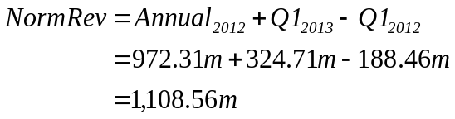
Price Sales Ratio
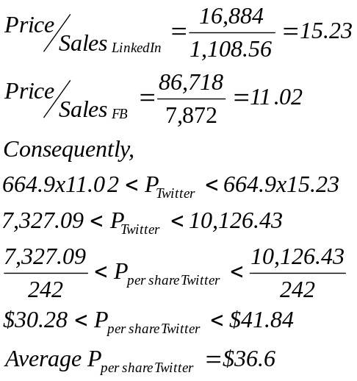
Price MAU
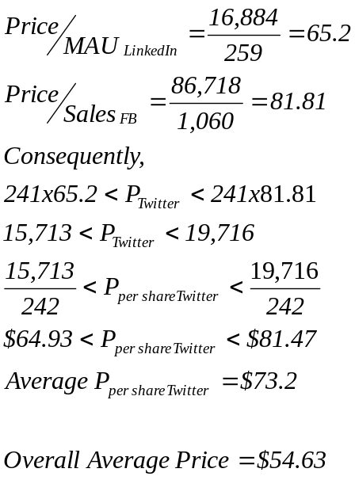
The average price is very close to the prevailing price ($\$55.4$ in March 2014). Some initial conclusions might include the speculation that the market weights both revenues and MAU equally. Any change in the figures is expected to have a significant impact on the share price.
DCF Valuation and Assumptions
Twitter is a money losing firm at the moment, but it is expected to grow fast, both in terms of revenues and MAU. Both EBIT and NI are negative, so the only positive figure that we can use is sales and consequently operating margin. We assume the following:
 | 0 | 1 | 2 | 3 | 4 | 5 | 6 | 7
Δsales |  | 100% | 75% | 50% | 25% | 10% | 5% | 3%
OPM | -95% | -50% | -20% | 0 | 5% | 15% | 19.33% | 19.33%
NetCapEx/Sales |  | 0.91% | 0.91% | 0.91% | 0.91% | 0.91% | 0.91% | 0.91%
NWC/Sales |  | 3.34% | 3.34% | 3.34% | 3.34% | 3.34% | 3.34% | 3.34%
Tax |  | 34% | 34% | 34% | 34% | 34% | 34% | 34%
Cost of Capital |  | 9.85% | 9.85% | 9.85% | 9.85% | 9.85% | 9.85% | 9.85%

The tax rate is the marginal tax rate for the US, Twitter is assumed to reach stable growth (3%) after 7 years. The, currently negative operating margin (OPM) will reach the industry average (taken from the file attached on page 1) in 6 years. It needs to reach a positive sign fairly soon, because assets turnover in the industry is very fast. We assume that Twitter will turn on the green side after around 3 to 4 years (around 2018). Re-investments are assumed to be consistent with industry averages in order to maintain growth. The expected growth of sales is consistent with the IPO expectations (see below). Cost of capital is assumed to be consistent with industry standards. The FCFF are given below. Sales grow at a rate stated above, EBIT is computed given the stated operating margin, while the re-investments are NetCapEX=0.91%*Sales and ΔNWC=3.34%xΔSales. FCFF is EBIT(1-T)-NetCapEX-ΔNWC. The Discounted FCFF is computed using 9.85% discount rate.
 | 0 | 1 | 2 | 3
growth |  | 100% | 75% | 50%
Sales | 664,890.00 | 1,329,780.00 | 2,327,115.00 | 3,490,672.50
OPM |  | -50.00% | -20.00% | 0.00%
EBIT |  | -664,890.00 | -465,423.00 | 0.00
NetCapEx/Sales |  | 0.91% | 0.91% | 0.91%
NWC/Sales |  | 3.34% | 3.34% | 3.34%
NetCapEx |  | 12,101.00 | 21,176.75 | 31,765.12
ΔNWC |  | 22,207.33 | 33,310.99 | 38,862.82
Tax |  | 34% | 34% | 34%
FCFF |  | -699,198.32 | -519,910.74 | -70,627.94
DFCFF |  | -636,502.80 | -430,852.55 | -53,281.49
 | 4 | 5 | 6 | 7
growth | 25% | 10% | 5% | 3%
Sales | 4,363,340.63 | 4,799,674.69 | 5,039,658.42 | 5,190,848.17
OPM | 5.00% | 15.00% | 19.33% | 19.33%
EBIT | 218,167.03 | 719,951.20 | 974,165.97 | 1,003,390.95
NetCapEx/Sales | 0.91% | 0.91% | 0.91% | 0.91%
NWC/Sales | 3.34% | 3.34% | 3.34% | 3.34%
NetCapEx | 39,706.40 | 43,677.04 | 45,860.89 | 47,236.72
ΔNWC | 29,147.12 | 14,573.56 | 8,015.46 | 5,049.74
Tax | 34% | 34% | 34% | 34%
FCFF | 75,136.73 | 416,917.20 | 589,073.19 | 609,951.57
DFCFF | 51,600.28 | 260,645.06 | 335,250.08 | 5,067,624.37
Vf | $ 4,594,482.96

From Twitter’s annual report we see that report Cash and securities equal to around $2.2b (Cash $841.01m + Short term investments $1,393.04m), while debt, in the form of lease payments is consolidated to $197.65m (short $87.13m + long $110.52m). Consequently, Value of equity is (242m shares):
$${MV}_{E}=V_{F}+CASH-{MV}_{D}=\$4,594,482+2,200-197=\$4,596,482.96 or \$18.99 per share$$
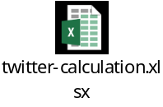

IPO valuation
Let s start with the discounted cash flows. The only difference we will assume is that investors were expecting a growth from year 0 to year 1 equal to 130% and that they were not expecting an operating loss of -95%. Consequently, the expected growth rate from period 1 is 130%, while OPM is expected to move from -24% (annual report 2012) to the industry average in 6 years. The Annual Revenue for 2012 was £316.99m (Twitter annual report). All other assumptions remain the same. The number of shares does not change, since it was an IPO. The cash flows can be summarized below
 | 0 | 1 | 2 | 3
growth |  | 130% | 100% | 75%
Sales | 316,993.00 | 729,083.90 | 1,458,167.80 | 2,551,793.65
OPM |  | -10.00% | 0.00% | 5.00%
EBIT |  | -72,908.39 | 0.00 | 127,589.68
NetCapEx/Sales |  | 0.91% | 0.91% | 0.91%
NWC/Sales |  | 3.34% | 3.34% | 3.34%
NetCapEx |  | 6,634.66 | 13,269.33 | 23,221.32
ΔNWC |  | 13,763.84 | 24,351.40 | 36,527.10
Tax |  | 34% | 34% | 34%
FCFF |  | -93,306.89 | -37,620.73 | 24,460.76
DFCFF |  | -84,940.27 | -31,176.48 | 18,453.12
 | 4 | 5 | 6 | 7
growth | 50% | 25% | 10% | 3%
Sales | 3,827,690.48 | 4,784,613.09 | 5,263,074.40 | 5,420,966.64
OPM | 10.00% | 15.00% | 19.33% | 19.33%
EBIT | 382,769.05 | 717,691.96 | 1,017,352.28 | 1,047,872.85
NetCapEx/Sales | 0.91% | 0.91% | 0.91% | 0.91%
NWC/Sales | 3.34% | 3.34% | 3.34% | 3.34%
NetCapEx | 34,831.98 | 43,539.98 | 47,893.98 | 49,330.80
ΔNWC | 42,614.95 | 31,961.22 | 15,980.61 | 5,273.60
Tax | 34% | 34% | 34% | 34%
FCFF | 175,180.63 | 398,175.50 | 607,577.92 | 636,991.68
DFCFF | 120,305.60 | 248,928.28 | 345,781.39 | 5,292,280.13
Vf | $ 5,909,631.76

Cash and Debt are computed the same way as before and they are $424.86m and $114.57m, respectively. Consequently, share price should be
$${MV}_{E}=V_{F}+CASH-{MV}_{D}=\$5,909,631.76+424.86-114.57=\$5,909,942.05 or \$24.42 per share$$

Relative Valuation-Multiples
The IPO was in November, when at the time there was no up to date information. We will estimate trailing 3rd quarter revenue figures and we will assume that MAU has not changed since then. Also, we will assume that the number of shares for Facebook and LinkedIn has not changed either. This will allow us to estimate MCAP from prevailing share prices. Data can be summarized below.
Company | MAU | MCAP | No Shares | Revenue
Twitter | $241m | - | 242m | $242.68m
Facebook | $1,060m | $60.75 | 1,292.6m | $5,725.05m
LinkedIn | $259m | $19.05b | 90.7m | $634.74m

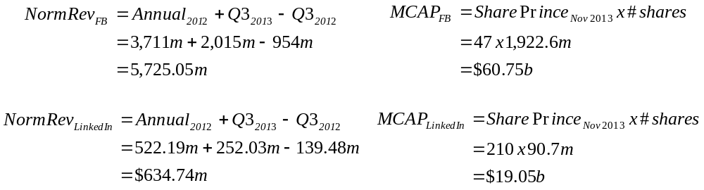
Price Sales | Price per MAU
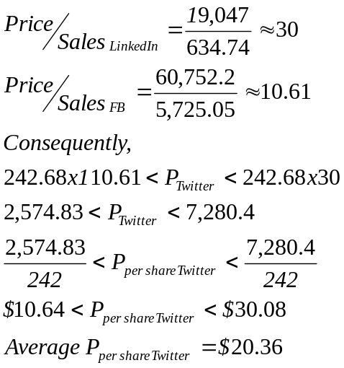 | 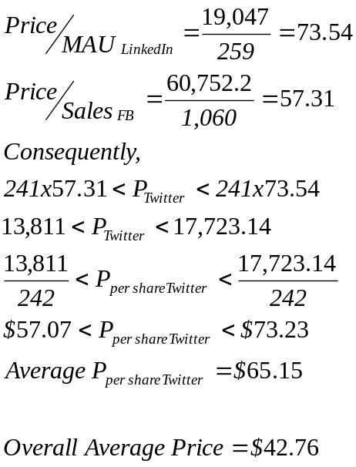

A brief conclusion is that the IPO price was close to the DCF valuation ($26 vs $24.42), but within a day went up to the overall average relative valuation price ($46 vs $42.76). On the long term the price seems to be moving to relative valuation average of $54.63 (current market price is $55.4 in March 2014). A major reason of mis-pricing seems to be the big surprise in FB’s revenue. Please note that trailing revenue for 2013 was $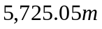, while the actual was $7,872m. This appears to be the main determinant for the all-time high of $73.31 for Twitter earlier in 2014, as well as for the sharp increase towards the end of 2013.

Valuation March 2017
Here we will try to evaluate Twitter in March 2017 (current Price is $14.50), using a slightly different approach (mainly for presentation purposes), by borrowing analysts estimates for almost all the figures we are using. First, we will perform a relative valuation and all statistics are taken from EIKON. The peers we considered are first, defined by EIKON, and second, we replace LinkedIn by Snapchat Inc., because the first was acquired by Microsoft, while the second was recently listed.
Company | MAU | MCAP | #shares | P/E | P/S | Revenue
Twitter | 319m | $10.97b | 726.89m | - | - | $2.53b
Facebook | 1.86b | $404.42b |  | 40.6 | 14.63 | $27.64b
Snapchat | 301 | $23.66b | 1.19b | <0 | 58.50 | $404.48m
Industry Average |  |  |  | 24.1 | 13.06 | $1.51b
Industry Median |  |  |  | 25.55 | 3.40 | $981,960
Net capital expenditure, WC needs, Operating margins and cost of capital are taken from industry (Software-Internet) averages for the US market from (2017) here.
 | Industry Average
NEC/Sales | 5.18%
WC/Sales | -3.70% Assume 0 for 5 years and then (long term) 10%
Operating Margin | 17.25%
Cost of capital | 9.97%

Relative Valuation
Price Sales Ratio
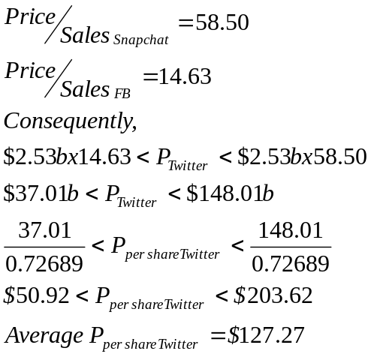
This price is completely off track, and the most likely reason is that Twitter is not (considered to be) a leading company in the sector. Therefore, the P/S multiples of Facebook and Snapchat would most likely overestimate its value. Let s try with the mean and median, assuming that Twitter is an average (rather than a leading) firm in the sector.
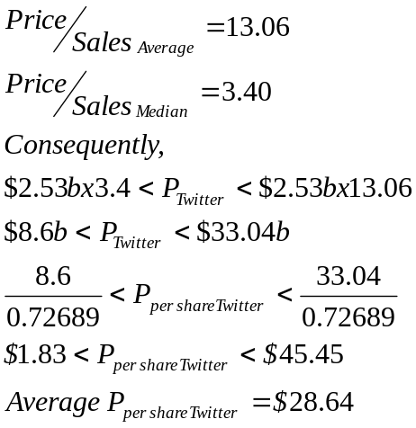
This is a more realistic valuation and seems that Twitter belongs to the lower 50% of the companies in this sector.
Price MAU
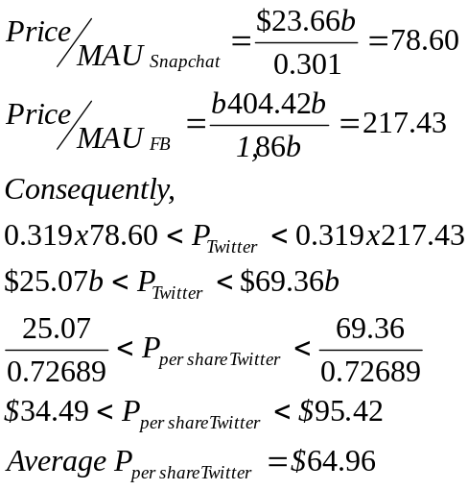
This price is again rather far from the market price and most likely it does not reflect the fundamentals. Let s see what assumptions we can develop and what price these would lead us to.
Fundamentals pricing
Twitter is still a money losing firm at an operational level (EBIT=-$367.21m, Operating margin = $367.21m / $2.53b = -14.51%). Unlike in the past it is not expected to growth as fast as its competitors, although there have been changes in management, as well as rumors that it might be taken over by a larger firm, such as Microsoft. We will assume that in any case, Twitter will be able to achieve some growth both on the number of MAU, as well as revenue due to either the managerial changes or a potential acquisition. It will reach as healthy operating margin in 3 years. It needs to reach a positive sign fairly soon, because assets turnover in the industry is very fast. It will enter a stable growth (3%) phase in 10 years from now. Investments will be comparable to the industry level.

 | 0 | 1 | 2 | 3 | 4 | 5
Δsales |  | 45% | 40% | 35% | 30% | 25%
OPM | -14.51% | -10% | -5% | 0 | 5% | 15%
NetCapEx/Sales |  | 5.18% | 5.18% | 5.18% | 5.18% | 5.18%
NWC/Sales | -3.70% | 0.00% | 0.00% | 0.00% | 0.00% | 0.00%
Tax |  | 32.86% | 32.86% | 32.86% | 32.86% | 32.86%
Cost of Capital |  | 9.97% | 9.97% | 9.97% | 9.97% | 9.97%
 | 6 | 7 | 8 | 9 | 10 | 11
Δsales | 20% | 15% | 10% | 8% | 6% | 3%
OPM | 17.25% | 17.25% | 17.25% | 17.25% | 17.25% | 17.25%
NetCapEx/Sales | 5.18% | 5.18% | 5.18% | 5.18% | 5.18% | 5.18%
NWC/Sales | 0.67% | 1.34% | 2.00% | 2.67% | 3.34% | 3.34%
Tax | 32.86% | 32.86% | 32.86% | 32.86% | 32.86% | 32.86%
Cost of Capital | 9.97% | 9.97% | 9.97% | 9.97% | 9.97% | 9.97%
The tax rate is the marginal tax rate for the US, We assume that Twitter will turn on the green side after around 3 to 4 years. Cost of capital is assumed to be consistent with industry standards. The FCFF are given below. Sales grow at a rate stated above, EBIT is computed given the stated operating margin, while the re-investments are NetCapEX=5.81%*Sales and ΔNWC=(03.34%)xΔSales. FCFF is EBIT(1-T)-Re-investment. The Discounted FCFF is computed using 9.97% discount rate.
 | 0 | 1 | 2 | 3 | 4 | 5
growth |  | 45% | 40% | 35% | 30% | 25%
Sales | 2.53 | 3.67 | 5.14 | 6.93 | 9.01 | 11.27
OPM | -14.51% | -10.00% | -5.00% | 0.00% | 5.00% | 15.00%
EBIT |  | -0.37 | -0.26 | 0.00 | 0.45 | 1.69
NetCapEx/Sales |  | 5.18% | 5.18% | 5.18% | 5.18% | 5.18%
NWC/Sales |  | 0.00% | 0.00% | 0.00% | 0.00% | 0.00%
NetCapEx |  | 0.19 | 0.27 | 0.36 | 0.47 | 0.58
ΔNWC |  | 0.00 | 0.00 | 0.00 | 0.00 | 0.00
Tax |  | 32.86% | 32.86% | 32.86% | 32.86% | 32.86%
FCFF |  | -0.56 | -0.52 | -0.36 | -0.16 | 0.55
DFCFF |  | -0.51 | -0.43 | -0.27 | -0.11 | 0.34
 | 6 | 7 | 8 | 9 | 10 | 11
growth | 20% | 15% | 10% | 8% | 6% | 3%
Sales | 13.52 | 15.55 | 17.10 | 18.47 | 19.58 | 13.93
OPM | 17.25% | 17.25% | 17.25% | 17.25% | 17.25% | 17.25%
EBIT | 2.33 | 2.68 | 2.95 | 3.19 | 3.38 | 2.40
NetCapEx/Sales | 5.18% | 5.18% | 5.18% | 5.18% | 5.18% | 5.18%
NWC/Sales | 0.67% | 1.34% | 2.00% | 2.67% | 3.34% | 3.34%
NetCapEx | 0.70 | 0.81 | 0.89 | 0.96 | 1.01 | 0.72
ΔNWC | 0.02 | 0.03 | 0.03 | 0.04 | 0.04 | 0.01
Tax | 32.86% | 32.86% | 32.86% | 32.86% | 32.86% | 32.86%
FCFF | 0.85 | 0.97 | 1.06 | 1.15 | 1.22 | 0.88
DFCFF | 0.48 | 0.50 | 0.50 | 0.49 | 0.47 | 4.87
Vf | $ 6.32

From Twitter’s annual report we see that report Cash and securities equal to around $3.44b (Cash $253.8m + Short term investments $2,768m + Money Market Funds 422.5), while debt is $1.69b. Consequently, Value of equity, is:
$${MV}_{E}=V_{F}+CASH-{MV}_{D}=\$6.32b+\$3.44b-\$1.69=\$8.07b or \$11.11 per share$$
This seems to be much closer to reality, as well as the market price. Still Twitter would be a rather strong sell. It underperforms its competitors and the initially high expectation of growth does not seem to be realized.
Valuation April 2018
Twitter generates positive earnings for the first time (Current price around $25)!
According to the previous valuations (especially the IPO and March 2014), Twitter was expected to generate positive Operating margin and positive income for the first time in 2017-2018. This was indeed realized and Twitter reports the following fundamentals in the annual report of 2017.
Item | Value
Revenue | $2,110m
NI (excluding Extraordinary items) | $244.8m
NPM | 11.6%
NPM (industry) | 13.08%
Growth in sales | -5%
Growth in MAU (0.319m→0.33m) | ≈1%
beta | 0.42
MRP | 5.08%
10y American Treasury bond yield | Long term expectation 3%
NCE | 8.35% of Revenue
ΔNWC | 9.95% of ΔSales
ROE (EIKON) | 4.85%
#shares | 750.90m
δ (EIKON) | 25%

In addition, with respect to comparable firms, Twitter seems to be the leading company, given that Facebook faces some severe price pressure due to scandals.

Company Name | Price / EPS | Price / FCFE | Market / Book | Price / Sales | Dividend Yield %
Facebook Inc | 20.30 | 15.88 | 4.56 | 7.64 | -
Twitter Inc | 41.15 | 22.99 | 3.83 | 7.75 | -
Snap Inc | - | - | 9.45 | 14.67 | -
Microsoft Corp | 23.33 | 15.28 | 6.78 | 6.10 | 1.9%
Tencent Holdings Ltd | 34.57 | 22.91 | 8.57 | 8.35 | 0.3%
Alphabet Inc | 23.67 | 16.75 | 4.01 | 5.09 | -
Amazon.com Inc | 135.00 | 23.96 | 17.19 | 2.80 | -

Therefore, We will pursue a DCF valuation, accompanied by a market wide multiples valuation.
DCF
The cost of equity is:
$$k_{e}=r_{f}+β_{l, FB} x MRP=3+0.45 x 5.08=6.93\%$$
According to market analysts, NI is expected to grow very fast over the next five years
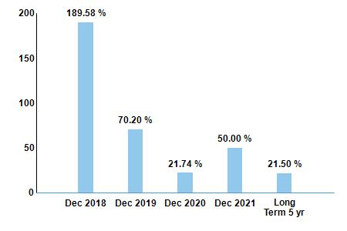
Then it is expected to be 10% in year six and then it is expected to stabilize at 3%. The Equity Re-Investment Rate for achieving a long term growth of 5% is:
$$ERR=\frac{g}{ROE}=\frac{0.03}{0.0485}≈63\%$$
The valuation then is:
 | 0 | 1 | 2 | 3 | 4 | 5 | 6 | 7
ke |  | 6.93% | 6.93% | 6.93% | 6.93% | 6.93% | 6.93% | 6.93%
growth |  | 190% | 70% | 22% | 50% | 22% | 10% | 3%
Sales | 2,110.00 | 6119.00 | 10402.30 | 12690.81 | 19036.21 | 23224.17 | 25546.59 | 26312.99
NI | 244.8 | 709.92 | 1206.86 | 1472.37 | 2208.56 | 2694.44 | 2963.89 | 3052.81
NetCapEx/Sales |  | 8.35% | 8.35% | 8.35% | 8.35% | 8.35% | 8.35%
NWC/Sales |  | 9.95% | 9.95% | 9.95% | 9.95% | 9.95% | 9.95%
ROE |  |  |  |  |  |  |  | 4.85%
ERR |  |  |  |  |  |  |  | 61.86%
δ |  | 25.00% | 25.00% | 25.00% | 25.00% | 25.00% | 25.00% | 25.00%
NetCapEx |  | 510.94 | 868.59 | 1059.68 | 1589.52 | 1939.22 | 2133.14
ΔΝWC |  | 398.90 | 426.19 | 227.71 | 631.37 | 416.70 | 231.08
FCFE |  | 27.55 | 235.78 | 506.83 | 542.89 | 927.50 | 1190.72 | 1164.47
DF |  | 25.76 | 206.21 | 414.54 | 415.26 | 663.46 | 796.55 | 19821.62
MVE | $22,343.40
Per share | $29.76

Multiple Valuation:
The size and the composition of the peer group would yield a rather biased (multiples) valuation and therefore, we will still use the P/E and P/Sales multiples, but we will compare Twitter to the market as a whole, based on the fundamentals that drive the two multiples:
Regression
PE = 4.20 + 149.0 g_{EPS} + 13.40 Payout - 2.86 Beta
(3.35) (26.82) (18.50) (2.93)
PS= 0.31+0.04 Payout + 9.17 g_{EPS} - 0.47 Beta + 12.60 Net Margin
(2.88) (4.70) (19.58) (4.54) (37.00)
Consequently, for Twitter
Regression | Multiple | Item | Price
PE  = 4.20 + 149.0 x 0.5 + 13.40 x 0 - 2.86 x 0.45 | 77.413 | Earnings  $244.8m | $18,950.7m  Or $25.24
PS  = 0.31+0.04x0 + 9.17x0.5 - 0.47x0.45 + 12.60x0.116 | 6.14 | $2,110m | $12,966.16m  Or $12.27
It seems that the asset in the market is priced according to multiples, rather than a DCF approach. According to analysts’ expectations, Twitter should be a strong buy. However there are some strong critiques against it:
Fore example, some insights
https://www.usatoday.com/story/money/business/2014/02/06/twitter-earnings-report-crash/5259453/
And this makes the recommendations being rather mixed:

From Nasdaq | From EIKON
From Nasdaq  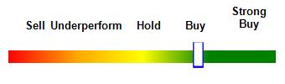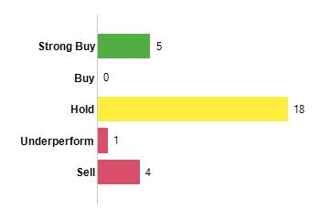 | 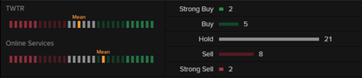

Update March 2019
Again, we will try to evaluate Twitter (currently traded at $32.59) in a similar way to the 2017 valuation, by borrowing analysts estimates for almost all the figures we are using. First, we will perform a relative valuation and all statistics are taken from EIKON. The peers we considered are first, defined by EIKON.
Company | MAU | MCAP | #shares | P/E | P/S | Revenue
Twitter | 326m | $23.98b | 772.69m | 20.11 | 7.40 | $3.04b
Facebook | 2.32b | $461.12b | 2,921m | 21.23 | 6.30 | $55.84b
Snapchat | 301m | $14.04b | 1,294.75b | N/A | 5.60 | $1.18b
Industry Average |  |  |  | 125.62 | 6.01 | $1.51b
Industry Median |  |  |  | 28.16 | 2.22 | $981,960

Net capital expenditure, WC needs, Operating margins and cost of capital are taken from industry (Software-Internet) averages for the US market from here.
 | Industry Average
NEC/Sales | 8.92%
WC/Sales | 9.86%
Operating Margin | 20.10%
Cost of capital | 8.36%

Some further inputs from the Damodaran database, from Nasdaq and from EIKON
Item | Value
EPS | $0.81
NPM | 28.09%
NPM (industry) | 23.83%
Growth in earnings (expected) | 35%
beta | 1.72
MRP (Lecture Notes/Damodaran) | 5.69%
10y American Treasury bond yield | Long term expectation 3%
D/E=0.17 | D/(D+E)=14.53%

Relative Valuation
Price Sales Ratio
$${P/S}_{Snapchat}=5.60<{P/S}_{T}<{P/S}_{Facebook}=7.40$$
$$\$17.02b=3.04b x 5.60<P_{T}<7.40 x 3.04=\$22.50b$$
$$\$22.26=\frac{\$17.02b}{772.69m}<P_{T, per share}<\frac{\$22.50b}{772.69m}=\$29.12$$
Unlike last year this valuation seems to be conservative with respect to what other investors believe. Facebook has had a rather tricky and eventful last year and that is reflected to all other valuations. However, as we have seen in 2017, Twitter starts being profitable. Comparing it to the average in the sector (defined by EIKON).
$${P/S}_{median}=2.22<{P/S}_{T}<{P/S}_{average}=6.01$$
$$\$6.75b=3.04b x 2.22<P_{T}<6.01 x 3.04=\$18.27b$$
$$\$8.73=\frac{\$6.75b}{772.69m}<P_{T, per share}<\frac{\$22.50b}{772.69m}=\$23.65$$
Again, this valuation seems to be rather conservative. This happens either because the market does not evaluate these stocks based on sales or because Twitter has changed drastically its ranking. Most likely the first.
Price MAU
$${P/{MAU}}_{Snapchat}=\frac{\$14.04b}{301m}=46.64<{P/{MAU}}_{T}<{P/{MAU}}_{Facebook}=\frac{\$461.12b}{2.32b}=198.76$$
$$\$15.20b=326m x 46.64<P_{T}<198.76 x 326m=\$64.80b$$
$$\$19.68=\frac{\$17.02b}{772.69m}<P_{T, per share}<\frac{\$22.50b}{772.69m}=\$83.86$$
$$Average=\$51.77$$
This price is again rather far from the market price and most likely it does not reflect the fundamentals. We can also check the Regressions taken from Damodaran.
Regression
PE = 4.20 + 149.0 g_{EPS} + 13.40 Payout - 2.86 Beta
(3.35) (26.82) (18.50) (2.93)
PS= 0.31+0.04 Payout + 9.17 g_{EPS} - 0.47 Beta + 12.60 Net Margin
(2.88) (4.70) (19.58) (4.54) (37.00)
Consequently, for Twitter
Regression | Multiple | Item | Price
PE  = 4.20 + 149.0 x 0.35 + 13.40 x 0 - 2.86 x 1.72 | 51.43 | Earnings  $0.81 | $41.67
PS  = 0.31+0.04 x 0 + 9.17 x 0.35 - 0.47 x 1.72 + 12.60 x 0.2809 | 6.25 | $3.04b | $19b  Or $24.59 p.s.
They are still rather far from the market price. I would consider the high volatility as a worrying sign and relative valuation being less reliable. Consider the difficulty in formulating expectations first due to the political situation and second due to the innate difficulty of evaluating high tech firms. A fundamental valuation might be more reliable in that case, assuming that we can get fair estimates for the necessary inputs. Let s see what assumptions we can develop and what price these would lead us to.
Fundamental Valuation
The cost of equity is:
$$k_{e}=r_{f}+β_{l, FB} x MRP=3+1.72 x 5.69=12.79\%$$
According to market analysts, NI is expected to grow very fast over the next five years. Then we will consider a slow down of five years and a mature growth of 5% after 10 years. The valuation then is:
 | 0 | 1 | 2 | 3 | 4 | 5
ke |  | 12.79% | 12.79% | 12.79% | 12.79% | 12.79%
growth |  | 35% | 35% | 35% | 35% | 35%
Sales | 3,040.00 | 4104.00 | 5540.40 | 7479.54 | 10097.38 | 13631.46
NPM |  | 23.83% | 23.83% | 23.83% | 23.83% | 23.83%
NI |  | 977.983 | 1320.28 | 1782.37 | 2406.21 | 3248.38
NetCapEx/Sales |  | 8.92% | 8.92% | 8.92% | 8.92% | 8.92%
NWC/Sales |  | 9.86% | 9.86% | 9.86% | 9.86% | 9.86%
δ |  | 14.53% | 14.53% | 14.53% | 14.53% | 14.53%
NetCapEx |  | 366.08 | 494.20 | 667.17 | 900.69 | 1215.93
ΔΝWC |  | 104.91 | 141.63 | 191.20 | 258.12 | 348.46
FCFE |  | 575.43 | 776.831 | 1048.72 | 1415.77 | 1911.3
DF |  | 510.179 | 610.64 | 730.884 | 874.806 | 1047.07
 | 6 | 7 | 8 | 9 | 10 | 11
ke | 12.79% | 12.79% | 12.79% | 12.79% | 12.79% | 12.79%
growth | 30% | 25% | 20% | 15% | 10% | 5%
Sales | 17720.90 | 22151.13 | 26581.35 | 30568.55 | 33625.41 | 35306.68
NPM | 23.83% | 23.83% | 23.83% | 23.83% | 23.83% | 23.83%
NI | 4222.89 | 5278.61 | 6334.34 | 7284.49 | 8012.93 | 8413.58
NetCapEx/Sales | 8.92% | 8.92% | 8.92% | 8.92% | 8.92% | 8.92%
NWC/Sales | 9.86% | 9.86% | 9.86% | 9.86% | 9.86% | 9.86%
δ | 14.53% | 14.53% | 14.53% | 14.53% | 14.53% | 14.53%
NetCapEx | 1580.70 | 1975.88 | 2371.06 | 2726.71 | 2999.39 | 3149.36
ΔΝWC | 403.22 | 436.82 | 436.82 | 393.14 | 301.41 | 165.77
FCFE | 2527.23 | 3216.48 | 3934.44 | 4617.95 | 5191.75 | 5580.14
DF | 1227.5 | 1385.12 | 1502.17 | 1563.2 | 1558.14 | 21498.2
MVE | $32,507.88
Per share | $42.07
The fundamental Valuation is consistent with a price above the current price. Analysts seem to also have a mixed feelings, also suggesting a hold. Considering the range of all the valuations we have performed here, it seems to be a rather tricky period to evaluate the stock.
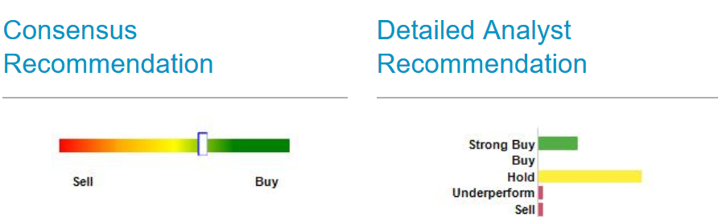
Probably it is a rather tricky period to evaluate these stocks and analysts suggest a hold rather than a buy. The market (relative) valuation is very volatile and therefore it might be better to base the recommendation on the DCF valuation with a target price > $40.
Update March 2021 (Coronavirus)
Twitter was one of the losers of the online hype peers during the coronavirus crisis. Its net income for 2020 was negative again at around $1,135.6b. However, it is currently experiencing a price rise. Its pre-crisis price was around $40 per share and after a 50% drop in value it now stands at around $70 ($68.10 at the time of valuation). We will try to evaluate its value with respect to its competitors (relative valuation), as well as its fundamentals (higher than expected growth in MAU).
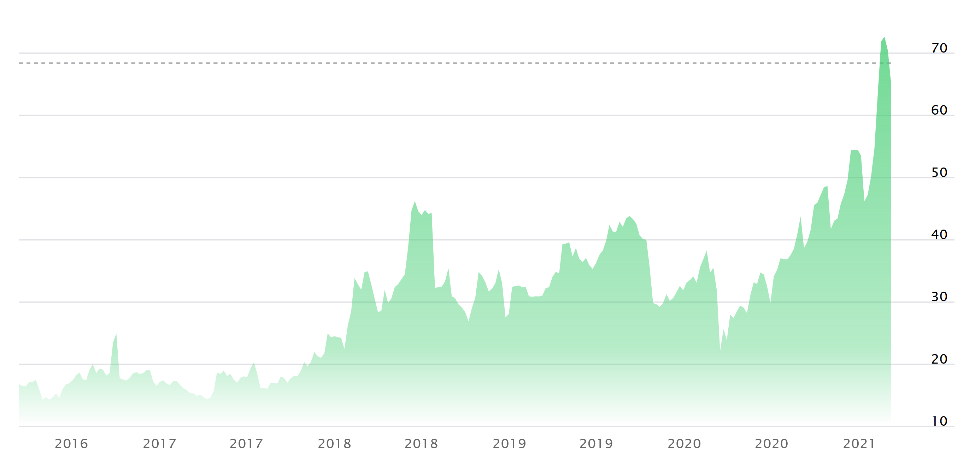
First, let us get some data on peers (data is taken from the links quoted and from EIKON).
Company | MAU | MCAP | #shares | P/E | P/S | Net Income | Revenue per share | ROE
Twitter | 322.4m | $54.35b | 787.86m | N/A | 14.63 | ($1,135.6b) | 4.66 | (6.95)
Facebook | 2,797m | $764.31b | 2,888m | 26.61 | 8.89 | $29.15b | 30.19 | 24.88
Snapchat | 364.6m | $94.56b | 1,455.63b | N/A | 37.72 | ($0.94b) | 1.66 | -4.79
Industry Average |  |  |  | 92.26 | 14.85 |  |  | 2.71%

Net capital expenditure, WC needs, Operating margins and cost of capital are taken from industry (Software-Internet) averages for the US market from here.
 | Industry Average
NEC/Sales | 6.95%
WC/Sales | 10.58%
Operating Margin  (Pre Tax, R&D and Lease adjusted) | 6.78%
Cost of capital | 4.36%

Earnings forecasts are taken from Nasdaq and as you can see, the analysts believe that the negative earnings this year is rather temporary. The values below give an estimated growth of about 55% growth. This is 60% for 2022, 57% for 2023 and 53% for 2024. Twitter is expected to come back to its pre-crisis level for earnings per share (around $1.44) in about 3 years time (in 2024). For current valuation we will consider the positive earnings (assuming that covid is now in the past and that there is adjustment to normality) as well as normalized earnings, which will be estimated as the mean between 2021 expected earnings and 2024 ($0.85=(0.35+1.35)/2)).
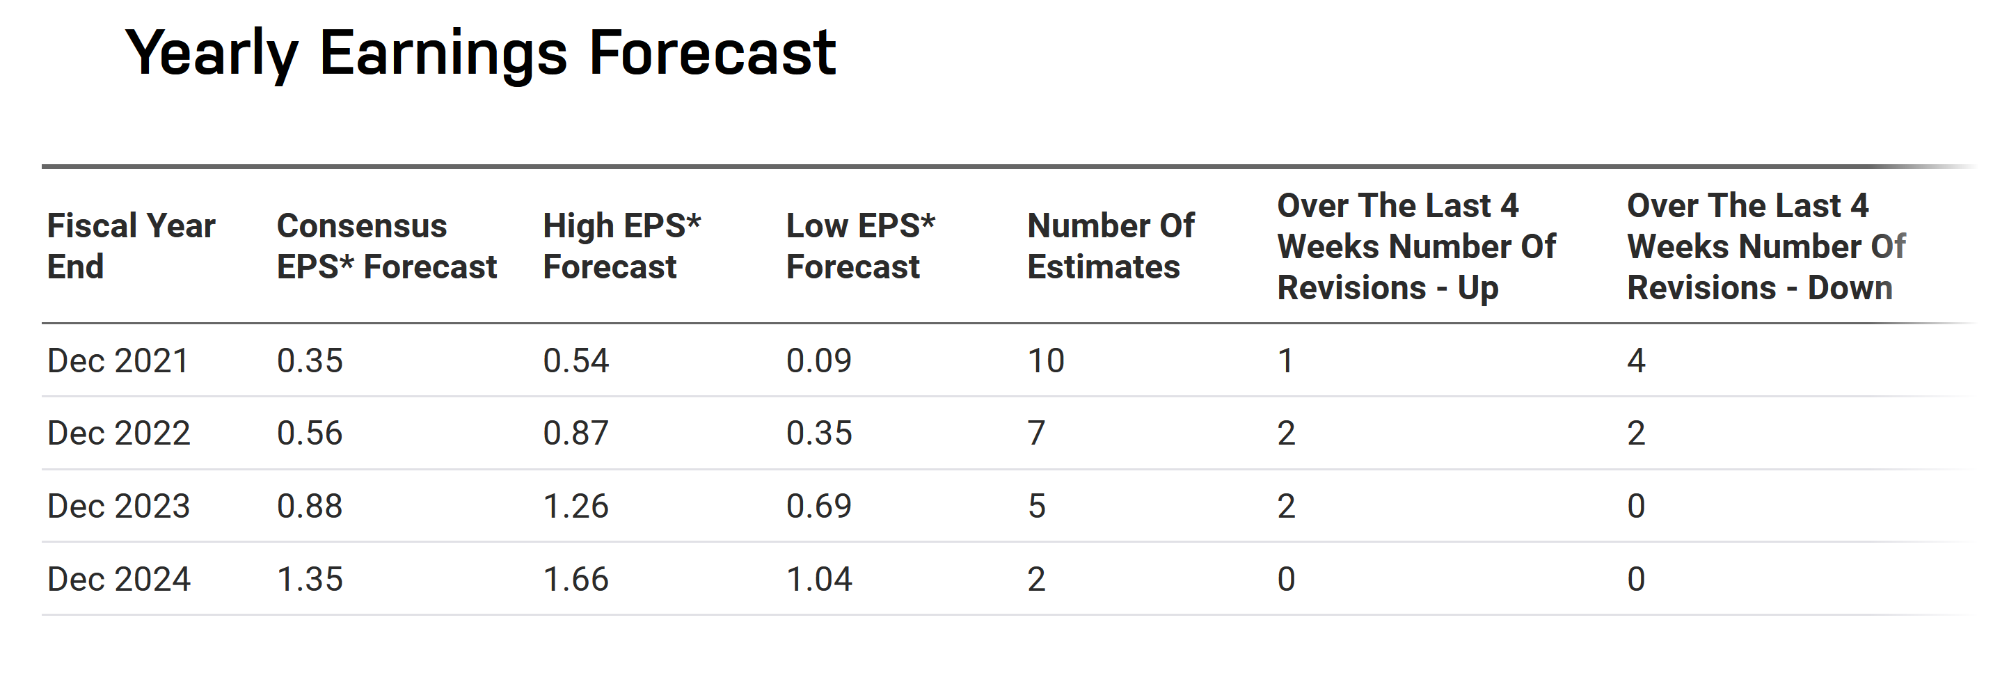
This is significant growth and in addition, the consensus of all analysts is that earnings will be positive again in 2021 with a consensus at around $0.23. We will use this as our reference for valuation.
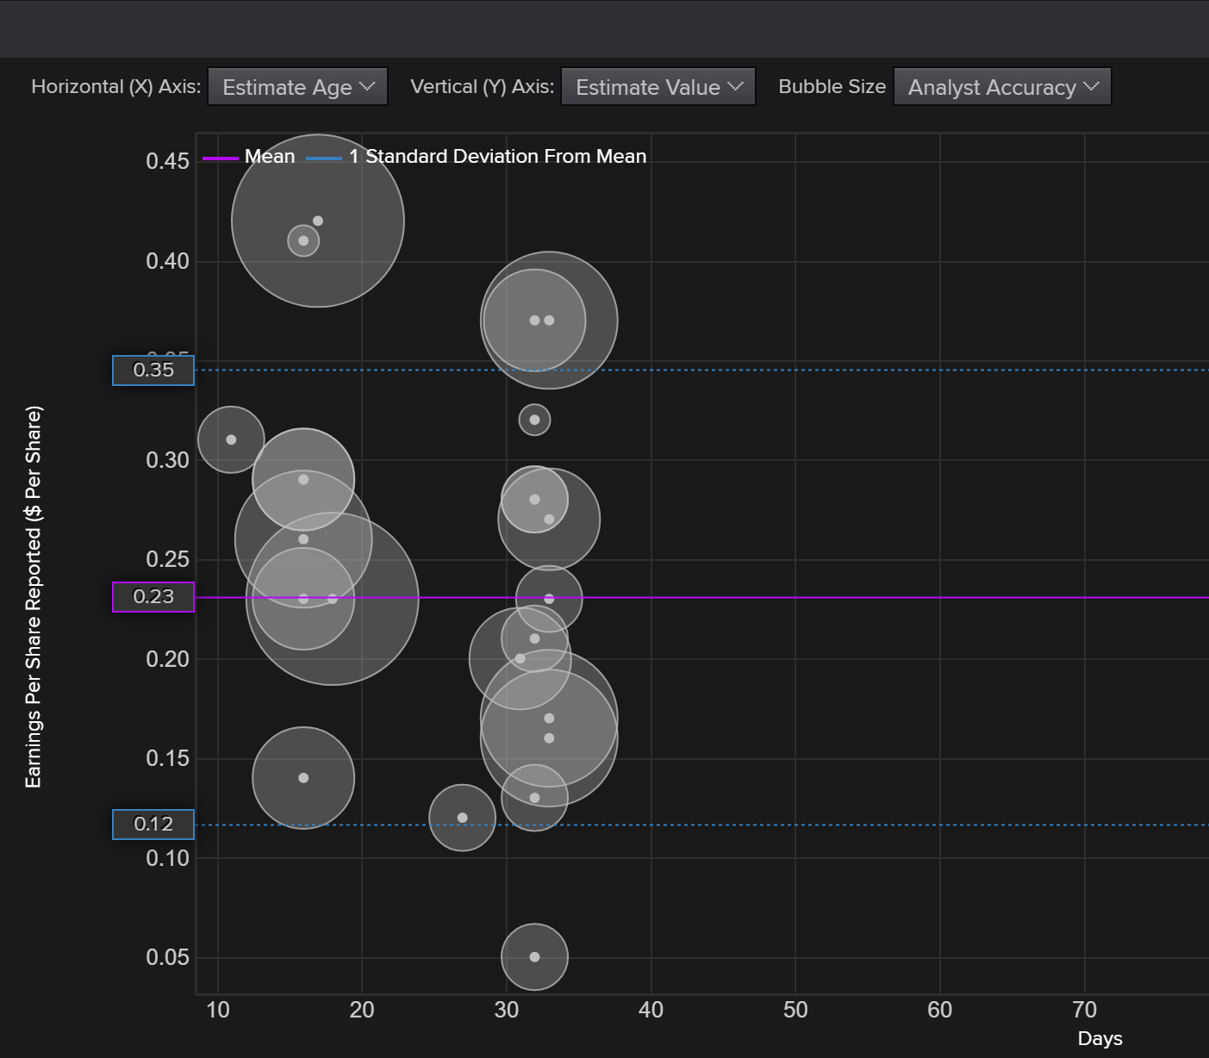
Some further inputs
Item | Value
beta | 0.81
MRP (Lecture Notes/Damodaran) | 5.2%
10y American Treasury bond yield | Long term expectation 2%
D/E=0.44 | D/(D+E)=31%
Industry D/(D+E) (EIKON) | 8.53%

Relative Valuation
Price Sales Ratio
Using the normalized (expected) earnings of $0.23 and the average P/E ratio taken from Damodaran the price for Twitter should be:
$$P_{Twitter}=92.26x\$0.23=\$21.22$$
This is a valuation that is considerably lower than the market price. EPS is low, but it is also consistent with ROEEPS=ROE*BE, which would imply EPS around $0.27. This is somewhat expected because the current year was rather problematic for all firms due to coronavirus. Considering a forward P/E ratio with normalized earnings ($0.85):
$$P_{Twitter}=92.26x\$0.85=\$78.42$$
Price Sales Ratio
$${P/S}_{Snapchat}=37.72>{P/S}_{T}>{P/S}_{Facebook}=8.89$$
$$\$175.78=4.66 x37.72<P_{T}<8.89 x 4.66=\$41.43$$
$$Average P_{T}=\$108.61$$
These valuations are rather wide in range and cannot be considered very reliable. The industry average (Damodaran, 14.85) might be more realistic than the average based on the two closest competitors.
$${P/S}_{Average}=14.85→P_{T}<14.85 x 4.66=\$69.20$$
This is surprisingly close to the market price. I would personally consider the valuations based on the normalized earnings and the average P/S as being more stable for the following reasons. The market seems to discount that the impact of covid will fade out quickly. Therefore, I would personally ignore the negative earnings this year because it is exceptional. In addition, the range of P/S of the closest peers (FB and Snapchat) is very wide and therefore, this valuation cannot be considered reliable.

Price MAU
In this industry, what is considered to be a more reliable metric is the monthly active users.
$${P/{MAU}}_{Snapchat}=\frac{\$94.56b}{364.6m}=259.35<{P/{MAU}}_{T}<{P/{MAU}}_{Facebook}=\frac{\$764.31b}{2.797b}=273.26$$
$$\$83.61b=322.4m x 259.35<P_{T}<273.26 x 322.4m=\$88.09b$$
$$\$106.13=\frac{\$83.61b}{787.86m}<P_{T, per share}<\frac{\$88.09b}{787.86m}=\$11.82$$
$$Average=\$108.98$$
This price is rather far from the market price and it suggests a clear and strong buy. Personally, I do not know how much I would trust it. Looking more closely the figures in statista regarding MAU, FB and Snapchat experience a steady growth, while Twitter has experienced higher sales, but from a smaller number of users. They are expected to grow moderately to around 340m. Consequently, it might not be directly comparable to FB and Snapchat.
Collectively, I would consider only:
Multiple | Implied Price
P/E (normalized) | $78.42
P/S (average) | $69.20
Combined (Target Price) | $73.81

The combined price ($73.81) is very close to the pick and it is a realistic expectation if the scenario assumed is realized. If, indeed, the impact of covid is temporary, then Twitter share price should be expected to raise.
Fundamental Valuation
The cost of equity is:
$$k_{e}=r_{f}+β_{l, FB} x MRP=2+0.81 x 5.2=6.21\%$$
It is in general low, but this is driven by generally low interest rates. The general market consensus is that they will remain low for the time being. The recent QE that passed by the Baiden administration seems to be inline with the expectations. Remember, this valuation is as good as the inputs. If you do not agree with this view, then the final price is not the one you should follow.
In any case, we follow the analysts forecasts for EPS and we assume that they will converge to stable growth after 10 years (annual increment of -6%). The implied equity re-investment rate will reach a stable level in the stable growth phase (with long term ROE=12%): $ERR stable=\frac{g}{ROE}=\frac{0.05}{0.12}=41.7\%$
The share price should be:
 | 0 | 1 | 2 | 3 | 4 | 5
ke |  | 6.21% | 6.21% | 6.21% | 6.21% | 6.21%
growth |  | 60% | 57% | 53% | 47.00% | 41.00%
Sales | 4.66 | 7.46 | 11.71 | 17.91 | 26.33 | 37.12
 |  | 0.05 | 0.05 | 0.05 | 10.00% | 15.00%
NI | (1.44) | 0.35 | 0.56 | 0.88 | 1.35 | 1.90
NetCapEx/Sales |  | 6.95% | 6.95% | 6.95% | 6.95% | 6.95%
NWC/Sales |  | 10.58% | 10.58% | 10.58% | 10.58% | 10.58%
ERR
δ |  | 31.00% | 31.00% | 31.00% | 31.00% | 31.00%
NetCapEx |  | 0.52 | 0.81 | 1.24 | 1.83 | 2.58
ΔΝWC |  | 0.30 | 0.45 | 0.66 | 0.89 | 1.14
FCFE |  | -0.21 | -0.31 | -0.43 | -0.53 | -0.66
DF |  | -0.18766 | -0.24495 | -0.30093 | -0.32567 | -0.36415
 | 6 | 7 | 8 | 9 | 10 | 11
ke | 6.21% | 6.21% | 6.21% | 6.21% | 6.21% | 6.21%
growth | 35.00% | 29.00% | 23.00% | 17.00% | 11.00% | 5%
Sales | 50.11 | 64.65 | 79.52 | 93.04 | 103.27 | 108.43
 | 23.83% | 23.83% | 23.83% | 23.83% | 23.83% | 23.83%
NI | 2.57 | 3.31 | 4.08 | 4.77 | 5.30 | 5.56
NetCapEx/Sales | 6.95% | 6.95% | 6.95% | 6.95% | 6.95%
NWC/Sales | 10.58% | 10.58% | 10.58% | 10.58% | 10.58%
ERR |  |  |  |  |  | 41.70%
δ | 31.00% | 31.00% | 31.00% | 31.00% | 31.00%
NetCapEx | 3.48 | 4.49 | 5.53 | 6.47 | 7.18
ΔΝWC | 1.37 | 1.54 | 1.57 | 1.43 | 1.08
FCFE | -0.78 | -0.85 | -0.82 | -0.68 | -0.40 | 3.24
DF | -0.37984 | -0.36441 | -0.31359 | -0.22944 | -0.12127 | 54.3487
Price | $ 51.52
The fundamental Valuation is below the market price and suggests a sell. Combined with the target price from Relative valuation
Relative Valuation | $73.81
DCF | 51.52
Combined | $62.67

Consequently, it is rather a hold. This years recommendations are in line with this valuation. The DCF seems to be on the low end, while the relative valuation seems to cover the mid to high range.
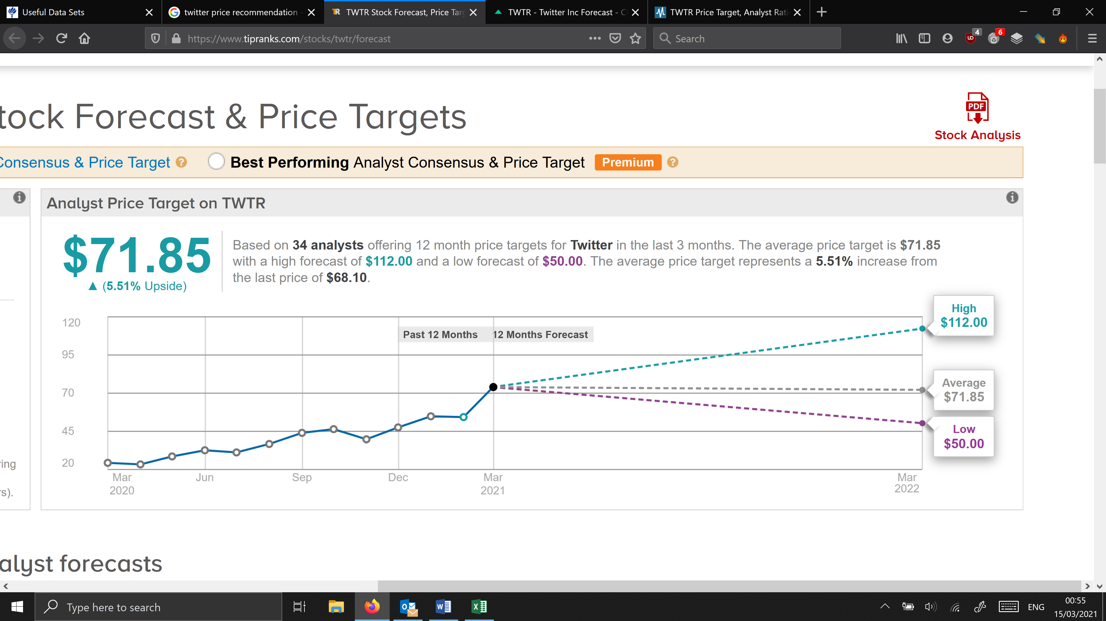
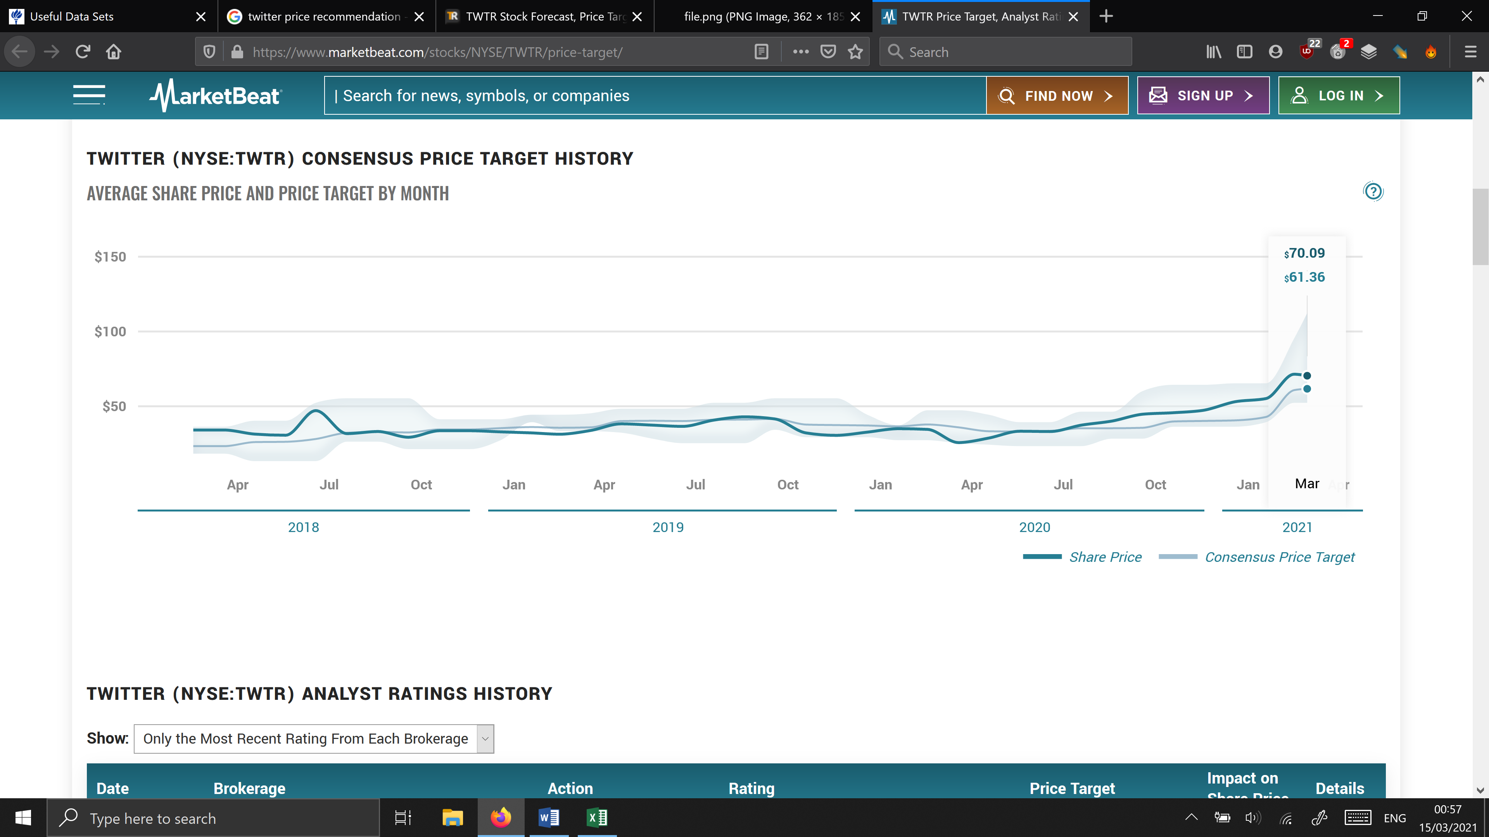
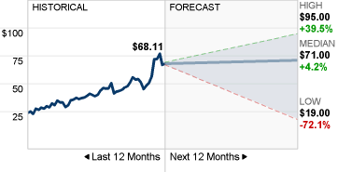
I would probably conclude that Twitter is a hold maybe sell. I do not believe that that target price of around $70 can be justified. I do believe that it is the outcome of an intensive QE program. In our valuation, this is reflected into a rather low discount rate. Even with that, the price is still lower than the market or the target (analysts) price. Therefore, I am more inclined to be on the conservative side.
March 2022
This is the evolution of price since last valuation
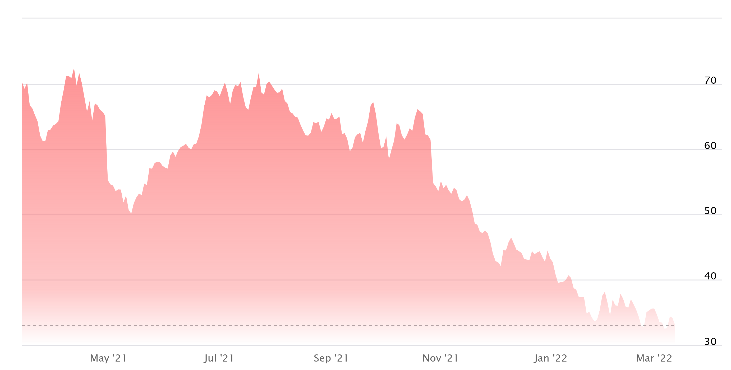
This time the valuation was on the right direction. Of course, since January 2022 there is the war in Ukraine, but still, you can observe that after a big swing in the first quarter of 2021 there is a clear trend towards the DCF valuation. In fact even lower. Excluding the war in Ukraine period, the target price seems to be around the low $40’s.
Again, nobody can know with certainty what will happen in the future. However, we can formulate an informed guess. The final outcome of valuation should be linked to the assumptions we make and how plausible they are.

September 2025

