# MRM PreQual Test for i.MX7D

Test results for the MRM Pre Qualification Test for i.MX7D

## TEST 1: AUDIO PIPELINE DRIFT

### Results

Observing a 1 cycle of the sine wave we can see there is exactly 100 samples per period

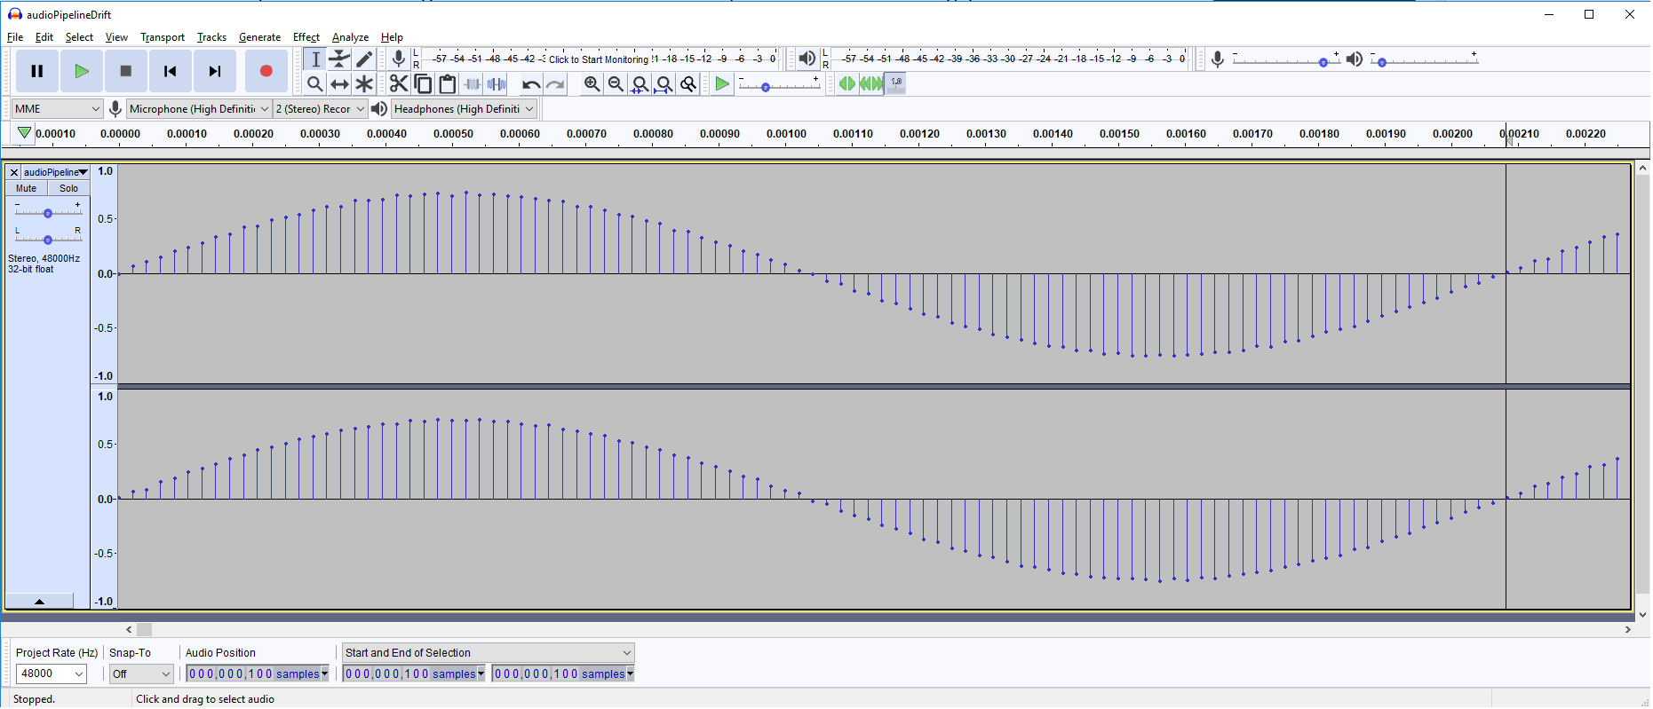

On a t = 0.5 seconds the upward-going zero crossing sample is at exact multiple of 100

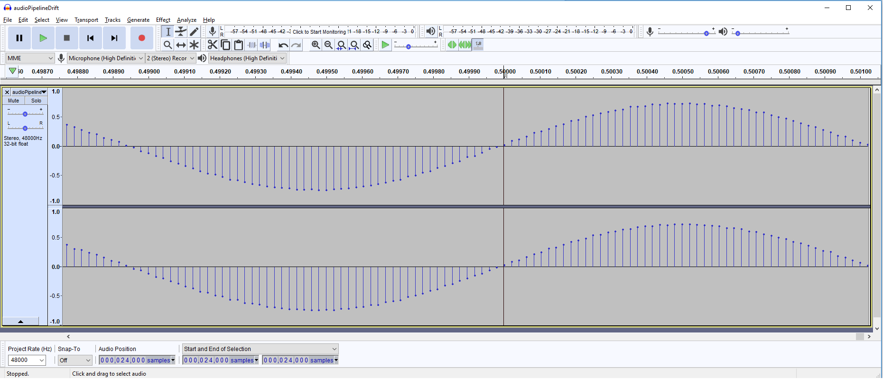

However in a more significant t = 10s, the drifting is now visible.

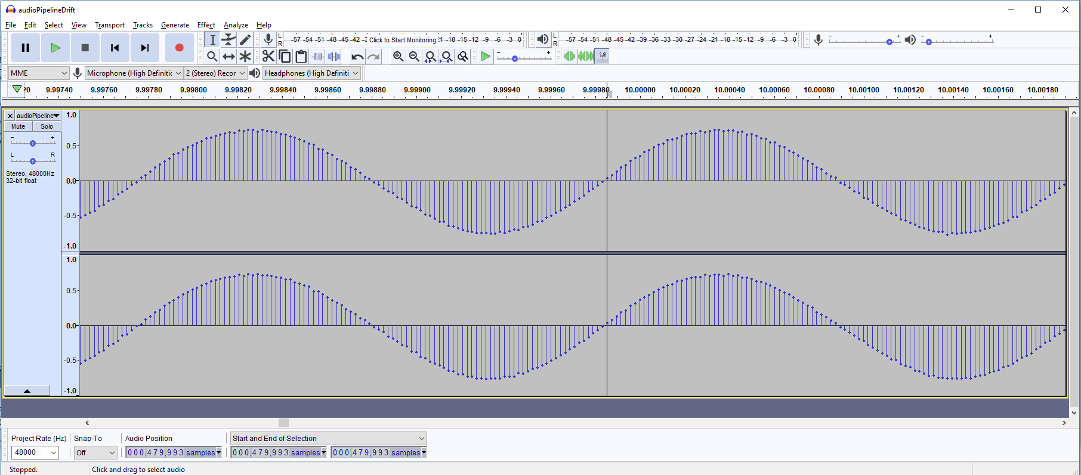

Doing the calculations with: S1=0, S2=479993, T1=0s, T2=9.99985s

wavFileFrequency = 480  
sampleRate = 48000  
samplesPerPeriod = sampleRate / wavFileFrequency = 100  
error_samples = (479993 - 0) – 100 * round((479993 - 0)/100) = 7  
deltaT = T2-T1 = 9.99985 - 0 = 9.99985  
error_PPM = 1.0E6 * (7 / 48000) / 9.99985 = 14.58

**ERROR PPM** = **14.58** which is < 20 PPM, so

**TEST is PASSED**

## TEST 2: HIGH-RESOLUTION TIMER

### Results

**Test PASSED** from observing console output

### Sample Output Evidence

root@imx7d-pico:~/mrm_prequaltest_mx7d# ./preQualTest --gtest_filter="HRT.*"  
sh: line 0: echo: write error: Device or resource busy  
PreQualification for device: 'Technexion PICO-IMX7 Dual/Solo', IPaddr: 192.168.1.127, run: 2018-04-26T23:37:21Z  
  
Note: Google Test filter = HRT.*  
[==========] Running 2 tests from 1 test case.  
[----------] Global test environment set-up.  
[----------] 2 tests from HRT  
[ RUN ] HRT.SlowAccessTest  
Ensures that HRT increments at about the right rate (~1E9 ns/sec)  
  
HRT1_ns,HRT2_ns,delta_ns,result  
973553772375,974553935625,1000163250,PASS  
974553999875,975554157750,1000157875,PASS  
975554208375,976554353500,1000145125,PASS  
976554397875,977554549625,1000151750,PASS  
977554593375,978554745750,1000152375,PASS  
978554788750,979554944000,1000155250,PASS  
979554997250,980555141875,1000144625,PASS  
980555187000,981555334875,1000147875,PASS  
981555378500,982555529375,1000150875,PASS  
982555572500,983555717750,1000145250,PASS  
983555760750,984555897375,1000136625,PASS  
984555953625,985556090000,1000136375,PASS  
985556135500,986556285000,1000149500,PASS  
986556330000,987556481500,1000151500,PASS  
987556524750,988556677250,1000152500,PASS  
988556720000,989556874125,1000154125,PASS  
989556916750,990557058625,1000141875,PASS  
990557102125,991557236000,1000133875,PASS  
991557278250,992557432000,1000153750,PASS  
992557475000,993557620625,1000145625,PASS  
993557663375,994557779875,1000116500,PASS  
994557822250,995557955000,1000132750,PASS  
995557996750,996558129375,1000132625,PASS  
996558172375,997558325375,1000153000,PASS  
997558367500,998558522000,1000154500,PASS  
[ OK ] HRT.SlowAccessTest (25005 ms)  
[ RUN ] HRT.FastAccessTest  
Ensures that the HRT can be accessed quickly (<=3us, 1 failure allowed)  
  
HRT1_ns,HRT2_ns,delta_ns,result  
998558807000,998558808375,1375,PASS  
998558825750,998558826500,750,PASS  
998558841875,998558842750,875,PASS  
998558857500,998558858375,875,PASS  
998558873125,998558874000,875,PASS  
998558888750,998558889500,750,PASS  
998558904250,998558905125,875,PASS  
998558919875,998558920625,750,PASS  
998558935500,998558936250,750,PASS  
998558951125,998558952000,875,PASS  
998558966750,998558967625,875,PASS  
998558982375,998558983250,875,PASS  
998558998000,998558998875,875,PASS  
998559013625,998559014500,875,PASS  
998559029250,998559030000,750,PASS  
998559044750,998559045625,875,PASS  
998559060375,998559061125,750,PASS  
998559076000,998559076875,875,PASS  
998559091625,998559092500,875,PASS  
998559107125,998559108000,875,PASS  
998559122750,998559123625,875,PASS  
998559138250,998559139125,875,PASS  
998559153875,998559154625,750,PASS  
998559169500,998559170375,875,PASS  
998559185000,998559185875,875,PASS  
[ OK ] HRT.FastAccessTest (0 ms)  
[----------] 2 tests from HRT (25006 ms total)  
  
[----------] Global test environment tear-down  
[==========] 2 tests from 1 test case ran. (25006 ms total)  
[ PASSED ] 2 tests.

## TEST 3: GPIO VALIDATION

### Results

**Test PASSED** by observing Logic Analyzers graphics the width of slow pulses are = 1s, while small pulses are 0.32us (< 1us)

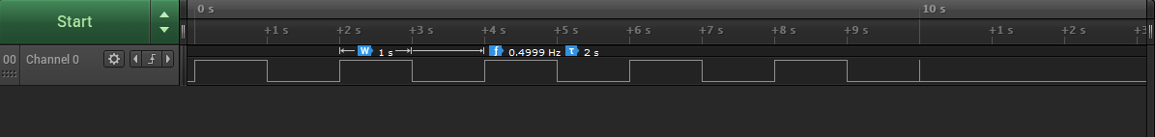

Gpio Slow Pulses



Gpio Short Pulses

### Sample Output

root@imx7d-pico:~/mrm_prequaltest_mx7d# ./preQualTest --gtest_filter="GPIO.*"  
sh: line 0: echo: write error: Device or resource busy  
PreQualification for device: 'Technexion PICO-IMX7 Dual/Solo', IPaddr: 192.168.1.127, run: 2018-04-27T01:08:03Z  
  
Note: Google Test filter = GPIO.*  
[==========] Running 2 tests from 1 test case.  
[----------] Global test environment set-up.  
[----------] 2 tests from GPIO  
[ RUN ] GPIO.SlowAccessTest  
Ensures that GPIO can be toggled  
  
Start recording on the logic analyzer.  
GPIO high  
GPIO low  
GPIO high  
GPIO low  
GPIO high  
GPIO low  
GPIO high  
GPIO low  
GPIO high  
GPIO low  
Stop recording on the logic analyzer.  
[ OK ] GPIO.SlowAccessTest (10002 ms)  
[ RUN ] GPIO.FastAccessTest  
Ensures that the GPIO can be toggled quickly (<1us)  
  
Start recording on the logic analyzer.  
GPIO transitioning 20 times.  
Stop recording on the logic analyzer.  
  
TODO: Manually check the logic analyzer output.  
 Slow pulses should have H/L time of ~1s.  
 Fast pulses should have H/L time of <1us.  
 Duration of fast pulse section should be <20us.  
[ OK ] GPIO.FastAccessTest (0 ms)  
[----------] 2 tests from GPIO (10002 ms total)  
  
[----------] Global test environment tear-down  
[==========] 2 tests from 1 test case ran. (10002 ms total)  
[ PASSED ] 2 tests.

## TEST4: TIME SYNCHRONIZATION

### Results

**Test PASSED** from graphics obtained from Logic Analyzer([TimeSync3.test.csv](TimeSync_results/TimeSync3.test.csv)) it can be observed that The TP95 is around **90us** of the median (TP50) line. (Application note marked as PASSED if within 150us)

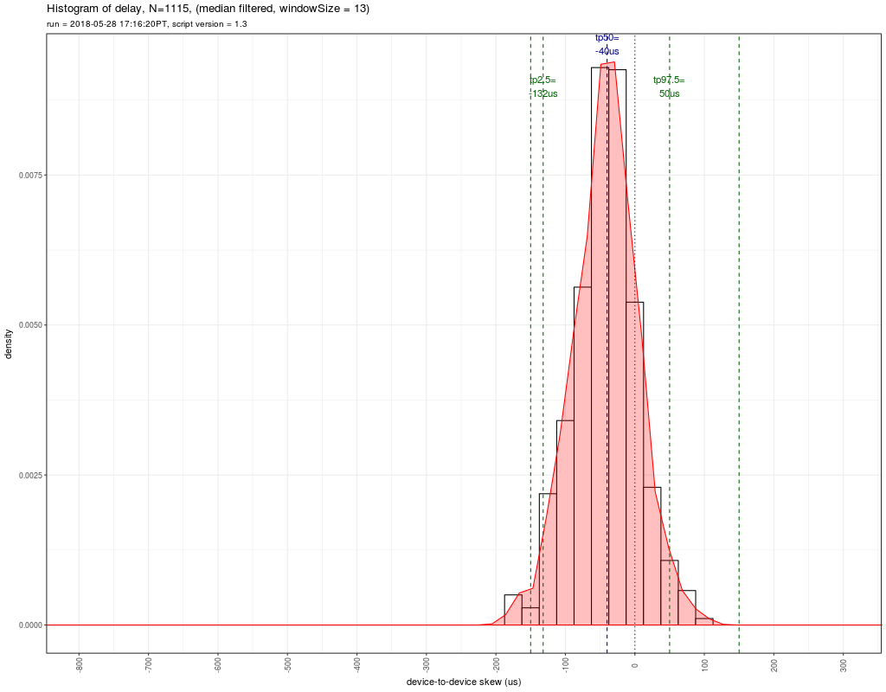

Plot with 2 i.MX7D - Device to Device TimeSync delay

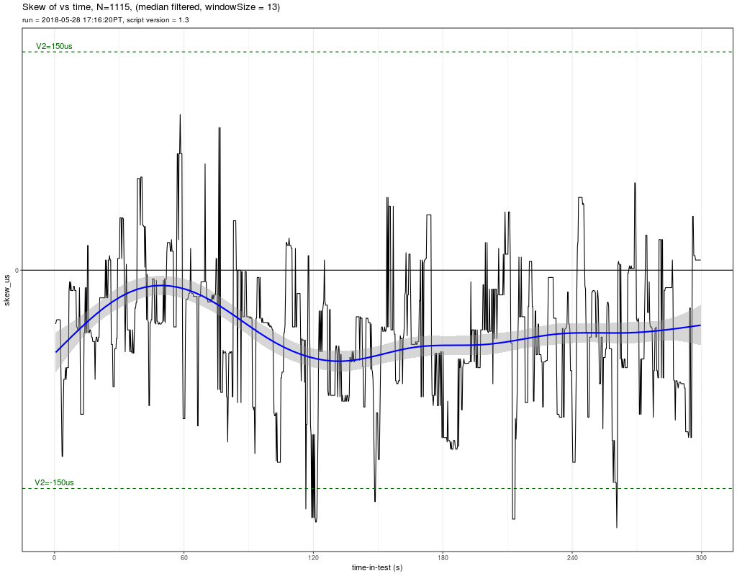

Plot with 2 i.MX7D - Device to Device TimeSync Skew vs Time

## TEST 5: AUDIO PLACEMENT

### Results Using Alsa Device as HW:2,0

#### Sample Output from RScript results

**Test PASSED** by inspecting [report_i.MX7D.txt](testresults/i.MX7D_20180529T230243Z/report_i.MX7D.txt) file

+-----------------------------------------------------+  
| AUDIO PLACEMENT FOR i.MX7D |  
| run = 2018-05-29 23:06:05 UTC, script version = 1.5 |  
+-----------------------------------------------------+  
N (number of samples) = 98  
  
TP0 (min) = 11166 µs = TP50 - 21 µs  
TP2.5 = 11166 µs = TP50 - 21 µs  
TP50 = 11187 µs  
TP97.5 = 11229 µs = TP50 + 42 µs  
TP100 (max) = 11229 µs = TP50 + 42 µs  
  
NOTE: always manually check the audio file, too.  
  
+-------------------------------------+  
| Level 1 KPI compliance (Multi-room) |  
+-------------------------------------+  
KPI1a (TP95 spread < 5000µs) = 63µs: PASS  
KPI1b (TP100 spread < 5000µs) = 63µs: PASS  
 Samples outside V1 TP100 KPI: 0 out of 98 = ~0%  
  
+------------------------------------+  
| Level 2 KPI compliance (LR Stereo) |  
+------------------------------------+  
KPI2a (TP95 spread < 150µs)= 63µs: PASS  
KPI2b (TP100 spread < 150µs) = 63µs: PASS  
 Samples outside V2 TP100 KPI: 0 out of 98 = ~0%  
  
+----------------------+  
| Audio Placement Data |  
+----------------------+  
  
Assume constant (correctable) lag is TP50(lag_µs): 11187 µs  
  
 sn burstStartSN lag_µsec uncorrected_lag_µsec V1_KPI V2_KPI  
1 286069 334606 11187 0 . .  
2 357246 405782 11166 -21 . .  
3 502561 551098 11187 0 . .  
4 574213 622751 11208 21 . .  
5 643678 692215 11187 0 . .  
6 713044 761581 11187 0 . .  
7 785604 834140 11166 -21 . .  
8 854858 903396 11208 21 . .  
9 928081 976618 11187 0 . .  
10 1000572 1049109 11187 0 . .  
11 1074433 1122971 11208 21 . .  
12 1146217 1194755 11208 21 . .  
13 1217971 1266508 11187 0 . .  
14 1289437 1337974 11187 0 . .  
15 1358639 1407176 11187 0 . .  
16 1432161 1480699 11208 21 . .  
17 1510067 1558604 11187 0 . .  
18 1580817 1629354 11187 0 . .  
19 1649803 1698340 11187 0 . .  
20 1731033 1779570 11187 0 . .  
21 1809037 1857575 11208 21 . .  
22 1885218 1933755 11187 0 . .  
23 1961302 2009840 11208 21 . .  
24 2043074 2091612 11208 21 . .  
25 2114371 2162908 11187 0 . .  
26 2184685 2233222 11187 0 . .  
27 2254103 2302641 11208 21 . .  
28 2333045 2381582 11187 0 . .  
29 2410838 2459375 11187 0 . .  
30 2492093 2540632 11229 42 . .  
31 2566612 2615149 11187 0 . .  
32 2646930 2695467 11187 0 . .  
33 2719543 2768080 11187 0 . .  
34 2796428 2844967 11229 42 . .  
35 2865428 2913966 11208 21 . .  
36 2938920 2987458 11208 21 . .  
37 3016595 3065132 11187 0 . .  
38 3089521 3138057 11166 -21 . .  
39 3163707 3212245 11208 21 . .  
40 3246034 3294572 11208 21 . .  
41 3322915 3371452 11187 0 . .  
42 3402399 3450935 11166 -21 . .  
43 3473521 3522057 11166 -21 . .  
44 3553576 3602112 11166 -21 . .  
45 3635957 3684495 11208 21 . .  
46 3707724 3756263 11229 42 . .  
47 3778342 3826879 11187 0 . .  
48 3855679 3904216 11187 0 . .  
49 3929576 3978113 11187 0 . .  
50 4001040 4049577 11187 0 . .  
51 4076609 4125147 11208 21 . .  
52 4145583 4194120 11187 0 . .  
53 4224200 4272738 11208 21 . .  
54 4307047 4355586 11229 42 . .  
55 4389162 4437699 11187 0 . .  
56 4470496 4519033 11187 0 . .  
57 4540641 4589179 11208 21 . .  
58 4624073 4672611 11208 21 . .  
59 4701388 4749926 11208 21 . .  
60 4780742 4829279 11187 0 . .  
61 4862004 4910541 11187 0 . .  
62 4930819 4979356 11187 0 . .  
63 5007515 5056052 11187 0 . .  
64 5078396 5126933 11187 0 . .  
65 5155571 5204109 11208 21 . .  
66 5232684 5281221 11187 0 . .  
67 5308482 5357019 11187 0 . .  
68 5380345 5428883 11208 21 . .  
69 5461831 5510367 11166 -21 . .  
70 5543304 5591842 11208 21 . .  
71 5614512 5663048 11166 -21 . .  
72 5689907 5738445 11208 21 . .  
73 5767858 5816395 11187 0 . .  
74 5841601 5890137 11166 -21 . .  
75 5914056 5962594 11208 21 . .  
76 5991437 6039975 11208 21 . .  
77 6068362 6116899 11187 0 . .  
78 6142820 6191358 11208 21 . .  
79 6214559 6263096 11187 0 . .  
80 6296826 6345364 11208 21 . .  
81 6373743 6422279 11166 -21 . .  
82 6452467 6501004 11187 0 . .  
83 6535085 6583623 11208 21 . .  
84 6607644 6656181 11187 0 . .  
85 6686233 6734771 11208 21 . .  
86 6838884 6887421 11187 0 . .  
87 6919081 6967618 11187 0 . .  
88 7000827 7049365 11208 21 . .  
89 7080431 7128968 11187 0 . .  
90 7157023 7205560 11187 0 . .  
91 7237018 7285556 11208 21 . .  
92 7316894 7365431 11187 0 . .  
93 7387194 7435731 11187 0 . .  
94 7469522 7518060 11208 21 . .  
95 7543560 7592098 11208 21 . .  
96 7622372 7670909 11187 0 . .  
97 7697538 7746075 11187 0 . .  
98 7774862 7823400 11208 21 . .

#### Graphics

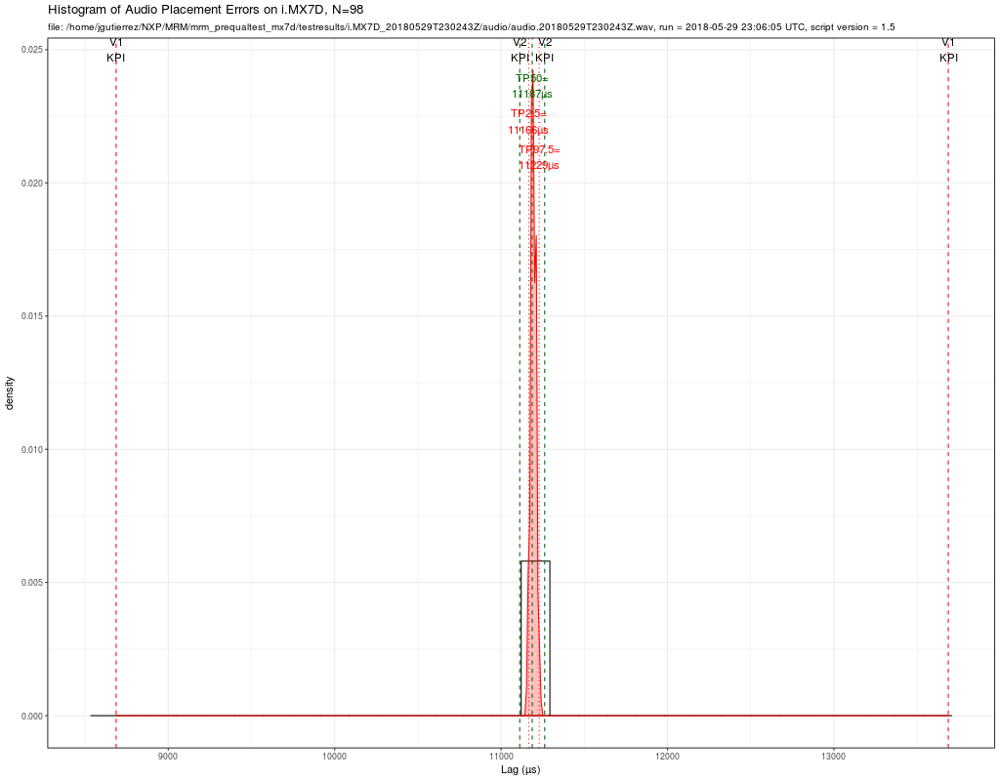

histogram of audio placement inaccuracy

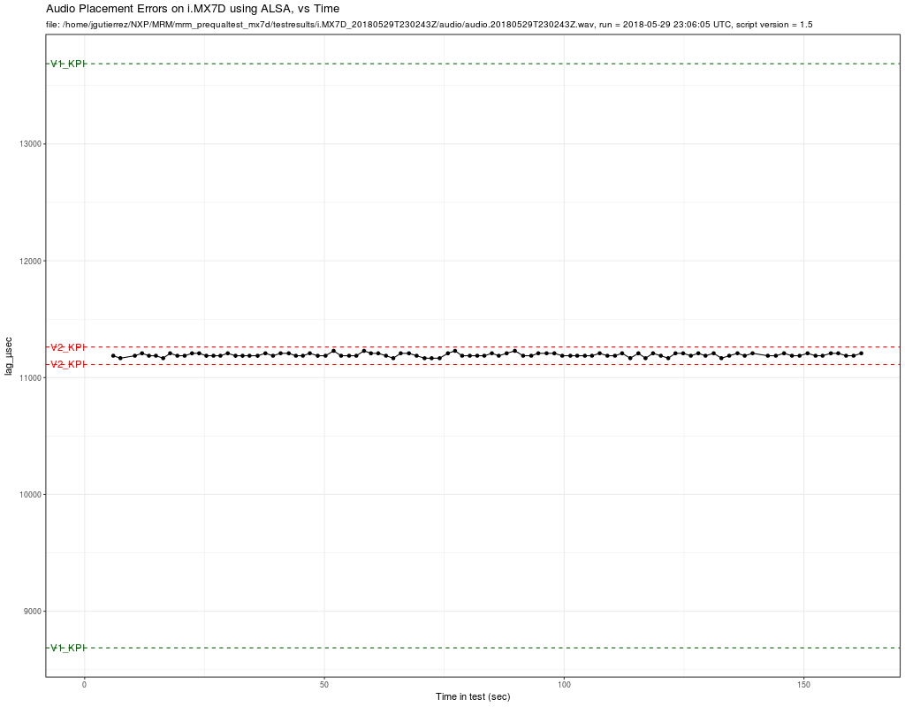

audio placement inaccuracy vs Time

### Results using Alsa plug:dmix

#### Sample Output from RScript results

**Test PASSED** by inspecting [report_i.MX7D_dmix.txt](testresults_dmix/i.MX7D_20180529T230243Z/report_i.MX7D.txt) file

+-----------------------------------------------------+  
| AUDIO PLACEMENT FOR i.MX7D |  
| run = 2018-05-30 21:58:46 UTC, script version = 1.5 |  
+-----------------------------------------------------+  
N (number of samples) = 121  
  
TP0 (min) = 10791 µs = TP50 - 42 µs  
TP2.5 = 10791 µs = TP50 - 42 µs  
TP50 = 10833 µs  
TP97.5 = 10854 µs = TP50 + 21 µs  
TP100 (max) = 10874 µs = TP50 + 41 µs  
  
NOTE: always manually check the audio file, too.  
  
+-------------------------------------+  
| Level 1 KPI compliance (Multi-room) |  
+-------------------------------------+  
KPI1a (TP95 spread < 5000µs) = 63µs: PASS  
KPI1b (TP100 spread < 5000µs) = 83µs: PASS  
 Samples outside V1 TP100 KPI: 0 out of 121 = ~0%  
  
+------------------------------------+  
| Level 2 KPI compliance (LR Stereo) |  
+------------------------------------+  
KPI2a (TP95 spread < 150µs)= 63µs: PASS  
KPI2b (TP100 spread < 150µs) = 83µs: PASS  
 Samples outside V2 TP100 KPI: 0 out of 121 = ~0%  
  
+----------------------+  
| Audio Placement Data |  
+----------------------+  
  
Assume constant (correctable) lag is TP50(lag_µs): 10833 µs  
  
 sn burstStartSN lag_µsec uncorrected_lag_µsec V1_KPI V2_KPI  
1 270063 318582 10812 -21 . .  
2 342450 390970 10833 0 . .  
3 417978 466498 10833 0 . .  
4 490126 538647 10854 21 . .  
5 562898 611419 10854 21 . .  
6 633527 682048 10854 21 . .  
7 704039 752559 10833 0 . .  
8 777753 826272 10812 -21 . .  
9 848209 896730 10854 21 . .  
10 922589 971109 10833 0 . .  
11 996261 1044781 10833 0 . .  
12 1071301 1119821 10833 0 . .  
13 1144239 1192759 10833 0 . .  
14 1217148 1265667 10812 -21 . .  
15 1289799 1338319 10833 0 . .  
16 1360197 1408716 10812 -21 . .  
17 1434879 1483399 10833 0 . .  
18 1513971 1562492 10854 21 . .  
19 1585860 1634379 10812 -21 . .  
20 1656020 1704540 10833 0 . .  
21 1738399 1786918 10812 -21 . .  
22 1817601 1866120 10812 -21 . .  
23 1894945 1943466 10854 21 . .  
24 1971952 2020470 10791 -42 . .  
25 2054896 2103415 10812 -21 . .  
26 2127338 2175859 10854 21 . .  
27 2198798 2247318 10833 0 . .  
28 2269379 2317899 10833 0 . .  
29 2349492 2398012 10833 0 . .  
30 2428403 2476921 10791 -42 . .  
31 2510796 2559317 10854 21 . .  
32 2586493 2635012 10812 -21 . .  
33 2667981 2716501 10833 0 . .  
34 2741772 2790292 10833 0 . .  
35 2819846 2868366 10833 0 . .  
36 2890031 2938550 10812 -21 . .  
37 2964722 3013241 10812 -21 . .  
38 3043587 3092106 10812 -21 . .  
39 3117720 3166239 10812 -21 . .  
40 3193116 3241637 10854 21 . .  
41 3276605 3325125 10833 0 . .  
42 3354681 3403202 10854 21 . .  
43 3435329 3483850 10854 21 . .  
44 3507593 3556113 10833 0 . .  
45 3588809 3637329 10833 0 . .  
46 3672392 3720912 10833 0 . .  
47 3745325 3793844 10812 -21 . .  
48 3817105 3865625 10833 0 . .  
49 3895608 3944128 10833 0 . .  
50 3970700 4019220 10833 0 . .  
51 4042889 4091408 10812 -21 . .  
52 4119635 4168155 10833 0 . .  
53 4189749 4238269 10833 0 . .  
54 4269553 4318074 10854 21 . .  
55 4353562 4402081 10812 -21 . .  
56 4436844 4485364 10833 0 . .  
57 4519332 4567853 10854 21 . .  
58 4590680 4639200 10833 0 . .  
59 4674813 4723333 10833 0 . .  
60 4753280 4801800 10833 0 . .  
61 4833800 4882320 10833 0 . .  
62 4916213 4964731 10791 -42 . .  
63 4986196 5034716 10833 0 . .  
64 5064058 5112576 10791 -42 . .  
65 5136124 5184643 10812 -21 . .  
66 5214464 5262983 10812 -21 . .  
67 5292741 5341261 10833 0 . .  
68 5369734 5418254 10833 0 . .  
69 5442764 5491282 10791 -42 . .  
70 5525399 5573919 10833 0 . .  
71 5608015 5656534 10812 -21 . .  
72 5680400 5728921 10854 21 . .  
73 5756958 5805477 10812 -21 . .  
74 5836088 5884609 10854 21 . .  
75 5910992 5959513 10854 21 . .  
76 5984592 6033112 10833 0 . .  
77 6063103 6111622 10812 -21 . .  
78 6141204 6189724 10833 0 . .  
79 6217716 6266236 10833 0 . .  
80 6290621 6339141 10833 0 . .  
81 6374058 6422578 10833 0 . .  
82 6452161 6500682 10854 21 . .  
83 6532046 6580567 10854 21 . .  
84 6615844 6664365 10854 21 . .  
85 6689546 6738066 10833 0 . .  
86 6769327 6817847 10833 0 . .  
87 6852255 6900775 10833 0 . .  
88 6924345 6972864 10812 -21 . .  
89 7005724 7054244 10833 0 . .  
90 7088655 7137174 10812 -21 . .  
91 7169399 7217919 10833 0 . .  
92 7247150 7295670 10833 0 . .  
93 7328346 7376867 10854 21 . .  
94 7409384 7457904 10833 0 . .  
95 7480872 7529392 10833 0 . .  
96 7564396 7612916 10833 0 . .  
97 7639637 7688157 10833 0 . .  
98 7719667 7768189 10874 41 . .  
99 7796030 7844550 10833 0 . .  
100 7874567 7923086 10812 -21 . .  
101 7953084 8001603 10812 -21 . .  
102 8027900 8076420 10833 0 . .  
103 8109059 8157580 10854 21 . .  
104 8179984 8228504 10833 0 . .  
105 8249785 8298305 10833 0 . .  
106 8321731 8370250 10812 -21 . .  
107 8396501 8445022 10854 21 . .  
108 8475078 8523598 10833 0 . .  
109 8555345 8603865 10833 0 . .  
110 8636006 8684526 10833 0 . .  
111 8717709 8766230 10854 21 . .  
112 8797246 8845765 10812 -21 . .  
113 8871838 8920359 10854 21 . .  
114 8949291 8997812 10854 21 . .  
115 9028445 9076965 10833 0 . .  
116 9107017 9155535 10791 -42 . .  
117 9180069 9228589 10833 0 . .  
118 9258016 9306536 10833 0 . .  
119 9338911 9387431 10833 0 . .  
120 9409193 9457713 10833 0 . .  
121 9485907 9534428 10854 21 . .

#### Graphics

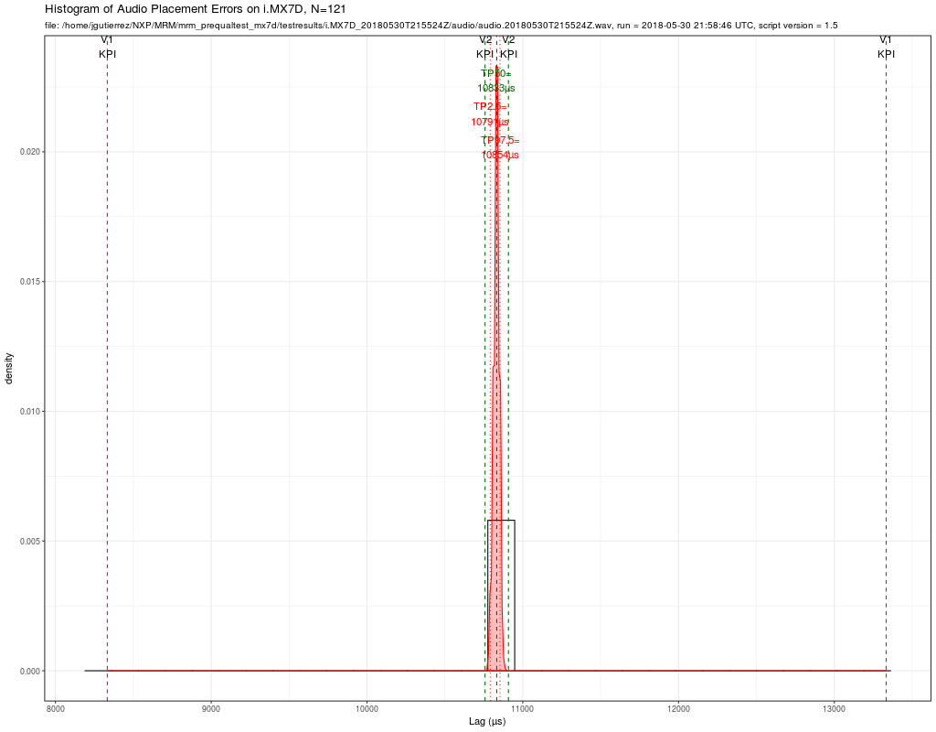

histogram of audio placement inaccuracy for dmix

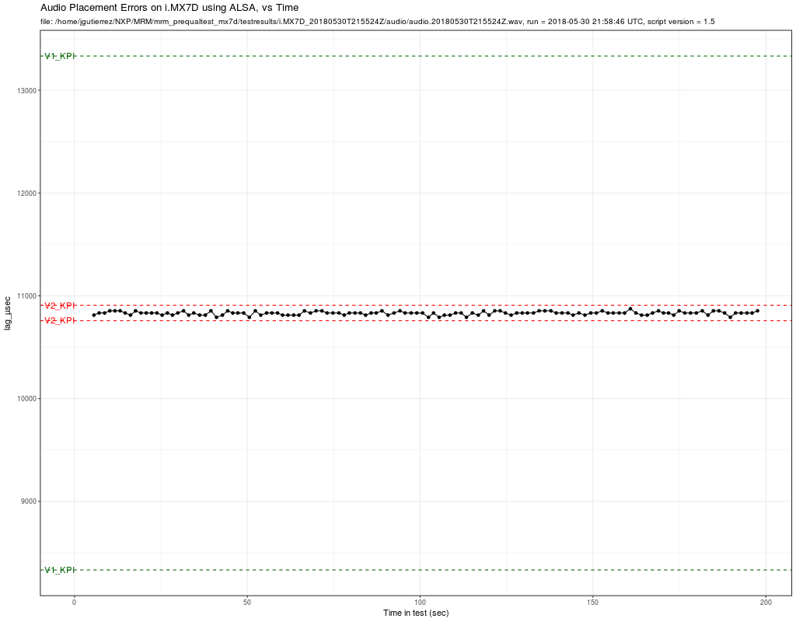

audio placement inaccuracy vs Time for dmix

## TEST 6: AUDIO DISTRIBUTION

### Results

**Test PASSED** from observing console output

### Sample Output Evidence

**Master**

root@imx7d-pico:~/mrm_prequaltest_mx7d#  
bution.Master 192.168.1.126altest_mx7d# ./preQualTest --gtest_filter=AudioDistri  
PreQualification for device: 'Technexion PICO-IMX7 Dual/Solo', IPaddr: 192.168.1.127, run: 2018-04-26T23:24:03Z  
  
Note: Google Test filter = AudioDistribution.Master  
[==========] Running 1 test from 1 test case.  
[----------] Global test environment set-up.  
[----------] 1 test from AudioDistribution  
[ RUN ] AudioDistribution.Master  
Audio Distribution Unicast MASTER  
Slave devices:  
Slave #0: 192.168.1.126  
Trying to connect to Slave #0 at '192.168.1.126'...CONNECTED.  
master: now connected to 192.168.1.126 on port 1234....  
DONE.  
[ OK ] AudioDistribution.Master (1846 ms)  
[----------] 1 test from AudioDistribution (1846 ms total)  
  
[----------] Global test environment tear-down  
[==========] 1 test from 1 test case ran. (1846 ms total)  
[ PASSED ] 1 test.

**Slave**

root@imx7d-pico:~/mrm_prequaltest_mx7d#  
bution.Slaveico:~/mrm_prequaltest_mx7d# ./preQualTest --gtest_filter=AudioDistri  
PreQualification for device: 'Technexion PICO-IMX7 Dual/Solo', IPaddr: 192.168.1.126, run: 2018-04-27T01:06:26Z  
  
Note: Google Test filter = AudioDistribution.Slave  
[==========] Running 1 test from 1 test case.  
[----------] Global test environment set-up.  
[----------] 1 test from AudioDistribution  
[ RUN ] AudioDistribution.Slave  
Audio Distribution Unicast: SLAVE  
slave: waiting for connections...  
slave: got connection from 192.168.1.127  
Each report below = ~1000000 bytes received.  
incrMbps,cumuMbps  
31.097,31.097,0.000  
43.388,36.211,0.000  
41.805,37.902,0.000  
50.485,40.417,0.000  
45.563,41.353,0.000  
52.957,42.918,0.000  
49.401,43.741,0.000  
55.178,44.899,0.000  
47.760,45.201,0.000  
58.714,46.267,0.000  
slave: recv -- Master disconnected  
[ OK ] AudioDistribution.Slave (30040 ms)  
[----------] 1 test from AudioDistribution (30040 ms total)  
  
[----------] Global test environment tear-down  
[==========] 1 test from 1 test case ran. (30041 ms total)  
[ PASSED ] 1 test.