**Mandatory – helloworld POC**

**Step1: k8s cluster configuration**

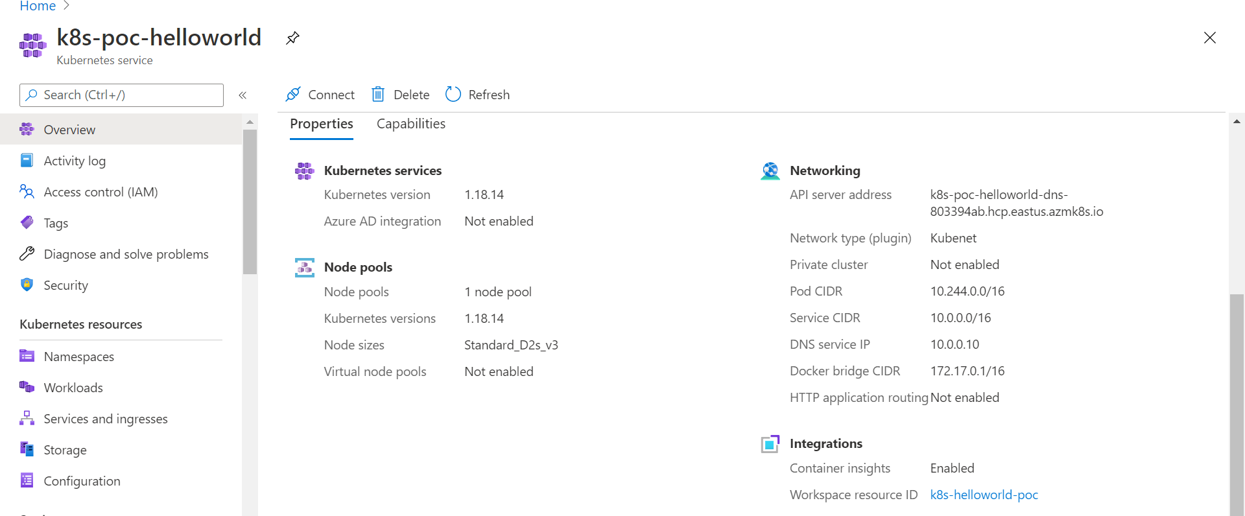

**Step2: to set subscription**

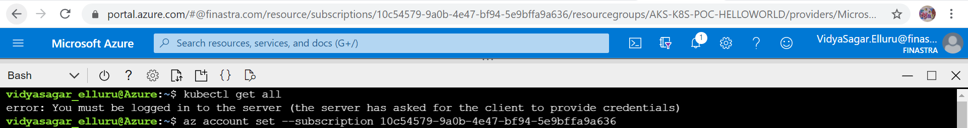

**Step3: Run the below command to lets get the access credentials for an AKS cluster and merges them into the kubeconfig file**



**Step4: create 2 separate namespaces one for each helloworld and prometheus/loki/grana operator setup**

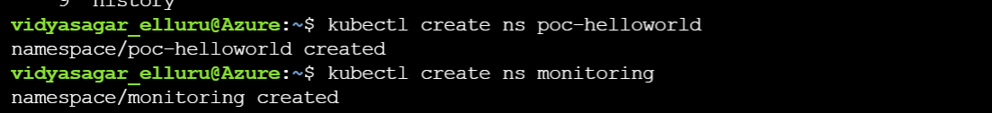

**Step4: create pod def yaml file for hello springboot application developed using micrometer config.**

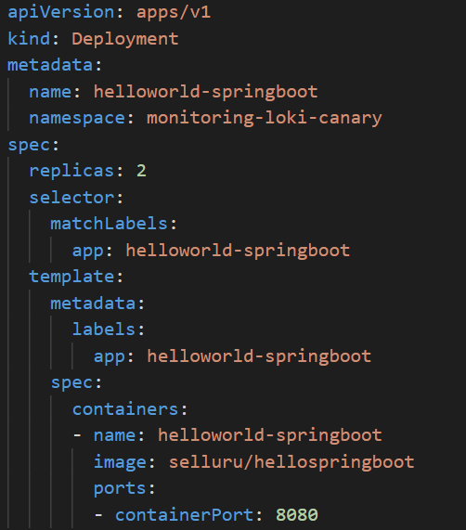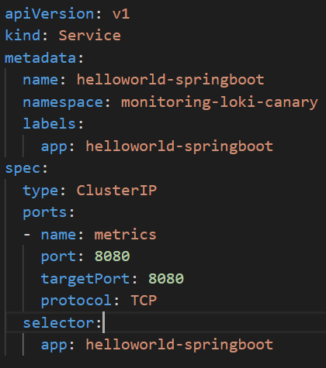

**Step4: Deploy yaml file for hello springboot**



**Step5: Verify for running pod details**

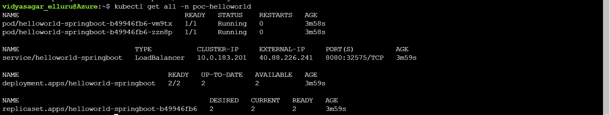

**Step6: Check for accessing application and metrics being pushed**

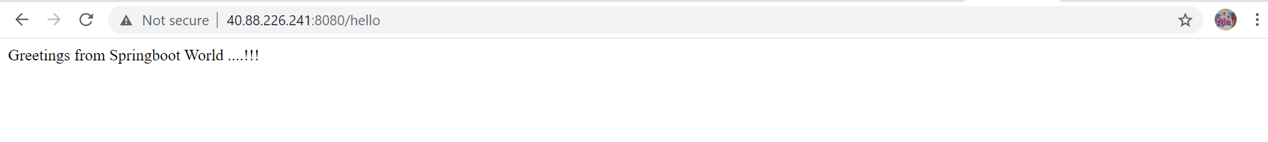

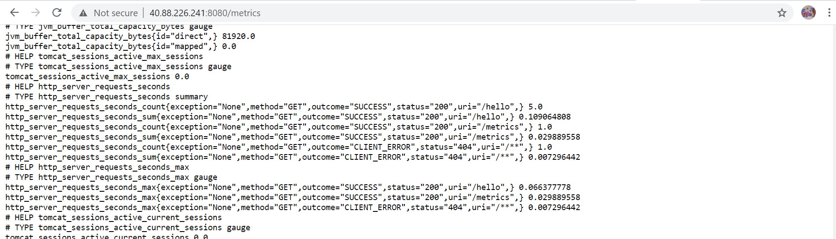

**Step7: Add helm repos to your local repo for prometheus and loki**

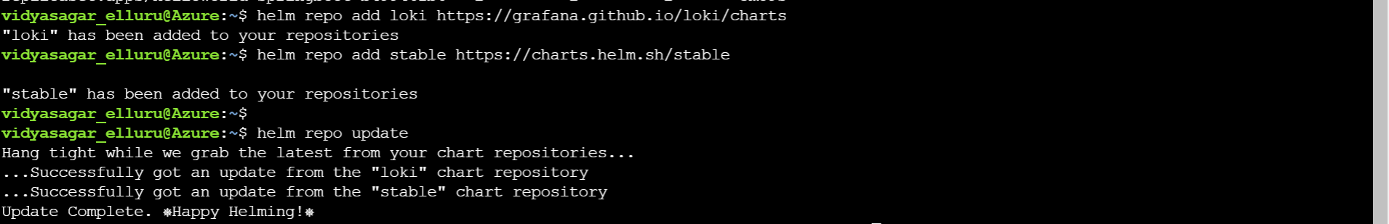

**Step8: Install prometheus operator using helm charts it adds CRDs to newly built k8s cluster**

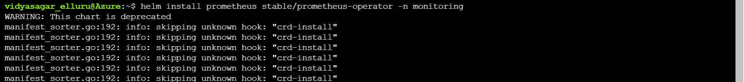

**Step9: verify pods for prometheus and Grafana in monitoring namespace**

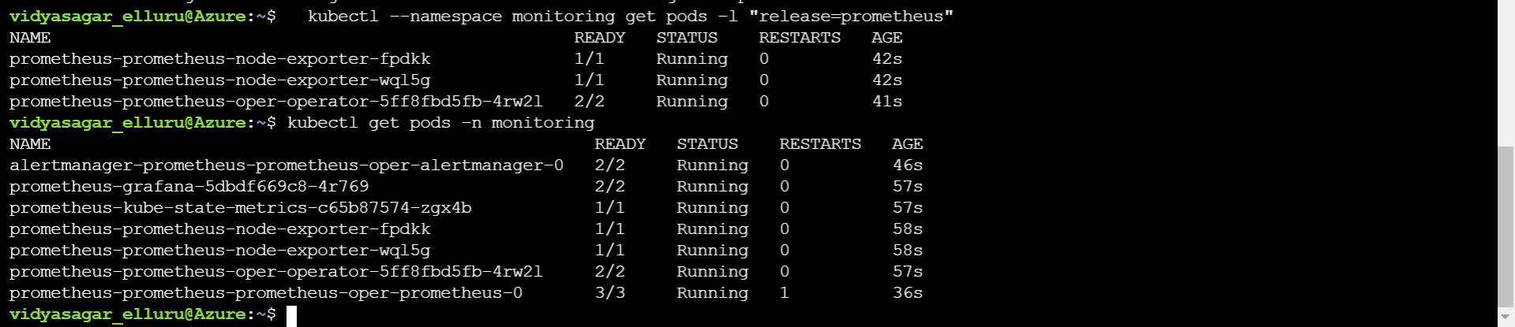

**Step10: create svc monitor yaml file for helloworld springboot to scrape its metrics to prometheus**

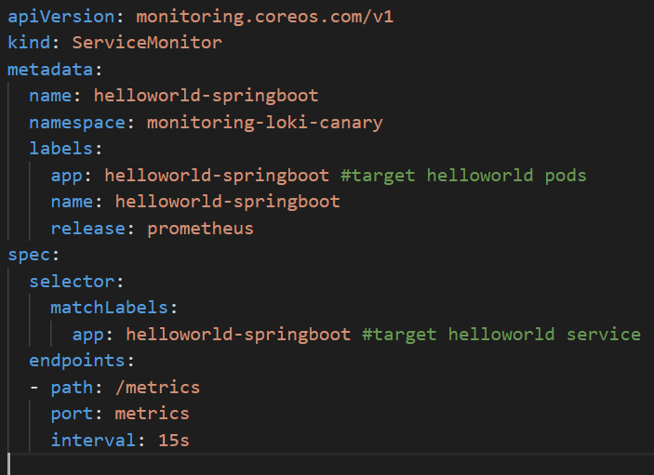

**Step11: Deploy svc monitor yaml file for helloworld**



**Step12: Expose the prometheus server and Grafana IPs**





**Step13: Check whether prometheus server and Grafana are accessible**

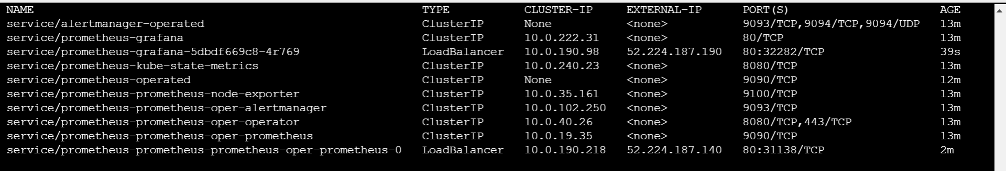

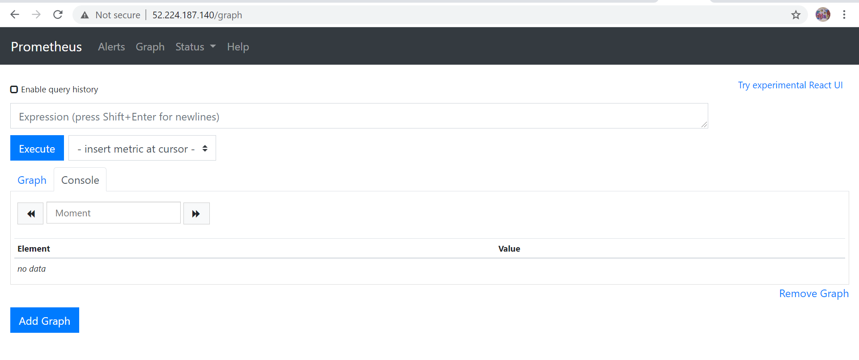

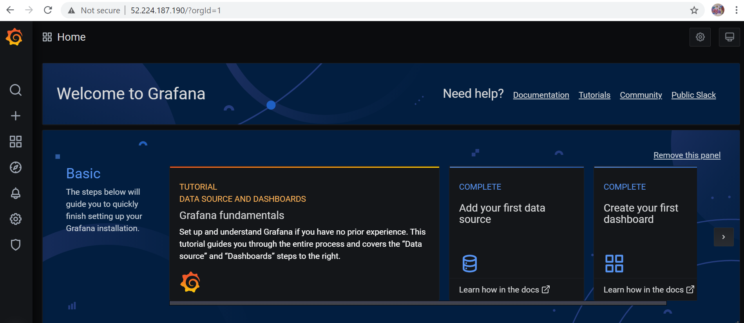

**Step14: Verify service discovery and targets for helloworld application on prometheus server**

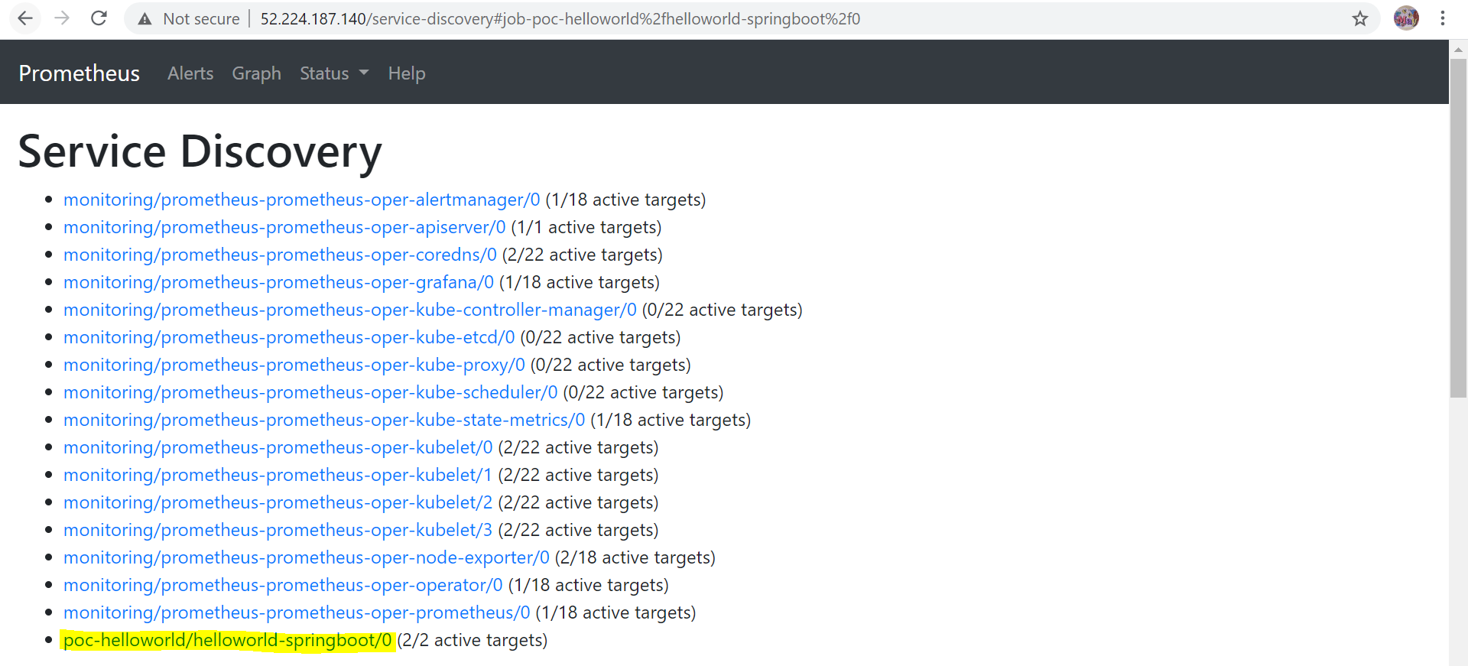

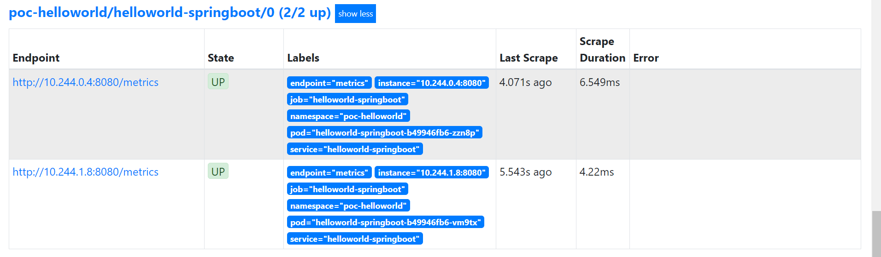

**Step15: Verify cpu, memory, error rate and response metrics for helloworld app**

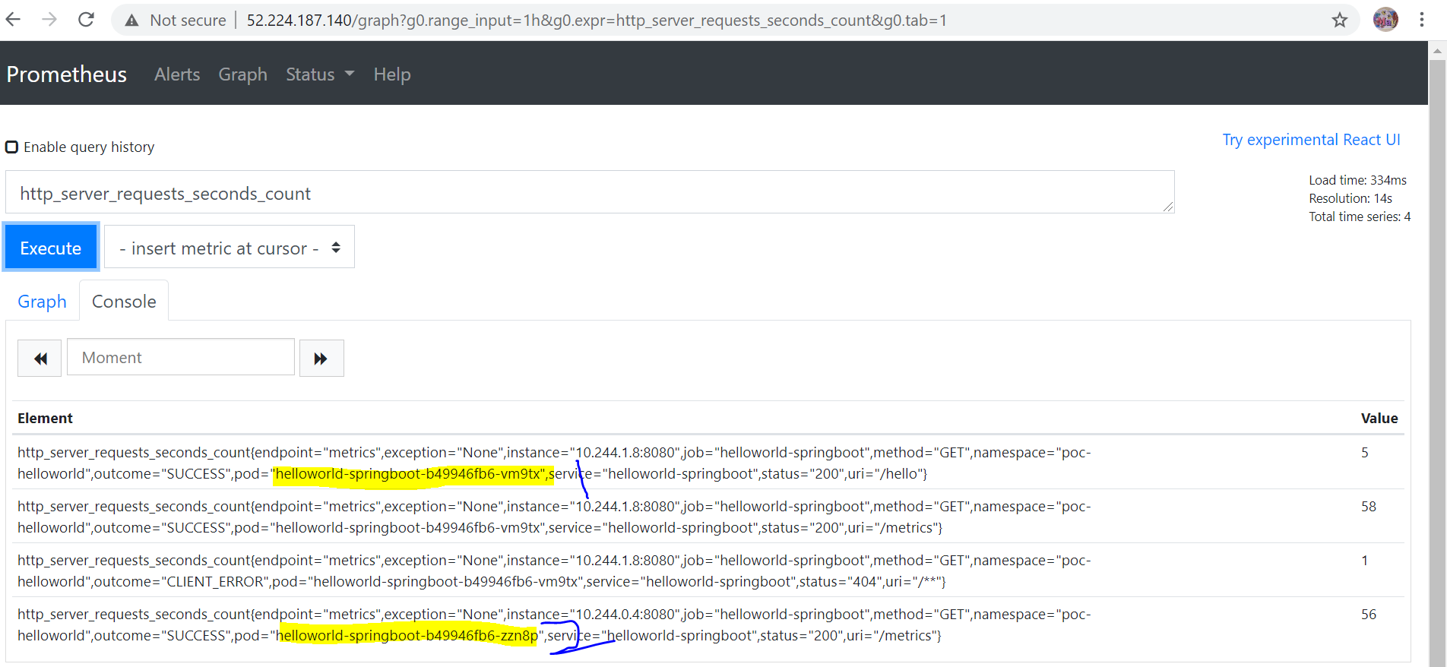

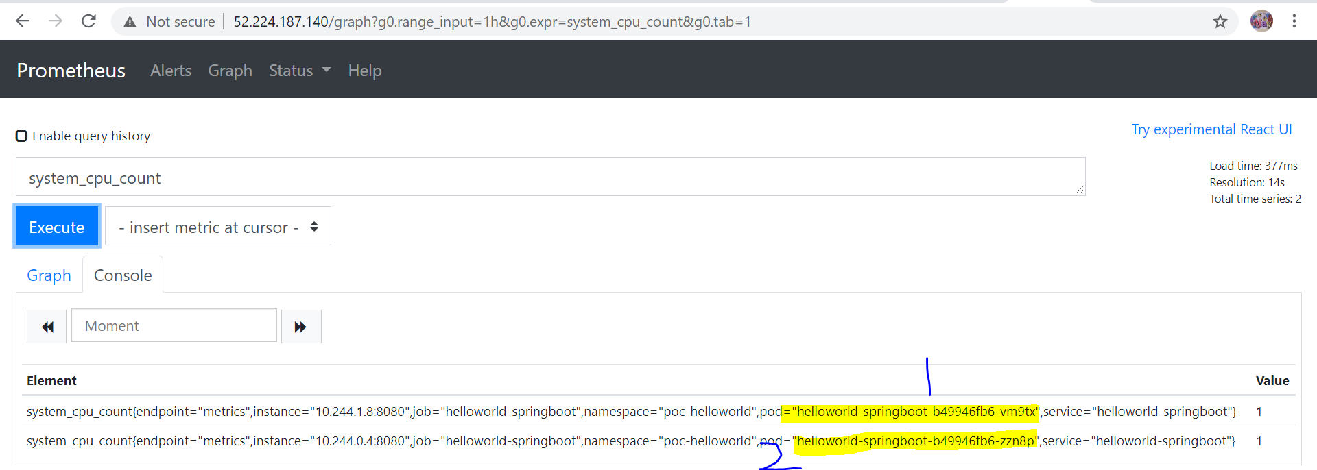

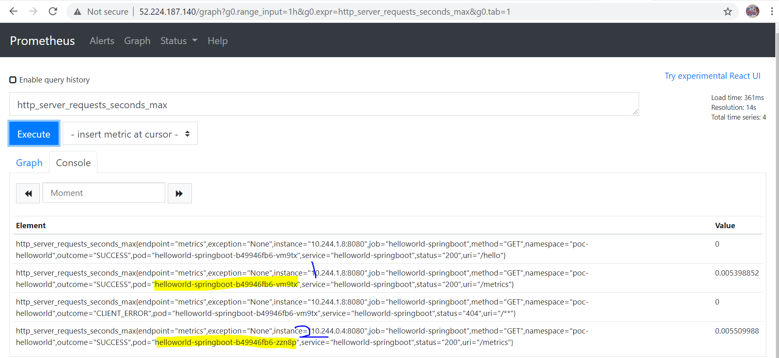

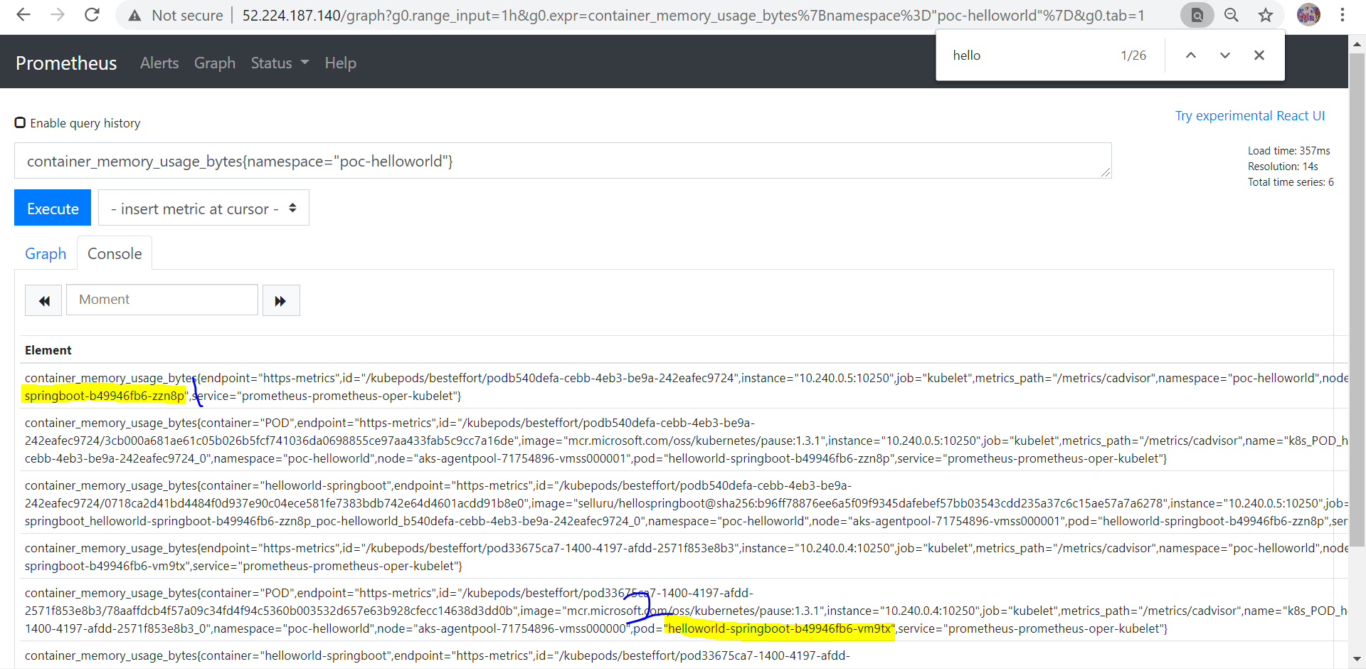

**Step16: Grafana dashboard for helloworld app metrics**

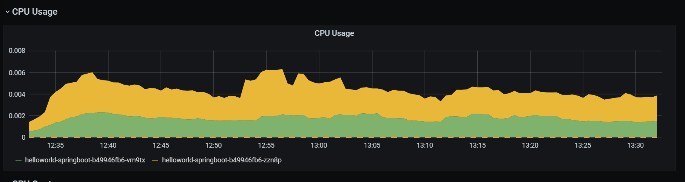

CPU usage

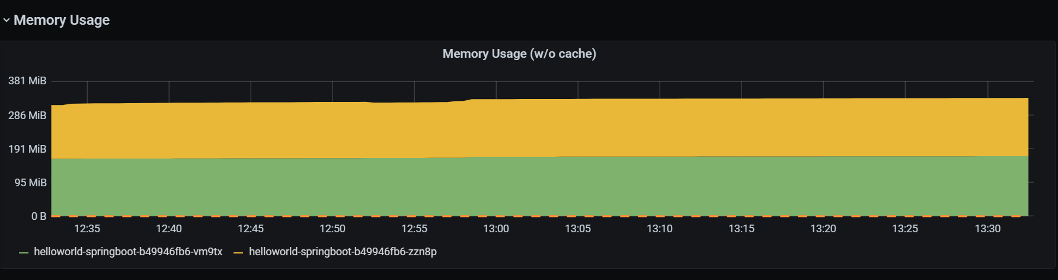

**RSS memory and memory used**

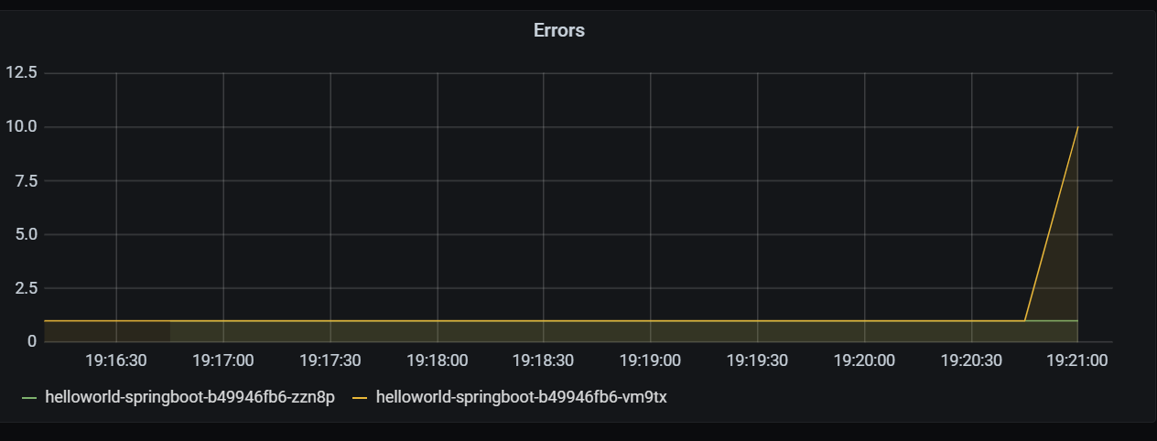

**Error 404 dashboard**

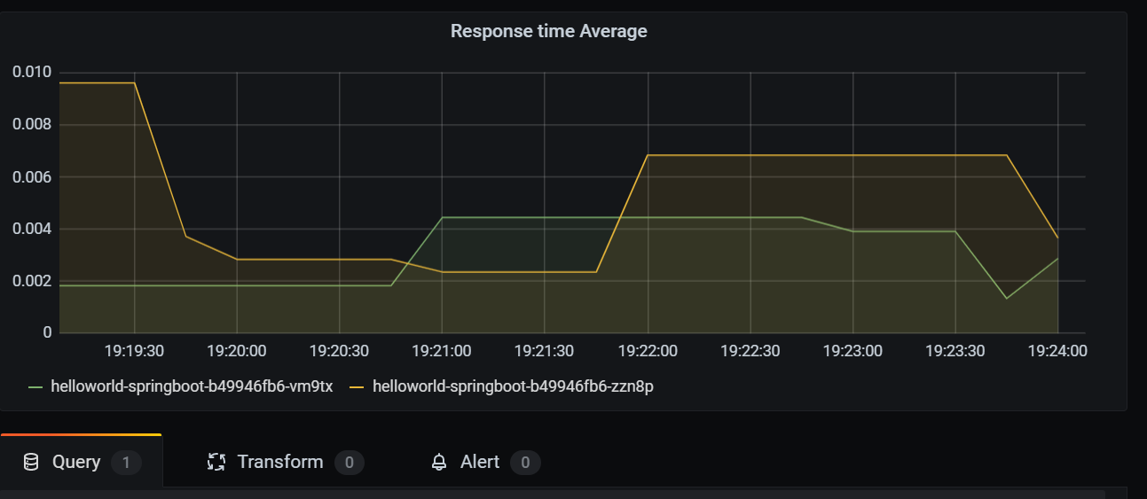

**Average Responsetime**

**Step17: Install loki with helm charts**

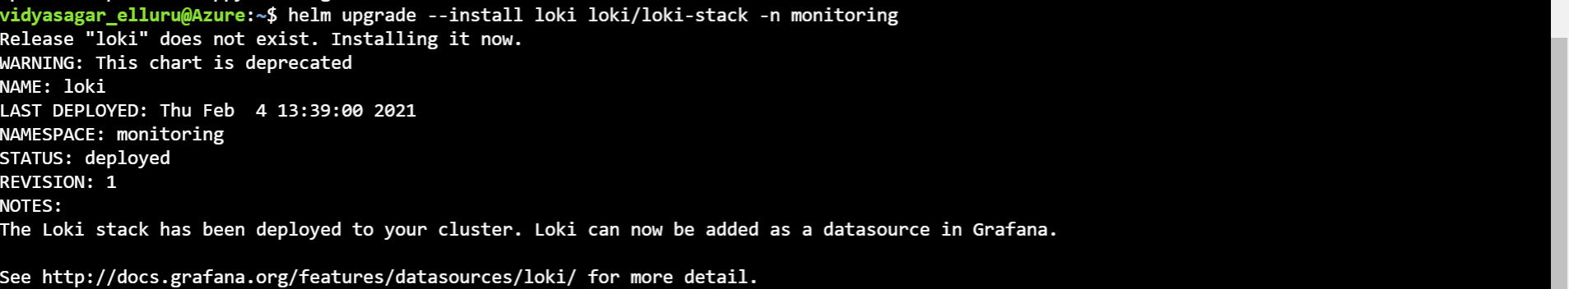

**Step18: verify promtail and loki agents installed on k8s cluster**

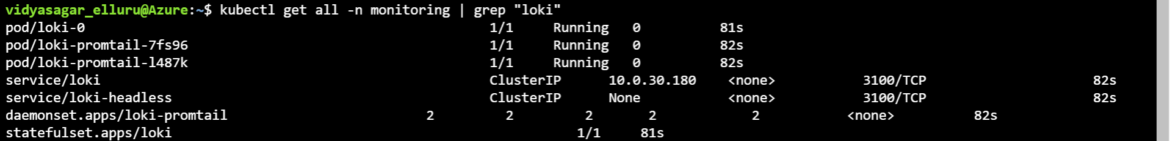

**Step19: Add loki as data source to Grafana portal**

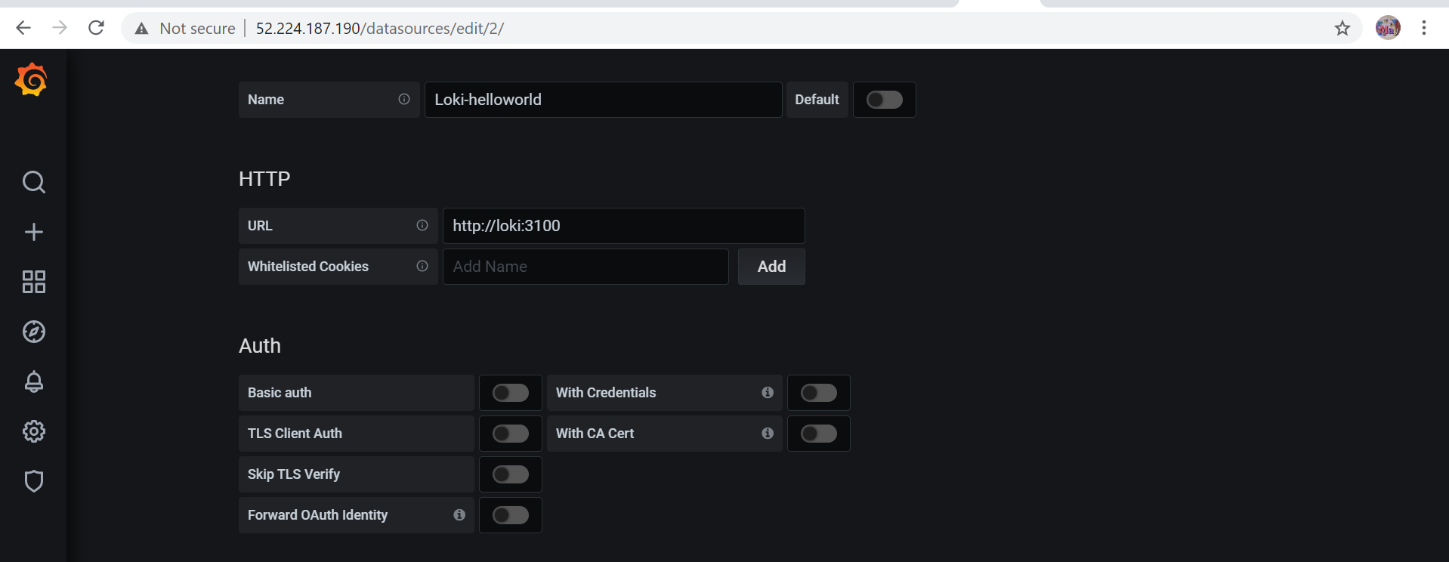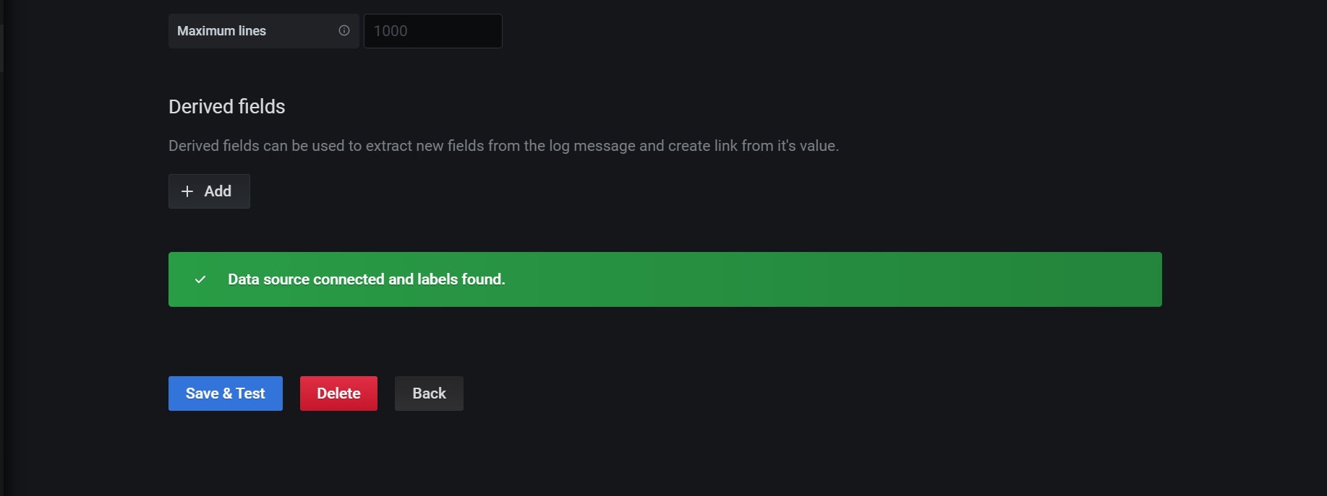

**Step20: check for logs for helloworld in loki via explore option in Grafana**

