Simulation parameter

Compilation
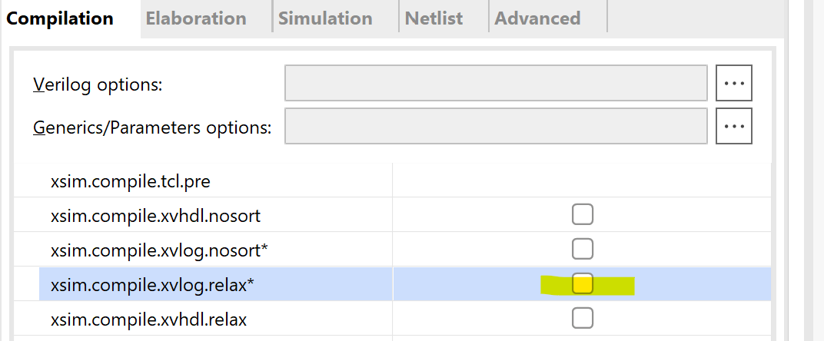

Elaboration
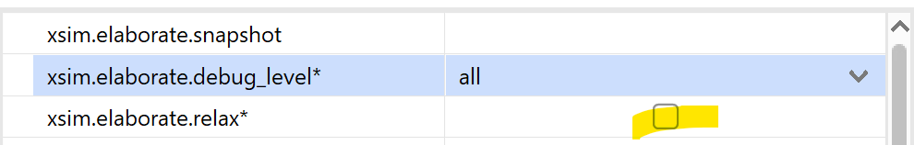

Coverage
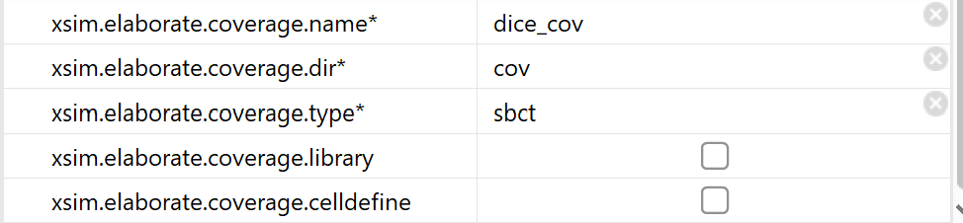

Simulation
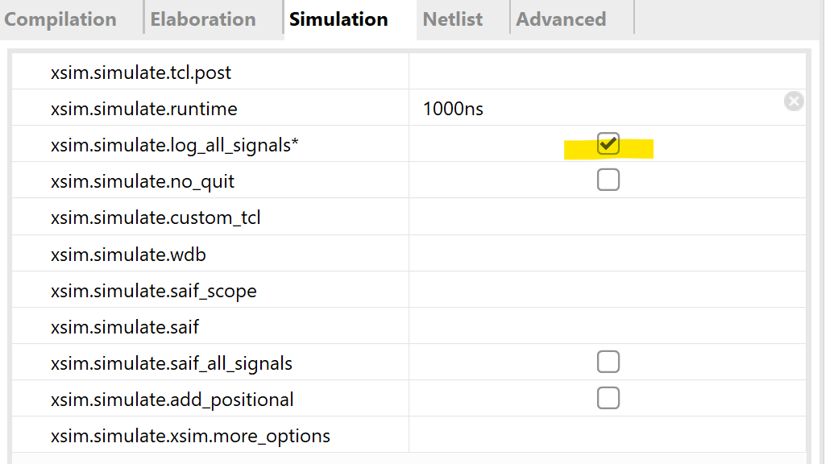

Simulation coverage information:
- Change to project location
- cd ste_vl.sim/sim_dice/behav/xsim
- xcrg -cov_db_dir cov -cov_db_name dice_cov
- xcrg -cov_db_dir . -cov_db_name ste_dice_tb_behav

Synthesis warnings to check for

No goes to continue
- Latch generated
- Multiple driver
- Bit width mismatch

To be checked
- Optimized FFs due to constant propgation

