This tab use NGLVieweR (R package) to visualize where the significant peptides are located using the protein crystal structure. To start, you will need either a pbd file or a pdb code. Select how you want to upload the pdb structure and click calculate.
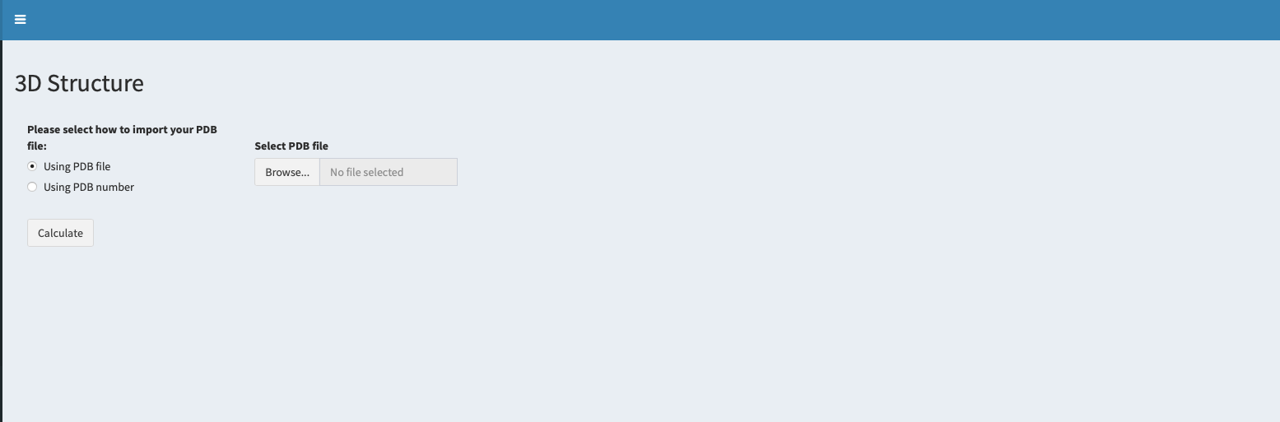
Click calculate!
Select here if you want to use wither a pdb file or a PDB code.
Add your file or input the code.

Once the calculate button is pressed, a cartoon representation of your protein will be displayed. The coloring scheme is the same as used in the global woodsplot representation. Colored in gray are the non-significant peptides, in red peptides with increased flexibility (positive deltaD values (state 2-state ref)), in blue, peptides with increased protection in the HDX experiment (negative deltaD values (state 2-state ref)). Regions colored in yellow are the regions showing both increase in protection and increase in flexibility at different timepoints.
Below the crystal structure, there are basic commands to change the representation. The user can select either cartoon, ball+stick or surface representations and to turn the spin on/off.
Additionally, there is a box to add an amino acid offset. We understand that sometimes the crystal structure used might have either additional or reduced number of residues at the N-terminal. For those cases the user can add an offset to match the amino acid sequences from the HDX experiment and the crystal structure.
Two buttons are located below the structure controls. One to download a high-resolution PNG screenshot of the crystal structure and another one to download a Pymol script with the significant peptides.
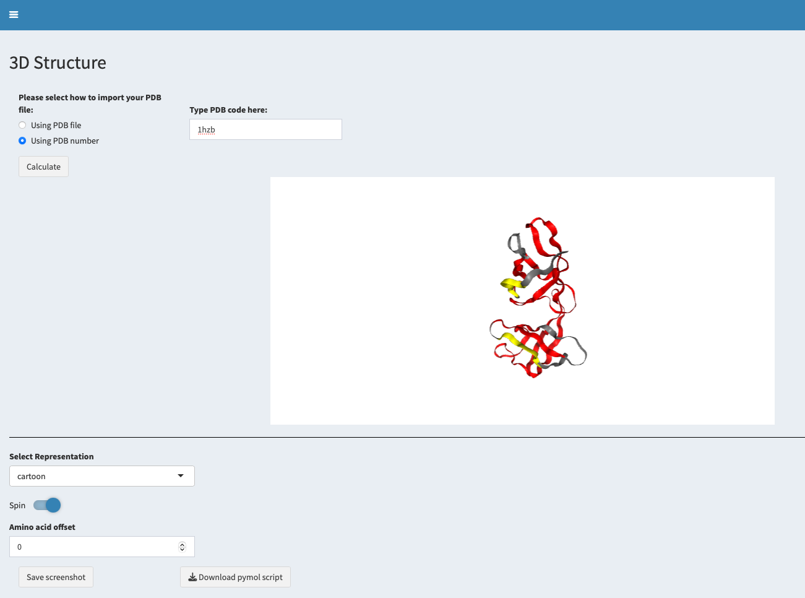
Click here to export the results into pymol.
Click to download a high-resolution PNG screenshot.
Structure controls

