This tab aims to help the user recognize how is the digestion performance of the protein in the HDX experiment. Following the recommendations of the HDX-MS community published in Nat Methods 16, 2019, we not only provide the user with a histogram of the distribution of peptide lengths and the mean length as a red dashed line but also include a table with the total number of peptides analyzed, the percent coverage of the protein, the average peptide length, and the redundancy of the digestion. We encourage the users to include this information as supporting information to easily comprehend the digestion performance in the experiment.
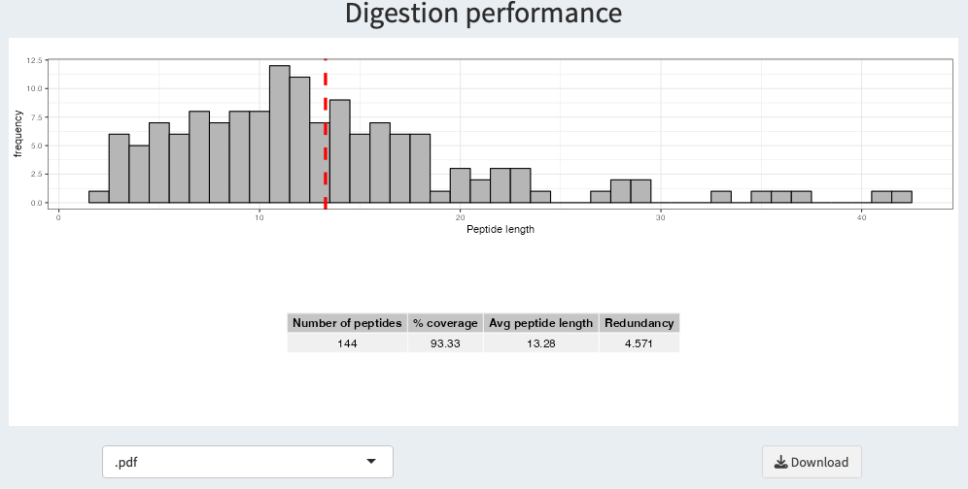

Below the plots, a drop down list and a button to allow the user to download the plots in the selected format.

