In the last tab, the user all the results can be exported.
First, a table show the basic results of the experiment with average deldaD values at each labeling timepoint and t-values from the Welch’s t-test for each peptide. In the last column are the condensed results from the hybrid significant test. A number zero (0) means the peptide is non-significant. A number one means the peptide has at least one timepoint showing increased flexibility. Peptides with a negative number one are the ones with at least one timepoint showing increase in protection. Finally, if a peptide has the word “check” means is showing both increase and decrease flexibility at different timepoints.
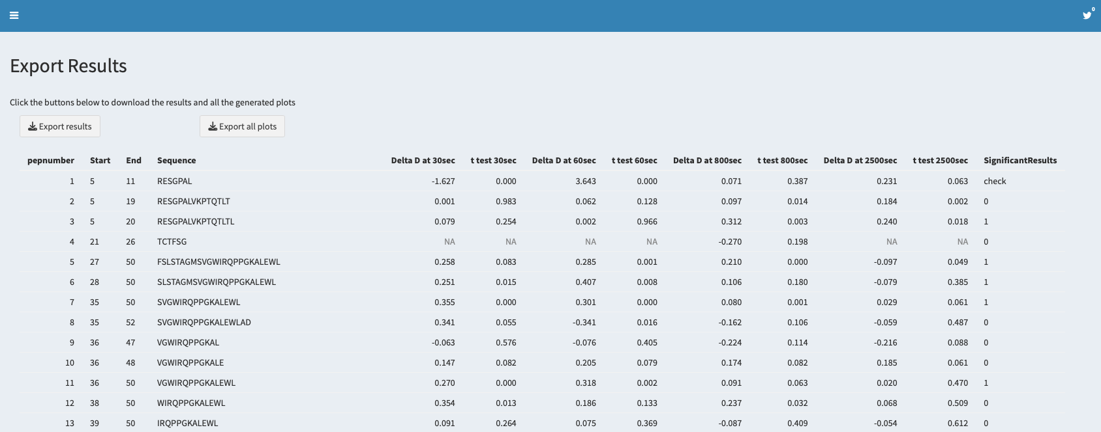

Two buttons are located at the top of the page. One (“Export all plots”) will enable the user to download all the plots from the different tabs together in a compressed zip file, and the other (“Export results”) button returns an excel spreadsheet with all the calculated results.

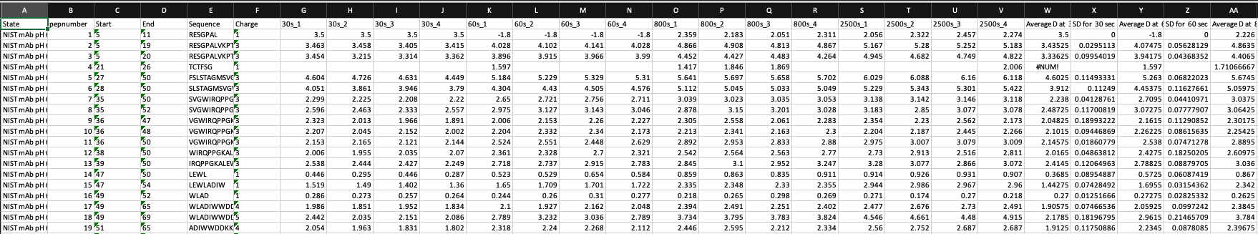
On the first sheet of the excel file, peptide number, start and end amino acid residue, sequence, charge, raw deuteration data, average deuteration and standard deviation for each labeling timepoint is displayed. Sheet two includes the same information but for protein state 2.

Sheet 3 contains all the statistical parameters used during calculations, such as the pooled standard deviation, the standard error of the mean, the significance level, the t value used to calculate the threshold and the actual global statistical threshold. Additionally, contains a small reminder of the coloring scheme used in the representations to identify significant peptides.

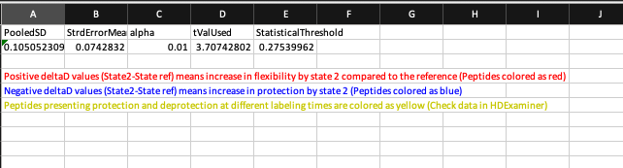

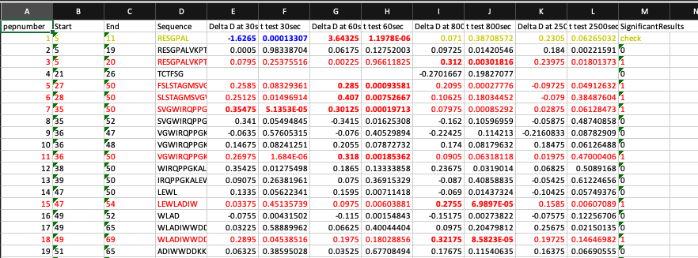
Sheet 4 contains the same table displayed at the beginning. Average deldaD values at each labeling timepoint and t-values from the Welch’s t-test for each peptide plus the summary of the hybrid significance test. Additionally, peptides considered significant will be colored. Red for peptides with increased flexibility, blue for peptides with increased protection and peptides colored yellow are the ones showing mixed behavior. Note that for a peptide to be considered significant at least one the labeling timepoints must be significant. Numbers in bold are the ones that failed the hybrid significance test.

Finally, in the last sheet are the k-means clustering results, average deuteration and t-value from the Welch’s t-test at each labeling timepoint for all peptides. Timepoints in cluster 1 are considered insignificant, timepoints in cluster 2 are considered intermediate effects and timepoints located in cluster 3 are considered strong effects.
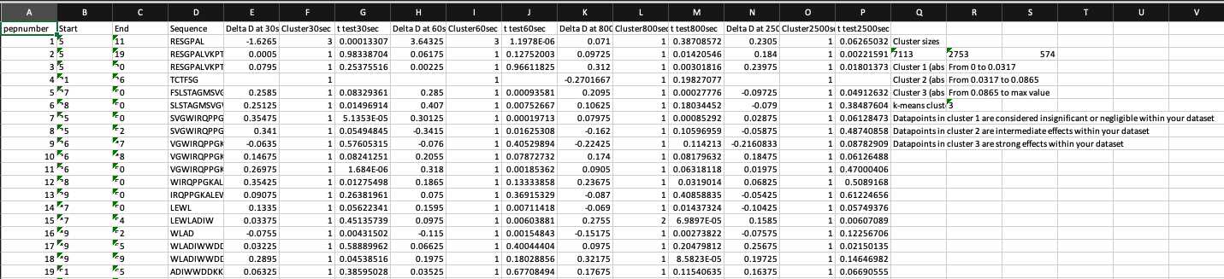
Additional information such as cluster sizes, cluster limits and number of iterations are also included here.

