The global woods plot is a nice way to visually identify regions within your protein where the significant peptides are located. Here peptides are plotted as rectangles with different colors depending on the results of the statistical analysis (see previous section). The x-axis represents the peptide number while the y-axis has the protein residues in the FASTA file. Colored in gray, are peptides considered as not statistically significant. In red, peptides with increased flexibility (positive deltaD values (state 2-state ref)). In blue, peptides with increased protection in the HDX experiment (negative deltaD values (state 2-state ref)). Additionally, peptides colored yellow, are peptides that show both increase in flexibility and increased protection at different timepoints. We recommend the analyst to manually check the data of all peptides colored yellow.

Note: The whole peptide is considered significant if at least one individual labeling time-point is identified statistically significant by the hybrid significant test.
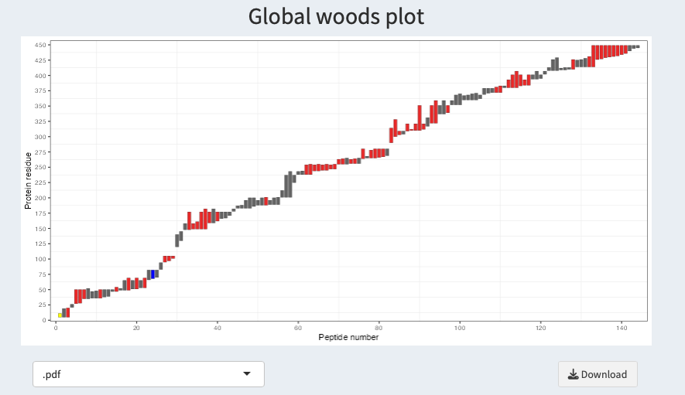
Again, below the plot a drop down list and a download button enables the user to download the plot in the selected format.

