This tab gives the user a traditional peptide coverage map. Peptides are plotted as blue rectangles. X-axis shows both the protein sequence and the residue number. This representation is incredibly useful to visually identify regions with low coverage within your HDX experiment.
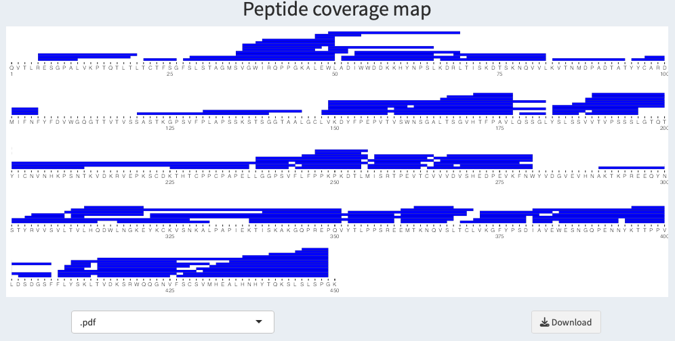

Below a drop down list and a download button to allow the user to get the plot in the specified format.

