The statistical analysis is done using the approach described by Hageman and Weis, 2019 (doi: 10.1021/acs.analchem.9b01325). We strongly recommend all users to read the original paper and familiarize with the code behind it.
The hybrid significant test evaluates both the significance and the magnitudes of the individual differences between two states.
In a volcano plot, individual deltaD differences (black dots) are plotted in the x-axis while p-values from the Welch’s t-test are plotted in the y-axis. All differential values located above both statistical thresholds (red dashed lines) are considered significant (see shaded regions below).

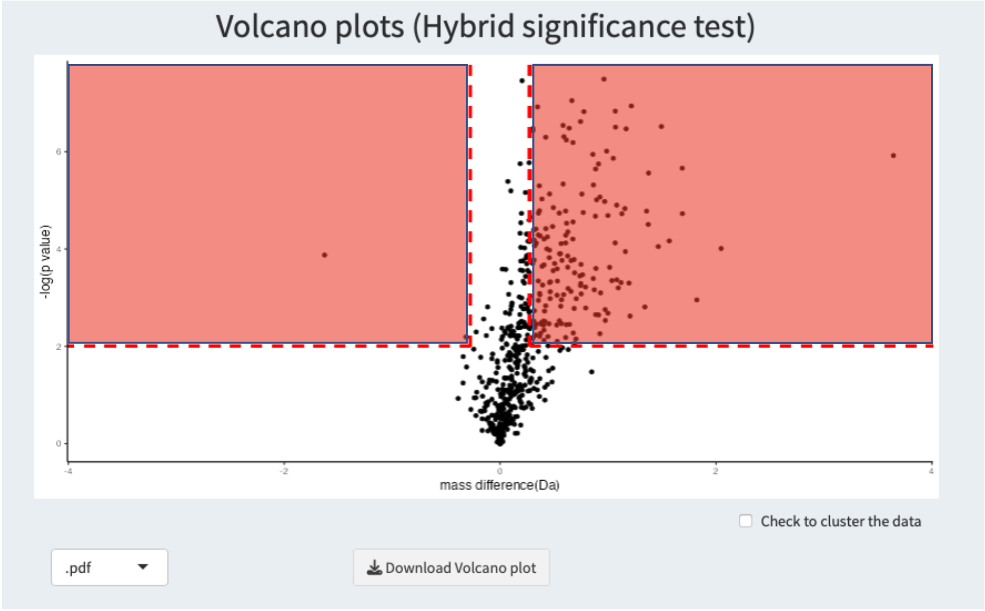

Below the volcano plot, a dropdown list and a download button are available to download the volcano plot in the format requested by the user.
If the check box to cluster the data is selected, absolute values for the individual deltaD differences are normalized using the number of amide hydrogens in each peptide (number of residues that cannot withhold deuteration in the N-terminal tail of each peptide can be changed in the input data tab). These normalized values are then clustered into three bins using a k-means clustering algorithm. The selection of three bins is completely arbitrary, however, we believe clustering the data into three bins can be used to identify insignificant, intermediate, and strong effects within the HDX data. Clustering approaches to identify the extent of the HDX change have been previously used (see here or here for some examples).
Gray dots represent data located in cluster 1 (insignificant differences), yellow dots data in cluster 2 (intermediate effects) and green dots represent values in cluster 3 (strong effects).
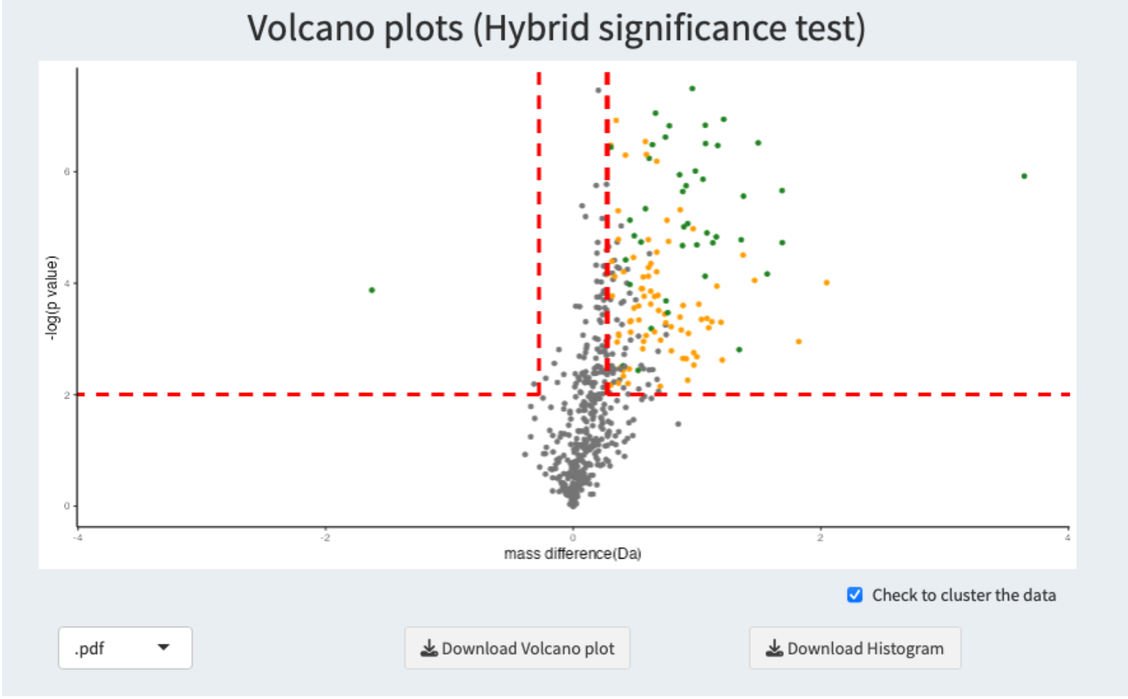

Additionally, a histogram of the normalized differences is shown with the limits of each cluster represented by red dashed lines (histogram bars al colored identically as the dots in the volcano plot). This histogram helps the user to visualize how the distribution of the data is in their HDX experiment. The number of bins in the histogram can be changed using the dropdown list below it.
Note: Modifying the number of bins in the histogram do NOT change the clustering results, this option is exclusively for better representation of the data in the histogram.

