This tab provides individual uptake plots of all peptides in the HDX-MS experiment. Individual uptake plots have time in a logarithmic scale (a-axis) to ease the visualization of differences. Error bars represent the standard deviation at each labeling time. To show the uptake plot, select the desired peptide from the drop-down list on the left menu and click show uptake plots.
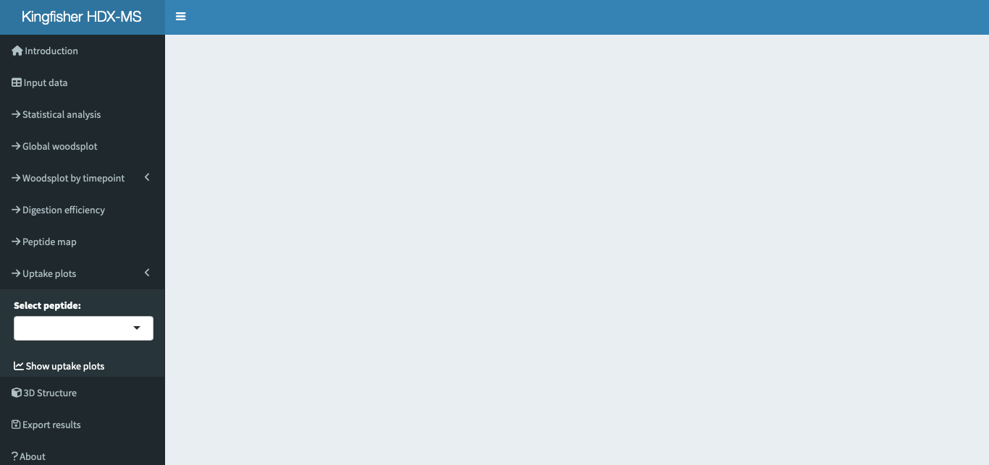
Select the desired peptide and click show uptake plots.

Title of the uptake plots consist of the start and end residue for the peptide and its sequence. A star (*) next to the sequence indicates that at least one individual difference in the peptide is considered statistically significant by the hybrid significance test. Two stars (**) indicate that the peptide present both increase in protection and increase in flexibility. We recommend the user to carefully review these results before getting conclusions.
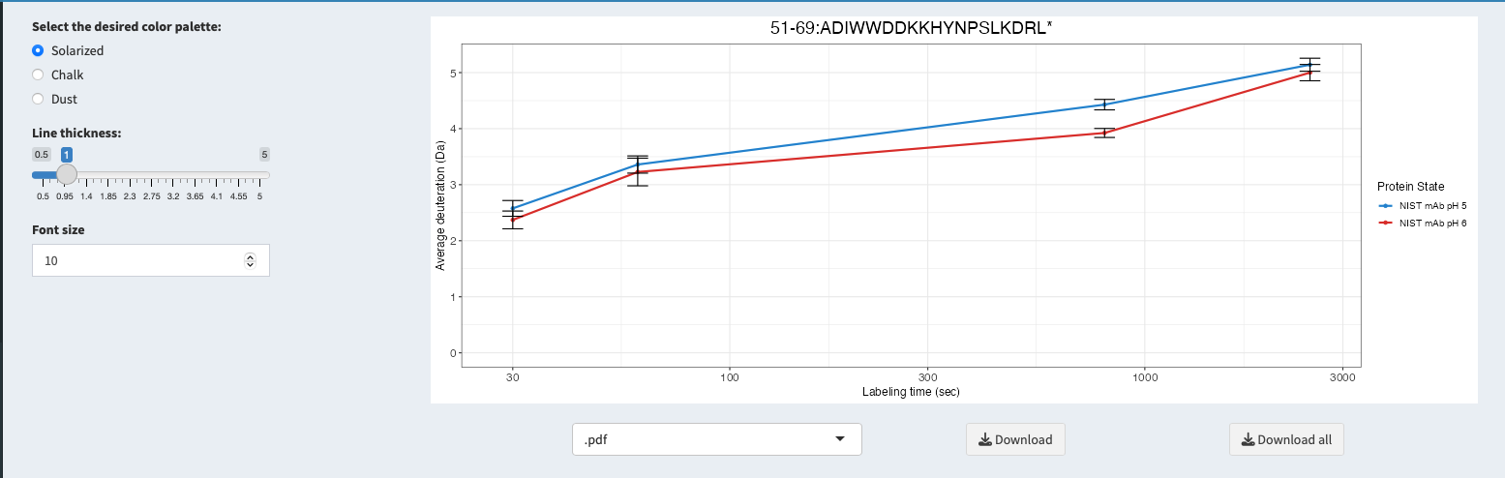
Left of the uptake plot, is a panel where the user can change the color palette, line thickness and font size of the elements of the plot.
Change plot aesthetics here.
Below the uptake plot there are two download buttons. When clicking “download” the uptake plot currently being showed will be download in the specified format selected in the drop-down list. When “download all” button is clicked, a pop-up window will appear. There, the user needs to select the number of plots wanted per row and per column and click the download uptake plots again. Note: When downloading all uptake plots, the file will be exported as a pdf, the type of file cannot be changed.
