Woods plots by timepoint are a similar representation to the global woods plot from the previous section. To access it, select the desired timepoint in the dropdown menu and click show woods plot.

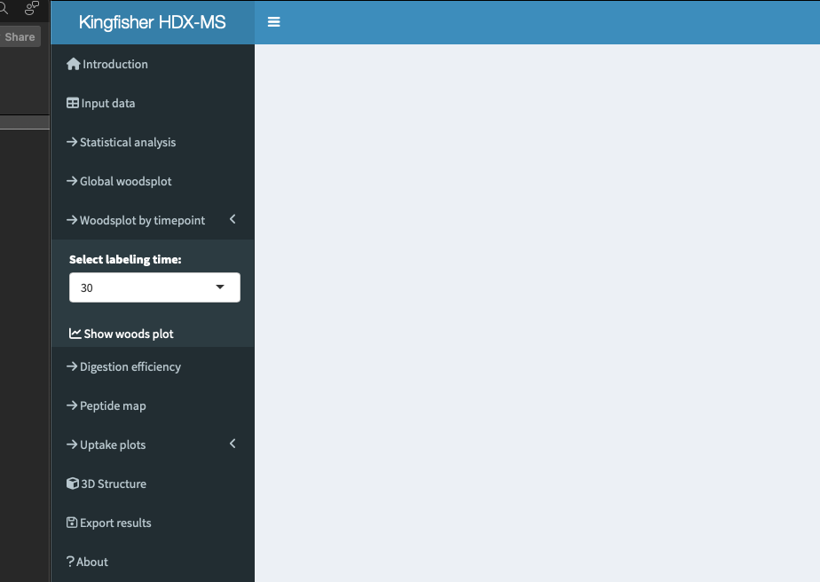
Select the desired labeling timepoint and click show woods plot.

In this representation, peptides are plotted as rectangles with different colors depending on the results of the statistical analysis (see previous section). The x-axis represents the protein residues, and the y-axis has magnitude of the differences. Colored in gray, are peptides considered not statistically significant. In red, peptides with increased flexibility (positive deltaD values (state 2-state ref)). In blue, peptides with increased protection in the HDX experiment (negative deltaD values (state 2-state ref)). Global statistical threshold as in the hybrid significant test is also included in this representation (red dashed lines).
Note: It is possible to have insignificant peptides (grey peptides) above the statistical threshold, this indicates that the magnitude of the change is enough to pass the global statistical threshold but is not considered significant because it failed the Welch’s t-test in the hybrid significant test.
As a reminder, in this representation only one labeling point is considered (selected by the user) to identify the significant peptides. By selecting a different labeling time for this representation, the user can visually identify how the statistically different peptides change and the magnitude of the change.

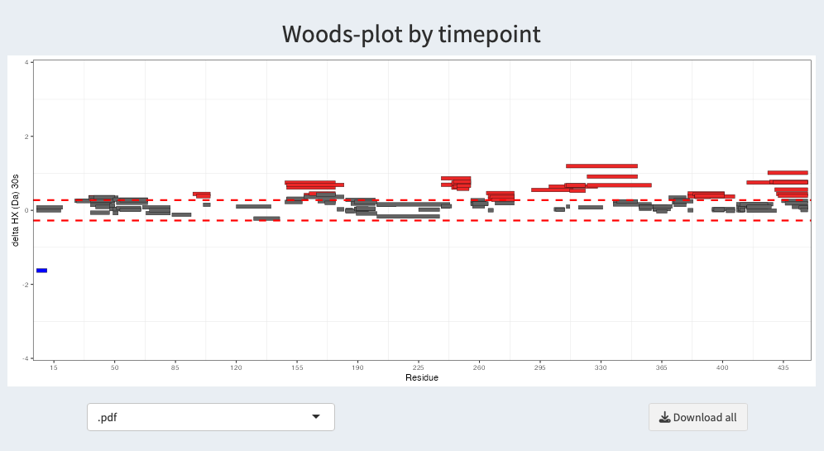

As before, a drop down list and a download button is located below the plot to allow the user to download the plot in the selected format.

