Here, all the basic information of your HDX-MS experiment needs to be uploaded.

Kingfisher HDX can read HDExaminer output files directly. Open HDExaminer, go to "Tools", select "Export," and click "Peptide Pool Results”. You can now upload that .cvs file directly to Kingfisher HDX.

If you are not using HDExaminer, you can still use Kingfisher HDX if you format your output data as seen in the test file (download the file using the bottom right link). Once you have formatted your data in the same way, upload your file and mark the checkbox for other output files.

In this tab you also need to input the FASTA file for your protein, number of protein states in your HDX experiment, the number of replicates per labeling time, number of labeling times, the significance level you want to use for the statistical analysis (we recommend using α=0.01), the labeling times in seconds and the number of residues in the N-terminal tail of each peptide that cannot withhold deuteration (we recommend using 2).

Download the .csv test file here.

Upload your protein FASTA file here.

Upload your HDExaminer output file here.

Mark this checkbox if you are NOT using an HDExaminer output file.

Once you have uploaded both your .csv output file and FASTA file, a new button will appear below the black line. Click “calculate” to start the analysis.

If the analysis is successful, two drown down lists will appear below. One to select your reference state and the other to select the protein state that you want to compare it with.

Once you selected your state 1 (reference) and state 2, you can now go navigate to all other tabs in the left menu.

**Note:** If when clicking “calculate” you get an error message, please check all your input data carefully and reload the webpage. Please remember that if you are not using an HDExaminer output file you will need to manually format your data as seen in the .csv test file.

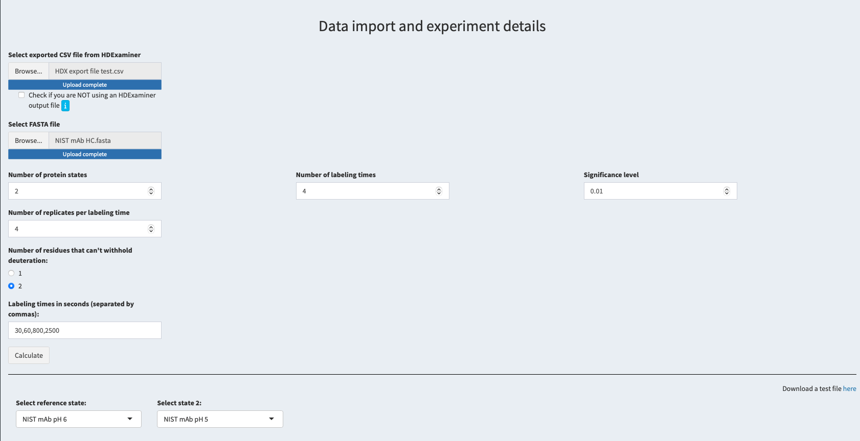

The calculate button will only appear once you have uploaded your files.

Select your reference state and the protein state you want to compare it with.

If you are NOT using an HDExaminer output file, please format your data as follows (must be a .csv file):

