**To add birthdays**

Assuming that you already have a sundance gmail account, go to the “Sundance Birthday and client” calendar and make sure that one is turned on and nothing else (for accessibility purposes). You can check if it’s turned on/off if the little square to the left is colored in (on) or colored off (off)

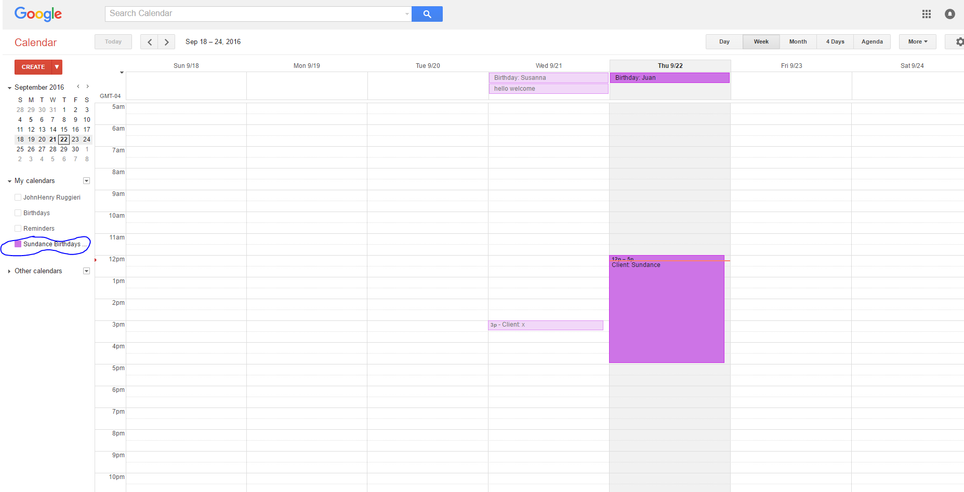

Then click on the top, below the day

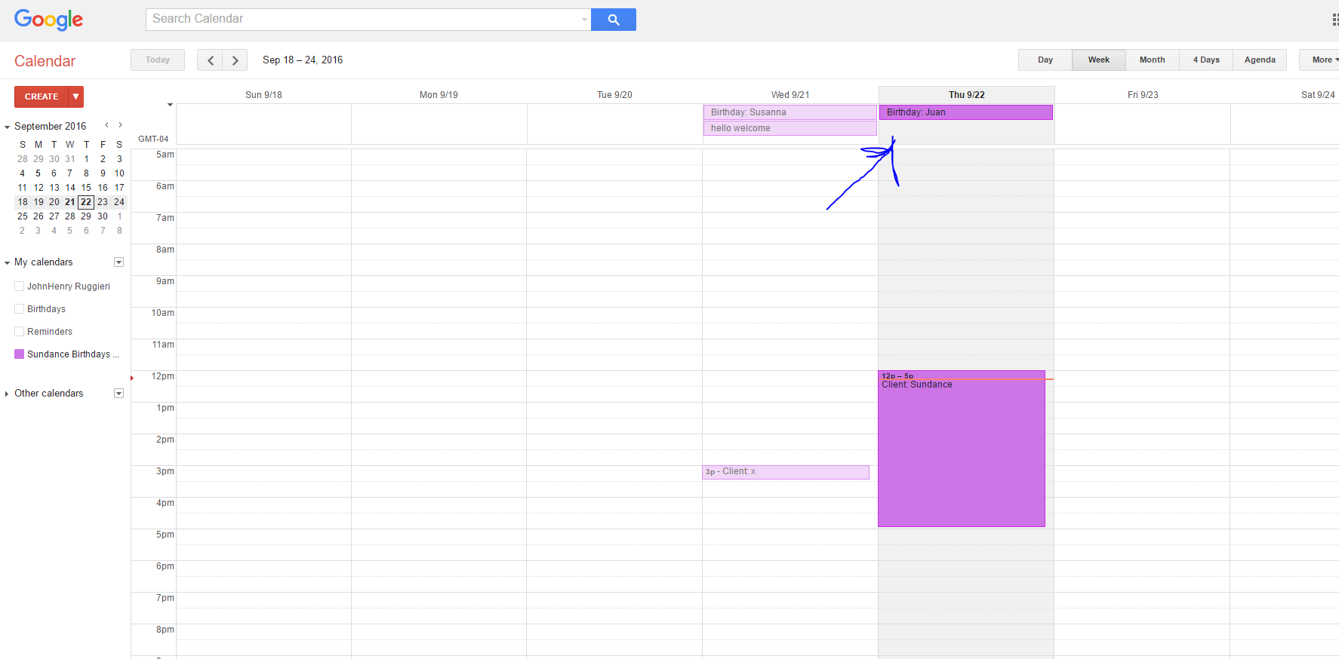

Then type “Birthday:” followed by the person’s name. It is extremely important that you type Birthday: with a capital B and ending in a colon. If it is not written this way, it will not work

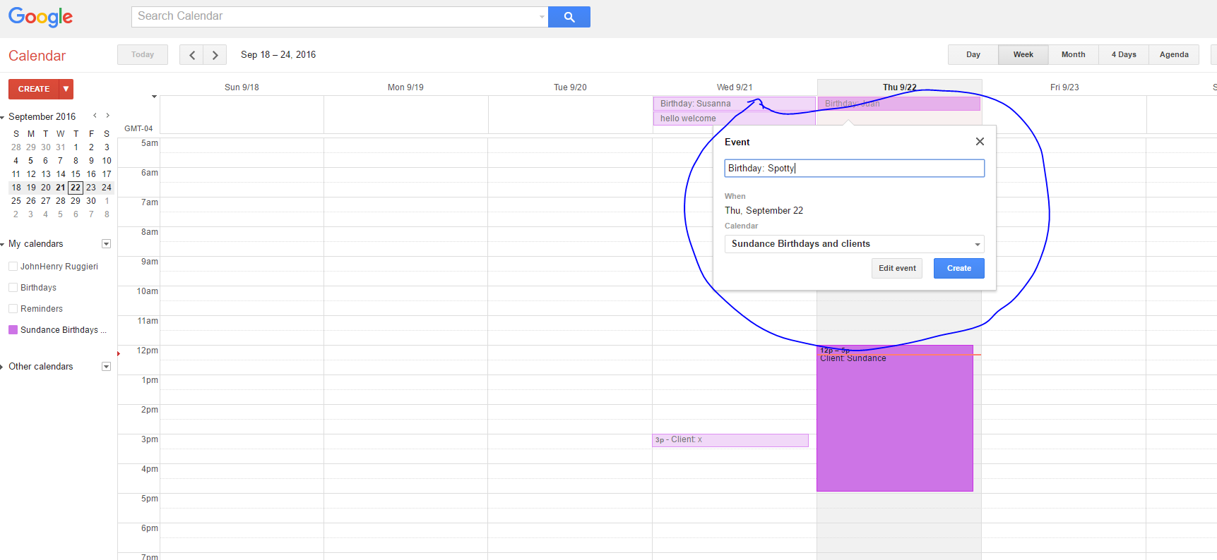

Press create and that is it. This person’s name will display on the day you’ve selected like so. To test it you can go here <http://uploads.sundancegraphics.com/~prepress/demo/Sundance-Dashoboard/birthdays.php> if it redirects you to another page, this means you did something wrong



**To add a client visit**

Much like a birthday, adding a client visit requires you to go to your “Sundance Birthdays and client” google calendar. Again, make sure that one is turned on and nothing else (for accessibility purposes). You can check if it’s turned on/off if the little square to the left is colored in (on) or colored off (off)



We then click anywhere on the day that the client will be here

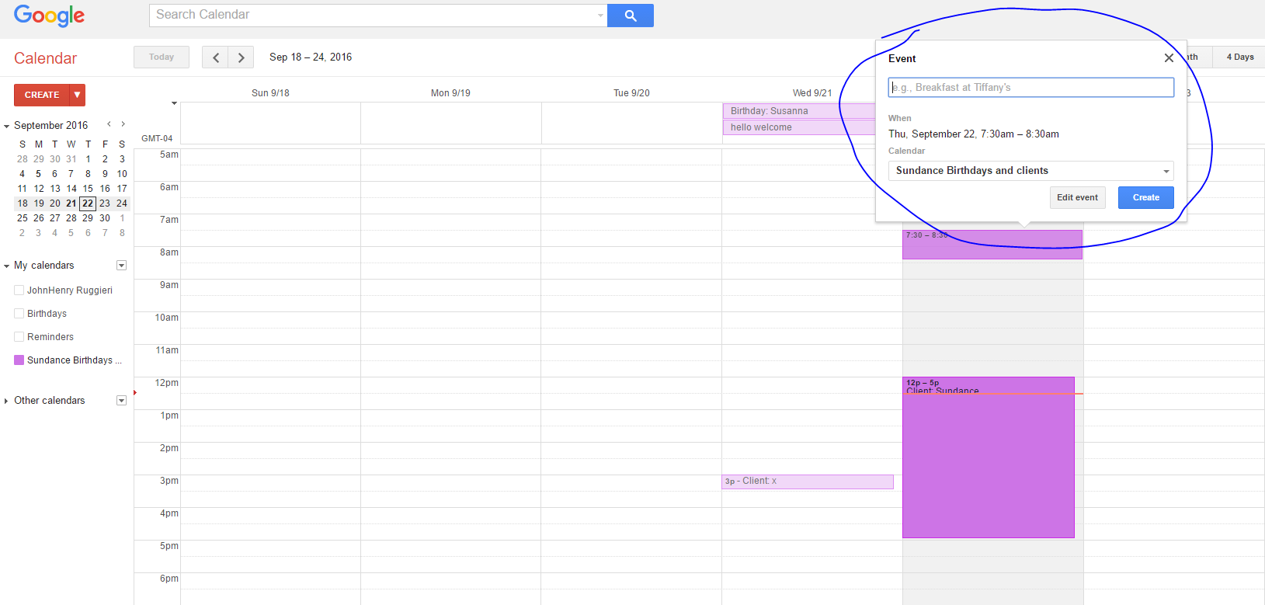

Click edit event

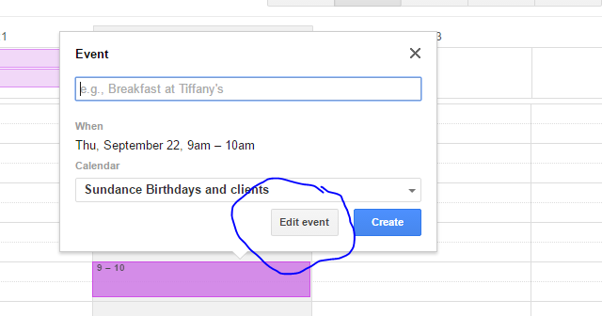

In here, please make sure you type “Client:” then the client’s name. It is extremely important that you type Client: with a capital C and ending in a colon. If it is not written this way, it will not work. Then select the time the client is expected to be here. I recommend putting the time 15 minutes prior and after the actual time to ensure the client sees this screen. After that is done, simply press “SAVE”

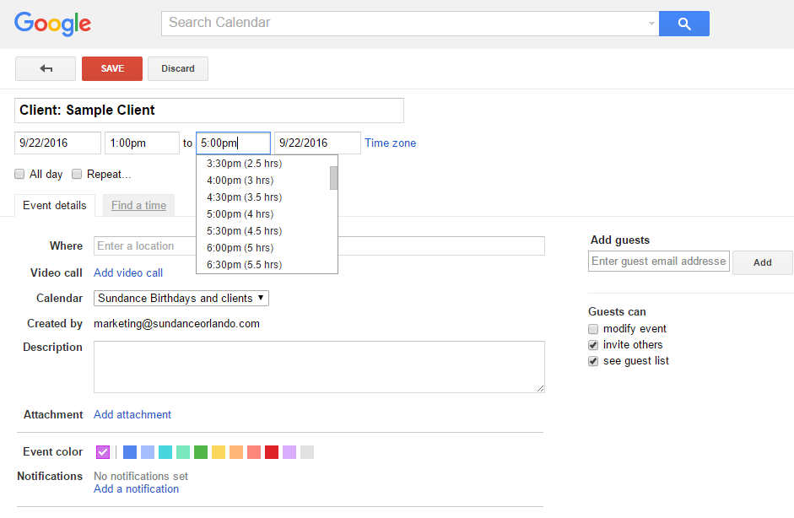

Now the clients’ name will show only for the time you’ve set like so. To test it you can go here <http://uploads.sundancegraphics.com/~prepress/demo/Sundance-Dashoboard/events.php> if it redirects you to another page, this means you did something wrong



**To add people to the “continuous improvement” winner’s screen.**

Please navigate to \\JENNY\users\prepress\public_html\demo\Sundance-Dashboard or simply paste this on your file explorer window

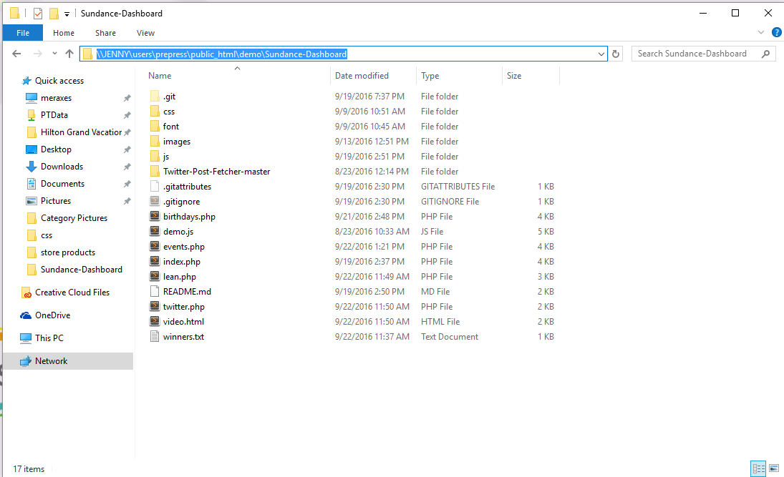

Open the “winners.txt” file, and type the employees name followed by “|” then his/her idea. . It is extremely important that you type “|” in between the employee’s name and his/her idea. If it is not written this way, it will not work.

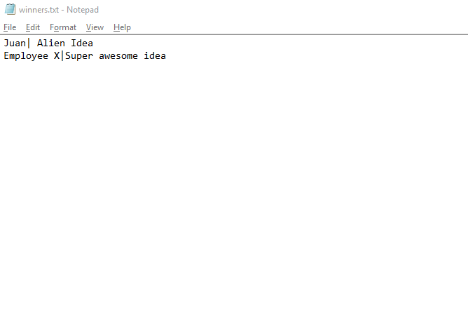

Save the file and that is it. To test it you can go here [http://uploads.sundancegraphics.com/~prepress/demo/Sundance-Dashoboard/lean.php](http://uploads.sundancegraphics.com/~prepress/demo/Sundance-Dashoboard/birthdays.php) if it redirects you to another page, this means you did something wrong

