

Postmortem Menú Reportes

29/04/17

0.1

|  |  |
| --- | --- |
| **Nombre.** | **Matricula** |
| **Jesús Alberto Goiz Barrales.** | **24400085** |
| **Juan Alberto Gutiérrez Canto.** | **24400063** |
| **Brenda Robles Antonio.** | **24400073** |
| **Rene Moratilla Montes.** | **24400075** |
| **Guillermo Vivaldo Vazquez** | **24400093** |

**Control De Versiones**

|  |  |  |  |  |
| --- | --- | --- | --- | --- |
| Nombre Del Archivo | Versión | Fecha | Autor | Comentarios |
| Csoft-PM_Menú_Reportes-290417.docx | 0.1 | 29/04/17 | BRA | Creación del Documento |
|  |  |  |  |  |
|  |  |  |  |  |
|  |  |  |  |  |
|  |  |  |  |  |
|  |  |  |  |  |

# Índice

**Índice** **2**

**I.- Forma PSP Project Plan Summary.** **3**

**II.- Time Recording Log.** **3**

**III.- Defect Recording Log.** **3**

**IV.- Diseño.** **3**

**V.- Design CheckList.** **3**

**VI.- Programa Fuente.** **4**

**VII.- Code CheckList.** **4**

**VIII.- Reporte de resultados.** **4**

**IX.- PIP** **4**

**X.- Size Estimating Template** **5**

**XI.- Task and Schedule** **5**

# I.- Forma PSP Project Plan Summary.

Se inició el proceso el 26/04/17

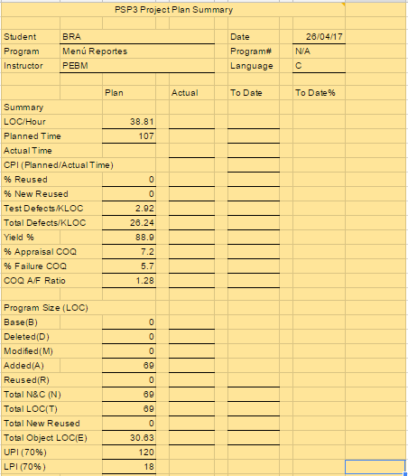

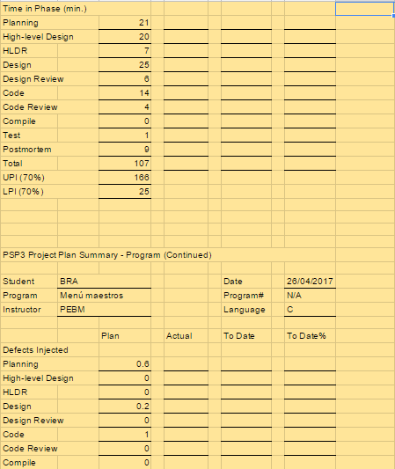

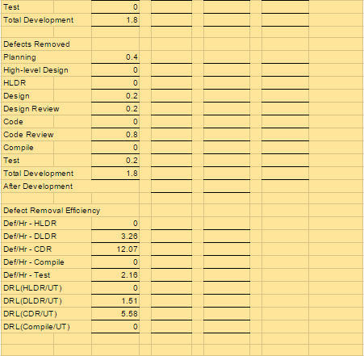

# II.- Time Recording Log.

# III.- Defect Recording Log.

# IV.- Diseño.

**State Specification Template**

# 

|  |  |  |  |  |  |  |  |
| --- | --- | --- | --- | --- | --- | --- | --- |
| Student | | BRA | | | Date | | 27/04/2017 |
| Program | | Menú Reportes | | | Program # | | N/A |
| Instructor | | PEBM | | | Language | | C |
|  | | |  | | | | |
| Menú principal | | | | | | | |
| **State Name** | | | | **Description** | | | |
| Inicio | | | | Inicia el programa. | | | |
| Reportes alumnos | | | | Se presentará el menú reportes alumnos | | | |
| Reportes maestros | | | | Se presentará el menú reportes maestros | | | |
| Reportes materias | | | | Se presentará el menú reportes materias | | | |
| Reportes planes | | | | Se presentará el menú reportes planes | | | |
| Salir | | | | Regresa al menú principal | | | |
|  | | | |  | | | |
| **Function/Parameter** | | | | **Description** | | | |
| printf() | | | | Imprime datos en la pantalla | | | |
| scanf() | | | | Lee datos de la pantalla | | | |
| opción | | | | opción que elegirá el usuario | | | |
|  | | | |  | | | |
| **States/Next States** | | | | **Transition Condition** | | **Action** | |
| Inicio | | | |  | |  | |
|  | Menú Reportes | | | True | | printf()-imprime el menú  scanf()- lee opción | |
| Menú principal | | | |  | |  | |
|  | Reportes alumnos | | | opción=1 | | Reportes_Alumnos() | |
|  | Reportes maestros | | | opción=2 | | Reportes_Maestros() | |
|  | Reportes materias | | | opción=3 | | Reportes_Materias() | |
|  | Reportes planes | | | opción=4 | | Reportes_Planes() | |
|  | Salir | | | opción=5 | | Fin. | |

# Logic Specification Template

# 

|  |  |  |  |  |
| --- | --- | --- | --- | --- |
| Student | BRA | | Date | 27/04/17 |
| Program | Menú Reportes | | Program # | N/A |
| Instructor | PEBM | | Language | C |
| Object | N/A | | Function | Menu_Reportes() |
| **INCLUDES:**  **TYPE DEFINITIONS:**  **Declaration:** | | #include <cstdio>  Using namespace std; | | |
|  | |  | | |

|  |  |
| --- | --- |
| **Reference:** |  |

|  |  |
| --- | --- |
| Logic reference numbers | Program logic, in pseudocode |
| 1 | Imprime el menú reportes con todas sus opciones |
|  | Leer la opción del usuario |
|  | En caso de que sea 1 |
|  | Va a la función Reportes_Alumnos() |
|  | En caso de que sea 2 |
|  | Va a la función Reportes_Maestros() |
|  | En caso de que sea 3 |
|  | Va a la función Reportes_Materias() |
|  | En caso de que sea 4 |
|  | Va a la función Reportes_Planes() |
|  | En caso de que sea 5 |
|  | Termina la función rompe el ciclo |
|  | Fin. |

# Functional Specification Template

|  |  |  |  |  |  |  |
| --- | --- | --- | --- | --- | --- | --- |
| **Student** | | | BRA | | **Date** | 27/04/17 |
| **Program** | | | Menú Reportes | | **Program #** | N/A |
| **Instructor** | | | PEBM | | **Language** | C |
|  | | | | | | |
| **Class Name** | | void Menu_reportes() | | | | |
| **Parent Class** | | N/A | | | | |
|  | | | | | | |
| **Attributes** | | | | | | |
|  | **Declaration** | | | **Description** | | |
|  | Int opcion | | | Corresponde a la opción que el usuario elegirá. | | |
|  | | | | | | |
| **Items** | | | | | | |
|  | **Declaration** | | | **Description** | | |
|  | Reportes_Alumnos() | | | Presenta el vínculo al menú de reportes de alumnos | | |
|  | Reportes_Maestros() | | | Presenta el vínculo al menú de reportes de maestros | | |
|  | Reportes_Materias() | | | Presenta el vínculo al menú de reportes de materias | | |
|  | Reportes_Planes() | | | Presenta el vínculo al menú de reportes de planes | | |
|  | int main() | | | Main del programa | | |
|  | printf() | | | Para imprimir directamente en la interfaz de usuario. | | |
|  | scanf() | | | Para leer datos de la interfaz de usuario. | | |

# Operational Scenario Template

|  |  |  |  |
| --- | --- | --- | --- |
| **Student** | BRA | **Date** | 27/04/17 |
| **Program** | Menu Reportes | **Program #** | N/A |
| **Instructor** | PEBM | **Language** | C |

|  |  |  |  |  |
| --- | --- | --- | --- | --- |
| **Scenario Number** | **1** | **User Objective** | Seleccione ir al menú reportes alumnos | |
| **Scenario Objective** | | Pasos para ir al menú reportes alumnos | | |
| **Source** | **Step** | **Action** | | **Comments** |
| Usuario | 1 | Abrir el programa. | |  |
| Programa | 2 | Desplegar el menú Reportes | | Dando las opciones del menú. |
| Usuario | 3 | Ver el menú reportes | | Revisar las opciones posibles |
| Usuario | 4 | Introducir opción deseada 1 | | Elegir entre las opciones posibles |
| Programa | 5 | Leer opción del usuario | | Verificar que sea válida |
| Programa | 6 | Mandar a reportes alumnos | | Dirige a la función de reportes de alumnos |
| Usuario | 7 | Ver pantalla de reportes de alumnos | | Presentar lo del módulo reportes de alumnos |
|  |  |  | |  |
|  |  |  | |  |

# V.- Design CheckList.

# Revisión diseño

|  |  |  |  |
| --- | --- | --- | --- |
| Student | BRA | Date | 27/04/17 |
| Program | Menú Reportes | Program # | N/A |
| Instructor | PEBM | Language | C |

|  |  |
| --- | --- |
| Purpose | To guide you in conducting an effective design review |
| General | - Review the entire program for each checklist category; do not attempt to review for more than one category at a time!  - As you complete each review step, check off that item in the box at the right.  - Complete the checklist for one program or program unit before reviewing the next. |

|  |  |  |  |  |  |
| --- | --- | --- | --- | --- | --- |
| Complete | Verify that the design covers all of the applicable requirements.  - All specified outputs are produced.  - All needed inputs are furnished.  - All required includes are stated. | MB  X  X  X | B | R | M |
| External Limits | Where the design assumes or relies upon external limits, determine if behavior is correct at nominal values, at limits, and beyond limits. |  |  |  |  |
| Logic | - Verify that program sequencing is proper.  Stacks, lists, and so on are in the proper order.  Recursion unwinds properly.  - Verify that all loops are properly initiated, incremented, and terminated.  - Examine each conditional statement and verify all cases. | X        X | X |  |  |
| Internal Limits | Where the design assumes or relies upon internal limits, determine if behavior is correct at nominal values, at limits, and beyond limits. |  |  |  |  |
| Special Cases | - Check all special cases.  - Ensure proper operation with empty, full, minimum, maximum, negative, and zero values for all variables.  - Protect against out-of-limits, overflow, and underflow conditions.  - Ensure “impossible” conditions are absolutely impossible.  - Handle all possible incorrect or error conditions. | X  X    X  X  X |  |  |  |
| Functional Use | - Verify that all functions, procedures, or methods are fully understood and properly used.  - Verify that all externally referenced abstractions are precisely defined. | X    X |  |  |  |
| System Considerations | - Verify that the program does not cause system limits to be exceeded.  - Verify that all security-sensitive data are from trusted sources.  - Verify that all safety conditions conform to the safety specifications. | X    X    X |  |  |  |
| Names | Verify that  - all special names are clear, defined, and authenticated  - the scopes of all variables and parameters are self-evident or defined  - all named items are used within their declared scopes |  | X  X  X |  |  |
| Standards | Ensure that the design conforms to all applicable design standards. | X |  |  |  |

# VI.- Programa Fuente.

/*=========================================================*/

/*Autor: Brenda Robles Antonio */

/*Componente: Menú Reportes */

/*Fecha: 29/04/17 */

/*Descripción: Codificación que muestra el menú reportes */

/*Versión: 0.1 */

/*=========================================================*/

/*==========================================================*/

/* El programa contiene lo siguiente: */

/* void menu_reportes() */

/* int main() */

/*==========================================================*/

#include <iostream>

#include <cstdio>

#include <cstdlib>

/***Esta función se encarga de presentar el menú principal y redireccionar a la opcion que el usuario eligió***/

void menu_reportes()

{

char opcion;

do

{

system("cls");

printf(" °----------------------------------------------------------°\n");

printf(" | ============== Sistema Acad%cmico =============== |\n",138);

printf(" °----------------------------------------------------------°\n");

printf(" °----------------------------------------------------------°\n");

printf(" ! Introduce la seleccion de men%c: !\n\n",163);

printf(" ! 1) Reportes Alumnos !\n\n");

printf(" ! 2) Reportes Maestros !\n\n");

printf(" ! 3) Reportes Materias !\n\n");

printf(" ! 4) Reportes Planes !\n\n");

printf(" ! 5) Volver al men%c principal !\n\n",163);

printf(" °----------------------------------------------------------°\n");

printf(" Opci%cn .-",162);

scanf("%c",&opcion);

switch(opcion)

{

case '1':

{

printf("Selecci%cn reportes alumnos\n",162);

system("pause");

//menu_reportes_alumnos();

break;

}

case '2':

{

printf("Selecci%cn reportes maestros\n",162);

system("pause");

//menu_reportes_maestros();

break;

}

case '3':

{

printf("Selecci%cn reportes materias\n",162);

system("pause");

//menu_reportes_materias();

break;

}

case '4':

{

printf("Selecci%cn reportes planes\n",162);

system("pause");

//menu_reportes_planes();

break;

}

case '5':

{

printf("Regresando al men%c principal...\n",163);

system("pause");

break;

}

default:

{

printf("Opci%cn incorrecta...\n",162);

system("pause");

break;

}

}

}

while(opcion!='5');

}

int main()

{

menu_reportes();

return 0;

}

# VII.- Code CheckList.

# Revisión codificación

|  |  |  |  |
| --- | --- | --- | --- |
| Student | BRA | Date | 27/04/17 |
| Program | Menú Reportes | Program # | N/A |
| Instructor | PEBM | Language | C |

|  |  |
| --- | --- |
| Purpose | To guide you in conducting an effective design review |
| General | - Review the entire program for each checklist category; do not attempt to review for more than one category at a time!  - As you complete each review step, check off that item in the box at the right.  - Complete the checklist for one program or program unit before reviewing the next. |

|  |  |  |  |  |  |
| --- | --- | --- | --- | --- | --- |
| Complete | Verify that the design covers all of the applicable requirements.  - All specified outputs are produced.  - All needed inputs are furnished.  - All required includes are stated. | MB  X  X  X | B | R | M |
| External Limits | Where the design assumes or relies upon external limits, determine if behavior is correct at nominal values, at limits, and beyond limits. |  |  |  |  |
| Logic | - Verify that program sequencing is proper.  Stacks, lists, and so on are in the proper order.  Recursion unwinds properly.  - Verify that all loops are properly initiated, incremented, and terminated.  - Examine each conditional statement and verify all cases. | X        X | X |  |  |
| Internal Limits | Where the design assumes or relies upon internal limits, determine if behavior is correct at nominal values, at limits, and beyond limits. |  |  |  |  |
| Special Cases | - Check all special cases.  - Ensure proper operation with empty, full, minimum, maximum, negative, and zero values for all variables.  - Protect against out-of-limits, overflow, and underflow conditions.  - Ensure “impossible” conditions are absolutely impossible.  - Handle all possible incorrect or error conditions. | X  X    X  X  X |  |  |  |
| Functional Use | - Verify that all functions, procedures, or methods are fully understood and properly used.  - Verify that all externally referenced abstractions are precisely defined. | X    X |  |  |  |
| System Considerations | - Verify that the program does not cause system limits to be exceeded.  - Verify that all security-sensitive data are from trusted sources.  - Verify that all safety conditions conform to the safety specifications. | X    X    X |  |  |  |
| Names | Verify that  - all special names are clear, defined, and authenticated  - the scopes of all variables and parameters are self-evident or defined  - all named items are used within their declared scopes |  | X  X  X |  |  |
| Standards | Ensure that the design conforms to all applicable design standards. | X |  |  |  |

# VIII.- Reporte de resultados.

# Template de pruebas

|  |  |
| --- | --- |
| Nombre de la Prueba | Prueba de Menú Reportes |
| Caso de Uso | N/A |
| Objetivo de la Prueba | Mostrar la estructura del Menú Reportes |
| Descripción de la Prueba | Se ingresará al sistema y se mostrará la estructura del menú |
| Test | 1.-Probar el acceso a reportes alumnos.  2.-Probar el acceso a reportes maestros.  3.- Probar el acceso a reportes materias.  4.- Probar el acceso a reportes planes.  5.-Probar que se pueda salir.  6.-Probar opciones inválidas. |
| Resultados Esperados | Mensaje de Éxito: Presione una tecla para continuar  Mensaje de Error: Opción Incorrecta |
| Capturas de pantalla |  |
| Estado caso de prueba | El menú funciona correctamente |
| Errores obtenidos | La opción 4 mostraba el mensaje de la opción 5 también. Se corrigió al momento de la prueba. |
| Responsable de prueba | BRA |
| Comentarios | Sin comentarios |

# IX.- PIP

|  |  |  |
| --- | --- | --- |
| Menú Reportes | | |
| No. PIP | Descripción del Problema | Descripción de la propuesta. |
| 1 | Horas de trabajo | Se trabajó de noche, lo cual afectó mi rendimiento en otras cosas, por lo que propongo trabajar dentro de un horario más conveniente. |
|  |  |  |
| Nombre Módulo | | |
| No. PIP | Descripción del Problema | Descripción de la propuesta. |

# X.- Size Estimating Template

**XI.- Task and Schedule**

Task

Schedule