Pseudocode Part 1

Sequence of precise, concise instructions
Guides computer to solve specific problem in finite amount of time
Algorithm can have grammatical errors and still make sense
Content is more important than form
Acceptable as long as describes how to perform the task
Program must follow syntax rules – form is important
Program will not be acceptable if there are syntax errors

While __ do
begin
___
end

Trace table tracks how variables change throughout the pseudocode
Can highlight a value in a cell for the end result that’s returned
Flag variable: boolean. True/False – can change the status of the flag
HCF is also known as greatest common divisor

Pseudocode Part 2

Use a flag as while condition to break the loop at the first occurrence of something (if)
Avoid using break – difficult to follow code, especially in larger programs

Algorithm Efficiency Part 1
Increase speed of hardware computation
Application ambition grows with computer power
Time complexity analysis:
Depends on computer speed
Measure running time of the program
Identify important steps/operations and count how many times they need to be executed
How much longer would it take if the input is larger
How much increase in data that can be handled as the computational power (speed) increases

E.g. assume algorithm takes n2 comparisons to sort n numbers
1 second required to sort 5 numbers (25 comparisons)
Suppose comp speed increases by factor of 100
1 second for 2500 comparisons: 50 numbers – only increase in factor of 10, so not very efficient
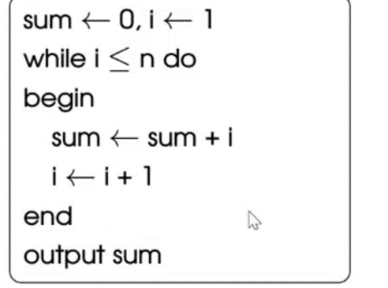
The important operation of summation is the addition
For each 1, there are 2 additions – the sum itself, and the increment
Therefore 2n additions required

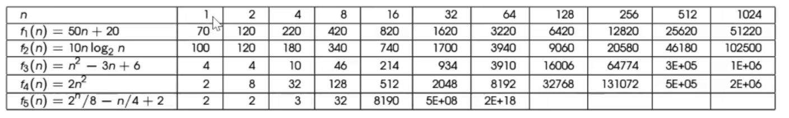
f(n) = number of operations needed for input n
Efficiency changes as the input increases
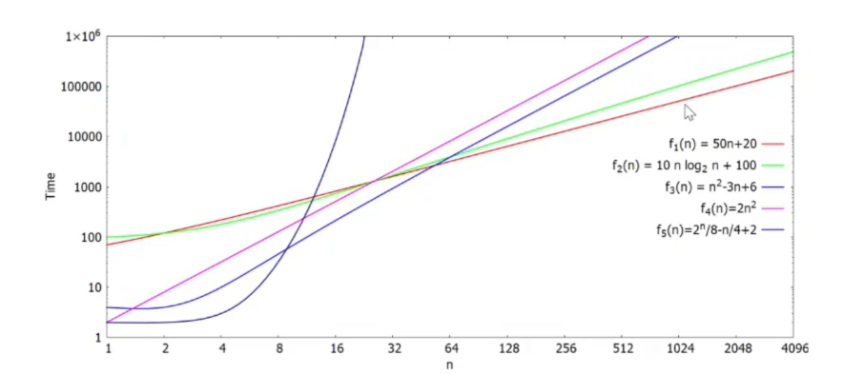

Exponential functions (powers by n): 2n, 3n, 100n
Polynomial functions (powers of n): n2, n3, n
For polynomials, functions with same power of n (e.g. both n2) are more comparable
- N2-3n+6 2) 2n2: function 1 is better

