Module Introduction
Mon/Tues – videos, quiz, ask questions on discussion board (Canvas)
Tues/Wed – 3hr lab slot, don’t have to take full 3 hours. Attend lab, solve programming exercises
Weds – 1 hour, lecture/Q&A, 1pm
Exercises (lab) are worth 10% of the module grade
Can go in labs whenever, but max 200 people allowed simultaneously
Recommend using web-based IDE

3 assignments (75%), lab exercises (10%), final quiz (15%)
Individual assignments, submitted with submit50
Individual feedback sent by email within 3 weeks of submission
Resit (less than 40%) after the term – 2 hour supervised programming session

Programming issues – ask during labs/lectures/Canvas discussion forum
Contact by email, or in Gather office (Wedsnesdays, 2-3pm)

OOP – paradigm (class of languages)
1940s – first universal machine (programmable)
1950s – Compilers and interpreters (rather than punching holes in the machine paper)
Doesn’t have to be written specific for every machine
Structured programming, code blocks (if/for/while).
1960s – Procedural programs. User-definable procedures
Late 60s, 70s – information hiding, separation of concerns
80s – OOP. SIMULA, Smalltalk

Interacting objects contain both data and procedures. Are instances of a whole class of similar objects
Encapsulation: grouping data & code that acts on it into one unit
Abstraction: Hiding implementation details from users
Inheritance: Known object classes can be blueprints of more specific ones
Polymorphism: Different uses of the classes
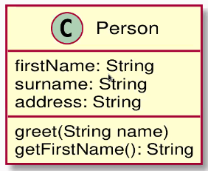
E.g. students & lecturers are people – have a Person class.
Each individual is an instance of the Person class.
Class contains their data –
UML (unified modeling language) class diagram

Student class extends Person class. Person attributes are inherited, but there is also studentID: Integer, and method getStudentID(): Integer (returns an integer)

If there are many instances of a subclass, can be stored as a list of the parent class e.g. studentList
Can use a for loop to iterate through the parent list (e.g. greet every student)

Check for lab slot (starting next week). Go through Canvas course page.
Start reading Week 1 materials

