Numbers and Polynomials
Lecture 1
N: Natural numbers. 0 doesn’t technically count.
W: Whole numbers. Includes 0
Z: Integers
Q: Rational
N W Z Q
All computers use only Q
R: Irrational numbers. E.g.
R modelled by float, double (approximations)

Lecture 2
Solutions to identities: values of x where a function p(x) = 0
Polynomial of degree k in x defined through k+1 coefficients
Functional form of polynomials: cnxn Coefficients: c0, c1, c2, c3, …, ck
Coefficients can be of any type
Coeffs can be limited to finite subsets e.g. Zm = {0, 1, 2, …, m-1}
If H is this set, Hk[X] and H[X] denote set of degree k polynomials with coeff H

A polynomial of degree k has k roots
Roots may not be distinct – can be repeated. Root has multiplicity
Roots may not be real numbers

p(x) has degree m, p(x) has degree n
p(x) + q(x): Add matching coefficients
ap(x): Scalar multiplication. Multiply each coefficient by a
p(x) x q(x): Has degree m + n
p(x)/q(x)

Can find roots of degree 2/3/4 directly using calculus

Q[X] are polynomials with only rational coefficients
The roots of a polynomial in this set don’t have to be in Q
Therefore an irrational number can still have a finite description (since is a root of a polynomial that has a coefficient of finite length i.e. is rational)

Vectors and Vector Operations
Cartesian co-ordinates: Lines from the origin (2-vectors, 3-vectors for 3 axis)
H is a number of a set (N/W/Z/Q/R)
Natural number n N
n-vector over H has n components x = x1, x2, …, xn
Each xk H Not a set: can have xs = xt and s t
Angle brackets: order matters, as is ordered sequence
Arbitrary vectors x y u v w etc
Write vector in full: u1, u2, …, un
For points, use (u1, u2, …, un)
Add, scalar multiply (dot product), length, product of vectors

Given n-vectors: u, v, w etc and constant H
W = u + v wk = uk + vk
W = u wk = uk
Size: or
I.e. Sum of the absolute value of each vector component, squared

Has size and direction
Doesn’t have a position
Operations can be interpreted geometrically
Length of a vector resulting from 2 others can be written in terms of basic trigonometric relations

X+y: tracing both vectors- the resultant vector
Scalar multiplication: Increases the length only (direction unchanged)
Length: Length of ‘hypotenuse’ formed by all the components
Dot product/scalar product: Multiply both x and y components, as well as multiplying the cos
For cos180, multiply by -1
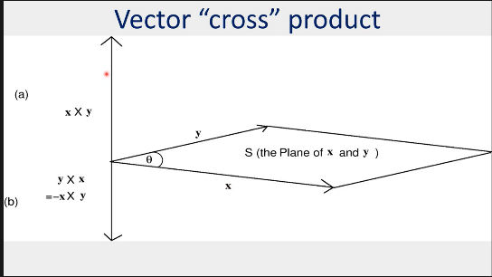
Cross product: x and y form a 4-figure shape. To find product in up direction, x × y. To find down product, y × x = -x × y
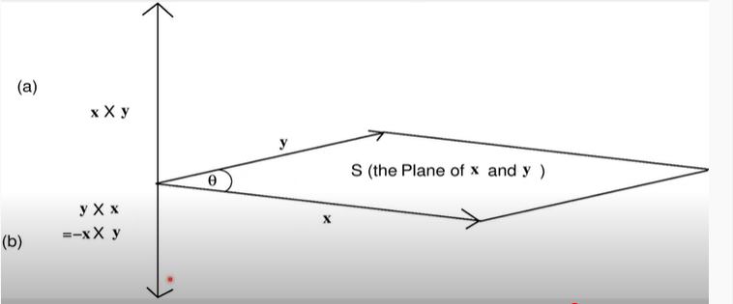

Special n-vectors
Zero vector: 0. All components are 0
Basis vector: ek. All components are 0, except the kth (equals 1). There are n basis vectors – one for each k
Unit vector: Size of 1
Orthogonal vector: u and v with u x v = 0. They are perpendicular

Used for graphic effects
Web page analytics
Multivariable optimization
Data Science
Computational Geometry
Vector Spaces
“Collect together” sets of vectors with “similar characteristics”
H (set of numbers) used to form set of n-vectors
Collection must satisfy algebraic property of being a “field”
“Field” definition is satisfied by Real numbers, and Zm {0, 1, 2, …, m-1} with mod m arithmetic

U – set of n-vectors, using H. E.g. all 2 vectors from R
A vector space must have 2 “closure properties”
- Adding any two vectors in U should give a vector in U
- Multiplying any vector in U by any constant in H must give a vector in U
Formal definition: Given U, a set of n-vectors using H. The set U defines a vector space if

Underlying set, H, is very important
E.g. EVEN = {< x, y> : x + y = 2p and p Z} (vectors where adding the 2 components gives an even integer)
If H = Zk then it is a vector space
If H = R then not a vector space, as not closed under multiplication. E.g. if = , = <> U

Attributes of Vector Spaces
If U is a vector space of n-vectors from R:
Important notion: A basis set, and its dimension
Basis allows reduction of U even if it is infinite to at most n distinct vectors
Done by expressing members of U (vectors) as linear combinations of each other

Linear Combinations
Take a set B of n-vectors from u: B = {t1, t2, …, tm}
Take a collection a of m values; at least 1 is non-zero, all non-zero values are from H
a = <a1, a2, …, am> - one vector
w is a linear combination of B using a if w =

Linear Dependence & Independence
Take a set B of k n-vectors from U: any w in U can be obtained as a linear combination of B

In principle, every vector in U can be described in terms of describing them in B
Only B is needed to capture U
Basis and Dimension
A subset B of U, where any vector in U can be formed as a linear combination of B, is called a basis of U
Dimension of U (dim(U)): size (number of vectors) of the smallest basis of U (the set B)
A vector space U of n-vectors has dim(U) of at most n
Examples
Even = {<x, y> : x + y = 2p and p H}
This is a vector space for H = Z4
If H = Z4, then the vector space Even contains {<0, 0>, <0, 2>, <2, 0>, <2,2>, <1, 1>, <1, 3>, <3, 1>, <3,3>}
Dim(Even) = 2; since B = {<0, 2>, <3,1>}
<0, 2>: Each with itself (<0, 0>, <2, 2>), crossing with each other (<0, 2>, <2, 0>)
<3, 1>: {<3, 3>, <1, 1>}, {<3, 1>, <1, 3>}
<1,1> = 1*<0,2> + 3*<3, 1> = <0, 2> + <9, 3> = <9, 5> = <(9 mod 4), (5 mod 4)> = <1, 1> etc.
2*<0,2> + 3*<3,1> = <0, 4> + <9, 3> = <9, 7> = <1, 3>

R4 = {<u, v, w, z> : u, v, w, z R}; H = R
Dim(R4) = 4; B = {e1, e2, e3, e4} – basis vectors
Dimension can be smaller than the size of the basis set
“Trivial” example of this:
One = {<x,x,x,x> : x R} Dim(one) = 1. B = {<1, 1, 1, 1>}

Summary
Especially important in CS applications for special cases e.g. R2, R3
Used in 2D and 3D graphics

Linear Transformations and their role in Computer Graphics
Used to map between vector spaces
Use a method T to produce v in vector space V from a vector u which is in the vector space U
T : U V
U and V can be the same (identical vector spaces)
E.g. U = V = R2 (containing vectors that are pairs of real numbers)
May also be different vector spaces
E.g. U = R3, V = R2 This could be used to project 3D objects onto 2D displays

Can also be used for graphical effects: scaling, rotation
Would use matrix and vector multiplication for this
Vectors correspond to screen positions (coordinates)

Use matrix multiplication for linear transformation

A (arbitrary matrix) = B (another matrix)
C = A x B =
Sizes of rows and columns may be different
A x B B x A

Formal Definition

T is a linear transformation if
1)
2)

Scaling
To scale by a factor :

Rotation
To rotate anti-clockwise by :

Translation
Move an object at (x, y) to a new position (x+p, y+q)
Not a linear transformation – each component is manipulated differently
Homogenous coordinate systems must be used to implement the translation effect by using matrix-vector products
Change (x, y) to (x, y, 1)

Effect Summary
Scaling and rotation can be done using 2 x 2 matrices
Scaling: Rotation:
Most other effects can be done using 3 x 3 matrices
Translation:

Combining Effects
Use 3x3 matrices – add an extra row & column to the scale/rotate ones
To do St, , M(m,n): multiply them all together

