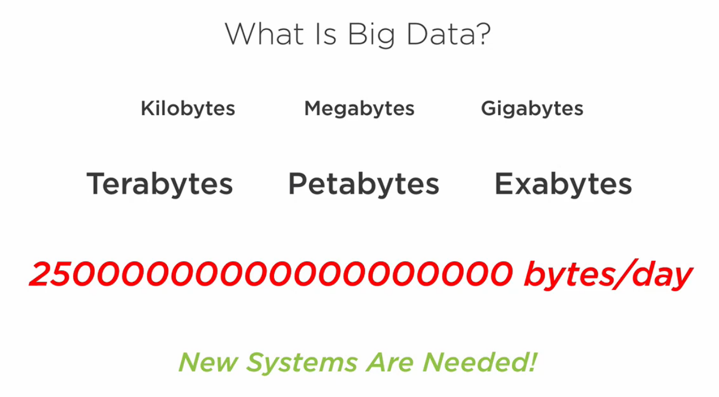

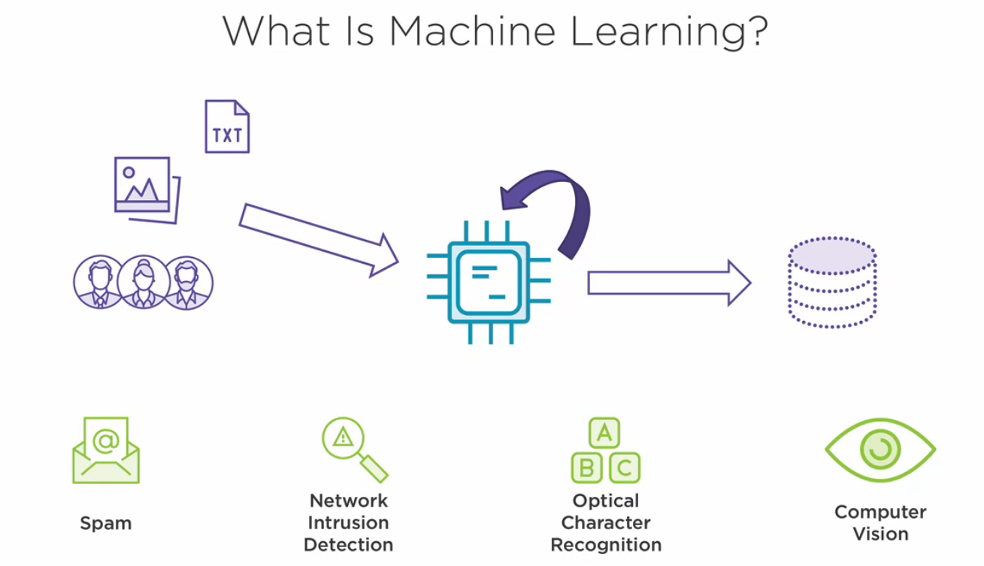
From a 30.000-foot level overview, today we are surrounded by data everywhere. It comes in all forms, shapes, and sizes. It might come from large text files. It might be generated by the actions of our users. It may even be large amounts of metadata available in pictures and videos. The many relationships that might exist between all this data is much more complex than any single person or group of people could find by themselves. So instead, algorithms are written in such a way that a computer can process all the data and find its own connections between the many different sources of data. The algorithm then output its results in a way that can be digested by humans or built in to applications. The real power, though, comes from the fact that it’s very common for these algorithms to feed the results back into themselves, learning how we can analyze the data even better for more accurate results. This is where you may hear the terms guided or directed learning, neural networks, and the like.
This grew out of the field of artificial intelligence and has now found its way into the cracks of many different enterprises. You can see it in determining whether a given piece of email is spam or not. Or you might find it being used for the purpose of network intrusion detection, using the vast amount of network traffic to detect what’s abnormal traffic or not. It’s used for optical character recognition to convert images of text into text data that a computer can understand and process. It’s also used for computer vision problems like face detection, object tracking, and motion tracking. And this is all the tip of the iceberg as well.

