PYTHON
High-level programming language, you won’t have to deal with the low level assembly instructions, machine specific details or other minus things.
Is a language with a dynamic type system. This means that any type checks in the programming language happen at runtime instead of compile time.
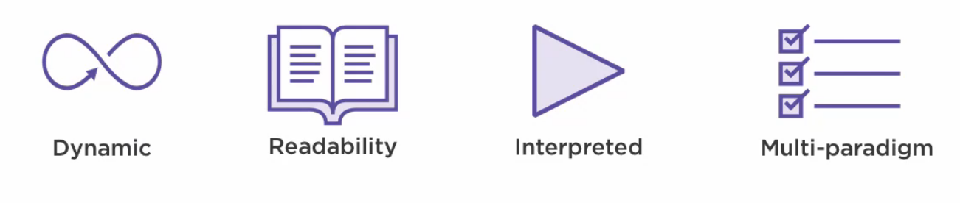

Simple is hard
Distilling a problem down to its core essence and finding a simple solution is incredibly difficult to do.
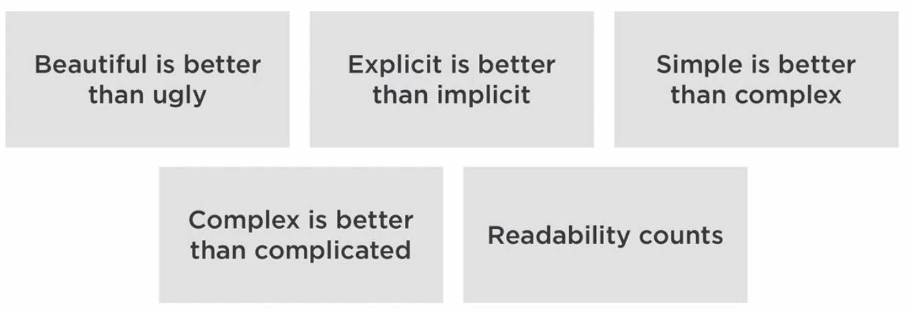

To quote Tony Hoare
“There are two ways to write code; write code so simple there are obviously no bugs in it, or write code so complex that there are no obvious bugs in it. “
We are striving to write code that is so simple there are obviously no bugs in it.

When and where is python being used?

