Video
https://youtube.com/shorts/_LteJliRof0
captura
Interfaz (frontend)
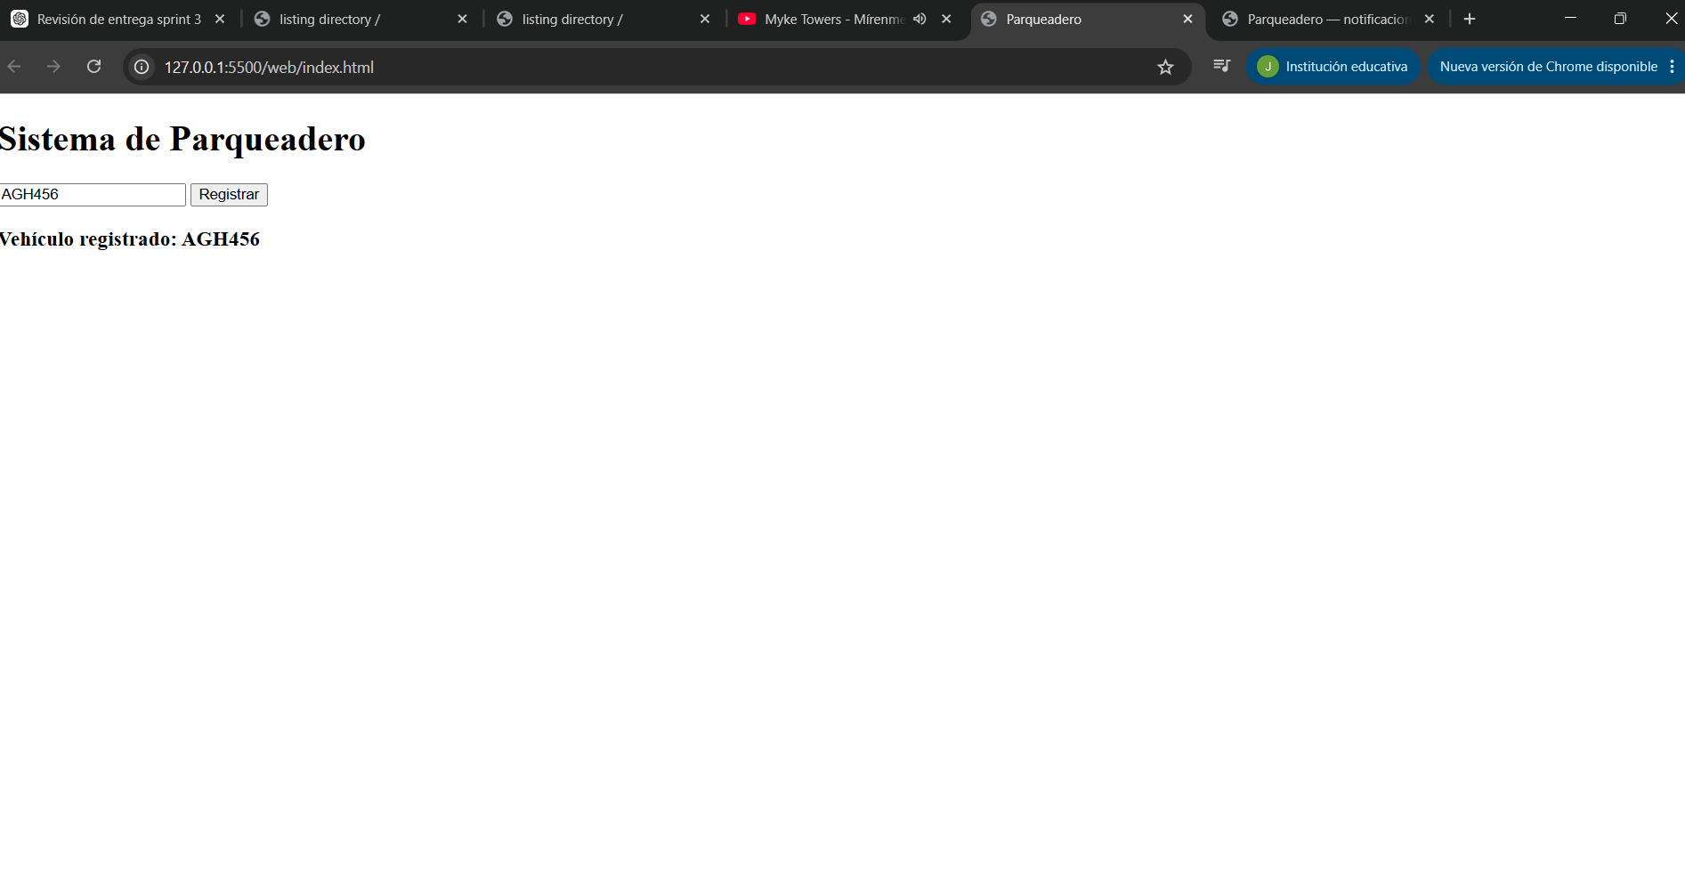
Consola (backend)

