**Interactive Story Editor**

**System Description:**

Interactive storytelling is a form of digital entertainment in which users create or influence a storyline through actions by issuing command or directing the story’s events. It has two parts: story editor and story reader. Story editor is an Android application which lets user create an interactive story for children’s use. Story reader is a mobile application that let’s children read and interact with the environment using NFC tags, QR codes, GPS and other media to advance through the chapters of the interactive stories.

**Tools (Framework):**

* Reader: Cordova
  + APIs:
    - NFC: phonegap-nfc
    - QR code scanner: BarcodeScannerPlugin
    - QR code generator: Google Chart API
    - Database: Cordova/PhoneGap SQLitePlugin
* Editor: Native Android

**Tablet Application - Story editor**

**Functional Requirements**

* Application should be able to send the story from editor to reader (format: JSON; share method: to be decided).
* Application should be implemented for smartphones running Android OS
* Application should be able to integrate NFC tags in the story
  + Write the NFC tag
* Application should be able to integrate QR codes in the story
* Application should let the user tag geolocation in the story
* Application should be able to offer a quiz interaction after a chapter
* Application should be able to offer a spell check interaction after a chapter
* Application should be able to let user add media resource in the story (video, audio, images, text)

**Smartphone Reader - Interactive story**

**Functional Requirements:**

* Application should be implemented using Apache Cordova
* Application should be OS independent and run on smartphone with Android, WP and iOS
* Application should have NFC interaction
* Write NFC tag
* Teacher version
* Application should have QR code interaction
* Application should be able to detect geolocation of the device (possibly GPS)
* Application should have geolocation interaction
* Application should have spell check interaction
* Application should have quiz interaction
* Application should have support of video, images, audio and text on each chapter
* Application should have linear storyline (one beginning, one end)
* Logs of data when children read a story
  + Software events
    - Start story
    - Interaction success
    - Interaction fail
    - Errors
  + Local DB and upload at request by user
* In order to proceed to the next chapter of the story, the application should require some interaction

**Future work:**

* Application could have non-linear storyline (one beginning, several ends)
* Application should require user-authorisation (sign up and login)
* There could exist an online stories’ database
* Smartphone application could download the desired story from the database
* Smartphone Application could have text recognition and image recognition implemented (Take picture interaction)
* Smartphone Application could allow audio recording as a type of interaction
* Interactions could be selected randomly for each chapter (multiple interactions)
* Story editor could have editing options such as change font or font size, themes, etc.
* NFC interaction to send story from editor to reader

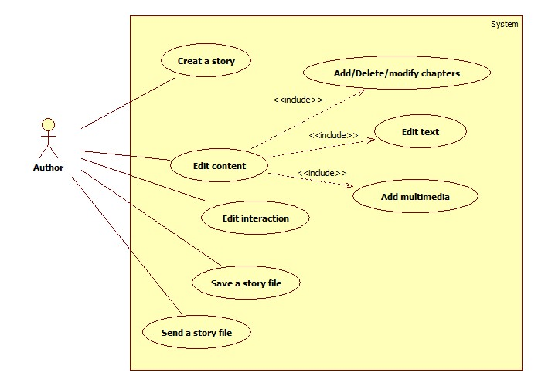

Figure 1. Use Case Diagram_Editor

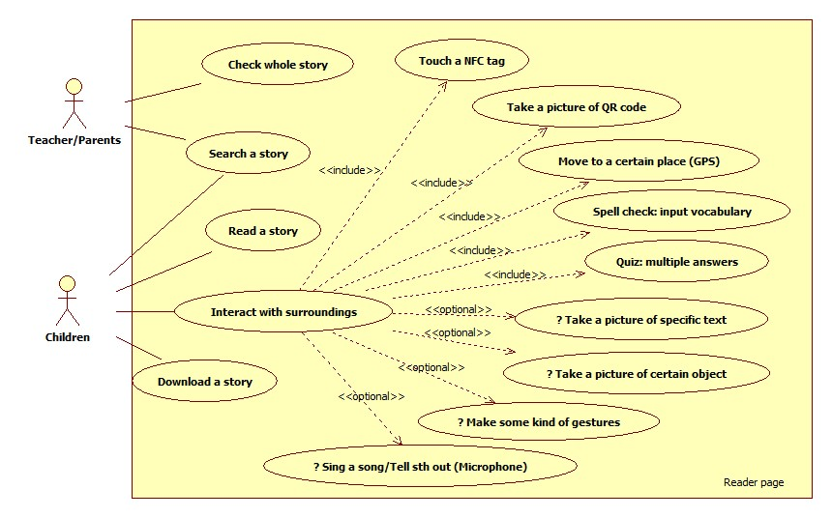

Figure 2. User Case Diagram_Reader

