**Requirements**

**Functional requirements**

The printer must receive a request to print a document, count pages of the document, check if there is paper and ink, take blank sheets of paper, print the document, and give it back. The printer should display its current state: ready to print, out of paper, out of ink, in progress.

**Non-functional requirements**

The print speed must be at least 20 sheets per min.

Printing resolution 300 DPI.

Printer memory RAM 64Mb.

The printer:

- can receive 1 request at a time. Until the request is finished other requests are declined.

- supports document types: doc, docx.

- supports black and white print only.

- supports A4 format only.

- must recover after stopping (out of paper, ink) to the current state (remember the page and continue printing starting from it).

- supports horizontal and vertical page orientation.

**Use Cases**

**Use Case:** Print document

**Actors:** User, Serviceman

**Precondition:** the printer is connected to any device that sends the request to print a document

**Trigger:** The user sends the request to the printer to print a document via any device.

**Main success scenario**

1. The printer receives the request, checks the format of the document and page orientation, counts pages.
2. The printer checks its status (paper and ink are in)
3. The printer prints the document sheet by sheet until the whole document is printed.
4. The user takes back the printed document.

**Alternative flows of events**

* 1. The printer doesn’t recognize the document format: the printer sends the message “Unsupported format”.
  2. The printer is occupied by another request: the printer sends the message “Is in use”.

2.1 There is no ink or paper: the printer sends the message “Ink tank is empty” or “Out of paper”.

* 1. The serviceman fills the ink tank or adds the paper.
  2. The printer runs out of ink or paper during printing the document: the printer sends the message “Ink tank is empty” or “Out of paper”.
  3. The serviceman fills the ink tank or adds the paper.
  4. The printer continues printing from the page where he stopped.

**CRC cards**

|  |  |
| --- | --- |
| **Printer** | |
| Prints the document and decreases resources (ink, paper, number of pages) | Status  Resources  Document |

|  |  |
| --- | --- |
| **Status** | |
| **Set of possible statuses** |  |

|  |  |
| --- | --- |
| **Document** | |
| **Contains info of a document (number of pages, format, orientation)** |  |

|  |  |
| --- | --- |
| **Resources** | |
| **Add or reduce resources (ink and paper)** |  |

**UML class diagram**

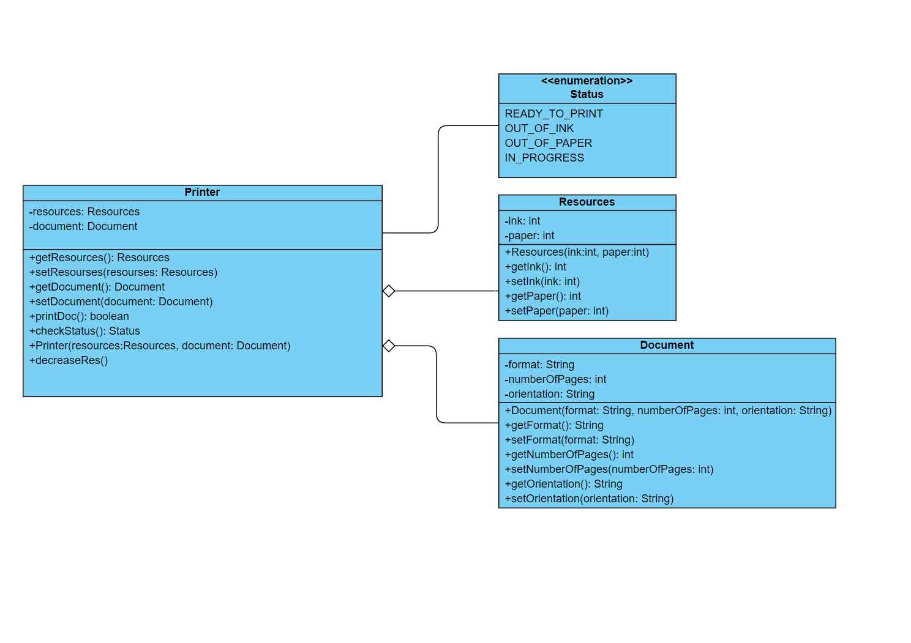

GitHub project:

https://gitlab.com/epam_java_course_ag/printingapp.git