# Public printer at University

## Functional requirements

1. Print
2. The system must connect to other systems (perform remote or shared print)
3. The system must charge for printing
4. Notify the printing is done
5. Allow for queuing jobs
6. Notify when out of paper/ink (running low)

## Non-functional requirements

1. Available 24/7
2. Daily off time for maintenance

## Use cases

**TITLE:** Print File

**ACTOR:** Student

**SCENARIO:** The student arrives at the printer kiosk and sends the file to be printed to the printer, which then proceeds with the task of printing.

The student takes the printed package with him.

**TITLE:** Printing kiosk

**ACTOR:** Kiosk

**SCENARIO:** The printing kiosk is composed of several printers to which the students have access for printing. To do so, they can go with their computer, thumb drive or other media options and print their file. They can also send the file and will be notified when to pick up their printer file.

The kiosk can be out of order completely or only a part of it due to maintenance or resupplying ink or paper.

**TITLE:** Print File

**ACTOR:** Student

**SCENARIO:** The student arrives at the printer kiosk and sends the file to be printed to the printer, which then proceeds with the task of printing.

The student takes the printed package with him.

**TITLE:** Print File

**ACTOR:** Student

**SCENARIO:** The student arrives at the printer kiosk and sends the file to be printed to the printer, which then proceeds with the task of printing.

The student takes the printed package with him.

**TITLE:** Print File

**ACTOR:** Student

**SCENARIO:** The student arrives at the printer kiosk and sends the file to be printed to the printer, which then proceeds with the task of printing.

The student takes the printed package with him.

**TITLE:** Charge for print

**ACTOR:** Administrator/System

**SCENARIO:** System/Administrator charges a fee for the use of the printer

**TITLE:** Done Printing

**ACTOR:** Administrator/System

**SCENARIO:** When the printing is done, a message is sent to notify the task has been finished.

**TITLE:** Remote print

**ACTOR:** Student

**SCENARIO:** Through a central system it is possible to queue print jobs remotely and pick up the package after it’s done.

**TITLE:** Maintenance

**ACTOR:** Administrator

**SCENARIO:** Schedule offline time that is necessary to ensure the proper working of the printers, such as greasing moving parts, change ink, clear paper jams, etc.

**TITLE:** Out of supplies

**ACTOR:** Administrator/System

**SCENARIO:** If the printer runs out of ink or paper, generate an alert so the system can be replenished and continue working

**TITLE:** Out of order

**ACTOR:** Administrator/System

**SCENARIO:** The system or administrator notifies users that the printer is out of order due to maintenance or lack of supplies

**TITLE:** Student verification

**ACTOR:** Kiosk / System

**SCENARIO:** As a printing service for students, the system or administrator must verify the user is in fact a student

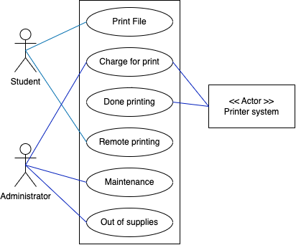

## Objects

* Kiosk
* Students
* Printers
* File to print
* Money (fee)
* Messages
* Paper
* Ink

## Relationships

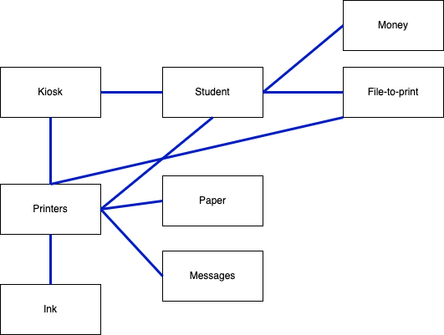

## Class Diagram

