**COFFEE VENDING MACHINE APPLICATION**

**FUNCTIONAL REQUIREMENTS**

**Selection of type of coffee:** The consumer must be able to select the type of coffee.

**Select coffee version:** The consumer can choose a coffee version (cappuccino, latte, mocha, tinto).

**Add sugar**: The consumer must be able to add different amounts of sugar to their coffee.

**Size selection:** The consumer must be able to select the size of the coffee cup.

**Cancel operation:** The consumer must be able to cancel the process.

**Payment:** the application must accept payments by card or cash.

**Payment validation:** The application must validate if the payment was accepted or rejected and return consumer cash in case of cancellation or that the user has entered a value higher than the price of the coffee.

**Create an inventory:** The administrator should be able to create initial inventory.

**Update prices:** The administrator should be able to modify the prices of any ingredient.

**Update Available Quantity:** The admin should be able to modify the available quantity of an ingredient.

**Inform availability:** The application should inform the consumer when an ingredient is not enough to add to their coffee.

**Discount from stock:** The application should reduce the amount of an ingredient available when a coffee is brewed.

**Send alert:** The application should send an alert to the administrator when the level of an ingredient is lower than the alert measure.

**NON-FUNCTIONAL REQUIREMENTS**

Usability: The application must be easily usable by people of all ages.

Accessibility: the application must be usable from different devices.

Scalability: The application must be able to handle a high number of users without problems.

**USE CASES**

***Use case 1: Selection of coffee preferences.***

**Actors:** User

**Preconditions:**None.

***main flow:***

* The application shows the user the available coffee type options (caffeinated or decaffeinated) and the user selects a type of coffee.
* The application displays different versions of coffee for the consumer to choose from (capuchino, latte…) and the user chooses a version or cancels the process.
* The application allows the consumer to order the amount of sugar they want and the user adds the quantity that they prefer or cancels the process.
* The application shows the user the available cup size options and the user selects the desired size or cancels the process.
* The application calculates and displays the price of coffee according to the consumer's choice.

***Alternative flows:***

* If there is not enough of an ingredient, the system informs the user.

***Use case 2: Payment with card***

**Actors:** User

**Preconditions:** The user has selected their coffee preferences.

***main flow:***

* The user passes the card through the reader, the bank validates the process and the application displays the response to the consumer.
* The application validates the payment and, if accepted, dispenses the selected coffee to the user.

***Alternative flows:***

* If the payment is declined, the application shows the user an error message and asks them to enter a valid card or select another payment method.

***Use case 3: Payment with cash***

**Actors:** User

**Preconditions:** The user has selected their coffee preferences.

***main flow:***

* The user enters the amount of cash into the machine.
* The application detects the amount of money entered and, if accepted, dispenses the selected coffee to the user and if the user has entered a higher value, it returns the rest.

***Alternative flows:***

* if the user enters less money than necessary, the machine asks him to enter the rest of the money or cancel the process.
* if the user cancels the purchase, the machine returns the money.

***Use case 4: Cancel the process.***

**Actors:** User

**Preconditions:** The user has started some coffee option /has entered less cash than the cost of the coffee.

***main flow:***

* If the user is selecting their preferences and cancels the process, the system reboots.
* If the user enters less cash than the cost of the coffee and later decides to cancel the purchase, the system returns the money entered.

***Use case 5: Manage the inventory.***

**Actors:** Administrator, system.

**Preconditions:** none.

***main flow:***

* The administrator creates the initial inventory.
* The system discounts quantities of each ingredient with each coffee preparation.
* The system sends an alert to the administrator when an ingredient reaches a limit.
* The system informs a consumer when there is not enough quantity of a certain ingredient to prepare their coffee.
* The administrator updates the available quantity of the ingredients when they do a refill.

**USE CASES DIAGRAM**

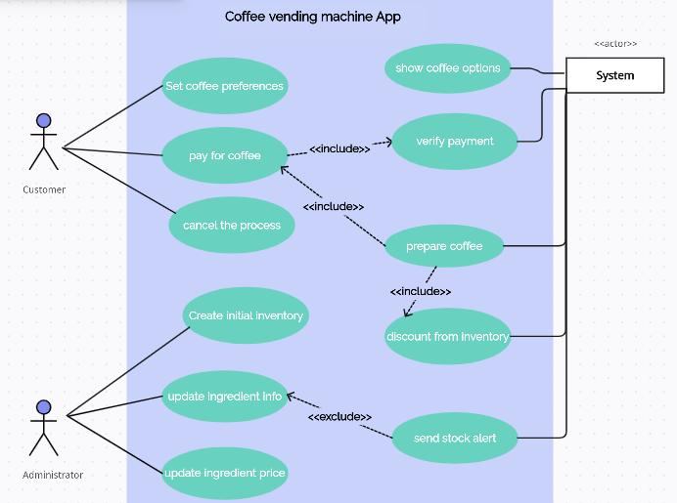

**UML DESIGN**

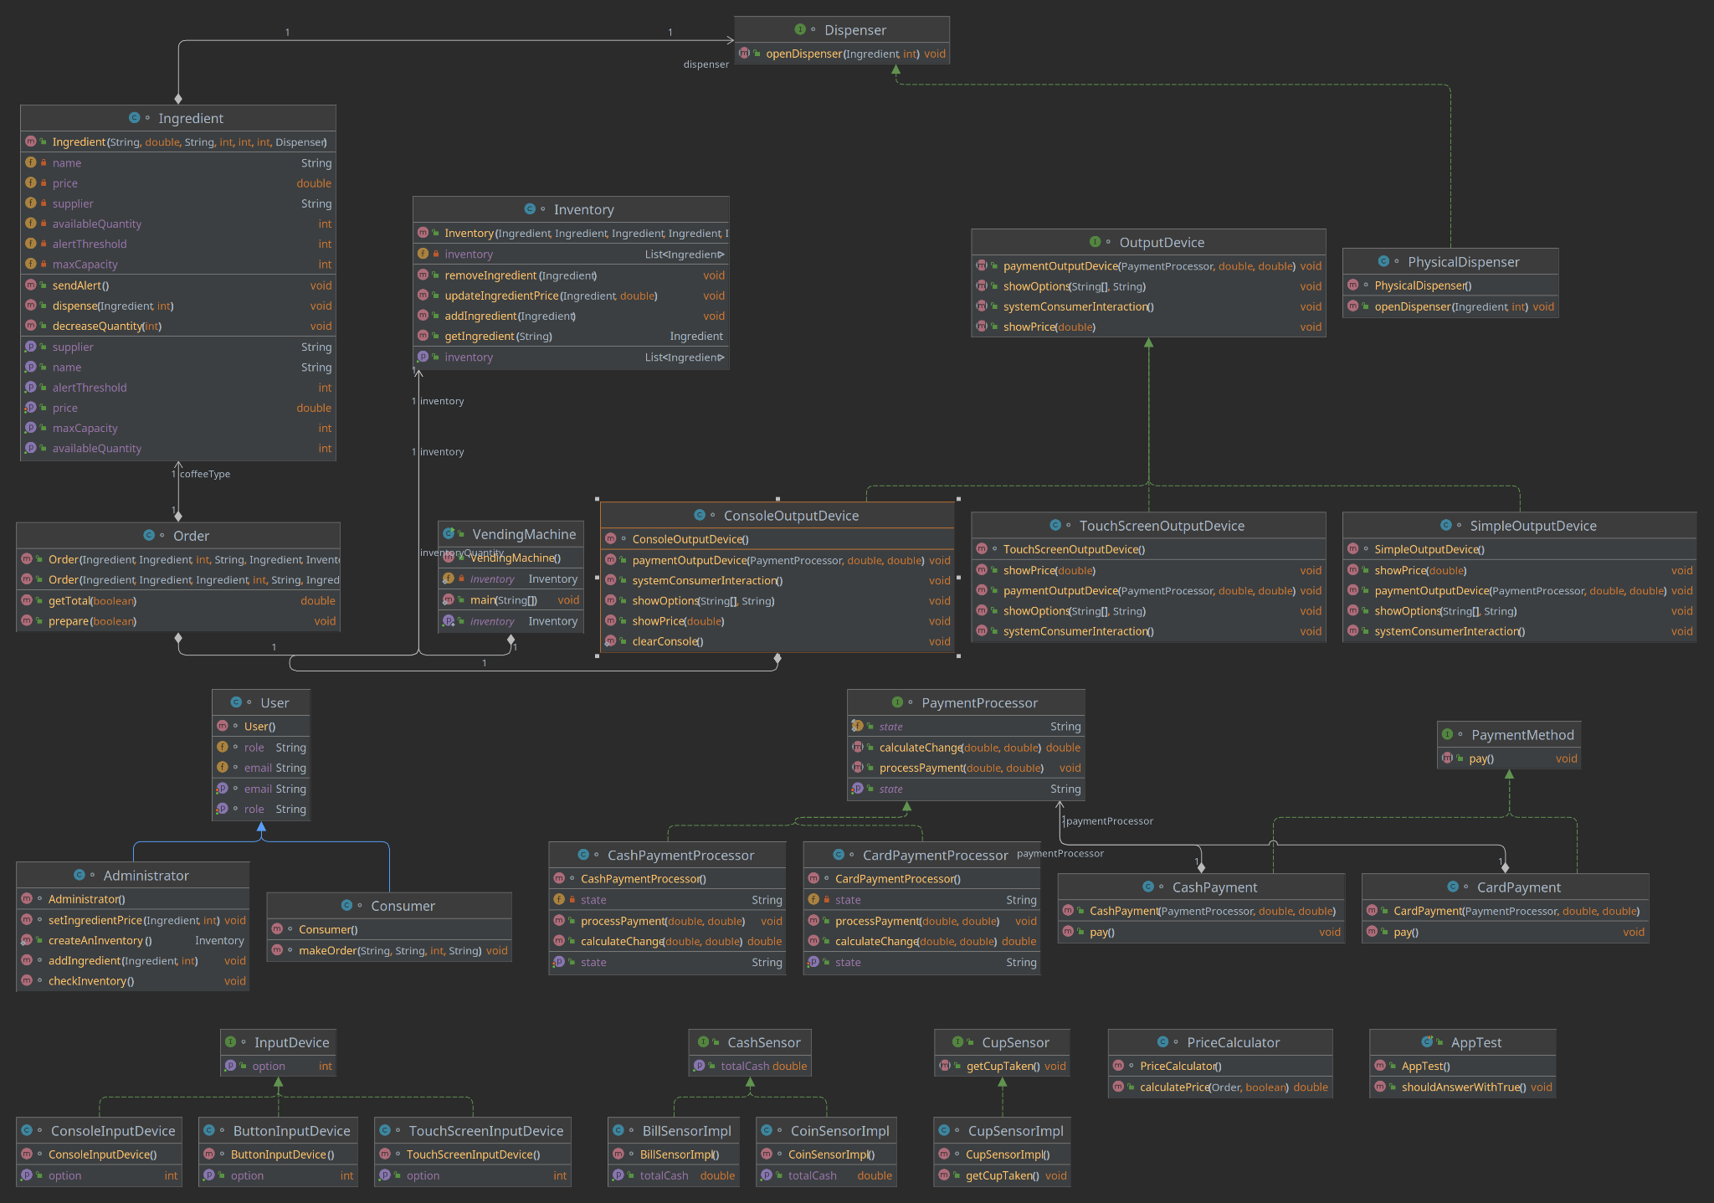

REPOSITORY

https://github.dev/kaviur/coffee-vending-machine