JUAN CARLO A. ORETO

SBIT 2H

LAB ACT 1

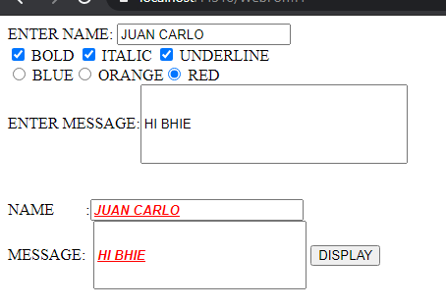

**SOURCE CODE**

Public Class WebForm1

Inherits System.Web.UI.Page

Protected Sub Page_Load(ByVal sender As Object, ByVal e As System.EventArgs) Handles Me.Load

End Sub

Protected Sub CheckBox1_CheckedChanged(sender As Object, e As EventArgs)

End Sub

Sub Button1_Click(sender As Object, e As EventArgs) Handles Button1.Click

Dim name As String

Dim msg As String

name = TextBox3.Text

msg = TextBox4.Text

If (CHECKBOX1.Checked = True) Then

TextBox4.Font.Bold = True

TextBox3.Font.Bold = True

TextBox3.Text = TextBox1.Text

TextBox4.Text = TextBox2.Text

End If

If (CHECKBOX2.Checked = True) Then

TextBox4.Font.Italic = True

TextBox3.Font.Italic = True

TextBox3.Text = TextBox1.Text

TextBox4.Text = TextBox2.Text

End If

If (CHECKBOX3.Checked = True) Then

TextBox4.Font.Underline = True

TextBox3.Font.Underline = True

TextBox3.Text = TextBox1.Text

TextBox4.Text = TextBox2.Text

End If

If (RadioButton1.Checked = True) Then

TextBox4.ForeColor = System.Drawing.Color.Blue

TextBox3.ForeColor = System.Drawing.Color.Blue

TextBox3.Text = TextBox1.Text

TextBox4.Text = TextBox2.Text

End If

If (RadioButton2.Checked = True) Then

TextBox4.ForeColor = System.Drawing.Color.Orange

TextBox3.ForeColor = System.Drawing.Color.Orange

TextBox3.Text = TextBox1.Text

TextBox4.Text = TextBox2.Text

End If

If (RadioButton3.Checked = True) Then

TextBox4.ForeColor = System.Drawing.Color.Red

TextBox3.ForeColor = System.Drawing.Color.Red

TextBox3.Text = TextBox1.Text

TextBox4.Text = TextBox2.Text

End If

End Sub

End Class