JUAN CARLO A. ORETO

SBIT 2H

LAB ACT 2

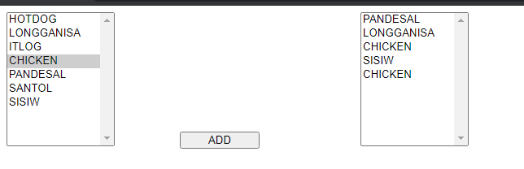

**CODE**

Public Class WebForm1

Inherits System.Web.UI.Page

Dim additem As String

Protected Sub Button1_Click(sender As Object, e As EventArgs) Handles Button1.Click

additem = ListBox1.SelectedValue.ToString()

ListBox2.Items.Add(additem)

End Sub

End Class