Study of BCG-subtracted images of nearby clusters
Juan Manuel Espejo Salcedo
Professor Henk Hoekstra
hoekstra@strw.leidenuniv.nl

Feview website and documentation of GALFIT
read about SEXtractor in astrometic.net

- it’s difficult to see how much the faint stars contribute to the mass of the system. We only see the new bright ones.

Read about IMF and gravitational lensing

- MNRAS: 2015, 45471
2014, 44369 (Russel Smith)
2013, 4341964 (Smith and Luci, strong lensing)
Hoekstra et. al. 2013
- IMF: (# of stars) / (unit mass)

- Normalize to better understand fraction of stars in a given mass range

- What is “heavy weight” IMF?

- The lens equation:

- beta = x – alpha(x)

- beta is true position, x is observed position, and alpha(x) is the deflection angle

- You get multiple solutions for x, that means that you get multiple images

- Smith, Lucey: Index data?

- Typical IMF’s: Kroupa, Chabrier, Salpeter and heavyweight
- We will work with ellipticals, BCGs!
- To get the lensing mass let’s use the simple technique of the single isothermal sphere
- the density is: rho = sigma

- Bending and Fourier modes:
F2) 0. 0. 1 1 # Fourier mode m=2
B1) 0. 1 # Shear term

GALFIT procedures report (22/02/2017)

Given the lack of improvement in the fitting of the galaxy profiles (too much noise around the BCG), I conducted some experiments to see what gave the best results focusing on the best data we have and applying the optimal fitting in every case.

After some filtering, there are 30 clusters left from which only ten are interesting candidates and should be studied case by case in detail. The clusters are:

A1033 | A1651 | A2065 | A2597 | A754
A1068 | A1795 | A2069 | A2627 | A763
A1132 | A2029 | A2142 | A2703 | A795
A119 | A2050 | A2319 | A399 | A85
A1413 | A2055 | A2420 | A553 | A961
A1650 | A2064 | A2440 | A655 | A990

In red, the chosen clusters that have (or may have) interesting features

Let’s take the case of the cluster A1068:

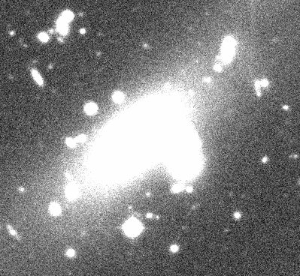

The first experiment is the fitting of a normal Sersic’s profile with index 4.26 for the two bright galaxies without masking the central region of the BCG but fixing the position that GALFIT had found in a previous fit.

The resulting residual image is:

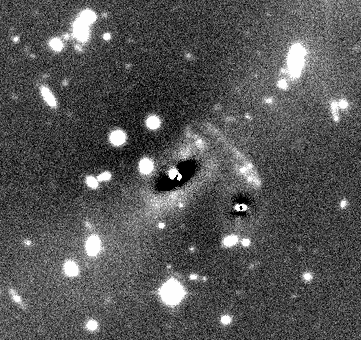
The second experiment consists of masking the very inner region of the BGC in order to let GALFIT put more weight on the outer parts of the fitting thus allowing for a better signal to noise ratio in the relevant regions. The size of the central region I decided to exclude was 1 arcsec because that’s the seeing of the observation, but I also made several experiments varying this value and the best results where given precisely by the 1 arcsec.

The segmentation image that GALFIT will use as a mask file now includes that central region and looks like this:

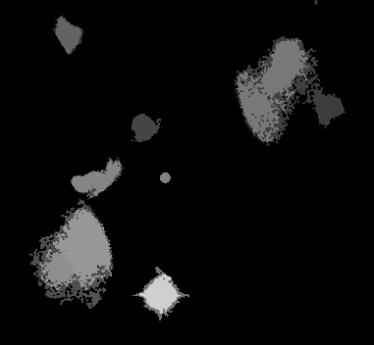

Then, I ran GALFIT again, and the residual image is:

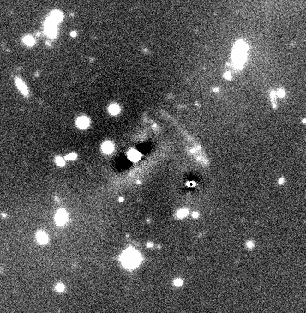
The signal to noise ratio is now better, and region surrounding the very center of the BCG shows more information than before.

Now, there is a strong feature in the low part of the BCG that might hide some information so I tried using different Fourier modes and also the “banana term” which allows the user to fit bending modes in galaxies.

The input in the configuration file for GALFIT now includes:

F2) 0. 0. 1 1 # Fourier mode m=2
B1) 0. 1 # Shear term

Where I varied the Fourier modes and the bending modes and the above where the best parameters, the result is:

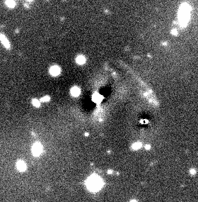

The residual image shows that there is not any significant improvement and actually the Fourier modes just put more noise in some parts of the BCG which we completely want to avoid.

Another conducted experiment consisted of manually masking some regions in the original image and then fit the BCG with GALFIT, to see if there were any improvements, the result was:

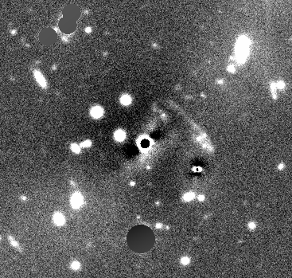

As we can see, masking completely those regions doesn’t seem to affect significantly the fitting neither positively nor negatively. The signal to noise ratio inside the Einstein ring didn’t change and since this is not the right approach, the experiment was neglected.

The best result is this:
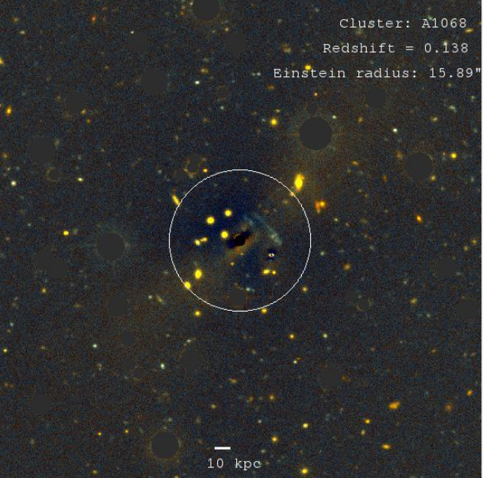
where the most relevant region is:

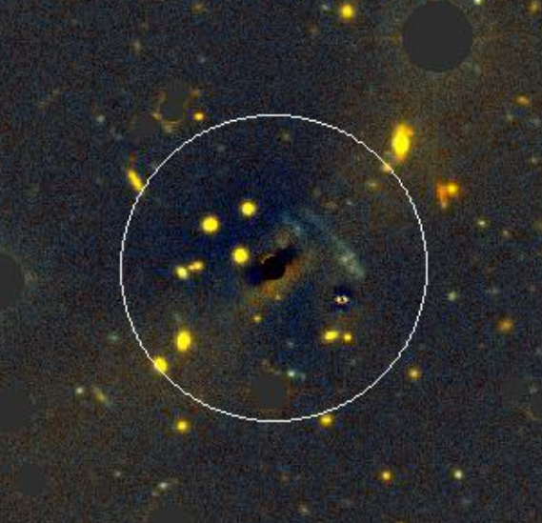
In comparison with the previous fit (two weeks ago):

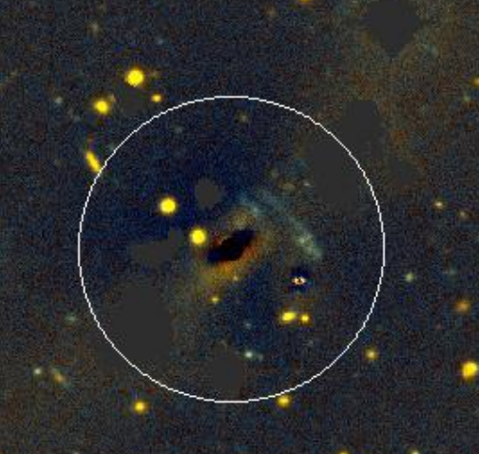
Although the improvement is not as optimal as desired, the fitting is better and excluding only the bright objects outside the Einstein ring allows for a better insight into the data.

The color magnitude diagram has been made so that it differenciates between stars and galaxies.

This was made by taking into account three parameters in the configuration file of sextractor:

flux_radius, class_star and FWHM_image

The criteria used to differenciate between stars and galaxies where the following:

class_stars gives a value close to 1 if the object is a star according to the “Neural-Network-based star/galaxy classifier” or 0 if the object is a galaxy. So I filtered out the big values of this parameter to discriminate.

FWHM_image: If the FWHM of the object is small, it means that the object is a point source so it must be a star, then I used the big values for galxies and small values for stars.

Flux_radius, or Fraction-of-light radii, is big for galaxies and small for stars so I also used this parameter to discriminate between them.

At the end, the different restrictions given by these parameters allows me to have the color magnitude diagram for the clusters in an area of 4000 x 4000 pixels. The color-mag diagram of A1068 is:

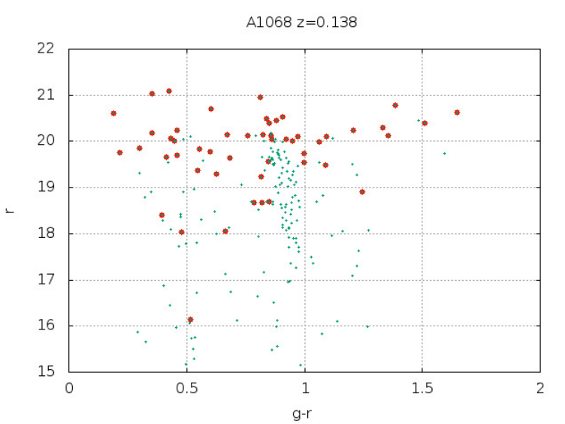
where the red points are the galaxies and the rest are stars.

These sets of experiments were made for the 10 relevant galaxy clusters and for the other 20 I used the general procedure that gave the best results which consisted in masking the very center of the BCG and fitting a Sersic’s profile with index ~4

As another example of how these procedures helped improve a little bit the fit, let’s see A119:

BEFORE:

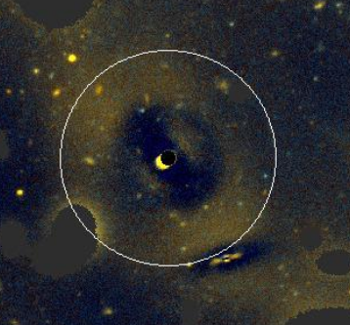

And AFTER:

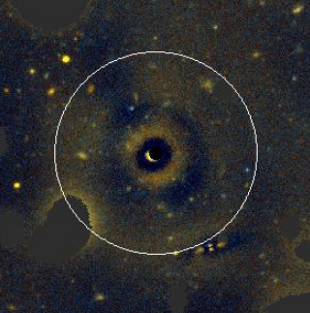

And it’s corresponding color magnitude diagram:

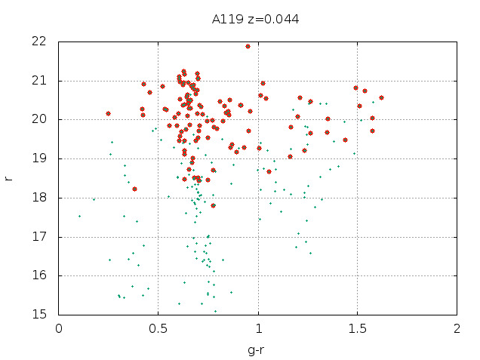

- Low redshift – is more blueish
- make the Magnitude vs flux_radius plot and differenciate between stars and galaxies
- shear14/hoekstra/MENEACS/INT
- fix_images
- Markermeer – shear14
- I and U bands
- Ls u_?.fits > u.list
- NFW profile (good for the introduction of the Thesis) we want to see what fraction od dark matter there is in the BCG, we expect a small fraction since the BCG is dominated by the stellar content. Dark matter to stellar ratio (we want to determine it)
- To run the fix_.py file use: # python fix...py abell1068.fits #
- INT used different exposures to get the data, so it is necessary to combine the images and create a mosaic iamge which contains the header information, this can be done using SWARP.
- SWARP is a program that resamples and co-adds together FITS images using arbitrary astrometric projection defined in the WCS standard.
- To use SWARP from the terminal do: # swarp -c cfltstsawrp list #
- the result is called coads.fits which is a 10000 x 10000 pixels image.
- /net/markermeer/data2/hoekstra/MENEACS/INT

