|  |
| --- |
| College LaSalle |
| Project - Internet Programming User Manual |
|  |
| Presented to: Mihai Maftei |

|  |
| --- |
| Author:….  00/00/2021 |

Describe your application by using print-screen images and a short description (use simple words) to describe what happens (the functionality of…) with each page/button/link/field of your web site.



**Example:**

1. Enter your Username and Password in order to enter to my web site. (**FName@proj.ca**, **pass123**)
2. Click on one of the links to have access to different applications.
3. the user must be an email
4. you can click on create your profile to go to the registration page

**Enter personal information :**

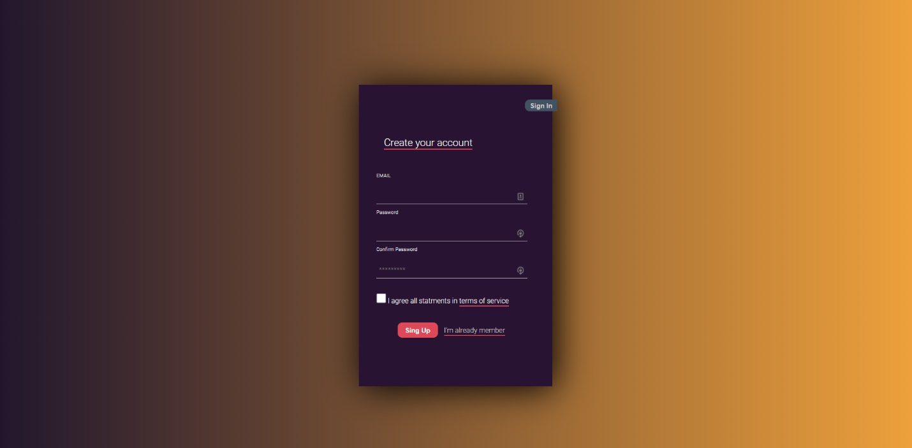

1. to create a user you must use an email
2. When creating the password it must have at least 8 characters
3. You must confirm the password, the system will verify if they are the same and will guide you to the menu after registering
4. You can return to the login page by clicking on login

**see our value proposition :**

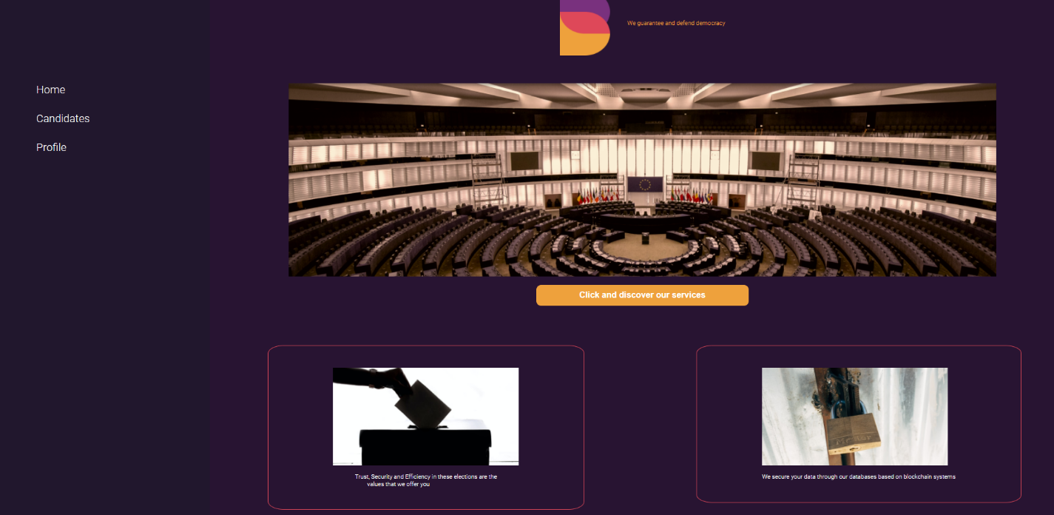

1. If you are interested in knowing our service offer you can click on the button

**find your candidate and their proposals:**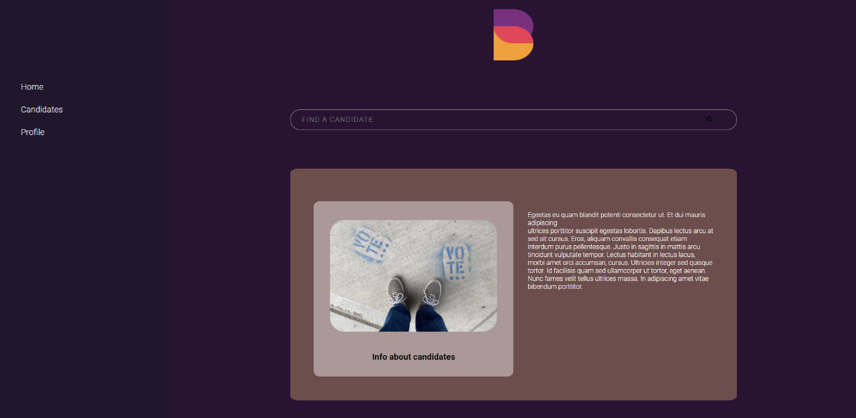

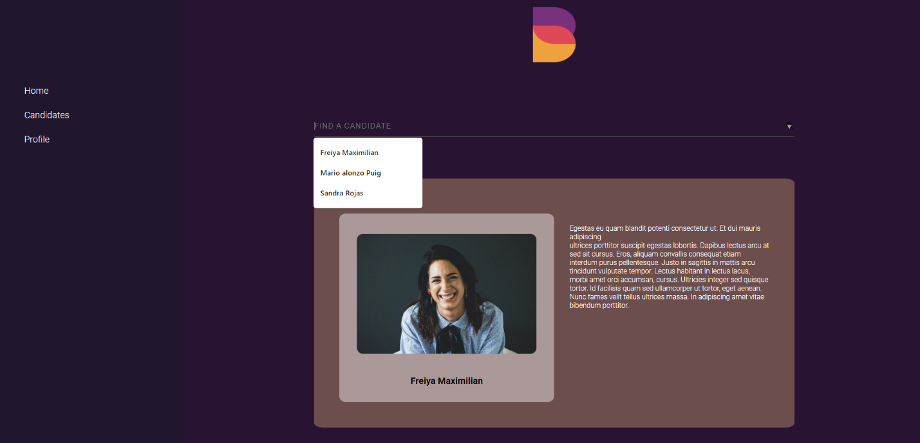

Just by typing the name of your candidate you will find all the information about him on the screen, this platform is very intuitive and easy to use.

**Map Of united states**

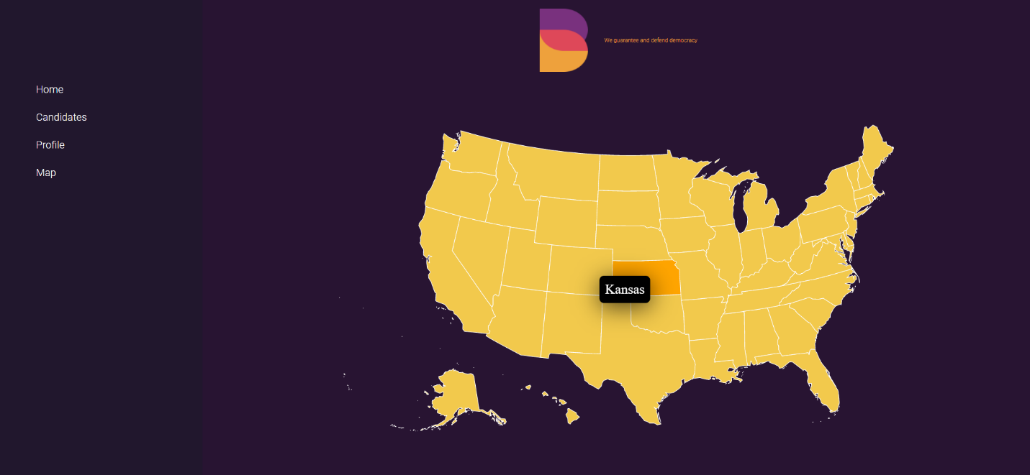

In this section you can find an interactive map where you can see the voting results just by clicking on each state.