Alencar Tecnologia da Amazônia LTDA  
CNPJ: 45.845.459/0001-24   
CONTACT: macalencar@gmail.com  
MANAUS, AM – BRAZIL



Datasheet project PC20230001 - Version: 2.0 – Release Date: 12/2023

|  |  |
| --- | --- |
| DESCRIPTION  This hardware is a modularized development board focused on monitoring environmental variables and sound recording. Its modular design allows for custom assembly of components based on the specific requirements of your application. The device is designed to streamline the non-industrialized production process through the soldering of prefabricated components.  FEATURES   * ESP32 WROOM (BLE v4.0 & Wifi 802.11 b/g) * Embedded RTC * Micro SD Card Slot * I2C and I2S pads sensors * LDR 5mm (ADC) * RGB Led * Power Regulator: 6.5V to 3.3V * Exposed UART Serial Pins * Switch On/Off * Reset Button * Firmware Burn Button (or as regular button) * 5mm holes for board support. * Sensors isolated on the bottom surface for safe exposure for data collection. * USB-C Connector   APPLICATIONS   * Monitoring remote areas with data storage on a memory card. * Monitoring structured environments with real-time data transmission via WiFi. * Propagation of data via Bluetooth Low Energy for proximity-based applications.   POWER COMSUMPTION  **Power Supply:**   * APK2112: 2.8V ~ 6.5V @ 800A - 3.3V @ 600mA   **Operation mode:**   * Reading Sensors: 50mA * SD Writing: 70mA * Deepsleep: 15mA * Waking up: 100mA * BLE: 170mA (RX) ~ 200mA (TX) * WIFI: 170mA (RX) ~ 260mA (TX)   Consumption Estimation (*for the following setup):   * Routine: 1 min recording, 5 min sleeping. * Cycle: Sleep (5min), Wakeup (2s), Record (1min), Writing (2s) * Repeat the cycle for 1 hour (~ 10 cycles / hour) * Estimation: 30mAh (3.3V - 0.15 Wh) | BOARD LAYOUT  TOP VIEW BOTTOM VIEW  Interface gráfica do usuário, Diagrama  Descrição gerada automaticamente Diagrama  Descrição gerada automaticamente  BOARD DIMENSIONS  TOP VIEW  Diagrama, Esquemático  Descrição gerada automaticamente  BOTTOM VIEW  Diagrama  Descrição gerada automaticamente |

APPENDIX I – SCHEMATIC

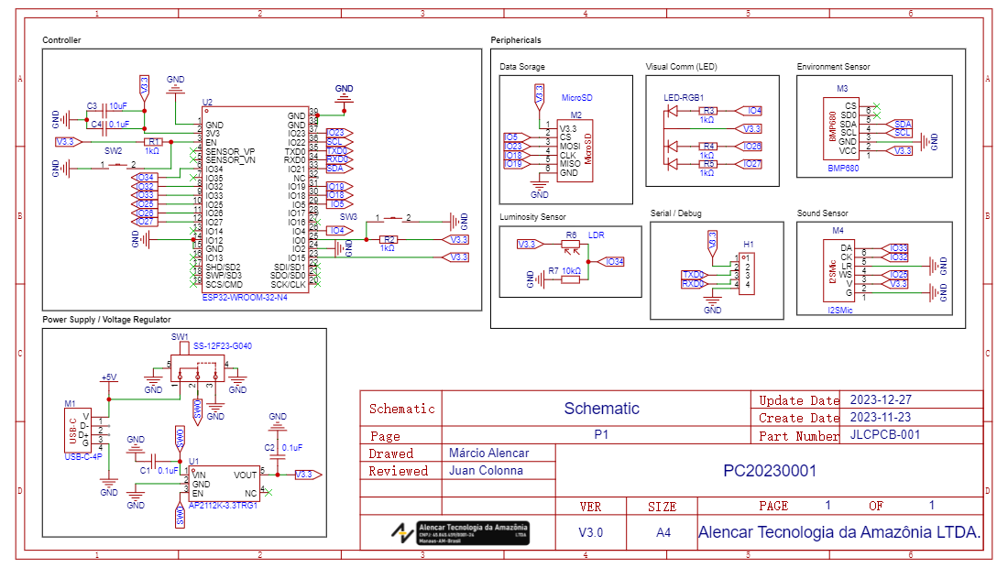

APPENDIX II – TABLE OF COMPONENTS

|  |  |  |  |  |
| --- | --- | --- | --- | --- |
| **#** | **SCHEMATIC DESIGNATOR** | **ITEM DESCRIPTION** | **ALIEXPRESS** | **REFERENCE IMAGE** |
| **1** | **SW1** | SS-12F23-G040 | [Link](https://pt.aliexpress.com/item/1005004402594340.html?spm=a2g0o.productlist.main.19.606b63c3kdU7wA&algo_pvid=b8ffe21e-5b61-4348-86bd-db1172408c72&aem_p4p_detail=202312271447462843313058011900002010617&algo_exp_id=b8ffe21e-5b61-4348-86bd-db1172408c72-9&pdp_npi=4%40dis%21BRL%215.16%214.05%21%21%211.02%21%21%402103205117037172664623551e1a1c%2112000029051761216%21sea%21BR%21196617401%21&curPageLogUid=jTmYfdcJhYBS&search_p4p_id=202312271447462843313058011900002010617_10) |  |
| **2** | **M1** | USB-C Module | [Link](https://pt.aliexpress.com/item/1005002265536286.html?spm=a2g0o.productlist.main.3.398542ea0aXKEM&algo_pvid=5867be52-c2c6-4a8a-a2a8-d4b7eb00e9a3&aem_p4p_detail=20231227145043713716173950320001728628&algo_exp_id=5867be52-c2c6-4a8a-a2a8-d4b7eb00e9a3-1&pdp_npi=4%40dis%21BRL%215.96%214.29%21%21%211.18%21%21%402103010c17037174429934978e3018%2112000019817899236%21sea%21BR%21196617401%21&curPageLogUid=vs1gcvOQKRwY&search_p4p_id=20231227145043713716173950320001728628_2) |  |
| **3** | **U1** | AP2112K-3.3TRG1 | [Link](https://pt.aliexpress.com/item/1005002927642789.html?spm=a2g0o.productlist.main.19.72032001jPIJK0&algo_pvid=36ef3cfe-34be-4c3b-981e-0f45e142b04c&aem_p4p_detail=2023122714514417854970009711910002038107&algo_exp_id=36ef3cfe-34be-4c3b-981e-0f45e142b04c-9&pdp_npi=4%40dis%21BRL%213.84%213.84%21%21%210.76%21%21%402103244b17037175048082719e48f5%2112000027502964974%21sea%21BR%21196617401%21&curPageLogUid=JXteVTxRoX7M&search_p4p_id=2023122714514417854970009711910002038107_10) |  |
| **4** | **SW2, SW3** | TS-1101-C-W | [Link](https://pt.aliexpress.com/item/1005003512969259.html?spm=a2g0o.productlist.main.113.144239339toQqr&algo_pvid=3140790f-2e3b-451c-8b24-17149bf241b2&aem_p4p_detail=2023122714575418977529148396220002064108&algo_exp_id=3140790f-2e3b-451c-8b24-17149bf241b2-56&pdp_npi=4%40dis%21BRL%214.04%213.99%21%21%210.80%21%21%40213db7b317037178745178160e0f64%2112000026123115808%21sea%21BR%21196617401%21&curPageLogUid=oLNyJqIfp7PM&search_p4p_id=2023122714575418977529148396220002064108_57) |  |
| **5** | **U2** | ESP32-WROOM-32 | [Link](https://pt.aliexpress.com/item/1005006102130416.html?spm=a2g0o.productlist.main.83.16d24d7d7foA1V&algo_pvid=07c107d1-7841-40a7-8288-bd4d052d9eaf&aem_p4p_detail=202312271459077901857884238200001712853&algo_exp_id=07c107d1-7841-40a7-8288-bd4d052d9eaf-41&pdp_npi=4%40dis%21BRL%2118.85%219.4%21%21%213.73%21%21%40213db7b317037179468961586e0f64%2112000035751682739%21sea%21BR%21196617401%21&curPageLogUid=L7csCuRhkH8d&search_p4p_id=202312271459077901857884238200001712853_42) |  |
| **6** | **M2** | MicroSD Card Module | [Link](https://pt.aliexpress.com/item/1005005284430059.html?spm=a2g0o.productlist.main.13.5c2a31f9tCuNq8&algo_pvid=a82963f0-5da4-4ba4-a959-1df2cf1e4a96&aem_p4p_detail=202312271500551276747421190150001731806&algo_exp_id=a82963f0-5da4-4ba4-a959-1df2cf1e4a96-6&pdp_npi=4%40dis%21BRL%2116.53%2113.24%21%21%213.27%21%21%40213db7b317037180549443394e0f64%2112000032487322387%21sea%21BR%21196617401%21&curPageLogUid=ODVt3rzyeh2g&search_p4p_id=202312271500551276747421190150001731806_7) |  |
| **7** | **RGB LED** | 5mm Common Anode RGB Led | [Link](https://pt.aliexpress.com/item/32278313170.html?spm=a2g0o.productlist.main.3.7b50bb254E8ViE&algo_pvid=2cc21f8e-0892-4d25-8c27-d5930fe1ef42&aem_p4p_detail=202312271501437009603288844650002060269&algo_exp_id=2cc21f8e-0892-4d25-8c27-d5930fe1ef42-1&pdp_npi=4%40dis%21BRL%2136.95%2125.88%21%21%217.31%21%21%40213db7b317037181031875273e0f64%2112000015876555298%21sea%21BR%21196617401%21&curPageLogUid=07iZKQ3SR1iA&search_p4p_id=202312271501437009603288844650002060269_2) |  |
| **8** | **M3** | BME680 | [Link](https://pt.aliexpress.com/item/1005005741812414.html?spm=a2g0o.productlist.main.31.6db07bcd4n2xIx&algo_pvid=207d10ad-4d99-4be5-9ead-47d134bf184f&aem_p4p_detail=20231227150342724440053386740001745795&algo_exp_id=207d10ad-4d99-4be5-9ead-47d134bf184f-15&pdp_npi=4%40dis%21BRL%2139.27%2139.27%21%21%217.77%21%21%40213db7b317037182216401544e0f64%2112000034179432669%21sea%21BR%21196617401%21&curPageLogUid=DexAf6rWD42Q&search_p4p_id=20231227150342724440053386740001745795_16) |  |
| **9** | **M4** | I2S Microphone | [Link](https://pt.aliexpress.com/item/1005006004974904.html?spm=a2g0o.productlist.main.35.73a45d0cIOX2ce&algo_pvid=cc823036-bbcf-45a6-922d-40da8e8b2e30&aem_p4p_detail=202312271511124859592130581650002068995&algo_exp_id=cc823036-bbcf-45a6-922d-40da8e8b2e30-17&pdp_npi=4%40dis%21BRL%219.08%219.08%21%21%2112.80%21%21%402167359c17037186722504656eef40%2112000035282631944%21sea%21BR%21196617401%21&curPageLogUid=QgCs6hMEwJXJ&search_p4p_id=202312271511124859592130581650002068995_18) |  |
| **10** | **R6** | 5mm LDR | [Link](https://pt.aliexpress.com/item/1005005391213072.html?spm=a2g0o.productlist.main.63.957a6049taHmEA&algo_pvid=87041648-28a8-4dec-a146-9ff5fadf5314&aem_p4p_detail=2023122715072858749984519590001737146&algo_exp_id=87041648-28a8-4dec-a146-9ff5fadf5314-31&pdp_npi=4%40dis%21BRL%2146.60%2146.15%21%21%219.22%21%21%402167359c17037184475125213eef40%2112000032864141912%21sea%21BR%21196617401%21&curPageLogUid=Zh6vjx9bFxR8&search_p4p_id=2023122715072858749984519590001737146_32) |  |
| **11** | **R1,R2,R3,R4,R5** | Resistor 1K THP |  |  |
| **12** | **R7** | Resistor 10K THP |  |  |
| **13** | **C1,C2** | Ceramic Capacitor 0.1uF SMD 0805 |  |  |
| **14** | **C3** | Ceramic Capacitor 10uF SMD 0805 |  |  |

APPENDIX III – DATA SAMPLING - BLE