Screenshot of code running (Gomez.java)
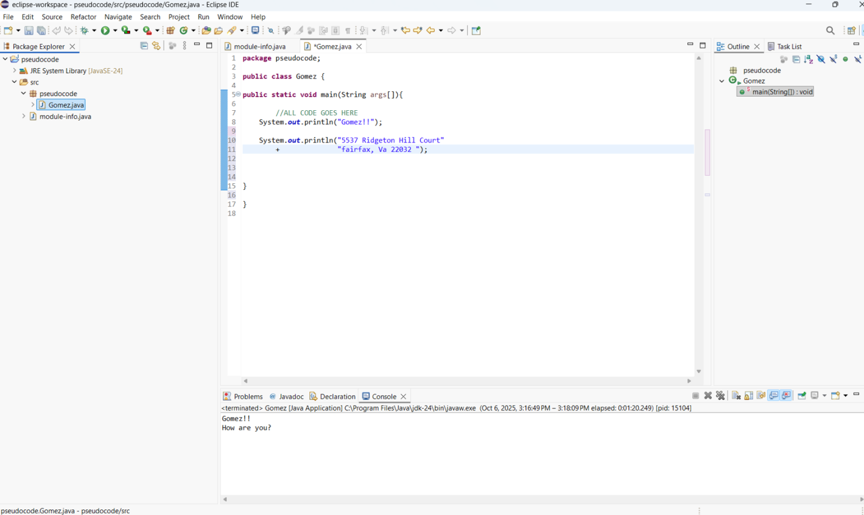

pseudocode code of Gomez.java
Start
DISPLAY
"Hello am George Gomez"
5537 Ridgeton Hill Court
Fairfax, Va 22032
PRINT
End

Source code of Gomez.java
package pseudocode;
public class Gomez {
public static void main(String args[]) {
//ALL CODE GOES HERE
System.out.println("Gomez!!");
System.out.println("5537 Ridgeton Hill Cout"
+ "fairfax, Va 22032 ");
}
}

