PICTOGRAMS TRANLATOR MANUAL

1. REGISTER
In order to translate in ARASAAC it is necessary to have a user in our platform. We enter https://beta.arasaac.org/register and register with our Google account (or Facebook) by clicking on the button SIGN IN WITH GOOGLE.
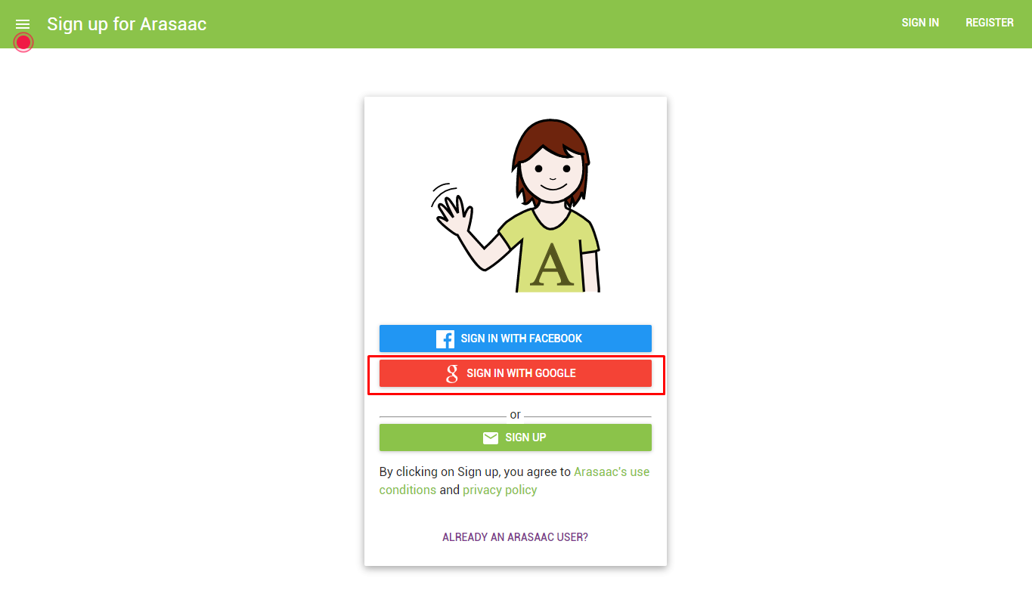
We can also register using another email account by clicking on SIGN UP (CREATE ACCOUNT).
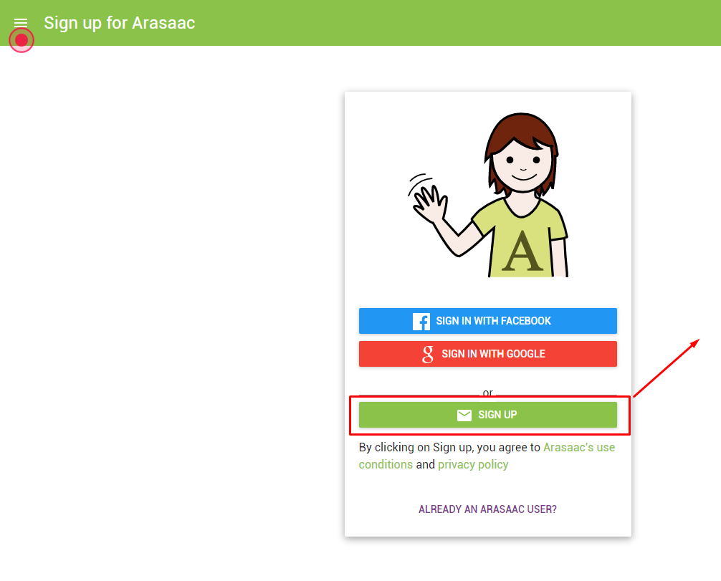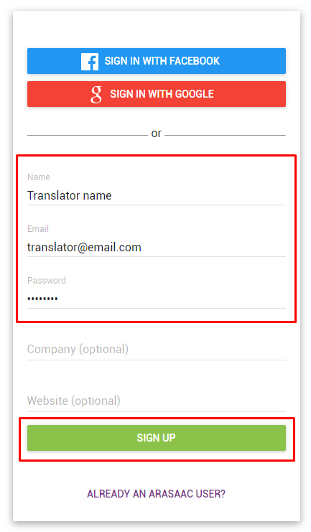
In this case you will receive an email to activate the account.

2. SEND US AN EMAIL
Send us an email to arasaac@gmail.com indicating us your name and surname, the email with which you have registered and what language you are going to translate in order we can give you translator permissions for this language.
3. EMAIL CONFIRMATION
Once we have given you translator permissions we will confirm it via email.
4. ACCESS AS A TRANSLATOR TO ADMINISTRATION PANEL
We access to the webpage https://admin.arasaac.org/ with the Google user account or with the email and password with which we have registered.
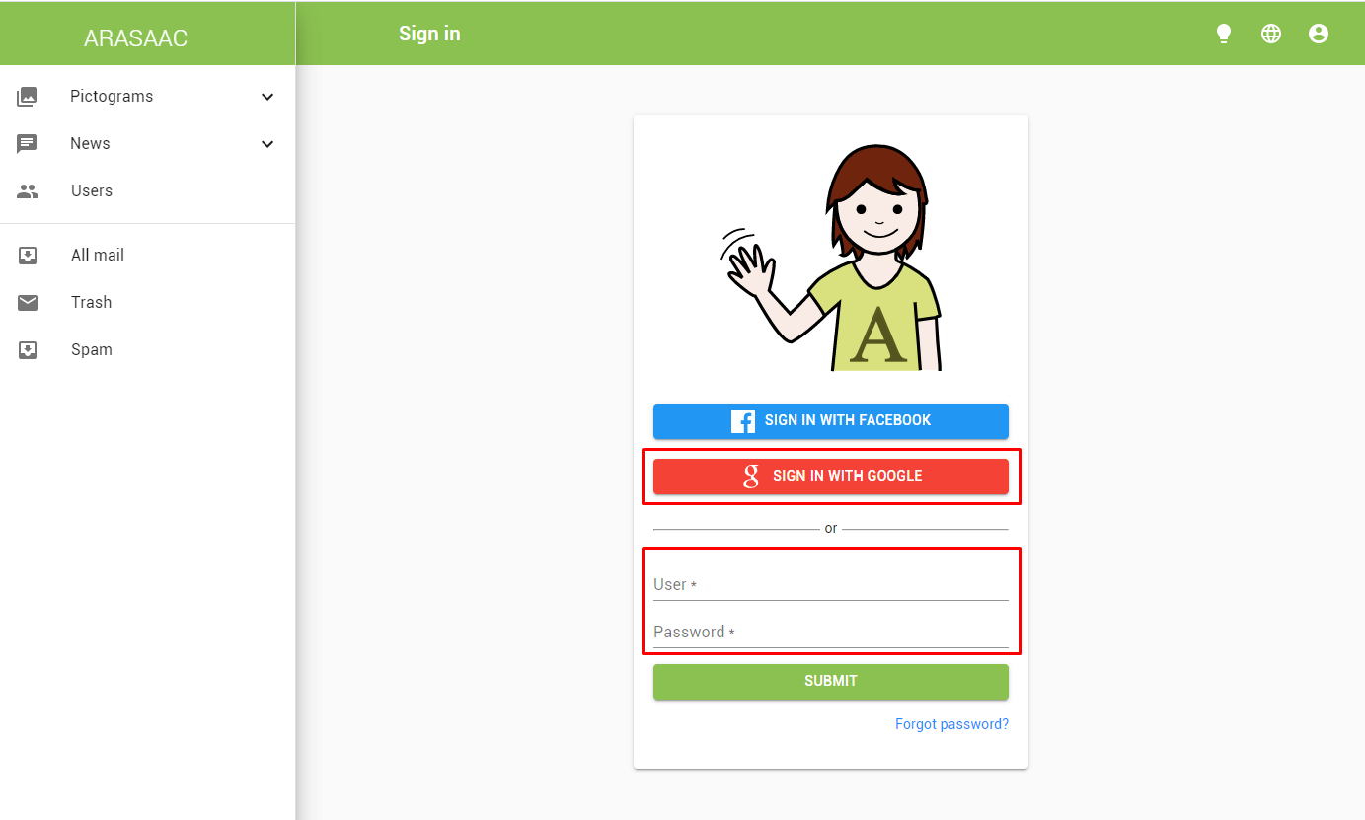
5. CHANGE THE LANGUAGE TO TRANSLATE
First of all, we must change the language and select our “objective” language (the one we are going to translate). To do this, click on the language selector and select the corresponding one in the list.
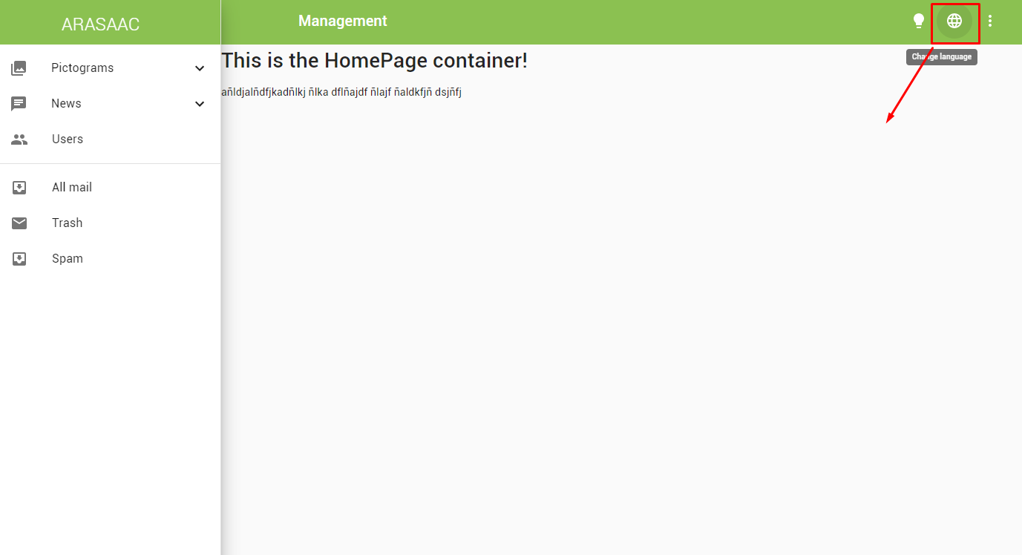
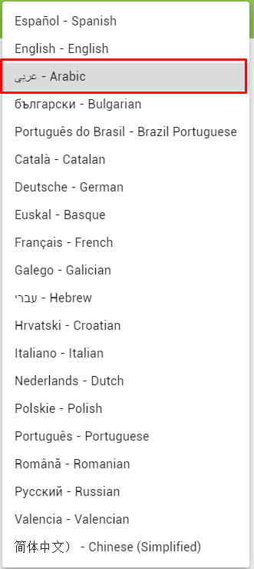

6. ACCESS TO THE PICTOGRAM CATALOG
To catalog those new pictograms that need translations or to validate those that already have previous translations we go to: (1) Pictograms, (2) Tag Pictograms. Three tabs appear:
- Search: To search pictograms by keyword or id.
- Not published: The list of pictograms that, for some reason, are not yet accessible to the public (for example a series of pictograms that are being prepared for some type of event) but can be cataloged.
Not validated (3): All pictograms that have not yet been translated or revised. Mainly it will be the tab that most interests as a translator. The first to appear will be the most recent.
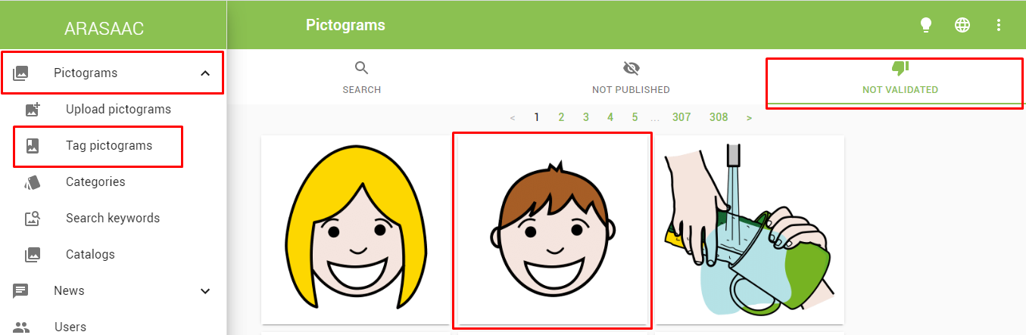
1
2
3
4
If we place the mouse on top of the pictogram we can see if it has or not a word assigned to it. As we can see, the smiling child has no word assigned so he will need us to add translations (words in your language).
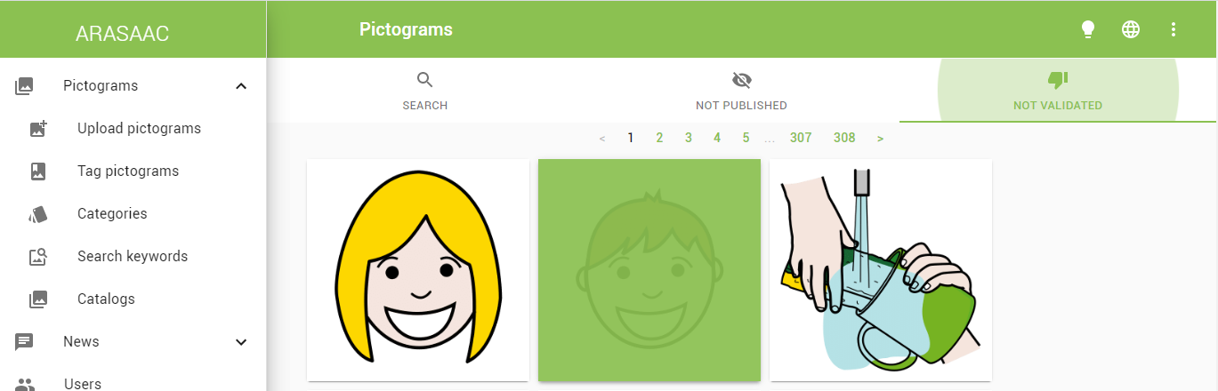
On the other hand, in the following pictogram, if we place the cursor over it, we see that the word “scrub the cup” has been added, so it´s a pictogram that we have to review the translations added and validate it.
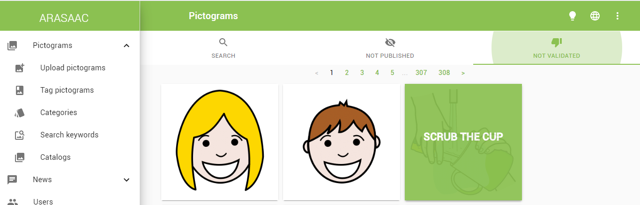

7. ADD WORDS (TRANSLATIONS) TO A NEW PICTOGRAM AND VALIDATE IT.
When we add a new picto to ARASAAC it is necessary to add the words that correspond to it in your language. To do this, click on the "+" sign. In this case we take the smiling children and click on it to access its. 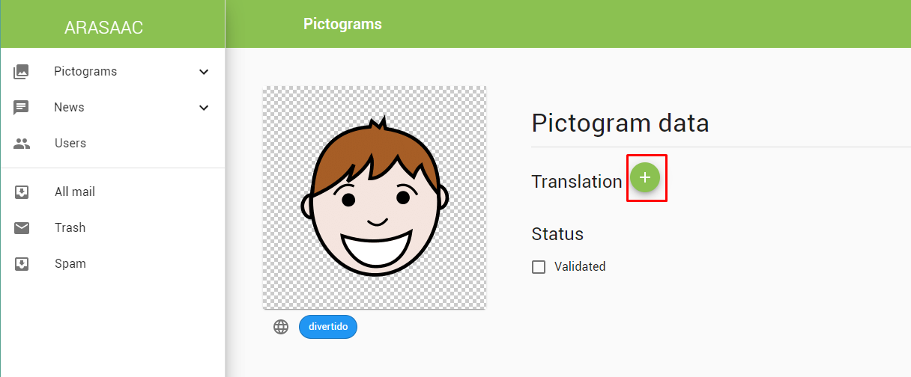
Next we add the word or words that it needs. Click on the "+".
As "help" to the translation under the pictogram we can see the words that have been added in other languages. It is only a help (never must condition the number of translations that you must add in your).
In this case, when you translate in English, the system suggests words in Spanish. Clicking on the world ball we can see the translations in other languages.
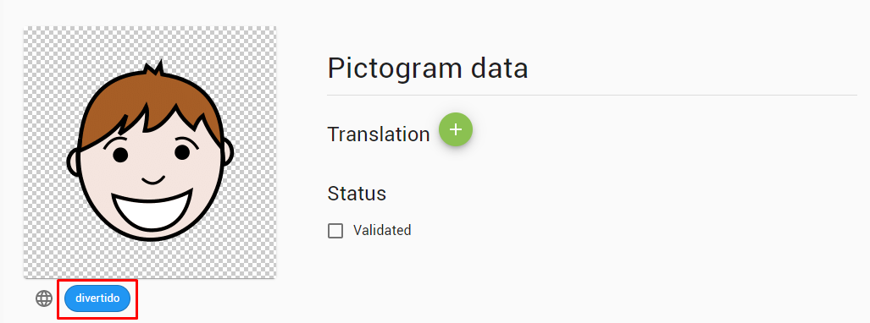
In addition to the words, these appear colored to indicate the type of word:
1. Yellow: proper names
2. Orange: common names
3. Green: verbs
4. Blue: adjectives and adverbs
5. Rosa: Social Content
6. White: Miscellaneous
As a general rule we must add the words that the pictogram needs and that are most frequently used in the language. It is interesting that you respect the type of suggested words. If in English or Spanish (which are the main languages) the pictogram only has descriptive words (adjectives in this case) we will only translate the pictogram with adjectives in our language. Anyway, could be some mistakes in English/Spanish or if you have some doubts write us to arasaac@gmail.com and comment us.
First we add "fun" and put as a type of word "Descriptive (adj or adv)". We do not have a save button since all the changes maked are "autosaved"
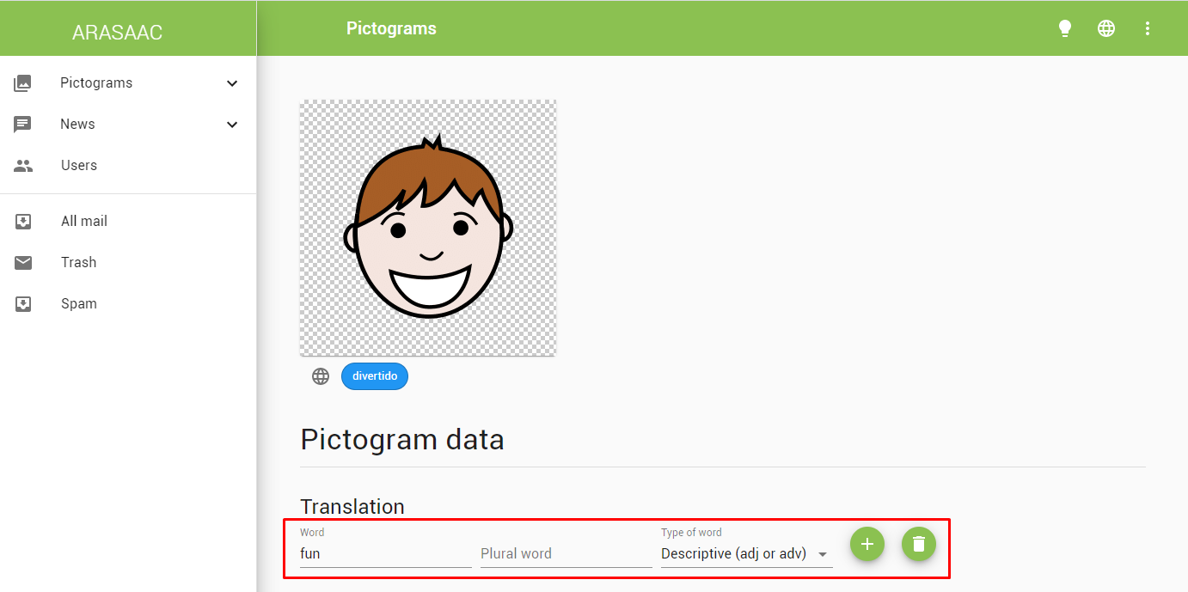
Click on the "+" again to add a new word (a new line appears)
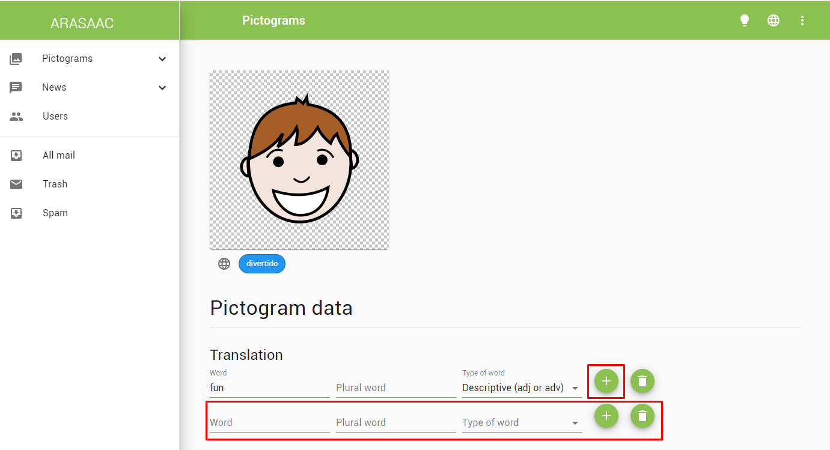
We add “funny”
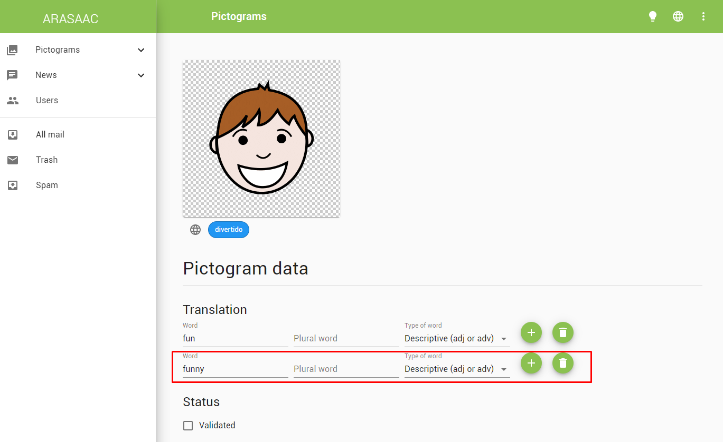
In this case, being an adjective in English does not have a plural or femenine/masculine but if in yor language has a plural we will add it in the "Plural word" field. If the word has masculine/femenine we add a new line (for femenine or masculine).
Important! We must not forget to add or check the type of word that corresponds according to the color classification:
1. Proper name (yellow color): includes proper names and pronouns
2. Common name (orange color): nouns
3. Verbs (green color)
4. Descriptive (blue color): adjectives and adverbs
5. Social Content (pink color): phrases made, courtesy formulas, questions, expressions,….
6. Miscellaneous (white color): includes numbers, alphabet, prepositions,…
Finally when we consider that the pictogram is well cataloged (we will always review it) and has the appropriate words click on "Validated".
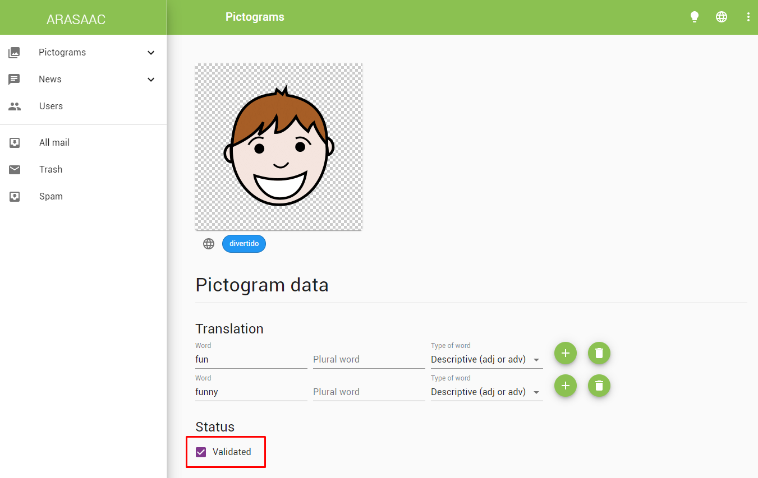

8. VALIDATE THE TRANSLATIONS AND ADD PLURALS TO THE PICTOGRAM
In case that the pictogram already has previous translations we should review them:
1- If some translation is not necessary, we will delete it by clicking on the trashcan on the right. For example, if in the suggested translations in English or Spanish we see that it is only translated as an adjective and the pictogram has some translation as a noun we will delete it. In this case, "weather" is a common name because in Spanish there is only the adjective "vestoso" (windy).

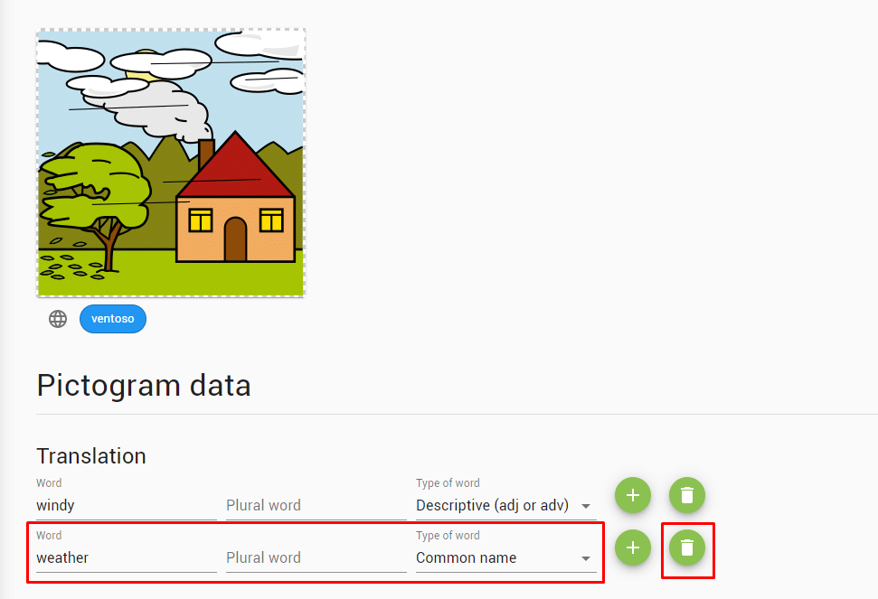

If any translation corresponds to a word that is rarely used, we can also delete it.

2- If the translation supports plural we will add it since, in this way, we can show the pictogram with the plural sign added in the public part of the portal.

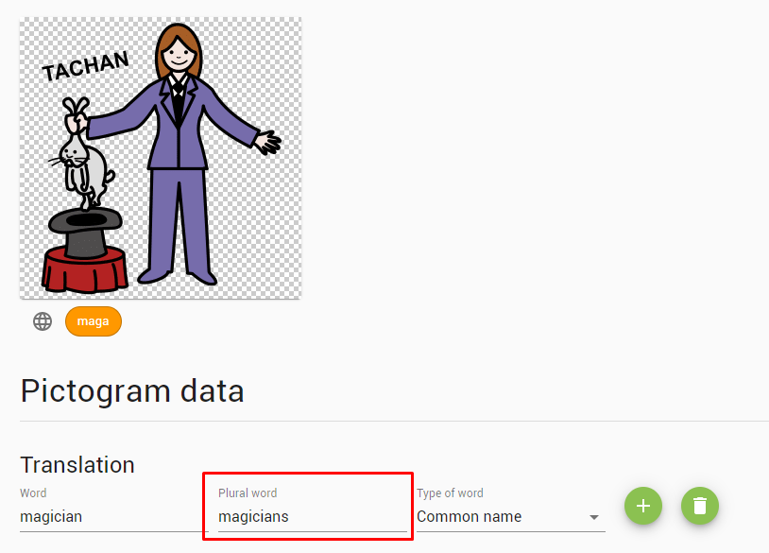

3- If we consider that the pictogram is already correctly translated and we have added the needed plurals, we will proceed to validate it (checking Validated checkbox). This will serve us, as translators, to know what pictograms are already fully translated and we don´t want that appear in the tab “Not Validated”.
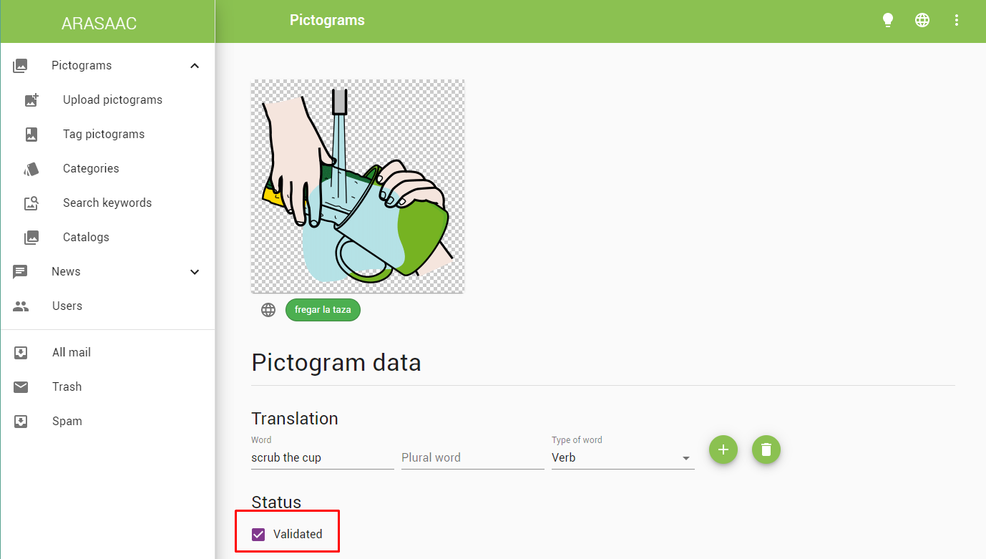
APPENDIX
PLURAL PICTOGRAM
If a pictogram already represents a plural concept (like this one of cherries) we must translate the pictogram already in the plural and don´t write anything in “plural word”. Anyway, in English or Spanish usually are translated correctly.
