# Translation of ARASAAC category tree

## Introduction

ARASAAC pictograms are classified following a taxonomy. This taxonomy provides us with some immediate advantages like search and filter suggestions.

We hope you see the benefits of categorization. Believe us, it has been a hard work of several months for the entire ARASAAC team. But this is only the beginning of the applications that we can carry out based on having the pictograms correctly classified.

## Example of use

If we search ***dog*** on the ARASAAC website (<https://arasaac.org/pictograms/search/>, see image below), ARASAAC offers some suggestions based on our search (*carnivorous animals, mammals…*).

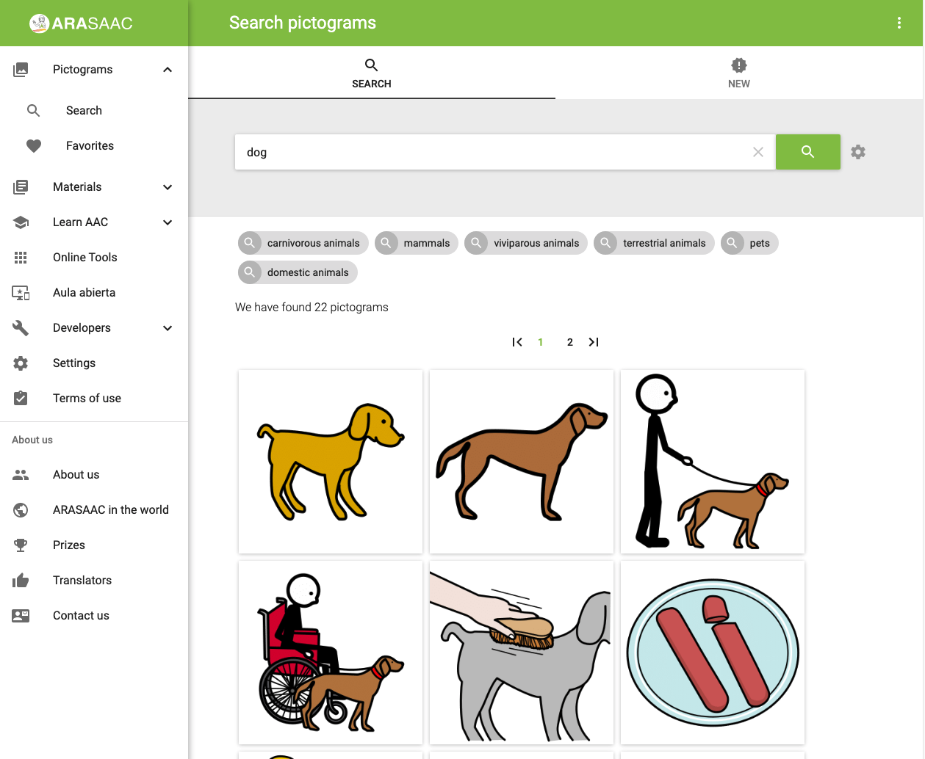

We could click on one of the suggestions, for example, *mammals*, and we would obtain all the pictograms classified as mammals in the ARASAAC set.

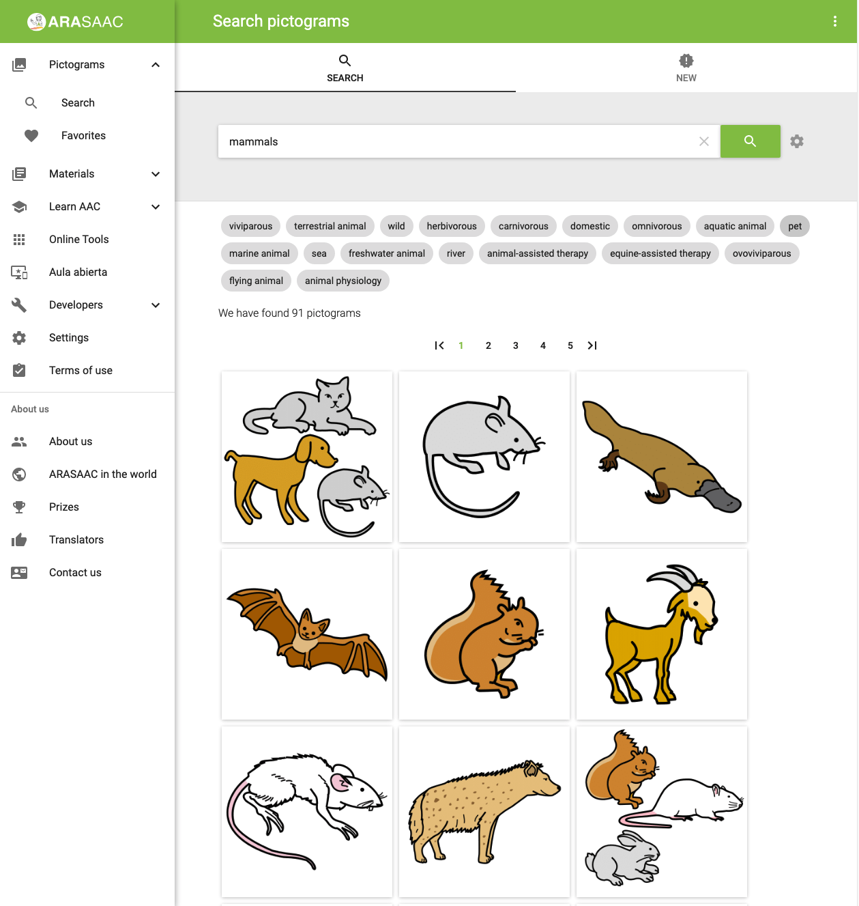

What happens under the hood, is that we are browsing one of the ARASAAC pictogram categories. As the categories have many pictograms, ARASAAC offers us filters. In this specific case, we could be interested in mammals that are pets. Clicking on the pet tag we would obtain pictograms about dogs, cats, and hamsters. Then we could filter again based on its feeding (carnivorous or omnivorous).

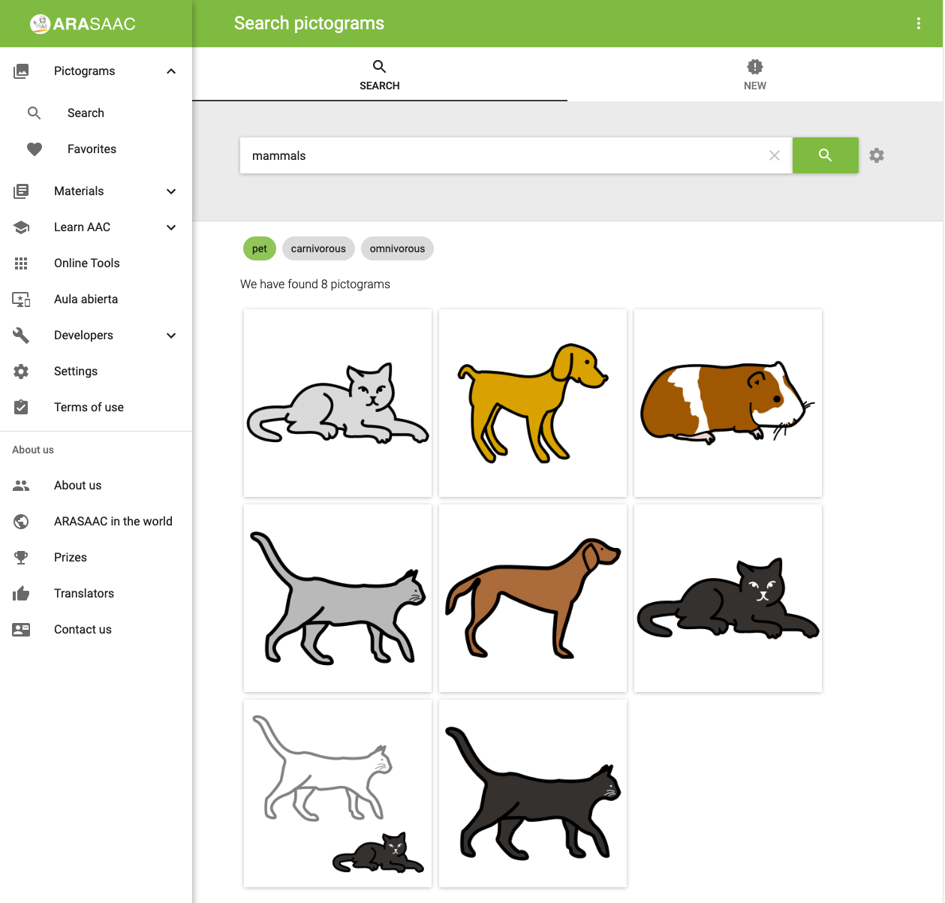

We could undo our search results deactivating *pet filter* and search for example “*mammals that live in the sea and are carnivorous*” using filter tags *sea* and *carnivorous*.

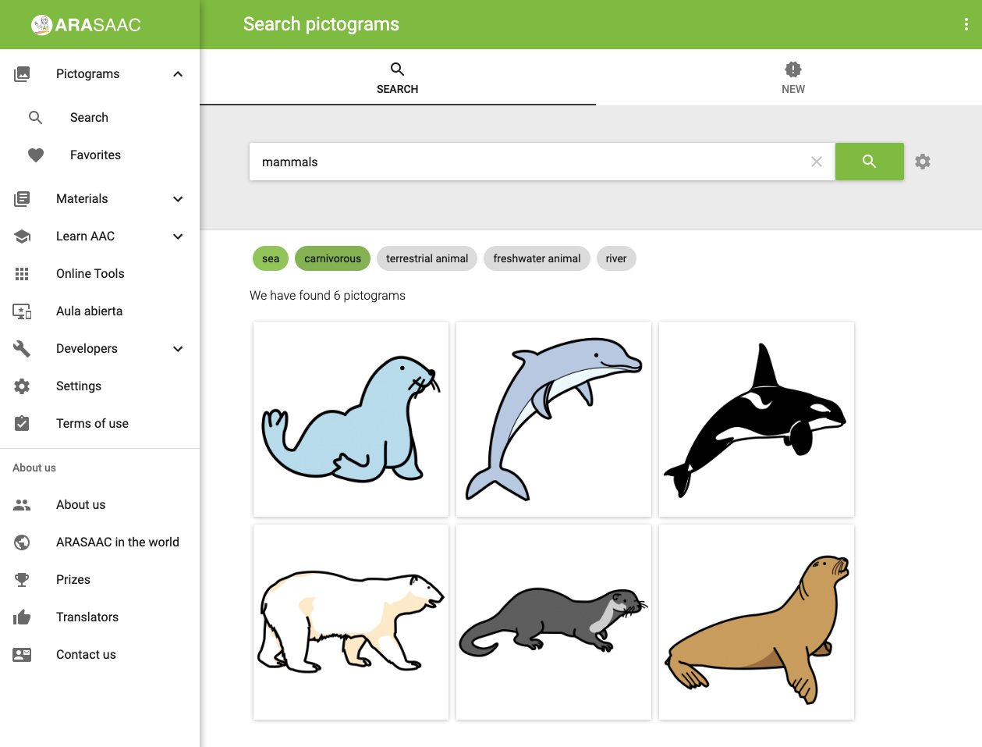

Returning to our initial search, if we obtain the pictogram of the dog (<https://arasaac.org/pictograms/en/2517/dog)>, we can see how the dog has been categorized and the tags (filters) that have been associated with it:

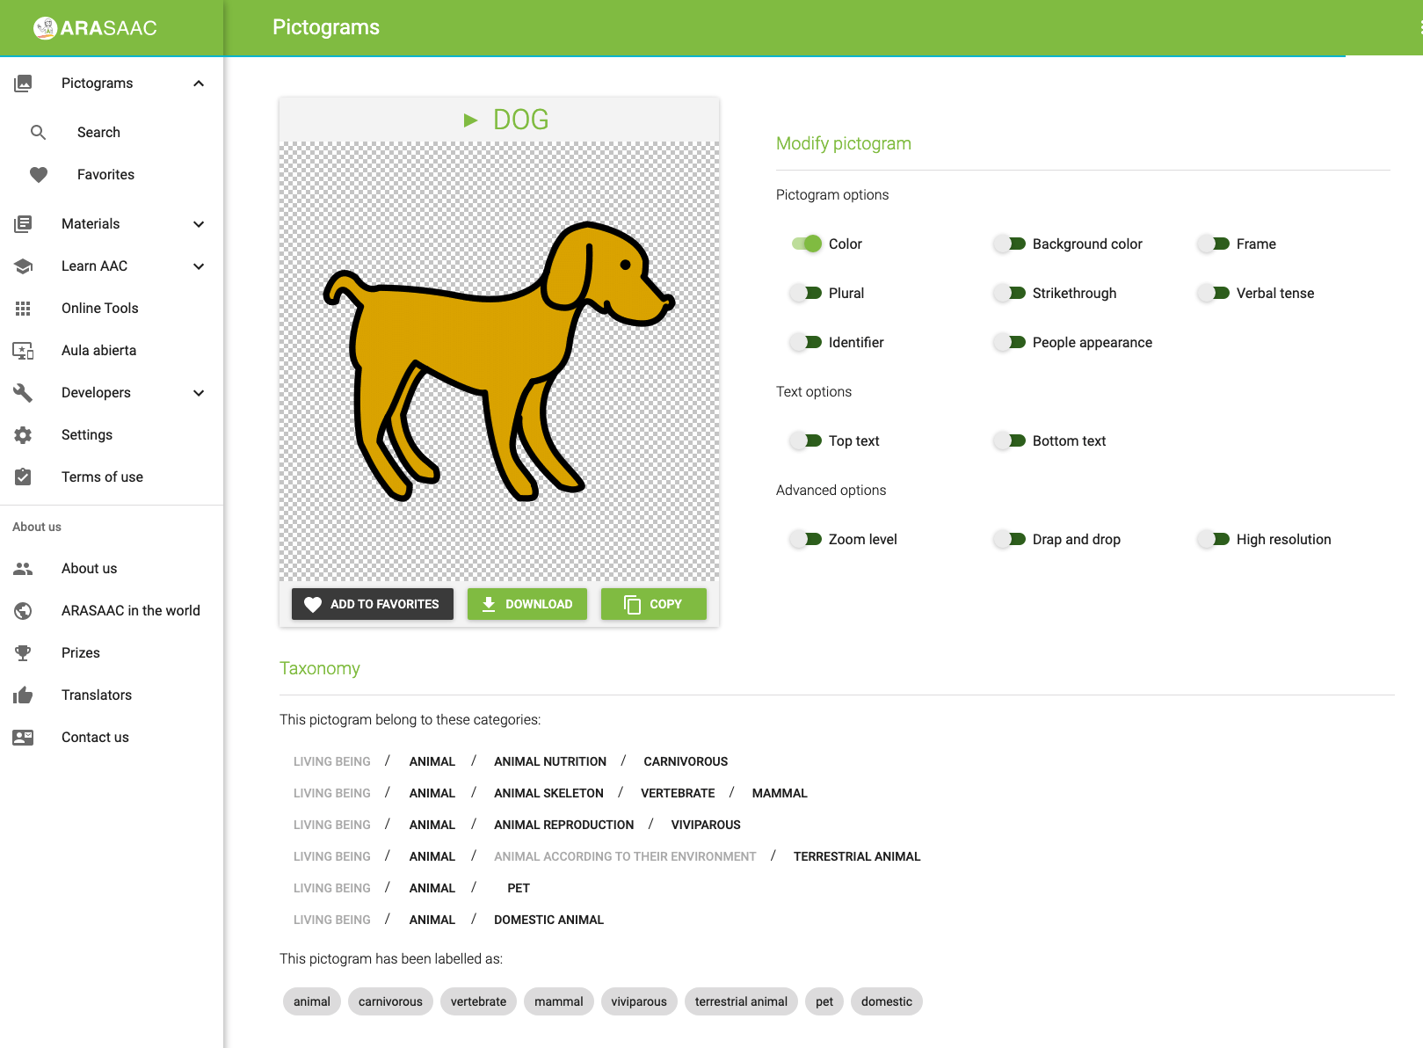

## Category tree translation

On the admin website, you can browse pictogram taxonomy. As it is quite complex we don’t show it on the ARASAAC website, it’s only used for suggestions, filters, or pictogram classification (see the previous example of use).

***How to access***

Browse to <https://admin.arasaac.org/> and select Categories in the left menu (red box with number 1 in the image below).

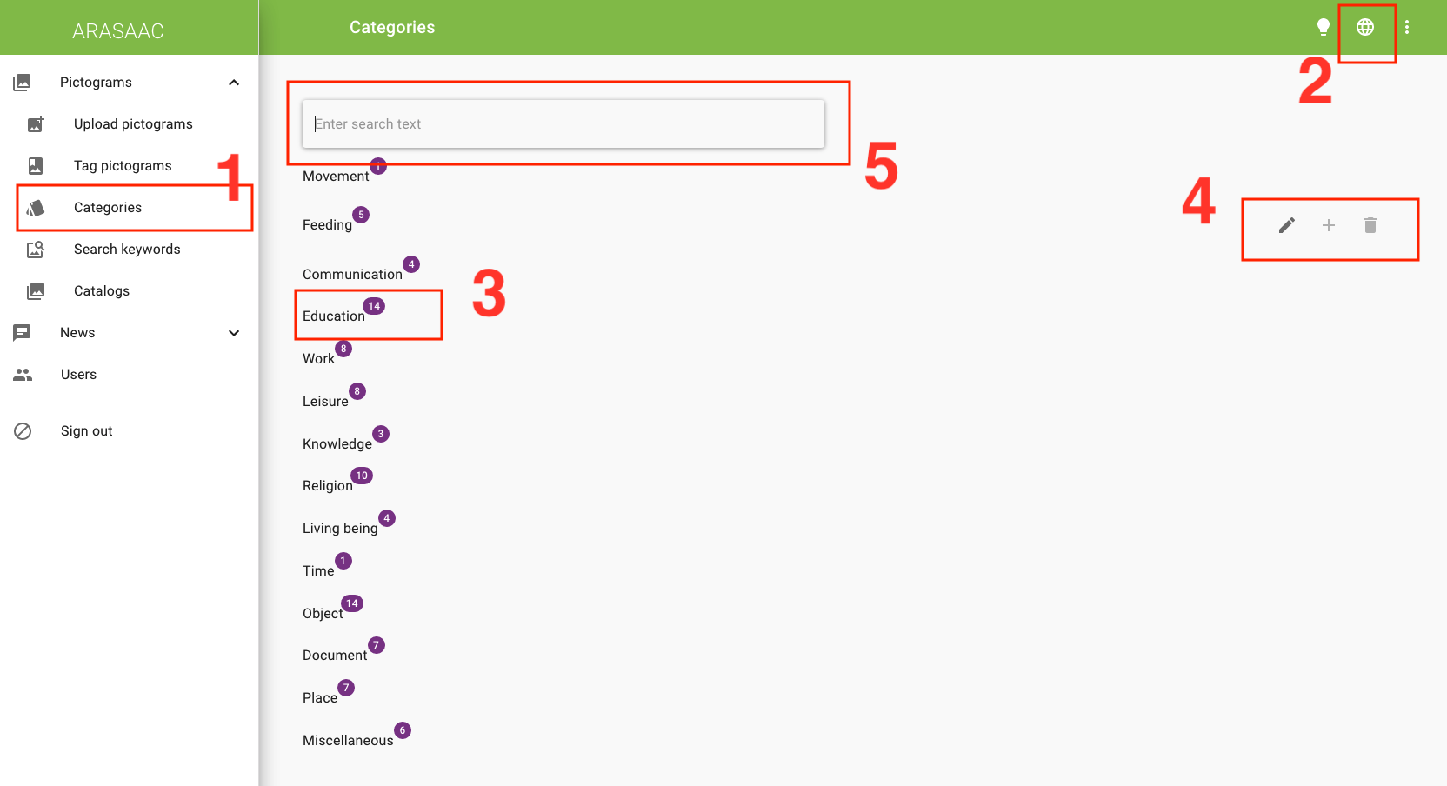

***Set your language***

If you change website language (red box with number 2), the category tree will change to that language. You’ll just have edition permissions in the languages that you’re set as a translator.

***Explore the category tree***

By default, your category tree is written in English. It has some main branches (Movement, Feeding, Communication, Education…). Each branch can have additional branches. For example, Education (red box with number 3) has 14 branches. You can click on it to browse the branch. You can also search for a branch using the search box (red box number 5).

***How to update categories***

Browse to the category you’d like to update. We suggest you start with one main category and all its descendants. Click the pencil icon (red box with number 4) when you’re over that category.

***Let’s begin!***

We will start with the first one, ***Movement***. If you click the pencil icon you’ll get this window:

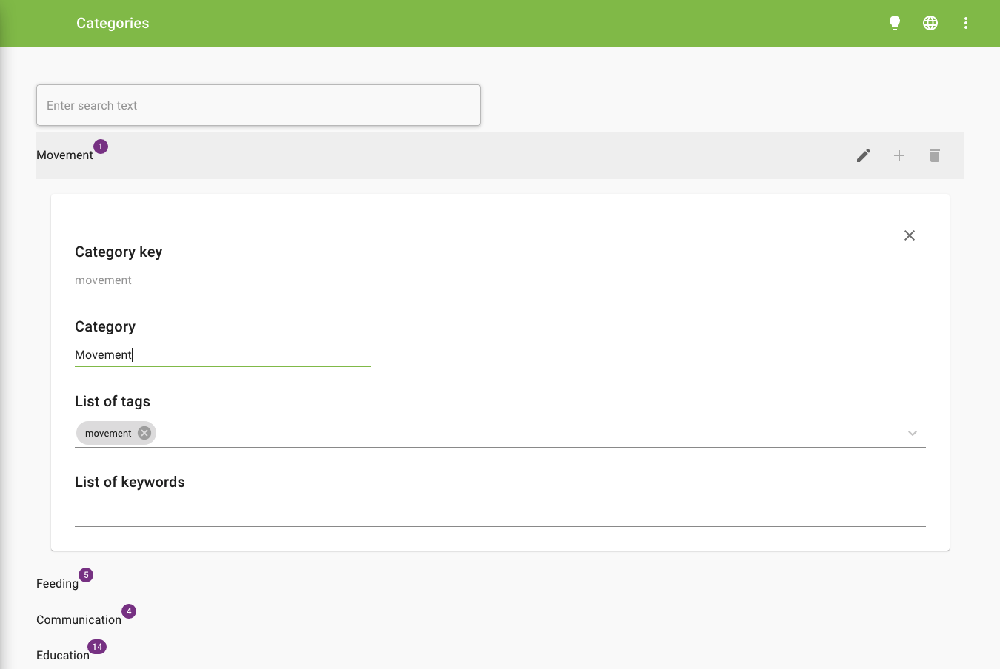

* Category key is used internally and can’t be modified.
* The category field has the English word for that category and should be translated to your language. Use singular if possible. It is used not only for category tree visualization inside the admin panel but also for the pictogram taxonomy on the ARASAAC website.
* The list of tags field is configured by us and translated via Crowdin.
* The list of keywords field consists of a group of keywords (one or more words per keyword) to refer to this category. It shouldn’t be changed if it’s empty. In this case, you should leave it blank.

This was an easy one. Now we will go with the first and unique subcategory, ***Traffic***:

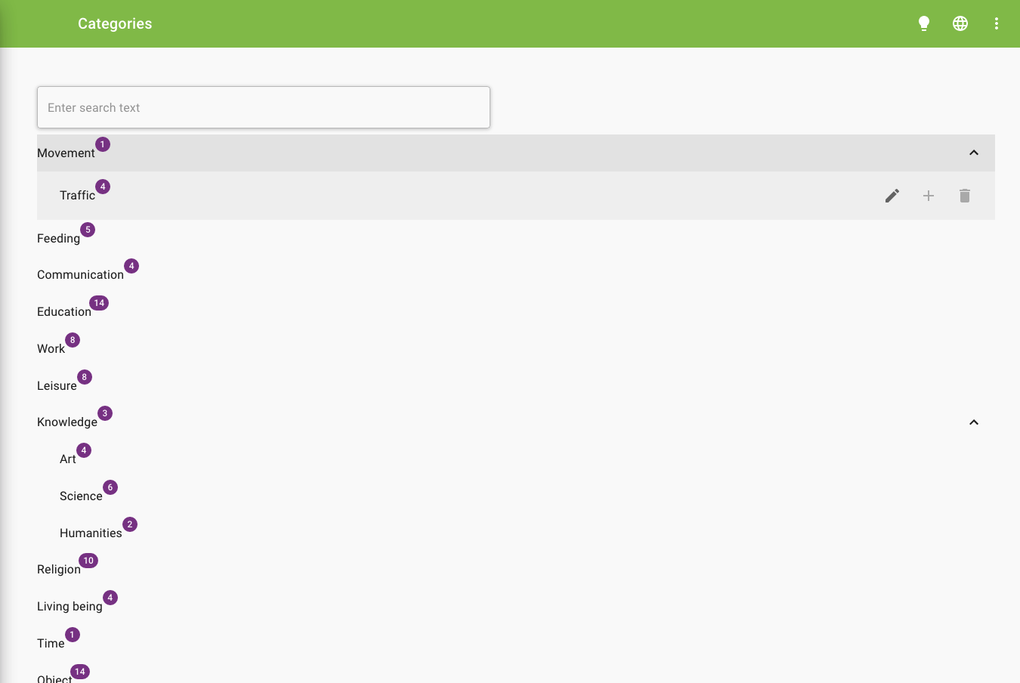

Click on Movement to see its subcategories (it may take a while). You’ll see the Traffic subcategory (with four descendants that should be updated later on). Click on the pencil icon to modify the Traffic category:

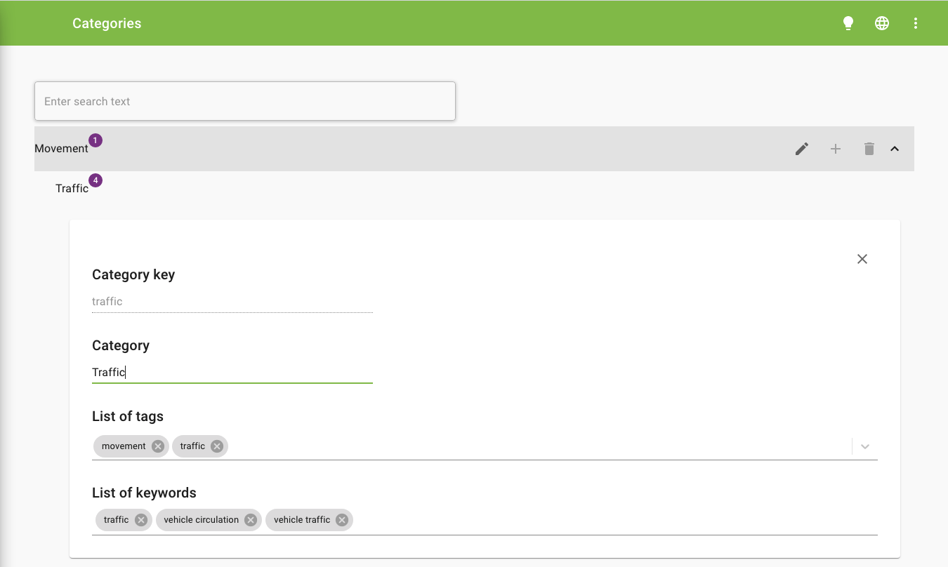

Translate the *Category* field to your language. Take into consideration that the category depends on another category that can provide semantic meaning, more on this in the latter example. Traffic would be better than “***traffic of vehicles”,*** for example.

Translate the list of keywords to your language. When people search pictograms on the ARASAAC website these keywords will be used for the autocomplete search box as suggestions. You can enter as many keywords as you need. For better usage take into consideration:

* The plural is preferred (you can enter also singular variations, it’s recommended)
* Put the more common and more complete in the first position.

**Example**

If you search dog in ARASAAC (<https://arasaac.org/pictograms/en/2517/dog)>, it has this taxonomy:

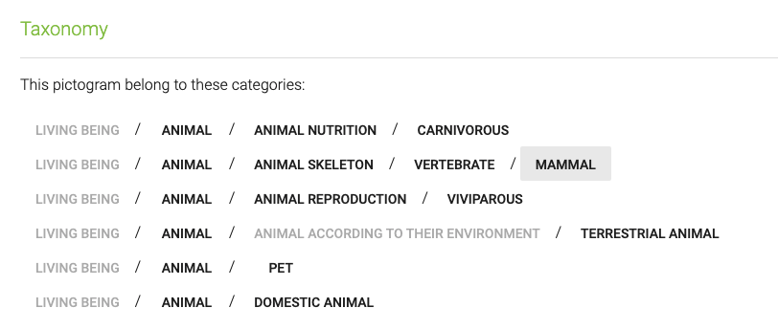

Each category corresponds to the category field. We defined the category carnivorous and not “carnivorous animal”, because it’s not necessary due to context.

When we make a search, it’s useful however to see “carnivorous animals” in the suggestions box as we don’t have the previous context so we should consider it as a keyword for our category.

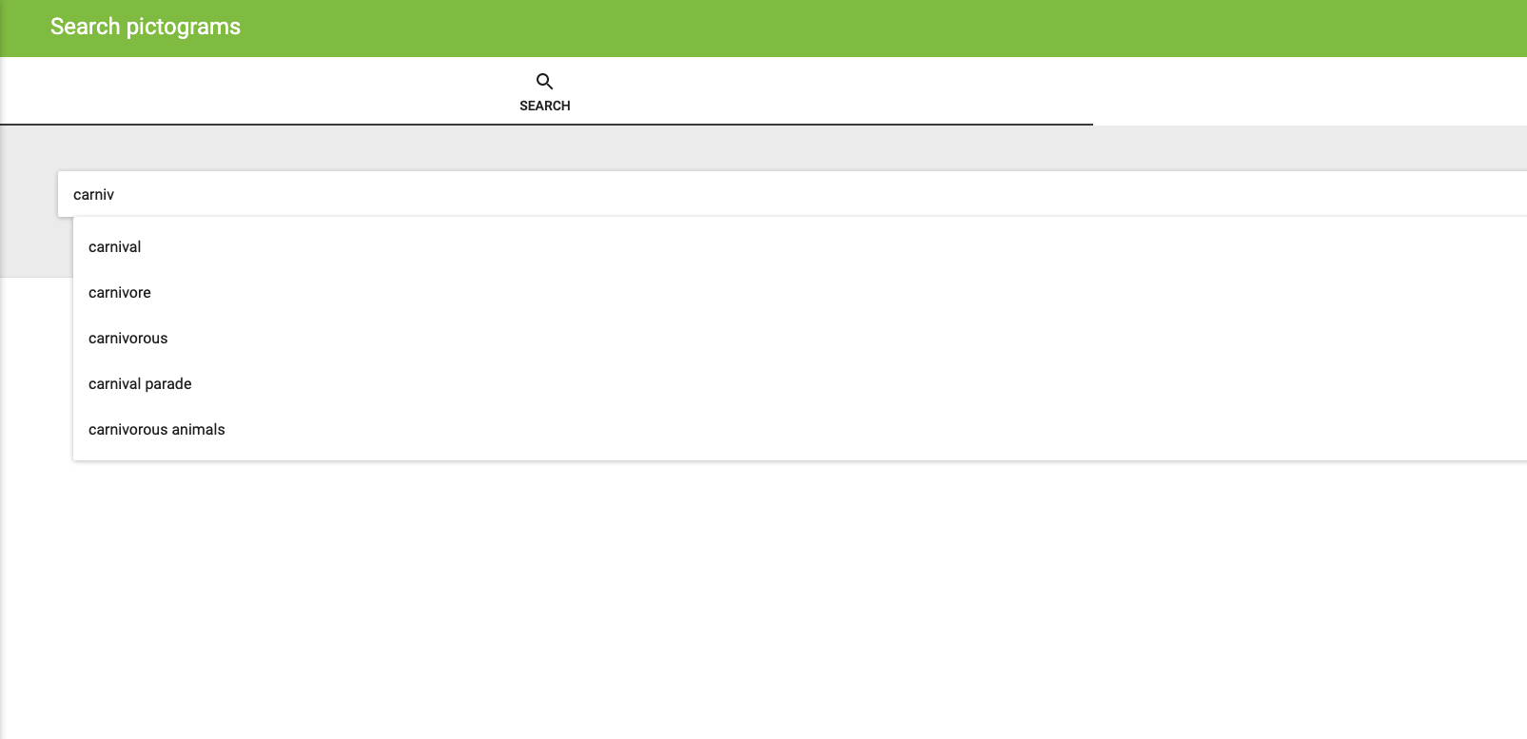

The first keyword we defined for a category will be the one used as a suggestion when searching for a specific pictogram, so long or commonly used keywords are preferred in the first place.

