**ARASAAC WEBSITE TRANSLATOR MANUAL**

**1. REGISTER**

In order to translate in ARASAAC it is necessary to have a user in our platform. We enter <https://beta.arasaac.org/register> and register with our Google account (or Facebook) by clicking on the button **SIGN IN WITH GOOGLE**.

If you already had a translator account created you can skip this step and go to number 2.

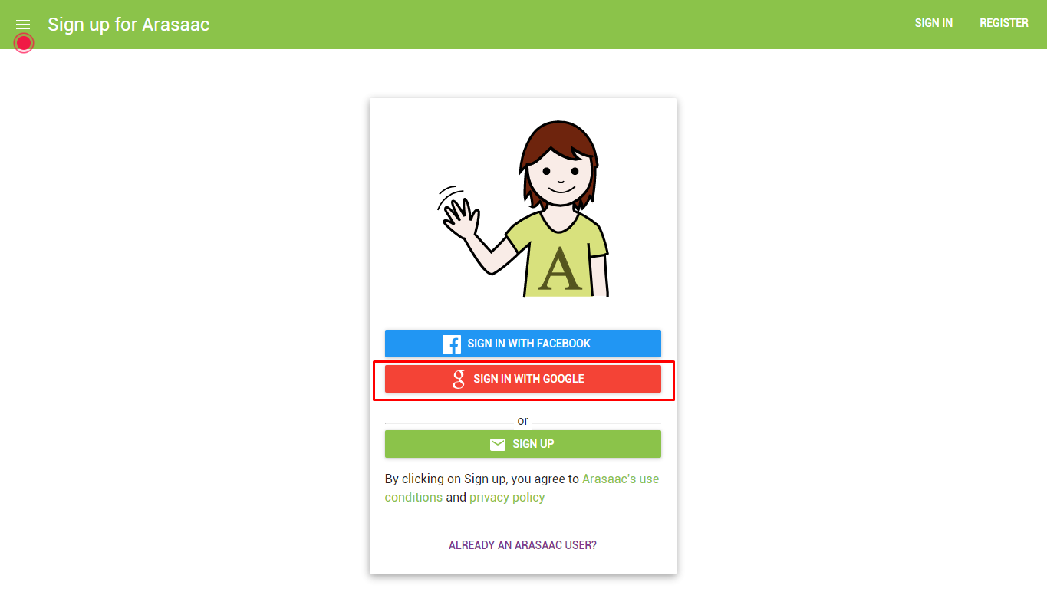

We can also register using another email account by clicking on **SIGN UP** (CREATE ACCOUNT).

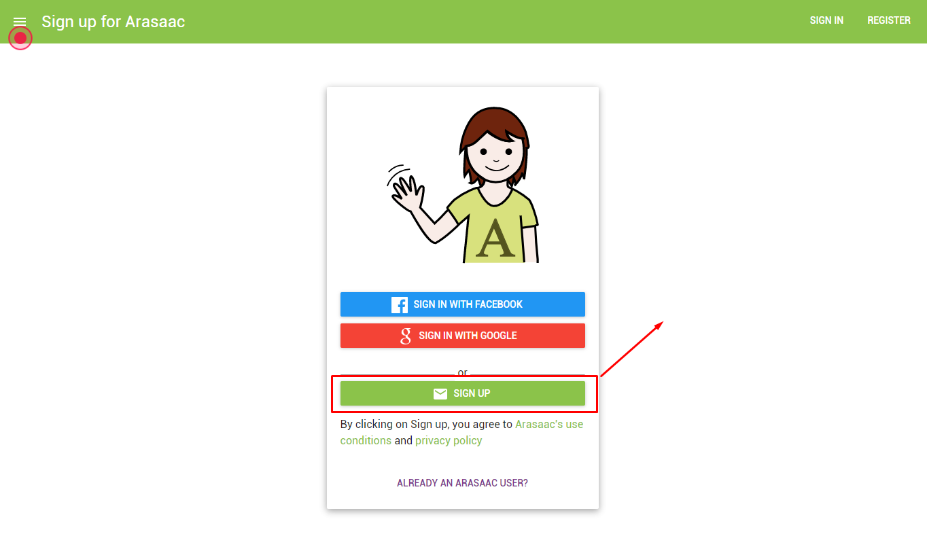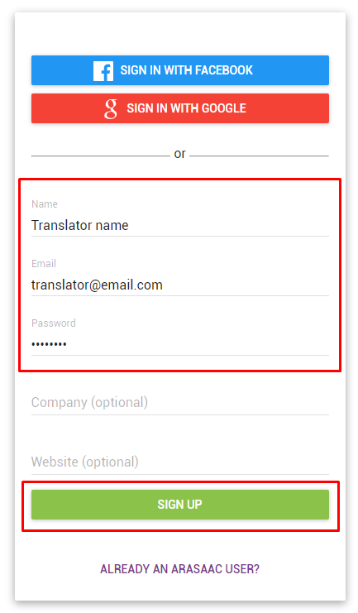

In this case you will receive an email to activate the account.

**2. SEND US AN EMAIL**

Send us an email to [arasaac@gmail.com](mailto:arasaac@gmail.com) indicating us your name and surname, the email with which you have registered and what language you are going to translate in order we can give you translator permissions for this language

If you already have a translator account in ARASAAC, just write to us to indicate that you are going to start translating the ARASAAC website. We will send you two links with invitations to translate our website and our administration panel through a web tool called Crowdin. The links will be similar to the following:

*https://translate.arasaac.org/project/arasaac/invite?d=o6853645o6h58383t693l4f3d303*

*https://translate.admin.arasaac.org/project/arasaac-management/invite?d=o6853645o6h58383t693l4f3*

**3. JOIN CROWDIN**

Click on the Crowdin invitation links we have provided. You must create a user on that platform or login using a social network to start translating.

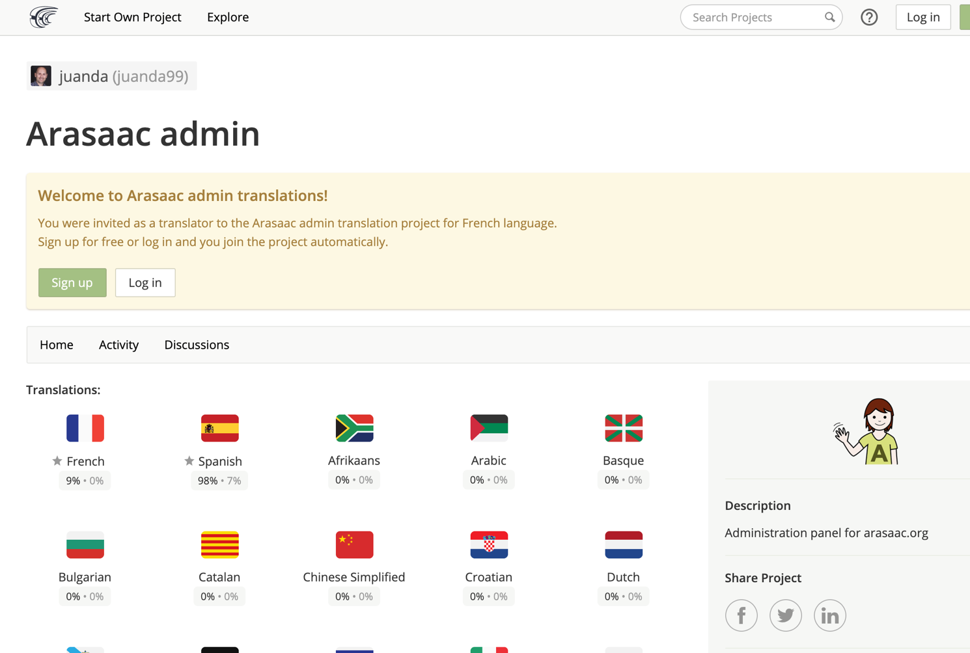

**4. ACCESS AS A TRANSLATOR FROM OUR ADMINISTRATION PANEL**

Login to <https://admin.arasaac.org/> with your new account (or using social login).

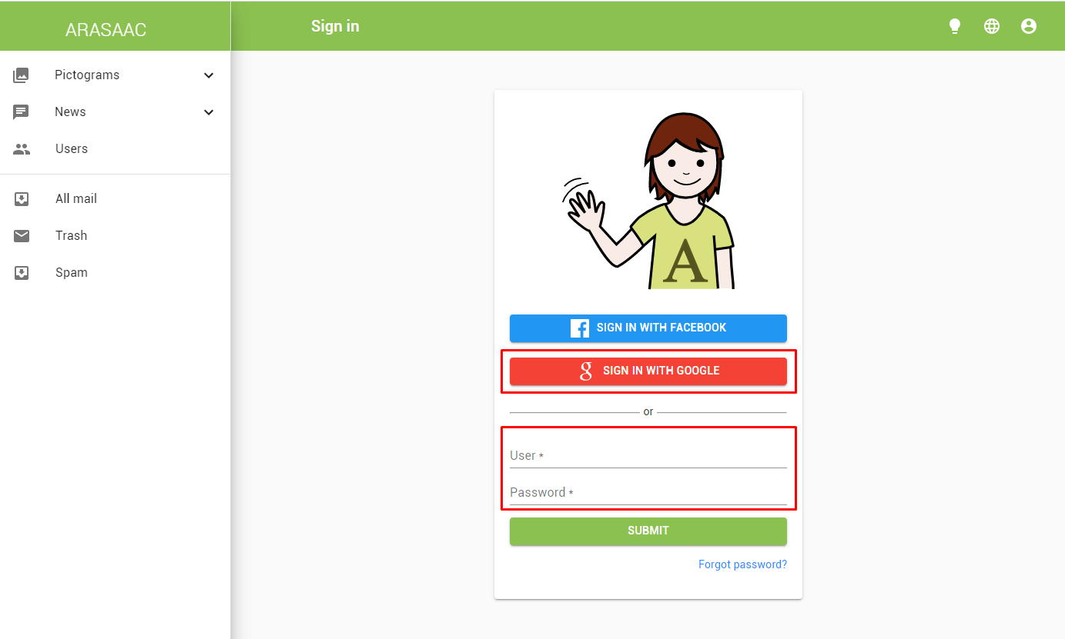

**5. WEB SELECCIÓN TO TRANSLATE**

On the home screen once logged in, we can see the status of our translations and choose the project we want to translate.

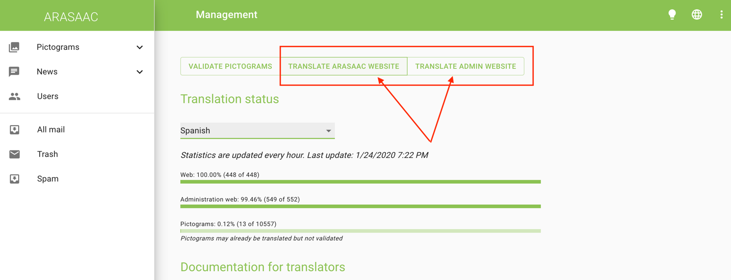

**6. LANGUAGE SELECTION TO TRANSLATE**

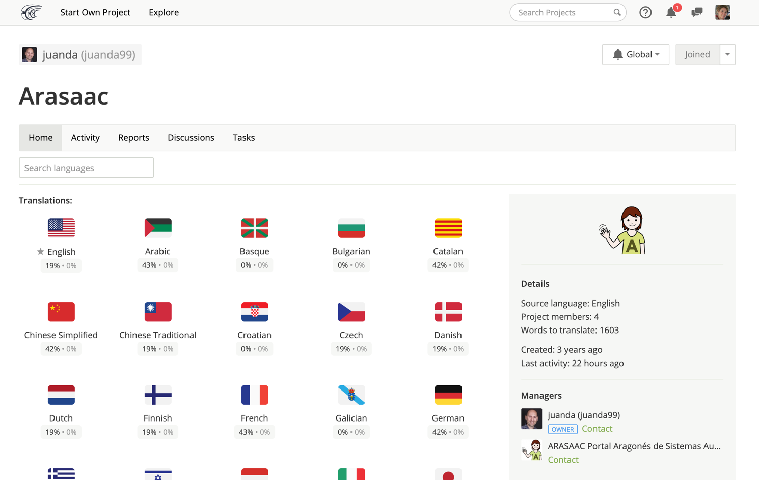

**7. SELECTION OF DATA TO TRANSLATE**

Click on the file that has the sources to be translated (***en.json***) or simply click on ***Translate All***

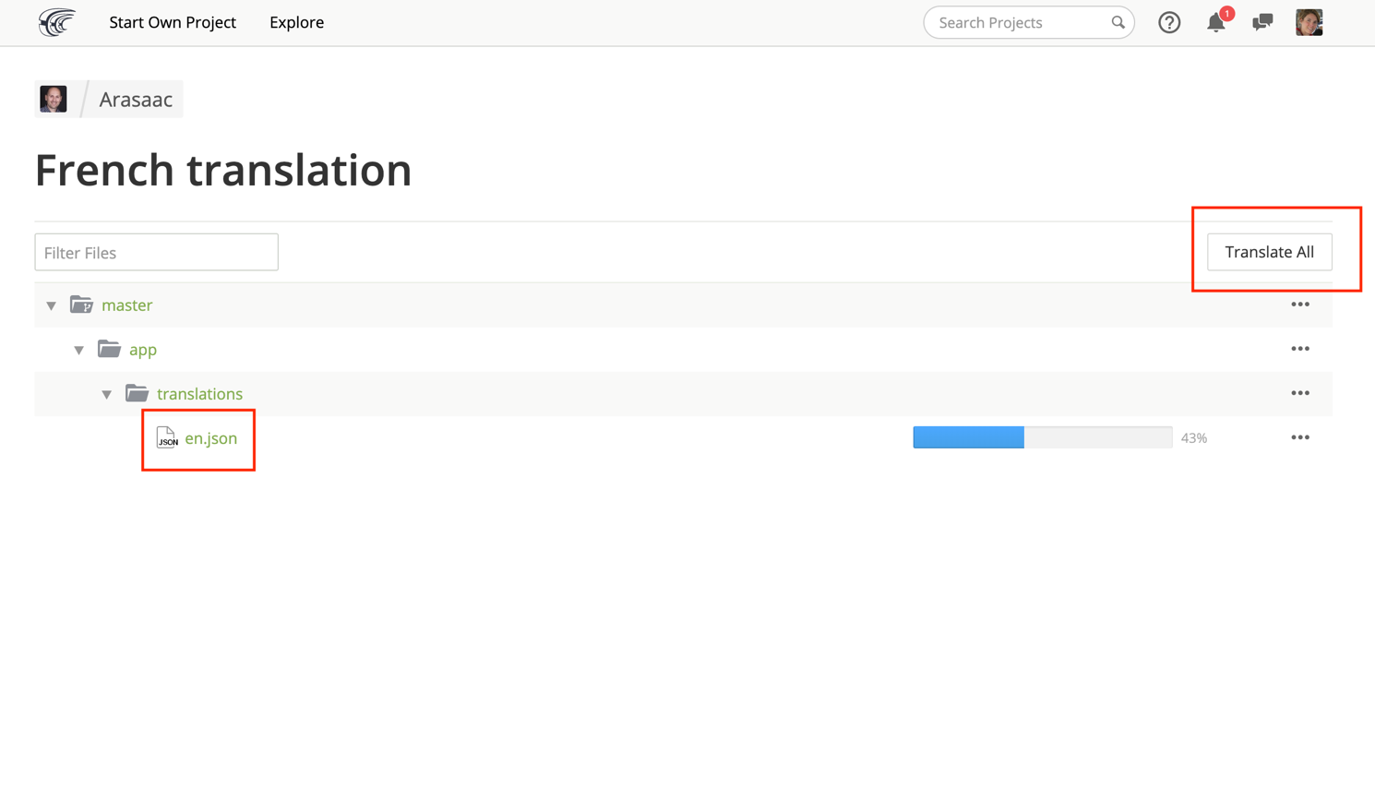

**8. TRANSLATIONS**

In section 1 (left column) we choose the string we want to translate. We can filter by clicking on the icon.

In section 2 (center column, top), we see the original string that we have selected to translate.

In section 3 we write the translation.

Section 4 offers suggestions for translation, if we click on one, it will write it automatically in section 3.

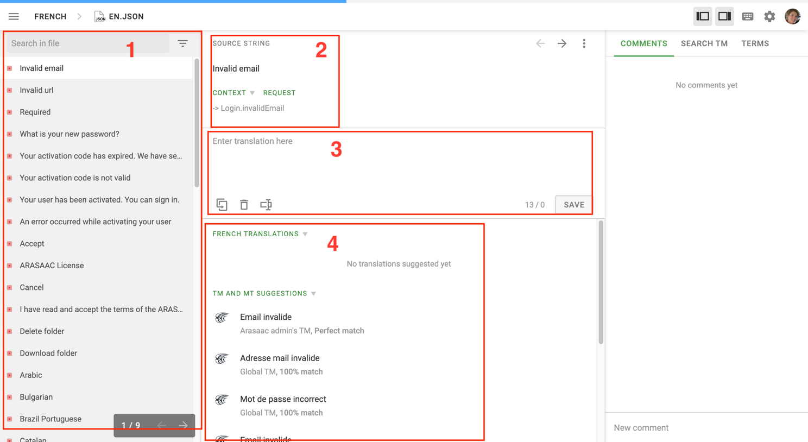

**9. INTEGRATE TRANSLATIONS**

Send us an email to [arasaac@gmail.com](mailto:arasaac@gmail.com) indicating that you want to integrate the translations you have made so that they can be visible.

**10. TRANSLATION REVIEW**

When we have confirmed that the translations are already integrated in the web you can browse the application to check if all the translations are correct. If any are missing or you want to make modifications, you can make them directly from the website (it is not valid for the administration website, in which case you must return to step 8).

Press on the user menu the option *Translate ARASAAC*

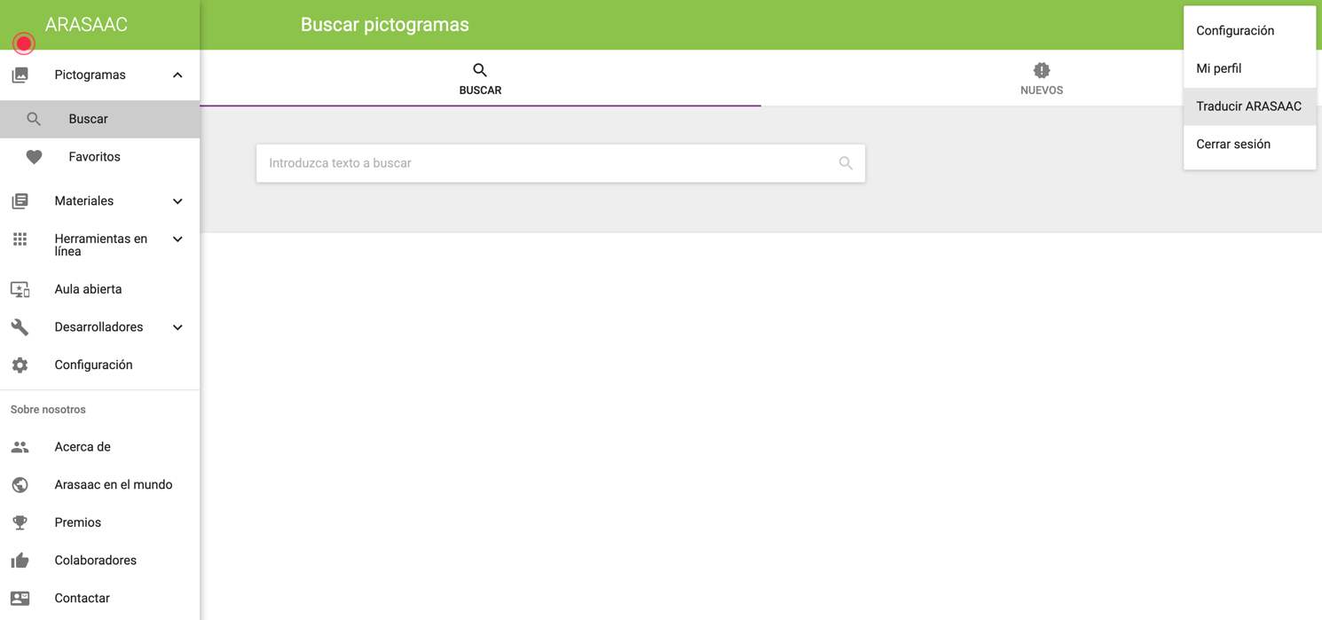

A box will be drawn on each element susceptible to translation. By clicking on an icon that appears above them, a specific translation window will open for that element.

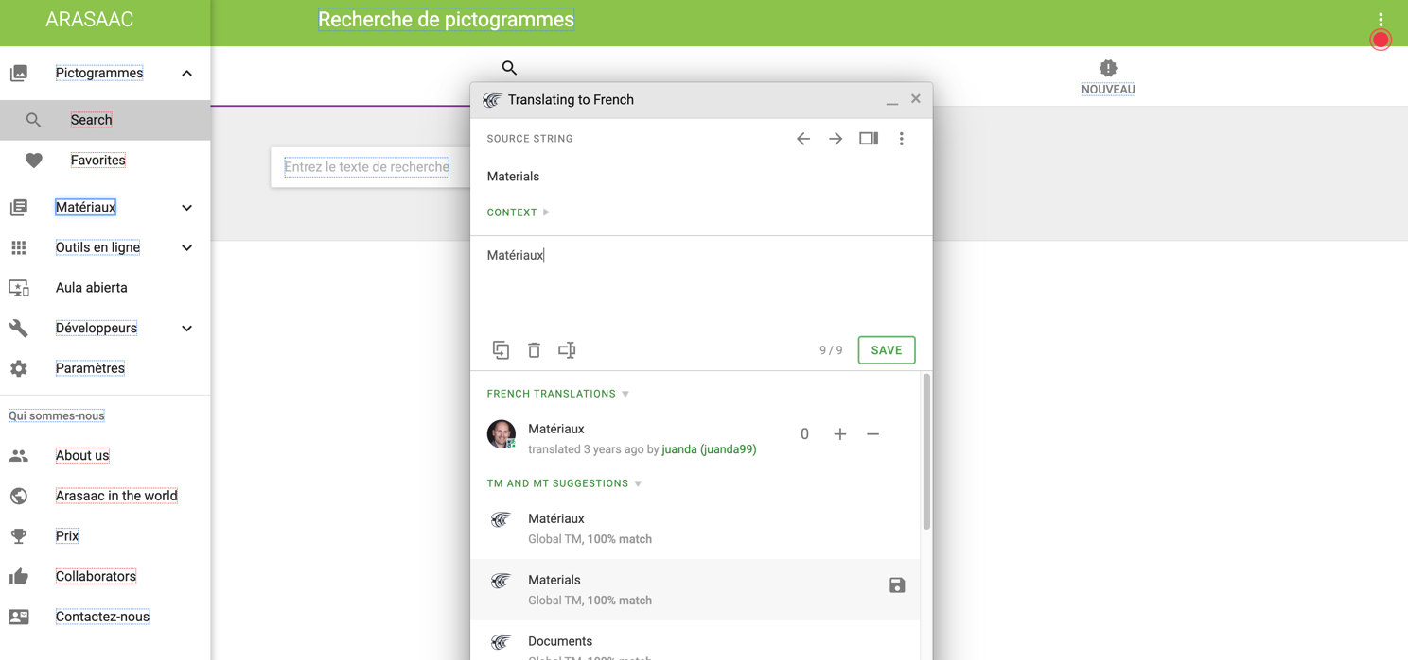

**11. INTEGRATE TRANSLATIONS**

If you have made changes, send us another email to [arasaac@gmail.com](mailto:arasaac@gmail.com) indicating that you want to integrate the translations you have made so that they can be visible.