**Steganography with CUDA using Google Colab**

Juan David Torres Velasco A01702686

**Abstract** - **The following document show the implementation of Steganography in images using CUDA C and OpenCV with Google Colab as the running environment.**

***Introduction***

Hiding information has been always necessary for humankind and the beginning of the digital era brought a lot of ways to hide information. Steganography is one of the many ways to encode, encrypt or hide information, this is done by hiding the information in the pixels of the image.

***State of the Art***

***Manual***

The objective of this manual is to show how to work with OpenCV in Google Colab given that there can be some hardware issues that can prevent us to do certain development like the use of CUDA in a computer without an NVIDIA GPU.

I will be giving some examples using the steganography project as way to show how OpenCV can be used.

1. ***Installing Google Colab***

Firstly, it is necessary to connect Google Colab to your Google account (if you already have it connected skip to the next step). To do this you will have to click on the **New** button, the same one used to create new folders or documents, then click on **More** and afterwards click on **Connect more apps**.

Figure 1 New button

Figure 2 Connect more apps

Then search for Colaboratory and add it to Google Drive using the drive button in the down right corner

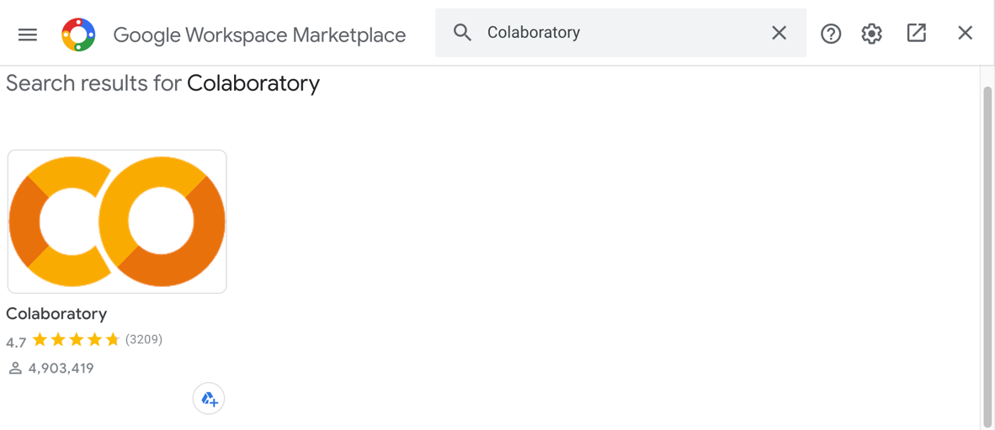

Figure 3 Install Colaboratory

Click install and you will have to accept the permissions in order to install it.

Figure 4 Install Colaboratory

***2. Creating Notebook***

Once Google Colab is installed, is necessary to create a Google Colab notebook through Google Drive, it can be created from any folder, but to have a better organization it will be done on the same folder where the CUDA files are going to be. Open the folder you’re going to be using and click the **New** button and select **Google Colaboratory**. This will create your Colab NotebookGraphical user interface, application

Figure Create new Notebook

***3. Connect Drive to Google Colab local environment***

*Disclaimer. You will have to do this every time you reconnect to your Google Colab notebook.*

You will have to add a piece of code to your Google Colab Notebook, to do so you will have to create a code block clicking on **+ Code.** 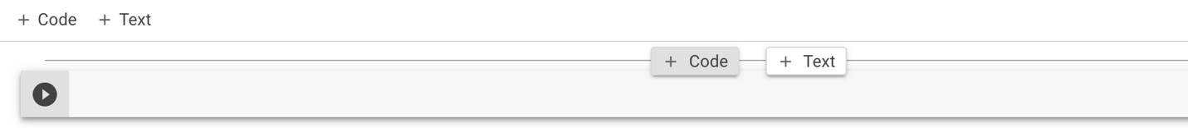

Figure Insert Snippet of Code

Then add the following snippet of code:

from google.colab import drive

drive.mount('/content/drive')

%cd "/content/drive/My Drive/YourFolder"

!pwd

If you added the folder to the root of your Google Drive you will have to replace “YourFolder” with the name of your folder. This folder is going to be the one in where the CUDA files will be present. Make sure that the path to your folder is correct, note that the root Drive Folder is **"/content/drive/My Drive”**.

Figure Authorization code copy

Run the snippet of code and once you run it a prompt like the following will appear. You will have to click on the link that is shown, follow the instruction and copy the authorization code to your clipboard using the clipboard button.

Then you will have to paste the code to the text field shown in the figure 8.

Figure Authorization Code Paste