GENERAL OBJETIVE  Partnering with Central Cervecera de Colombia to develop applications and connections with machines that generate smart data, providing our clients with the insights they need to make informed decisions and drive business growth.  overview  [08-08-2023] - currently  As a Software Developer at ACI group (partner of Siemens in Colombia) working on the MindSphere IIoT cloud, I have gained experience in developing applications using a low code platform called Edge2Web. In my role, I design and develop event tables and time series data with assets and aspect types, while utilizing JavaScript to manipulate JSON structures and calculate KPIs for data analysis and visualization. Through collaboration with cross-functional teams, I have gained valuable experience in delivering high-quality software solutions in a timely manner.  TASKS  - Develop and maintain applications using Edge2Web, a low code platform, for Siemens' MindSphere IIoT cloud.  - Design and develop event tables and time series data with assets and aspect types to support application functionality and performance.  - Utilize JavaScript to manipulate JSON structures and calculate KPIs to support data analysis and visualization.  - Collaborate with cross-functional teams to ensure timely delivery of high-quality software solutions.  - Participate in code reviews and provide technical guidance to team members. | PERSONAL OBJETIVES  Gain knowledge and experience in IoT developments, especially in those related with applications and web developments.  - Practice for coding in front and back-end languages.  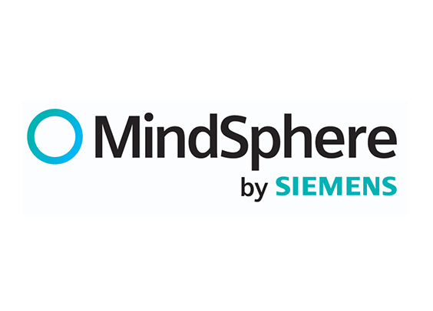 IIoT Cloud powered by Siemens  Low code platform   Intermediate level  Experienced level 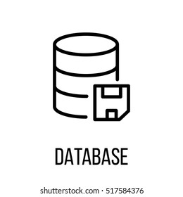 Management of event tables and time series  Intermediate level  Siemens RESTful APIS  +15 developments for customers  Experiencia de voluntariado o liderazgo  ¿Ha administrado un equipo de un club, liderado un proyecto para su organización benéfica favorita o ha editado el periódico de su centro educativo? Prosiga y describa las experiencias que ilustran sus habilidades de dirección.

