OVERVIEW  Through the study of personal development and the works of various authors, I have gained a wealth of knowledge and skills that have helped me to achieve success and fulfillment in my life. Being focus in the study of humand mind and the relation between Counscious and Subcounscious.  skills  - Goal-setting: I have learned how to set clear and achievable goals for myself, thanks to Napoleon Hill's "Think and Grow Rich."  - Communication: "How to Win Friends and Influence People" by Dale Carnegie taught me valuable communication skills, such as active listening and effective speaking.  - Mindfulness: The Silva Mind Control Method has helped me to develop mindfulness techniques, which allow me to stay calm and centered in difficult situations.  - Positive thinking: "The Power of Your Subconscious Mind" by Joseph Murphy has taught me how to harness the power of subcouncious mind to achieve my goals.  - Scientific curiosity: "The Dragons of Eden" by Carl Sagan, “A brief history of time” by Stephen Hawking and “Hyperspace” by Michio Kaku, have inspired me to cultivate a scientific curiosity, which helps me to explore new ideas and approaches.  Personal development is a journey of self-discovery, growth, and fulfillment. By taking the time to invest in yourself and develop new skills, you can unlock your full potential and achieve your goals. But remember, true success is not just about external achievements, but also about inner growth and self-awareness. It requires dedication, perseverance, and a willingness to learn from your experiences. So, embrace the journey of personal development, stay curious, and trust in yourself and your abilities. With the right mindset and approach, you can overcome any obstacle and create a life that is both meaningful and fulfilling. | PERSONAL OBJETIVES  Learn more about myself.  - Deep understanding of the highest faculties in the human mind  - Develop better social skills  - Improve my meditation  - Listen the gratest in the history and learn from them  - See beyond the apparent  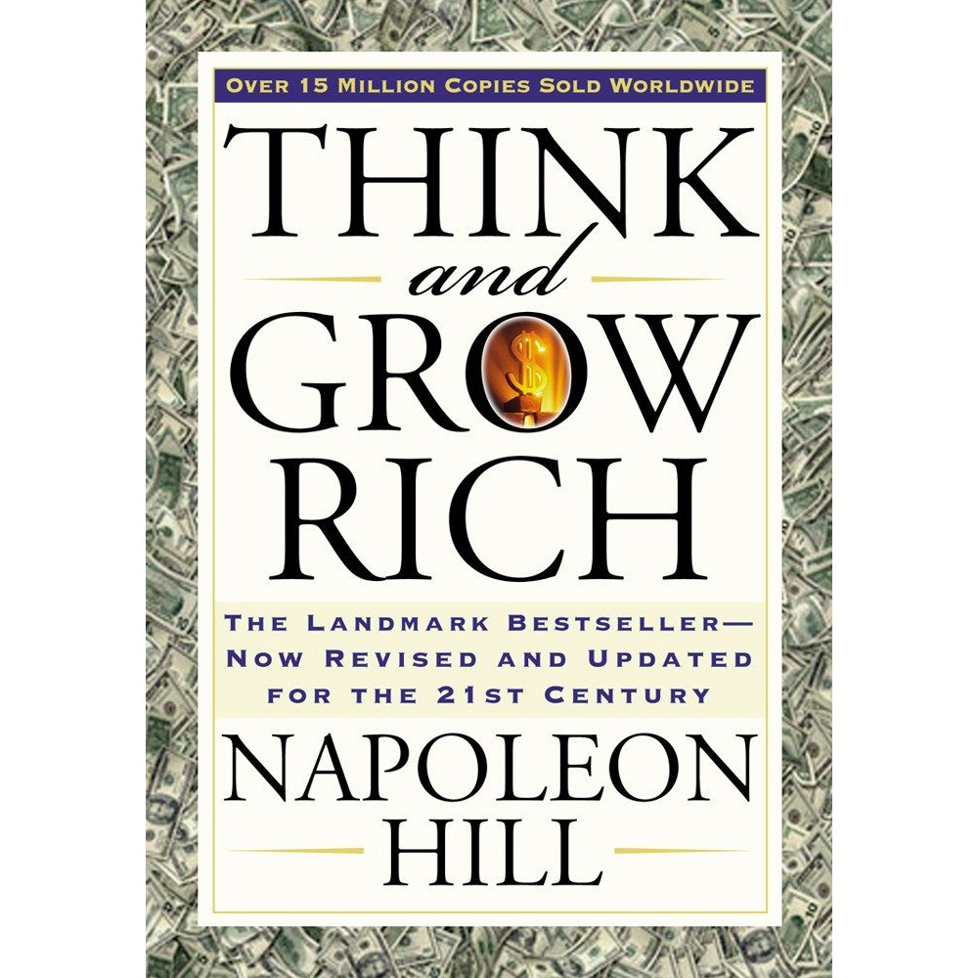 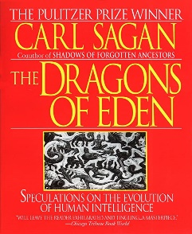    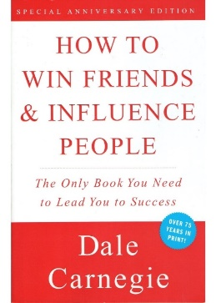  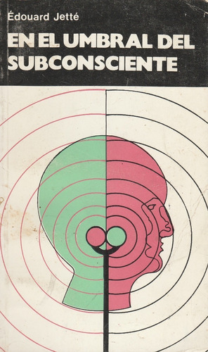 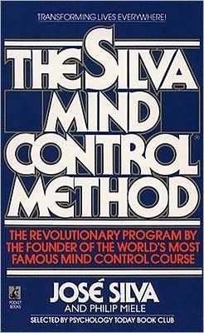  Experiencia de voluntariado o liderazgo  ¿Ha administrado un equipo de un club, liderado un proyecto para su organización benéfica favorita o ha editado el periódico de su centro educativo? Prosiga y describa las experiencias que ilustran sus habilidades de dirección.

