OVERVIEW  I had the opportunity to be teachers assistant in the mechanical physics laboratory during my bachelor studies at National University.  Experience and learning  I skilled subjects related with basic physics, metrology and statistics neccesary to deploy mechanical experiments and teach effectively a wide range of topics to more than 300 students during my almost 2 years of experience.  COMMUNICATION  Improved my ability to communicate complex concepts in a clear and concise manner, ensuring that students of all levels were able to understand and apply the material.  FOUNDAMENTALS  With a strong focus on statistical uncertainty, I was able to teach students how to approach and analyze basic scientific problems with a critical and analytical mindset. I also helped them to develop their problem-solving skills and fosters a deeper understanding of the subject matter.  INSPIRATION  I felt I enhanced my ability to inspire and engage students in the study of physics. Through my expertise and dedication, some of them were able to aquire love of learning and a deep appreciation for the beauty and complexity of the natural world, spetially from a classical perspective of nature, vitally important to develop future scientists.  INFORMATION TECHNOLOGIES  Knowing better and managing the fundamentals of physics has improved my skills in a deep understanding of mathematical and computational principles that some fields like full stack web development and data analysis require.  Links:  https://virtualciencias.medellin.unal.edu.co/course/view.php?id=31 | lessons  Fundamentals of Metrology, Static Calibration of a Spring, Equilibrium of a particle: Concurrent forces, Equilibrium of a rigid body: Non-concurrent forces, Freefall, the inclined plane, Parabolic movement, Circular movement, Newton's Second Law: Rectilinear Motion and Circular Motion, Energy conservation,collisions, centers of mass.     +2 years being assistant +210 teaching class in the experience   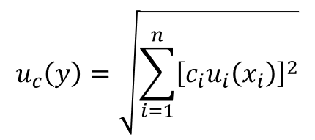  interactions with +300 students in the experience Statistical Uncertainty focused lessons  Experiencia de voluntariado o liderazgo  ¿Ha administrado un equipo de un club, liderado un proyecto para su organización benéfica favorita o ha editado el periódico de su centro educativo? Prosiga y describa las experiencias que ilustran sus habilidades de dirección.

