--------------------------------------------------------------------

1. GENERAL INFO

GEMALTO SUPPORT TEAM - TECHNICAL REPORT

Customer: TigoBo

Contac Name: Carlos Mercado

Call id:

Date & Time: 05-10-2020

--------------------------------------------------------------------

**Cliente ID: 49249**

**Descripcion: TIGOBO_M_029_Equipetrol Norte_LTE_Santa Cruz**

--------------------------------------------------------------------

2. DETAILS OF INCIDENT:

Impacted platform:

Root Cause: desconocida aun

Incident description:

Evidencias:

|  |
| --- |
| 2020-10-04 20:36:43.208 - SessionManager.DialerConnect - sms.net.QmiDialer.WorkerChannelReader - ERROR - QmiDialer WorkerChannelReader getConnectionToken has timed out 100 times  2020-10-04 20:36:43.211 - SessionManager.DialerConnect - sms.net.QmiDialer - WARN - Retrying qmi connection...  2020-10-04 20:36:53.655 - SessionManager.DialerConnect - sms.net.QmiDialer.WorkerChannelReader - ERROR - QmiDialer WorkerChannelReader getConnectionToken has timed out 100 times  2020-10-04 20:36:53.658 - SessionManager.DialerConnect - sms.net.QmiDialer - WARN - Retrying qmi connection...  2020-10-04 20:37:04.109 - SessionManager.DialerConnect - sms.net.QmiDialer.WorkerChannelReader - ERROR - QmiDialer WorkerChannelReader getConnectionToken has timed out 100 times  2020-10-04 20:37:04.112 - SessionManager.DialerConnect - sms.net.QmiDialer - WARN - Retrying qmi connection...  2020-10-04 20:37:14.533 - SessionManager.DialerConnect - sms.net.QmiDialer.WorkerChannelReader - ERROR - QmiDialer WorkerChannelReader getConnectionToken has timed out 100 times |

--------------------------------------------------------------------

3. RESOLUTION

Incident Analysis: ya lo escribo coma ...

Workaround: se aplica fix

Recommendation: visita a sitio

Additional comments: NA

--------------------------------------------------------------------

**Cliente ID: 1019**

**Descripcion: TIGOBO_M_055_Hermanos Ruiloba_LTE_Tarija_Julio Baldiviezo**

--------------------------------------------------------------------

2. DETAILS OF INCIDENT:

Impacted platform:

Root Cause: desconocida aun

Incident description:

Evidencias:

|  |
| --- |
| 2020-10-04 16:49:42.924 - SessionManager.DialerConnect - sms.net.QmiDialer.WorkerChannelReader - ERROR - QmiDialer WorkerChannelReader getConnectionToken has timed out 100 times  2020-10-04 16:49:42.924 - SessionManager.DialerConnect - sms.net.QmiDialer - WARN - Retrying qmi connection...  2020-10-04 16:49:53.332 - SessionManager.DialerConnect - sms.net.QmiDialer.WorkerChannelReader - ERROR - QmiDialer WorkerChannelReader getConnectionToken has timed out 100 times  2020-10-04 16:49:53.332 - SessionManager.DialerConnect - sms.net.QmiDialer - WARN - Retrying qmi connection...  2020-10-04 16:50:03.767 - SessionManager.DialerConnect - sms.net.QmiDialer.WorkerChannelReader - ERROR - QmiDialer WorkerChannelReader getConnectionToken has timed out 100 times  2020-10-04 16:50:03.767 - SessionManager.DialerConnect - sms.net.QmiDialer - WARN - Retrying qmi connection...  2020-10-04 16:50:14.324 - SessionManager.DialerConnect - sms.net.QmiDialer.WorkerChannelReader - ERROR - QmiDialer WorkerChannelReader getConnectionToken has timed out 100 times |

--------------------------------------------------------------------

3. RESOLUTION

Incident Analysis: ya lo escribo coma ...

Workaround: se aplica fix

Recommendation: visita a sitio

Additional comments: NA

--------------------------------------------------------------------

**Cliente ID: 36710**

**Descripcion: TIGOBO_M_009_Villa Busch_LTE_Pando**

--------------------------------------------------------------------

2. DETAILS OF INCIDENT:

Impacted platform:

Root Cause: desconocida aun

Incident description:

Evidencias:

|  |
| --- |
| 2020-10-04 11:04:43.219 - SessionManager.DialerConnect - sms.net.QmiDialer.WorkerChannelReader - ERROR - QmiDialer WorkerChannelReader getConnectionToken has timed out 100 times  2020-10-04 11:04:43.219 - SessionManager.DialerConnect - sms.net.QmiDialer - WARN - Retrying qmi connection...  2020-10-04 11:04:53.653 - SessionManager.DialerConnect - sms.net.QmiDialer.WorkerChannelReader - ERROR - QmiDialer WorkerChannelReader getConnectionToken has timed out 100 times  2020-10-04 11:04:53.655 - SessionManager.DialerConnect - sms.net.QmiDialer - WARN - Retrying qmi connection...  2020-10-04 11:05:04.136 - SessionManager.DialerConnect - sms.net.QmiDialer.WorkerChannelReader - ERROR - QmiDialer WorkerChannelReader getConnectionToken has timed out 100 times  2020-10-04 11:05:04.138 - SessionManager.DialerConnect - sms.net.QmiDialer - WARN - Retrying qmi connection...  2020-10-04 11:05:14.580 - SessionManager.DialerConnect - sms.net.QmiDialer.WorkerChannelReader - ERROR - QmiDialer WorkerChannelReader getConnectionToken has timed out 100 times |



--------------------------------------------------------------------

3. RESOLUTION

Incident Analysis: ya lo escribo coma ...

Workaround: se aplica fix

Recommendation: visita a sitio

Additional comments: NA

--------------------------------------------------------------------

**Cliente ID: 42139**

**Descripcion: TIGOBO_M_008_Av. Pedro Marban_3G_Beni**

--------------------------------------------------------------------

2. DETAILS OF INCIDENT:

Impacted platform:

Root Cause: No aplica

Incident description:

Evidencias:

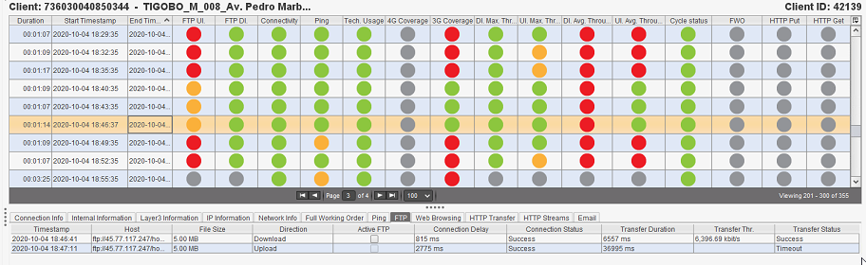

--------------------------------------------------------------------

3. RESOLUTION

Incident Analysis: prueba de Analisis

Workaround: NA

Recommendation: NA

Additional comments: NA

--------------------------------------------------------------------

**Cliente ID: 42149**

**Descripcion: TIGOBO_M_024_Raquelita_3G_Cochabamba _Diego Vargas**

--------------------------------------------------------------------

2. DETAILS OF INCIDENT:

Impacted platform:

Root Cause: No aplica

Incident description:

Evidencias:

--------------------------------------------------------------------

3. RESOLUTION

Incident Analysis: prueba de Analisis

Workaround: NA

Recommendation: NA

Additional comments: NA