--------------------------------------------------------------------

1. GENERAL INFO

GEMALTO SUPPORT TEAM - TECHNICAL REPORT

Customer: TigoBo

Contac Name: Carlos Mercado

Call id:

Date & Time: 06-10-2020

--------------------------------------------------------------------

**Cliente ID: 42139**

**Descripcion:** TIGOBO_M_008_Av. Pedro Marban_3G_Beni

--------------------------------------------------------------------

2. DETAILS OF INCIDENT:

Impacted platform:

Root Cause: desconocida aun

Incident description:

Evidencias:

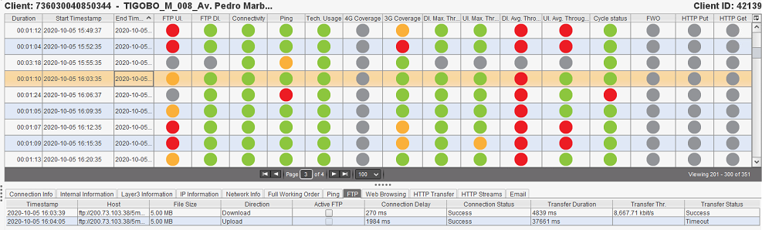

--------------------------------------------------------------------

3. RESOLUTION

Incident Analysis: ya lo escribo coma ...

Workaround: se aplica fix

Recommendation: visita a sitio

Additional comments: NA

--------------------------------------------------------------------

**Cliente ID: 36652**

**Descripcion:** TIGOBO_M_013_Ciudad Satelite_GSM_La Paz

--------------------------------------------------------------------

2. DETAILS OF INCIDENT:

Impacted platform:

Root Cause: desconocida aun

Incident description:

Evidencias:

|  |
| --- |
| 2020-10-05 18:13:49.505 - SessionManager.DialerConnect - sms.net.QmiDialer.WorkerChannelReader - ERROR - QmiDialer WorkerChannelReader getConnectionToken has timed out 100 times  2020-10-05 18:13:49.505 - SessionManager.DialerConnect - sms.net.QmiDialer - WARN - Retrying qmi connection...  2020-10-05 18:13:59.973 - SessionManager.DialerConnect - sms.net.QmiDialer.WorkerChannelReader - ERROR - QmiDialer WorkerChannelReader getConnectionToken has timed out 100 times  2020-10-05 18:13:59.976 - SessionManager.DialerConnect - sms.net.QmiDialer - WARN - Retrying qmi connection...  2020-10-05 18:14:10.441 - SessionManager.DialerConnect - sms.net.QmiDialer.WorkerChannelReader - ERROR - QmiDialer WorkerChannelReader getConnectionToken has timed out 100 times  2020-10-05 18:14:10.443 - SessionManager.DialerConnect - sms.net.QmiDialer - WARN - Retrying qmi connection... |

--------------------------------------------------------------------

3. RESOLUTION

Incident Analysis: ya lo escribo coma ...

Workaround: se aplica fix

Recommendation: visita a sitio

Additional comments: NA

--------------------------------------------------------------------

**Cliente ID: 38701**

**Descripcion:** TIGOBO_M_003_Av. Litoral_3G_La Paz - El Alto

--------------------------------------------------------------------

2. DETAILS OF INCIDENT:

Impacted platform:

Root Cause: desconocida aun

Incident description:

Evidencias:

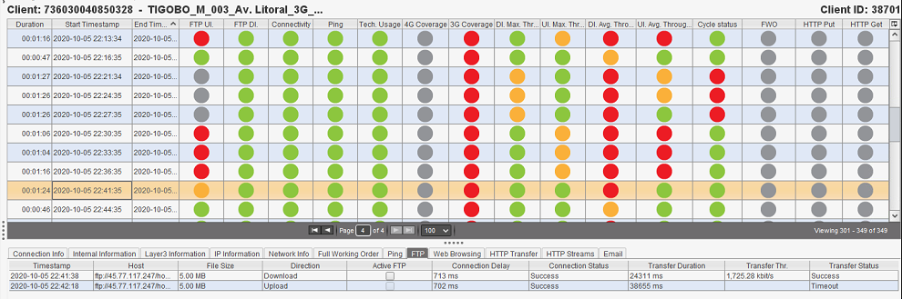

--------------------------------------------------------------------

3. RESOLUTION

Incident Analysis: ya lo escribo coma ...

Workaround: se aplica fix

Recommendation: visita a sitio

Additional comments: NA

--------------------------------------------------------------------

**Cliente ID: 42149**

**Descripcion:** TIGOBO_M_024_Raquelita_3G_Cochabamba _Diego Vargas

--------------------------------------------------------------------

2. DETAILS OF INCIDENT:

Impacted platform:

Root Cause: desconocida aun

Incident description:

Evidencias:

--------------------------------------------------------------------

3. RESOLUTION

Incident Analysis: ya lo escribo coma ...

Workaround: se aplica fix

Recommendation: visita a sitio

Additional comments: NA