

**Gazi University**

**BMT-209 Project**

**Gazi University Technology Faculty**

**Computer Engineering Project Report**

**MiKurī**

**Project Creators**

**First Manager’s**

**Name:** Juan Diego

**Surname:** RonMolina

**Number:** 22181616070

**Second Manager’s**

**Name:** Mohammad Murad

**Surname:** Chamaa

**Number:** 23181616063

**Project Assigner’s**

**Name:** Ayberk

**Surname:** Şencan

**Date: 23/12/2024**

1. **Determining the Subject for**

**Object-Oriented Programming**

* Java is quite efficient for creating games as it has object-oriented programming feature, which is important for games as they contain many objects. That’s why wethought we can make a game project in Java.

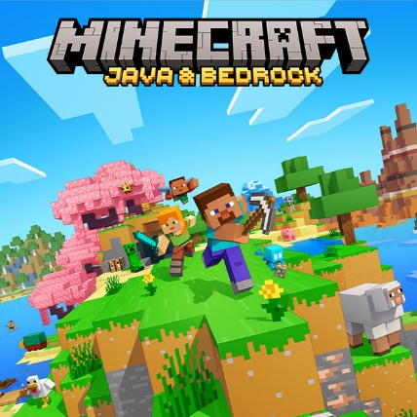 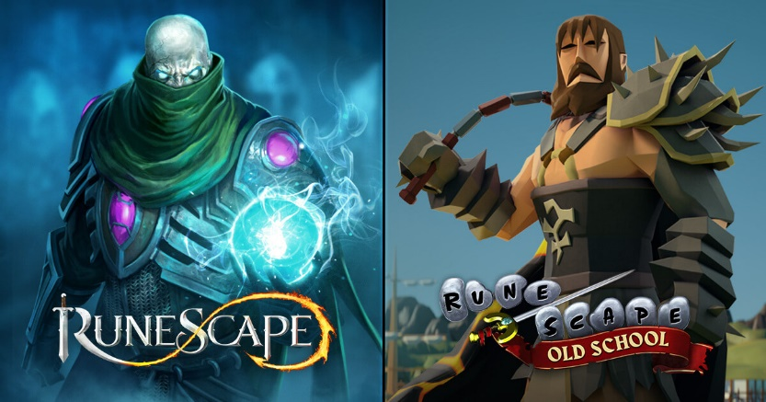 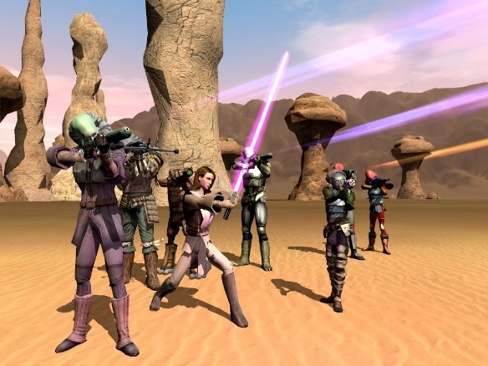

Minecraft RuneScape Star Wars Galaxies

* Many popular games that written in Java is made for web version and they are old (not including Minecraft). Because in Java there are great reasons to make the game capable for website: cross-platforming compatibility, browser integration, robust networking capabilities …
* But by the time, web-based games are slowly falling apart. Players love to play the games on a downloaded app, not from the website and the developers can’t make a huge space-consuming game. Because of that, we want to make our game as a downloadable app. There is one more problem that we didn’t choose to make it for web version, our game will be playable offline.
* We wanted to use the object-oriented programming feature as much as possible. That’s why we thought that we can make a Pokémon type game.
* MiKurī means Mini Kurīchā (Mini Creatures), that is the name of the game.

1. **Planning to How to Create the Game**

* Here is the process of how to create our game:
* **Start & Loading Screen (Options, Credits, Progress Bar, Tips and Tricks)**
* **Juan & Murad**
* **Ingame & Pause Screen (Environment/Map/Save Game/Options/Main Menu)**
* **Juan & Murad**
* **Player’s Setup (Specialties/Inventory)**
* **Murad**
* **Battle Screen (4 Type Feature, Bonus Attacks (Increase Damage), Animations)**
* **Juan**

**2.1) Start & Loading Screen**

* Continue
* New Game
* Options
* Exit Game

**Fire, Water, Electric, Grass, Ice, Fighting, Poison, Flying, Rock**

