SwissBytes Ltda.

CHANGE HISTORY

|  |  |  |  |
| --- | --- | --- | --- |
| DATE | DESCRIPTION | VERSION | AUTHOR |
| 27.08.2012 | Create Initial Documentation | 1.0 | Eduardo F. Sandino |
| 03.09.2012 | * Inserting Native App. GUI in the document * Defining Use cases of the application. | 1.1 | Eduardo F. Sandino |
|  |  |  |  |

REVIEW HISTORY

|  |  |  |  |
| --- | --- | --- | --- |
| DATE | DESCRIPTION | VERSION | AUTHOR |
| <dd.mm.yyyy> | <what did you add> | 1.0 | <who are you> |
|  |  |  |  |
|  |  |  |  |

INVOLVED PERSONS

|  |  |  |
| --- | --- | --- |
| PerSON | COMPANY | ROLE |
| <First Name, Name> | <Company> | <Role in project/company> |
|  |  |  |
|  |  |  |
|  |  |  |
|  |  |  |
|  |  |  |
|  |  |  |

CONTENT

1 Introduction 5

1.1 Goal 5

1.2 Focus 5

1.3 Definitions, abbreviations and acronyms 5

1.4 References 5

1.5 Overview 5

2 Architectural Overview 6

2.1 Architectural goals and conditions 6

3 Actors and roles 7

3.1 Actors and Actions 7

4 Use Case view 8

4.1 Manage Users 9

4.2 Manage Publishers 10

4.3 Manage Flyer Publication 11

5 Process View 12

6 Status View 12

6.1 Flyer Status 12

7 Interfaces with External Systems 12

8 Batch Order Processing Diagrams 12

9 User interface 13

9.1 Flyer Native App. GUI 13

9.1.1 Activation and Category Subscription 13

9.1.2 List of Categories 14

9.1.3 Available options in the Menu 16

9.1.4 Offer List 17

9.1.5 List of favorite offers 18

9.1.6 Offer detail and Geographic Information 19

9.1.7 Configuration Options 20

table of figures

Figure 1 – Architectonic design of the whole solution 6

Figure 2 – actors 7

Figure 3 - actors and Actions 7

Figure 4 - use cases 8

Figure 5 - Manage users 9

Figure 6 - Manage Publishers 10

Figure 7 - Manage flyer publication 11

Figure 8 - FLYER STATUS 12

Figure 9 - Oferta digital activation 13

Figure 10 - category list 14

Figure 11 - opening menu 15

Figure 12 - menu options 16

Figure 13 - offer list 17

Figure 14 - list of favorite offers 18

Figure 15 - offer detail and geographic information 19

Figure 16 - configuration options 20

# Introduction

## Goal

The goal of this document is describe the architecture of Flyer Manager Project. Flyer Manager is a project that will manage flyers from external customers and display them over cell phones like Android. For realizing this, the android app should be connected to a main server. In this document we describe the details of the project’s architecture.

## Focus

This document is meant to describe the architecture of Flyer Manager Project; the project is compound of two components:

* Flyer Manager Server
* Flyer Native Android Application

## Definitions, abbreviations and acronyms

|  |  |
| --- | --- |
| TERM | DESCRIPTION |
| Android | Android is a Linux-based operating system primarily designed for mobile devices such as smartphones and tablet computers utilizing ARM processors |
| Flyer | A flyer or flier, also called a circular, handbill or leaflet, is a form of paper advertisement intended for wide distribution and typically posted or distributed in a public place. |

Table 1 – definitions, abbreviations and acronyms

## References

|  |  |  |
| --- | --- | --- |
| ID | TITLE | SOURCE |
|  |  |  |
|  |  |  |
|  |  |  |

Table 2 – references

## Overview

This chapter gives an overview about all the containing information in this document.

In chapter 0 you will find …

# Architectural Overview

In this chapter we present our proposal of the technical architecture for archiving current and future requirements of the Flyer Manager project.



Figure – Architectonic design of the whole solution

## Architectural goals and conditions

The aim of our architecture is to fulfill actual requirements and facilitate further modular extensions. The entire architecture bases on a loose coupled modular service dependent design.

# Actors and roles

Flyer manager will contain the actors shown in Figure 1.



Figure – actors

## Actors and Actions

Overview of actions an actor can execute in the flyer server application can be found in the Figure 3.

|  |  |
| --- | --- |
| Actor | actions |
| Administrator | * Can execute all the actions of the system. * Can view advanced configurations. |
| Agency Administrator | * Can create a limited number of publishers * Can manage categories. * Can publish flyers. * Can browse reports. (related to his account) |
| Publisher | * Can publish flyers. * Can browse reports. (related to his account) |
| Observer | * Can read flyers. * Can sub-scribe to categories. * Can mark flyers as favorite. |

Figure - actors and Actions

# Use Case view

In this chapter we detail the uses cases of Flyer Manager, as you can see in Figure 4 you can have a big view of the main uses cases. Then in the following sections each use case will be exploded to see internal details.



Figure - use cases

## Manage Users

This set of use cases is related to the user management. As you can see in Figure 5 all the related use cases to the user management are displayed.



Figure - Manage users

## Manage Publishers

This set of use cases is related to the management of publishers. As you can see in Figure 6 all the related use cases are displayed.



Figure - Manage Publishers

## Manage Flyer Publication

This set of uses cases detail the operations needed to manage the flyers as denoted in the Figure 7.



Figure - Manage flyer publication

# Process View

# Status View

## Flyer Status

In the Figure 8 you can see the statuses used by the flyer during their life time. The flow is quite simple but this should cover all the needed functionalities.



Figure - FLYER STATUS

# Interfaces with External Systems

# Batch Order Processing Diagrams

# User interface

In this chapter we will show some GUI Mocks of the Flyer Server and Flyer Clients.

## Flyer Native App. GUI

### Activation and Category Subscription

In the Figure 9 we can see the GUI’s that are part of the activation process. Initially the user that downloads the application should put some initial data, activate and select some basic categories to start browsing the expected offers.

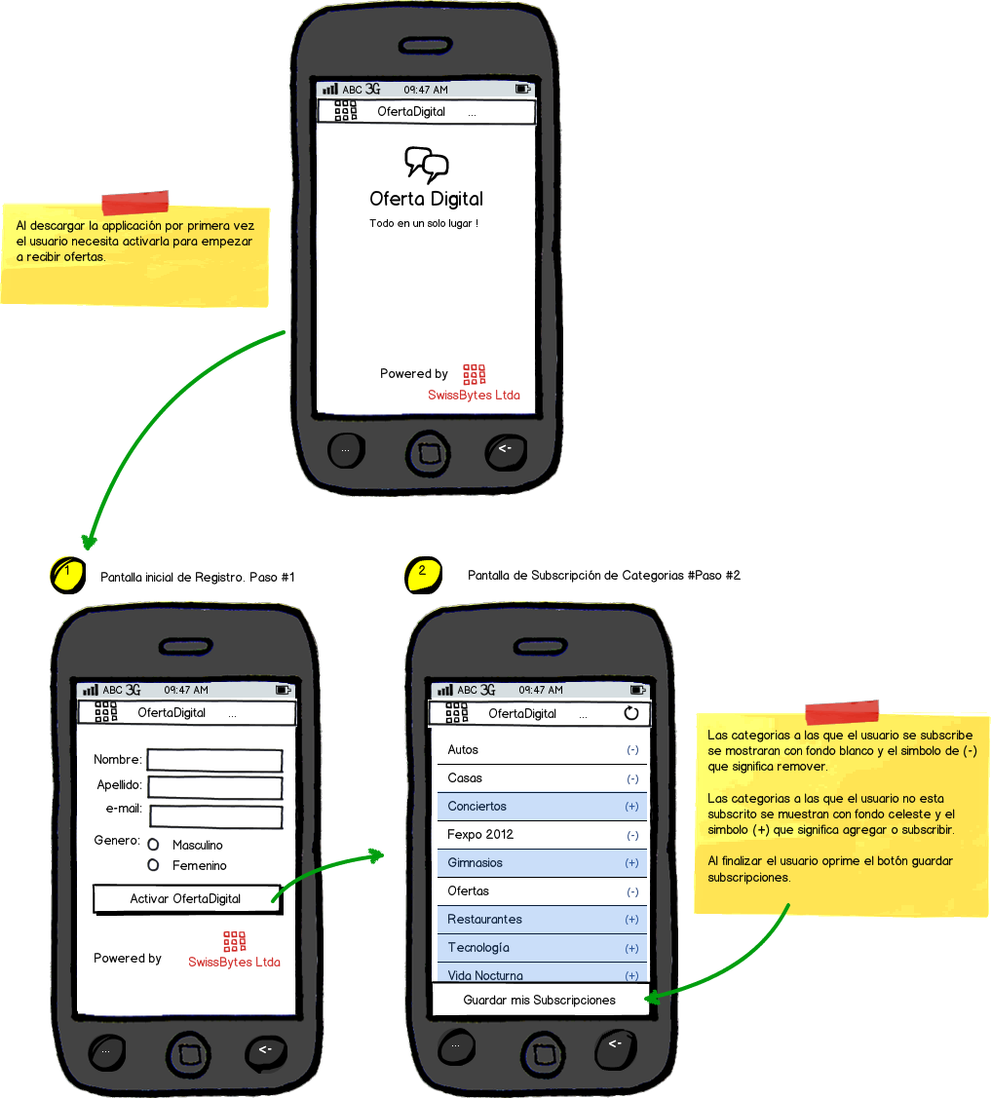

Figure - Oferta digital activation

### List of Categories

In the Figure 10 you can see the detail of the category list and in Figure 11 you can see what happens when you click the menu for displaying the menu.

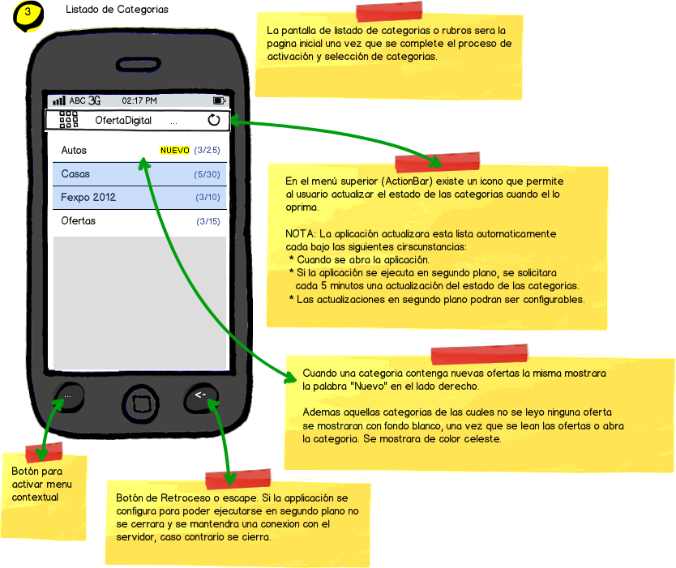

Figure - category list

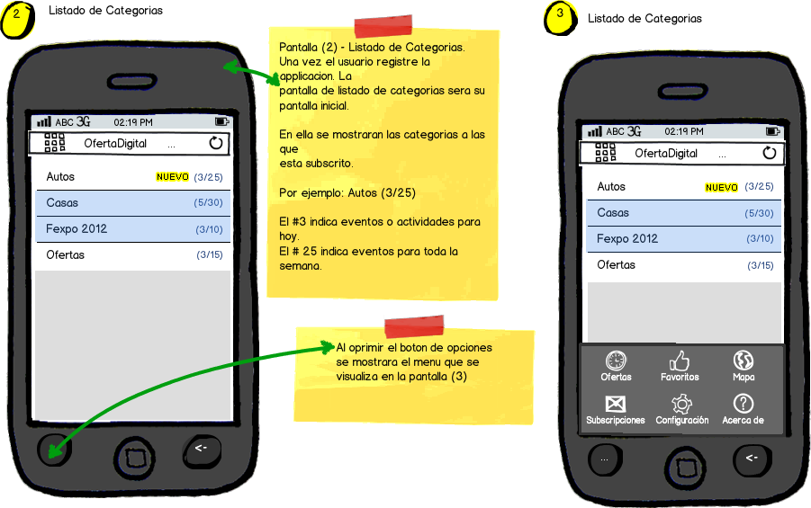

Figure - opening menu

### Available options in the Menu

In the Figure 12 you can see detailed options from the native’s app menu such as:

* Offers – Redirects to the category list.
* Favorites – Redirects to the favorite page.
* Map – Shows a map of your current location.
* Subscriptions – Allows manage the user’s subscriptions.
* Configuration – Allows managing some extra configurations.
* About – Show information about SwissBytes Ltda. The company that developed this application.

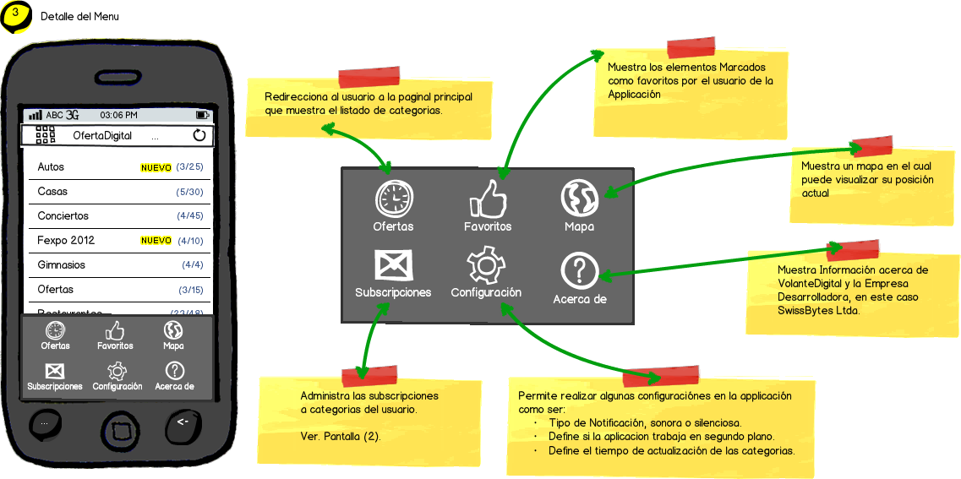

Figure - menu options

### Offer List

In the Figure 13 the two views used to browse the offer list. The user can filter offers that are available for today or the week. There are other additional options that can be used in the list of offers such as: mark offer as favorite and browse map position. Also in the right top of GUI you have an icon of a curved row that allows you to refresh the list of offers.

NOTE: The application will automatically hide offers and events that are outdated.

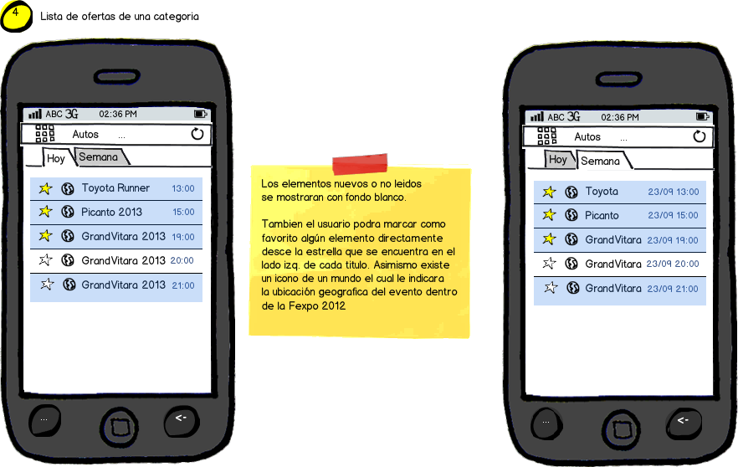

Figure - offer list

### List of favorite offers

In the Figure 14 you can see the list of favorite offers marked by the user of the mobile application. This GUI allows you to browse your favorites in similar way as the list of offers using the tabs: TODAY and WEEKEND.

NOTE: The application will automatically hide offers and events that are outdated.

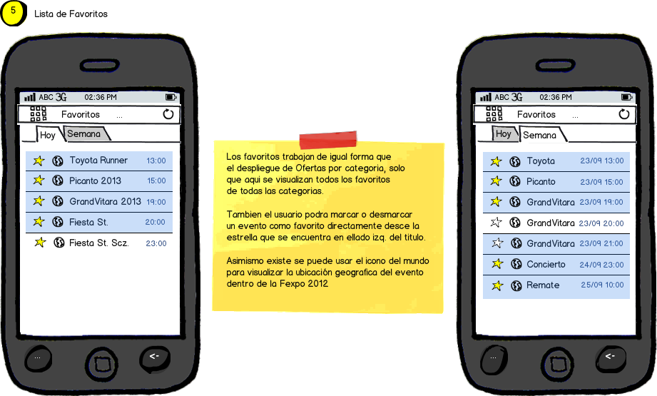

Figure - list of favorite offers

### Offer detail and Geographic Information

In the GUIS shown in Figure 15 you can see the offer detail and the geographic information of the offer.

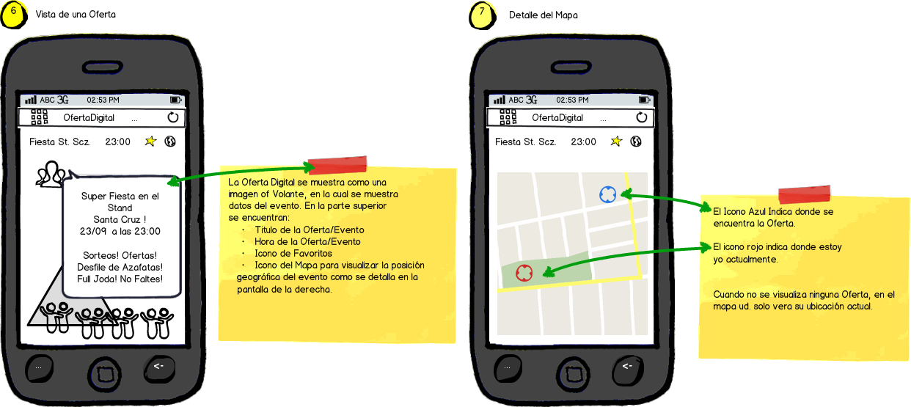

Figure - offer detail and geographic information

### Configuration Options

In the Figure 16 you can see the available options to customize the configuration of the mobile application. These options are described in detail in the corresponding use case. By the moment we will list the options:

* Silent notifications. (This means that when a new offer is detected the app won’t produce any noise unless the user unchecks this configuration).
* Run OfertaDigital in background. (This means that the application never is closed. The application will run in background). If the user select this option also can change the time of synchronization with the main server to get updates every 5, 10 and 15 minutes.

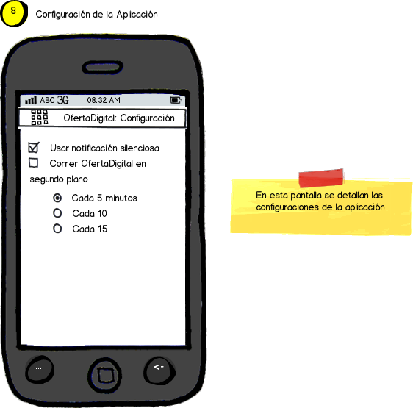

Figure - configuration options