Sign up Facebook

Sign up with Google

Sign up with Twitter

**Join Miles2Run Today**

Capture all your runs, anytime, anywhere.

Miles2Run is a fast and fun way to share your running activities with friends and family.

Sign up, enter an activity, share, and track your progress. It’s easy.

**About Contact FOLLOW US TWITTER GOOGLE+ FACEBOOK**

Why join Miles2Run community

CONNECT WITH LOCAL RUNNERS TRACK YOUR ACTIVITY SHARE WITH FRIENDS

**Miles2Run Home User Profile**

5 Countries

20 Cities

10 Hours

10 Miles

100 Runners

**Total Activities**

3

**Average Pace**

3:00

**Covered**

5Kms

**Goal**

10Kms

**Recent Activities**

**Miles2Run *Home* Notifications User Profile**

***DASHBOARD***

TIMELINE

POST ACTIVITY

CALENDAR

FRIENDS

Shekhar Gulati completed a 1 Km running activity.

1 day ago

Shekhar Gulati complete a 2 Km running activity.

2 hours ago

Edit Delete

Shekhar Gulati complete a 2 Km running activity.

1 week ago

**Arun Gupta** completed a 5 km running activity. 2 days ago

Awesome experience

**Share**

**Shekhar Gulati** completed a 10 km running activity. 2 minutes ago

Feeling great after the activity.

**Share**

**Timeline**

**Miles2Run *Home* Notifications User Profile**

DASHBOARD

***TIMELINE***

POST ACTIVITY

CALENDAR

FRIENDS

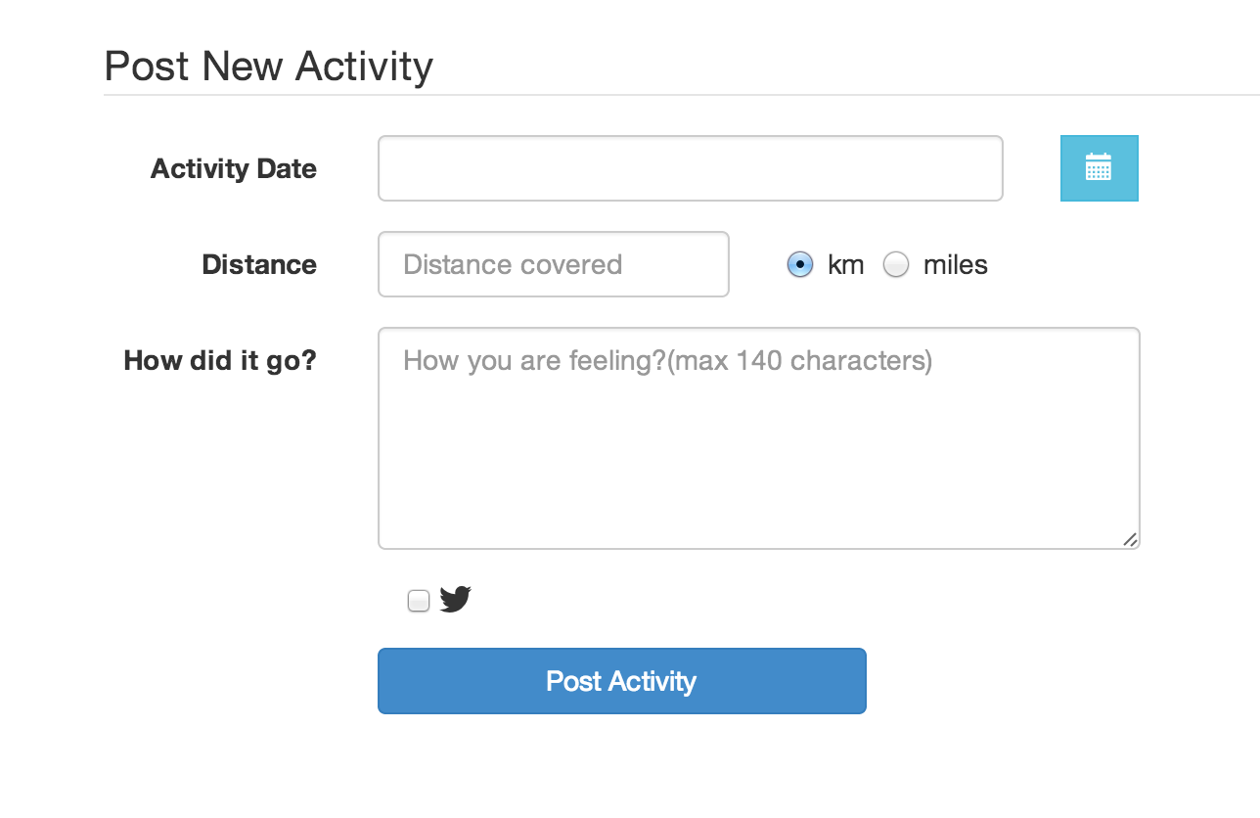

DASHBOARD

TIMELINE

***POST ACTIVITY***

CALENDAR

FRIENDS

**Miles2Run *Home* Notifications User Profile**

**Miles2Run *Home* Notifications User Profile**

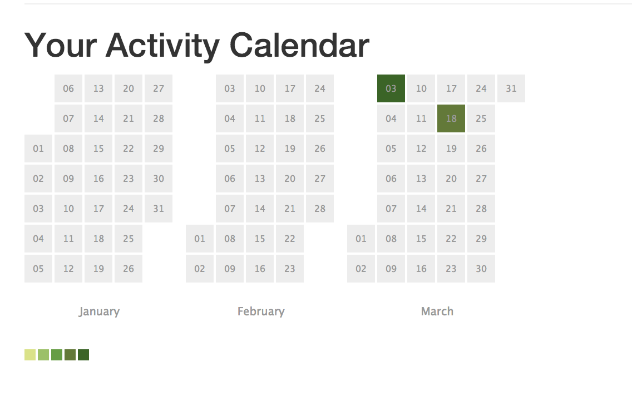

DASHBOARD

TIMELINE

POST ACTIVITY

***CALENDAR***

FRIENDS

User 3

User 2

User 1

Here are some people you can follow

DASHBOARD

TIMELINE

POST ACTIVITY

CALENDAR

***FRIENDS***

**Miles2Run *Home* Notifications User Profile**

Search Users…