UNIVERSITAT JAUME I
Master's Degree in Intelligent Systems — Master's Thesis
Development and Implementation of a Person-Following System on a Mobile Robot — Part 2 Extension
Master's Thesis Report
Author: Juan Muñoz Rovira
Supervisor: Enric Cervera
Academic Year 2025–2026

Abstract
This thesis extends a person-following system on a TurtleBot 2 with mapping, autonomous navigation, and gesture control. The robot detects legs with a 2D LiDAR, estimates pose with vision (MediaPipe), and tracks the person with a Kalman filter; SLAM Toolbox builds the lab map and Nav2 navigates on it. A “go home” gesture brings tracking and navigation together in one system, completing 82% of return trips in its first session. Everything was tested on the real robot, in the robotics lab at Universitat Jaume I, with the limited resources of a single onboard computer.
Keywords: person-following; mobile robot; 2D LiDAR; SLAM; Nav2; sensor fusion; ROS 2.

Note on the status of this document
This report has six chapters, a bibliography, and two appendices and is based on what is in the project repository and on the data from the lab sessions. The last session, on 23 September 2026, validated the “home” gesture (§5.8). Chapter 5 covers the tests up to the closing date, and whatever falls outside the scope of the thesis appears as future work (§5.10).

Table of Contents
Abstract 1
Note on the status of this document 1
Table of Contents 2
Chapter 1 — Introduction and Problem Statement 4
1.1 Context and Motivation 4
1.2 Thesis Objectives 4
1.3 Scope and Limitations 5
1.4 Planning 5
1.5 Cost Estimate 6
1.6 Structure of the Report 6
Chapter 2 — State of the Art 7
2.1 Introduction and Scope of the Chapter 7
2.2 Person-Following Systems with Mobile Robots 7
2.3 Person Detection via 2D LiDAR (Leg Detection) 7
2.4 Vision-based Human Pose Estimation 7
2.5 LiDAR-camera Sensor Fusion for Robust Detection 8
2.6 Gesture-based Human–Robot Interaction 8
2.7 State Tracking: Bayesian Filters 8
2.8 Obstacle Avoidance and Motion Control 9
2.9 Mapping and Autonomous Navigation (SLAM and Nav2) 9
2.10 Synthesis: What This Thesis Contributes 9
Chapter 3 — System Architecture 9
3.1 Overview 9
3.2 Node and Topic Diagram 10
3.3 Description of Each Node 11
3.4 Coordinated Shutdown Management 14
3.5 Transform Tree (TF) 14
3.6 Configuration Parameters 14
3.7 ROS 2 Package Dependencies 14
3.8 Nav2 Architecture (Phase 3) 15
Chapter 4 — Implementation 17
4.1 Introduction and Scope 17
4.2 Package Structure and Configuration Management 17
4.3 detection_node — Clustering, Leg Features, and Temporal Filtering 17
4.4 visual_detection_node — Dual Detection and Gesture Recognition 18
4.5 tracking_node — Kalman Filter, PD Control, and Obstacle Avoidance 18
4.6 control_node — Finite-State Machine and Teleoperation 19
4.7 collision_handling_node 19
4.8 user_interface_node 20
4.9 slam_node (experimental, disabled by default) 20
4.10 Deployment: Building and Syncing with the Robot 20
4.11 Code Not Registered in the Package 20
Chapter 5 — Results and Evaluation 21
5.1 Validation Methodology 21
5.2 Experimental Setup 21
5.3 Result 1 — Sensor Fusion, No Motion (25 June 2026) 21
5.4 Result 2 — Progression of In-motion Continuity Fixes (8 July 2026) 22
5.5 Result 3 — Per-scenario Repetitions with the System Stabilized (22 July 2026) 24
5.6 Result 4 — Obstacle Scenario: from First Contacts to Contact-free Avoidance (22–23 July 2026) 25
5.7 Result 5 — Nav2: Localization and Autonomous Navigation (27 July 2026) 25
5.8 Result 6 — “Home” Gesture: Integrating Tracking and Navigation (23 September 2026) 26
5.9 Limitations of the Current Results 26
5.10 Future Work 27
Chapter 6 — Conclusions 28
References 28
Appendix A — Use of Artificial Intelligence Tools 29
A.1 Declaration of Use 30
A.2 Tools Used 30
A.3 Reflection on the Ethical Use of Artificial Intelligence 30
A.4 Impact Estimate 30
Appendix B — Development Diary 32

Chapter 1 — Introduction and Problem Statement

1.1 Context and Motivation
At UJI's lab there was already a TurtleBot 2 that followed a person with its LiDAR, but it did not know where it was or how to get back to a place.
This thesis builds on an earlier project that produced a person-following system on a TurtleBot 2 (Kobuki base), able to detect and follow a person using an RPLIDAR A2M8 LiDAR and clustering (DBSCAN) over the leg pattern.
The TurtleBot 2 is a differential-drive research robot platform built on a Kobuki base (Yujin Robot); the RPLIDAR A2M8 is a low-cost 2D LiDAR with a range of up to 12 m. To build maps and localize within them, the project uses SLAM Toolbox (Macenski & Jambrecic, 2021) and AMCL, the particle-filter localizer from the Nav2 navigation stack (Macenski et al., 2020).
The original system had several limitations, and this extension comes from them:
- No mapping: no map of the environment, which prevented any planned navigation.
- No global localization: if the person was lost, the robot could not orient itself.
- Limited interaction: no clear mechanism for the user to start and stop tracking.
- No camera integration: visual detection was not part of the control loop.

1.2 Thesis Objectives

General objective
To extend the person-following system into a mobile assistance platform capable of autonomous navigation, environment understanding, and communication with the user indoors.

Specific objectives
- Gestural interaction module. Starting and stopping tracking with gestures, using MediaPipe Pose (right hand raised to start, left hand to stop). After replacing the camera (Logitech C270 → SPCA2650) and adjusting the visibility threshold, both gestures triggered reliably in real tests. Objective completed.
- SLAM-based mapping. SLAM Toolbox was integrated with the LiDAR to build real-time maps of the lab, reused for localization and navigation. Objective completed.
- Autonomous navigation with Nav2. Scope: AMCL over a saved map and navigation to a target point. The DDS latency failures were fixed by using longer commands, and navigation reached six of seven goals, including two ~8 m routes and avoidance of an unmapped obstacle. Objective completed.
- LiDAR-camera sensor fusion. The camera supplies the bearing when the LiDAR finds no valid leg pair. The static validation gave 100% detection, but in motion jumps and angular saturation appeared; they were fixed with a continuity filter, a Mahalanobis gate and an angular speed limit, plus a corrected inverted sign in the PD control and the avoidance sector. Objective completed.
- User guidance. Having the robot escort the person to predefined destinations in the building. First step validated on the real robot on 23 September 2026: with the “home” gesture, tracking and navigation work together in one system, with 9 of 11 home-return attempts completed (82%) and a 0.27 m mean arrival error (§5.8). Guidance to multiple destinations remains as future work (§5.10).
- Exploratory objective. Try QR codes so the robot can recognize rooms. Still pending at the close of this chapter.

1.3 Scope and Limitations
Development is carried out on the hardware available in the robotics lab at Universitat Jaume I:
- Robot: TurtleBot 2 on a Kobuki base.
- Onboard computing unit: Intel NUC with Ubuntu 24.04 LTS and ROS 2 Jazzy.
- Sensors: 2D LiDAR RPLIDAR A2M8 (12 m range, 10 Hz) and an RGB camera (Logitech C270 until replaced by an SPCA2650, prompted by gesture framing issues). An Orbbec Astra RGB-D camera is also an option, but its integration is still pending.
- Test environment: indoor facilities at Universitat Jaume I.
The following limitations are assumed:
- Navigation restricted to two dimensions (single floor).
- Person detection limited to the horizontal plane, at leg height, since that is the LiDAR's scanning plane.
- Communication between the control PC and the robot over the lab's WiFi network.

1.4 Planning
Development was organized into five phases, shaped by lab availability (limited sessions in June-July, none in August). Table 1.1 summarizes the status of each phase.
Table 1.1
Project phases
Phase | Description | Period | Status
1 | Definition, review of the prior system, and initial drafting | May 2026 | Completed
2 | Gestural interaction module, SLAM integration, and sensor fusion | June 2026 | Completed
3 | Full autonomous navigation with Nav2 | July 2026 | Completed
4 | Experimental validation at UJI's facilities | June–July 2026 | Completed
5 | Closing, final report, and defence | August–September 2026 | Ongoing
Validation tasks not completed within the available lab schedule are documented as future work in Chapter 5.

1.5 Cost Estimate
Table 1.2 estimates the project's costs. The hardware is the equipment already available in UJI's robotics lab, not purchased specifically for this thesis; prices are approximate market prices. The software is entirely open source. The hours line is an estimate based on the lab sessions documented in Appendix B and on the time spent writing this report, not an exact log of hours worked.
Table 1.2
Project cost estimate.
Item | Approximate cost
TurtleBot 2 (Kobuki base) | ~€500
RPLIDAR A2M8 LiDAR | ~€100
Onboard compute unit (Intel NUC) | ~€400
RGB camera (Logitech C270 / SPCA2650) | ~€30
Software (ROS 2, SLAM Toolbox, Nav2, MediaPipe, OpenCV, Python) | €0 (open source)
Development and writing hours (estimated: ~350 h at €15/h) | ~€5,250
Approximate total | ~€6,280

1.6 Structure of the Report
The rest of the report is organized as follows:
- Chapter 2 — State of the Art: literature review connected to the design decisions.
- Chapter 3 — System Architecture: nodes, topics, and data flow.
- Chapter 4 — Implementation: algorithms, control formulas, and package structure.
- Chapter 5 — Results and Evaluation: analysis of the experimental validation data.
- Chapter 6 — Conclusions: final synthesis and closing.
- References: bibliography cited throughout the report.
- Appendix A — AI Tools: declaration of their use as a development aid.
- Appendix B — Development Diary: chronological record of technical progress.

Chapter 2 — State of the Art

2.1 Introduction and Scope of the Chapter
This chapter puts the design decisions of Chapter 3 in context. It goes through the prior work in each area (2D LiDAR detection, vision-based pose, sensor fusion, gestures, Bayesian filters, obstacle avoidance and SLAM/Nav2), without trying to be an exhaustive review.

2.2 Person-Following Systems with Mobile Robots
Person-following is a classic service-robotics problem, combining perception, state estimation and motion control. With LiDAR alone, the geometry of the legs can be used and lighting is not a problem, but chair legs or columns get mistaken for legs. With a camera alone there is a lot of information (gestures, identity, orientation), but occlusions, poor light and a limited field of view cause trouble. Fusion tries to keep the best of each: Sarmento et al. (2024) fuse time-of-flight with a monocular camera, and Kitamoto et al. (2025) propose tracking with 3D LiDAR and point-cloud projection.
These robots typically move indoors on differential bases, like the TurtleBot 2/Kobuki in this thesis. There, perception matters more than kinematics. On outdoor Ackermann bases (Li et al., 2026) maneuverability is limited, which adds constraints not present here.
This thesis's system falls into the multi-sensor fusion category (LiDAR + camera), with the clustering-based LiDAR detector inherited from the initial phase and a visual fallback path added in Phase 2 (§2.5).

2.3 Person Detection via 2D LiDAR (Leg Detection)
Detection from 2D scans at leg height is a well-established line: cluster segmentation, filtering by leg-compatible geometric features (size, radius, circularity, curvature), and pairing plausible candidates, optionally tracking their trajectory to distinguish gait from similar static objects.
Cha and Chung (2020) propose leg detection in a 3D feature space with 2D LiDAR for person-following robots; Yao et al. (2023) address differentiating multiple targets in multi-person scenarios. A recurring challenge is geometric ambiguity: chair/table legs, columns and other cylindrical objects can produce false positives, and partial occlusions —one leg blocking the other during a turn— break the pairing. Guerrero-Higueras et al. (2019) explore convolutional networks over raw 2D scans as an alternative to hand-crafted features, for robustness in cluttered environments.
This project's detection node (§3.3.1) follows the classic geometric-feature approach (DBSCAN clustering, filtering by size and radius, pairing by plausible distance) rather than a deep-learning alternative such as Guerrero-Higueras et al. (2019). That way no dedicated GPU is needed and the original system's already-validated detector is reused. The geometric ambiguity described above is what motivates the camera-based fallback of §2.5. The joint loss of LiDAR and camera observed during turns, still unresolved at the end of this chapter, is a concrete case of the partial-occlusion problem described by Cha and Chung (2020) and Yao et al. (2023).

2.4 Vision-based Human Pose Estimation
BlazePose (Bazarevsky et al., 2020) is a lightweight convolutional network. It produces 33 body keypoints at more than 30 fps without a dedicated GPU and is the basis of MediaPipe Pose, used in this project. Its GHUM Holistic extension (Grishchenko et al., 2022) adds 3D hand and face landmarks, though this thesis only needs shoulder and wrist landmarks for gestures and bearing.
Compared to HOG, used in the original version, landmark-based models do better in two ways. First, they do not need the full body in frame, which is impossible at the real tracking distance (~1 m). Second, they give meaningful anatomical points (wrist, shoulder) that can be used directly for gestures and orientation, instead of a plain bounding box. That is why HOG was replaced with MediaPipe Pose (§3.3.2).

2.5 LiDAR-camera Sensor Fusion for Robust Detection
LiDAR-camera fusion is an active area. LiDAR gives precise but ambiguous geometry; the camera gives semantics, but it suffers from occlusion and lighting and gives no reliable distance when monocular. The work reviewed ranges from 360° vision-LiDAR (Li et al., 2026) to the transformer of Minase and Tanaka (2026) for LiDAR and thermal imagery. In both, fusion beats a single sensor.
This design uses a lighter scheme, without a depth camera: visual_detection_node computes an angular bearing from the shoulder midpoint (MediaPipe), and detection_node uses it only as a disambiguator when it finds no valid leg pair. This is an asymmetric late fusion: LiDAR remains the primary source of 2D position, and the camera only acts as a tiebreaker when the LiDAR geometry is not enough.
It is asymmetric by design, so as not to depend on calibrating the camera against the LiDAR precisely: only the horizontal field of view and a calibration sign are used. The cost is that the camera is wasted when the LiDAR already sees the legs, and during turns both modalities share the same frontal blind spot, so they can lose the person at the same time. It is a known limitation that this thesis does not solve.

2.6 Gesture-based Human–Robot Interaction
Gesture recognition has been reviewed extensively (Wang et al., 2022). The trend now is to use body landmarks rather than classifiers over the whole image. They are lighter and need no dataset: the gesture is just a geometric rule over points the model already provides. Work with MediaPipe reports 94-96% success in gesture-driven tasks (Zhang et al., 2025).
The system follows this rule-based approach. It has two gestures, right hand to start and left hand to stop, defined as geometric conditions over MediaPipe Pose landmarks, with frame confirmation and inter-command waiting (§3.3.2). The vocabulary is minimal on purpose, since interaction is limited to starting and stopping tracking.

2.7 State Tracking: Bayesian Filters
Bayesian filters (Kalman, EKF, UKF and particle filters) have been the standard way to track people with mobile robots for over two decades (Urrea & Agramonte, 2021). Bellotto and Hu (2010) show that the UKF can give results close to a particle filter at a much lower computational cost. That matters on embedded platforms like this project's, with no dedicated GPU and a CPU shared between LiDAR detection, MediaPipe and the rest of the ROS 2 nodes. Schulz et al. (2003) address simultaneous tracking of several people from a mobile robot with sample-based joint probabilistic data association filters.
The tracking node uses a plain linear Kalman filter with state [x, y, vx, vy, ax, ay] and a constant-acceleration model (§3.3.3, §4.5). It is the lightest option and it fits, because the motion and observation models are already linear: an EKF, a UKF or a particle filter would cost more and would only pay off if the observation model were non-linear.

2.8 Obstacle Avoidance and Motion Control
To turn the estimated position of a person into safe velocity commands, the classic method in the reactive navigation literature is the Dynamic Window Approach (DWA; Fox et al., 1997), which restricts the search to the robot's directly reachable velocity space, simulating short-term trajectories and selecting the one that avoids collisions. It is among the most widely adopted reactive avoidance methods indoors, and the one Nav2 (§2.9) uses as a standard local controller.
The tracking node avoids obstacles with a similar idea: it turns away and slows down when something is close (§3.3.3). It is a simplified version of full DWA, because it does not simulate trajectories and just applies a direct reactive rule over the frontal sector. Nav2 reserves full DWA for point-to-point navigation without active tracking.

2.9 Mapping and Autonomous Navigation (SLAM and Nav2)
For mapping, the system uses SLAM Toolbox (Macenski & Jambrecic, 2021), the reference implementation for ROS 2 (synchronous and asynchronous mapping, localization on a saved map, map merging). In Phase 2 it replaced the basic SLAM from Phase 1 (§3.3.7), because it is more robust and closes loops.
For navigation, the system uses Nav2, the successor to the ROS 1 stack (Macenski et al., 2020), which separates global planning, local control and perception and coordinates them with behavior trees and lifecycle nodes (more in Macenski et al., 2023). This thesis only reaches a minimal demonstration: AMCL on a saved map and navigation to one goal. Nav2 can do much more, but the number of sessions was limited (§1.4).

2.10 Synthesis: What This Thesis Contributes
None of the pieces is new. All the techniques already existed; the work was to make them run together on the NUC, which is short of computing power. The clearest design decisions are these:
- DBSCAN reimplemented over scipy.cKDTree, because scikit-learn was not compatible with the NUC's Python version (§3.3.1).
- A LiDAR-camera fusion scheme that is asymmetric on purpose and needs little calibration, unlike the more symmetric or deep-learning-based schemes in the recent literature (§2.5).
- A linear Kalman filter, not an EKF or UKF: since this system's observation model is already linear, nothing more is needed (§2.7).
The real contribution is in control_node: it decides who commands the base, tracking or Nav2, so that they do not step on each other. That explains the decisions in Chapter 4 and the results in Chapter 5, including bringing tracking and navigation together in the “home” gesture (§5.8).

Chapter 3 — System Architecture

3.1 Overview
ROS 2 (Robot Operating System 2) is the robotics middleware used in this project: it structures the system as a graph of independent nodes that communicate by message passing over DDS (Data Distribution Service), using topic publish-subscribe and service calls (Macenski et al., 2022).
The system is organized as independent ROS 2 nodes, communicating only over the message bus (DDS). This way nodes can be switched on or off, a module (for example the person detector) can be swapped without rewriting the rest, and only part of the system can be launched during development.
The whole system is packaged under the ROS 2 package person_follower, of type ament_python.

3.2 Node and Topic Diagram
Figure 3.1 summarizes the data flow between the main nodes. Since Phase 2, visual_detection_node also sends detection_node the person's approximate bearing (topic /person_bearing). That value is only used as a fallback: if the LiDAR finds no valid leg pair, detection_node falls back on that camera bearing so it does not lose the person (see §3.3.1).
Figure 3.1
Node and topic flow of the person_follower system.
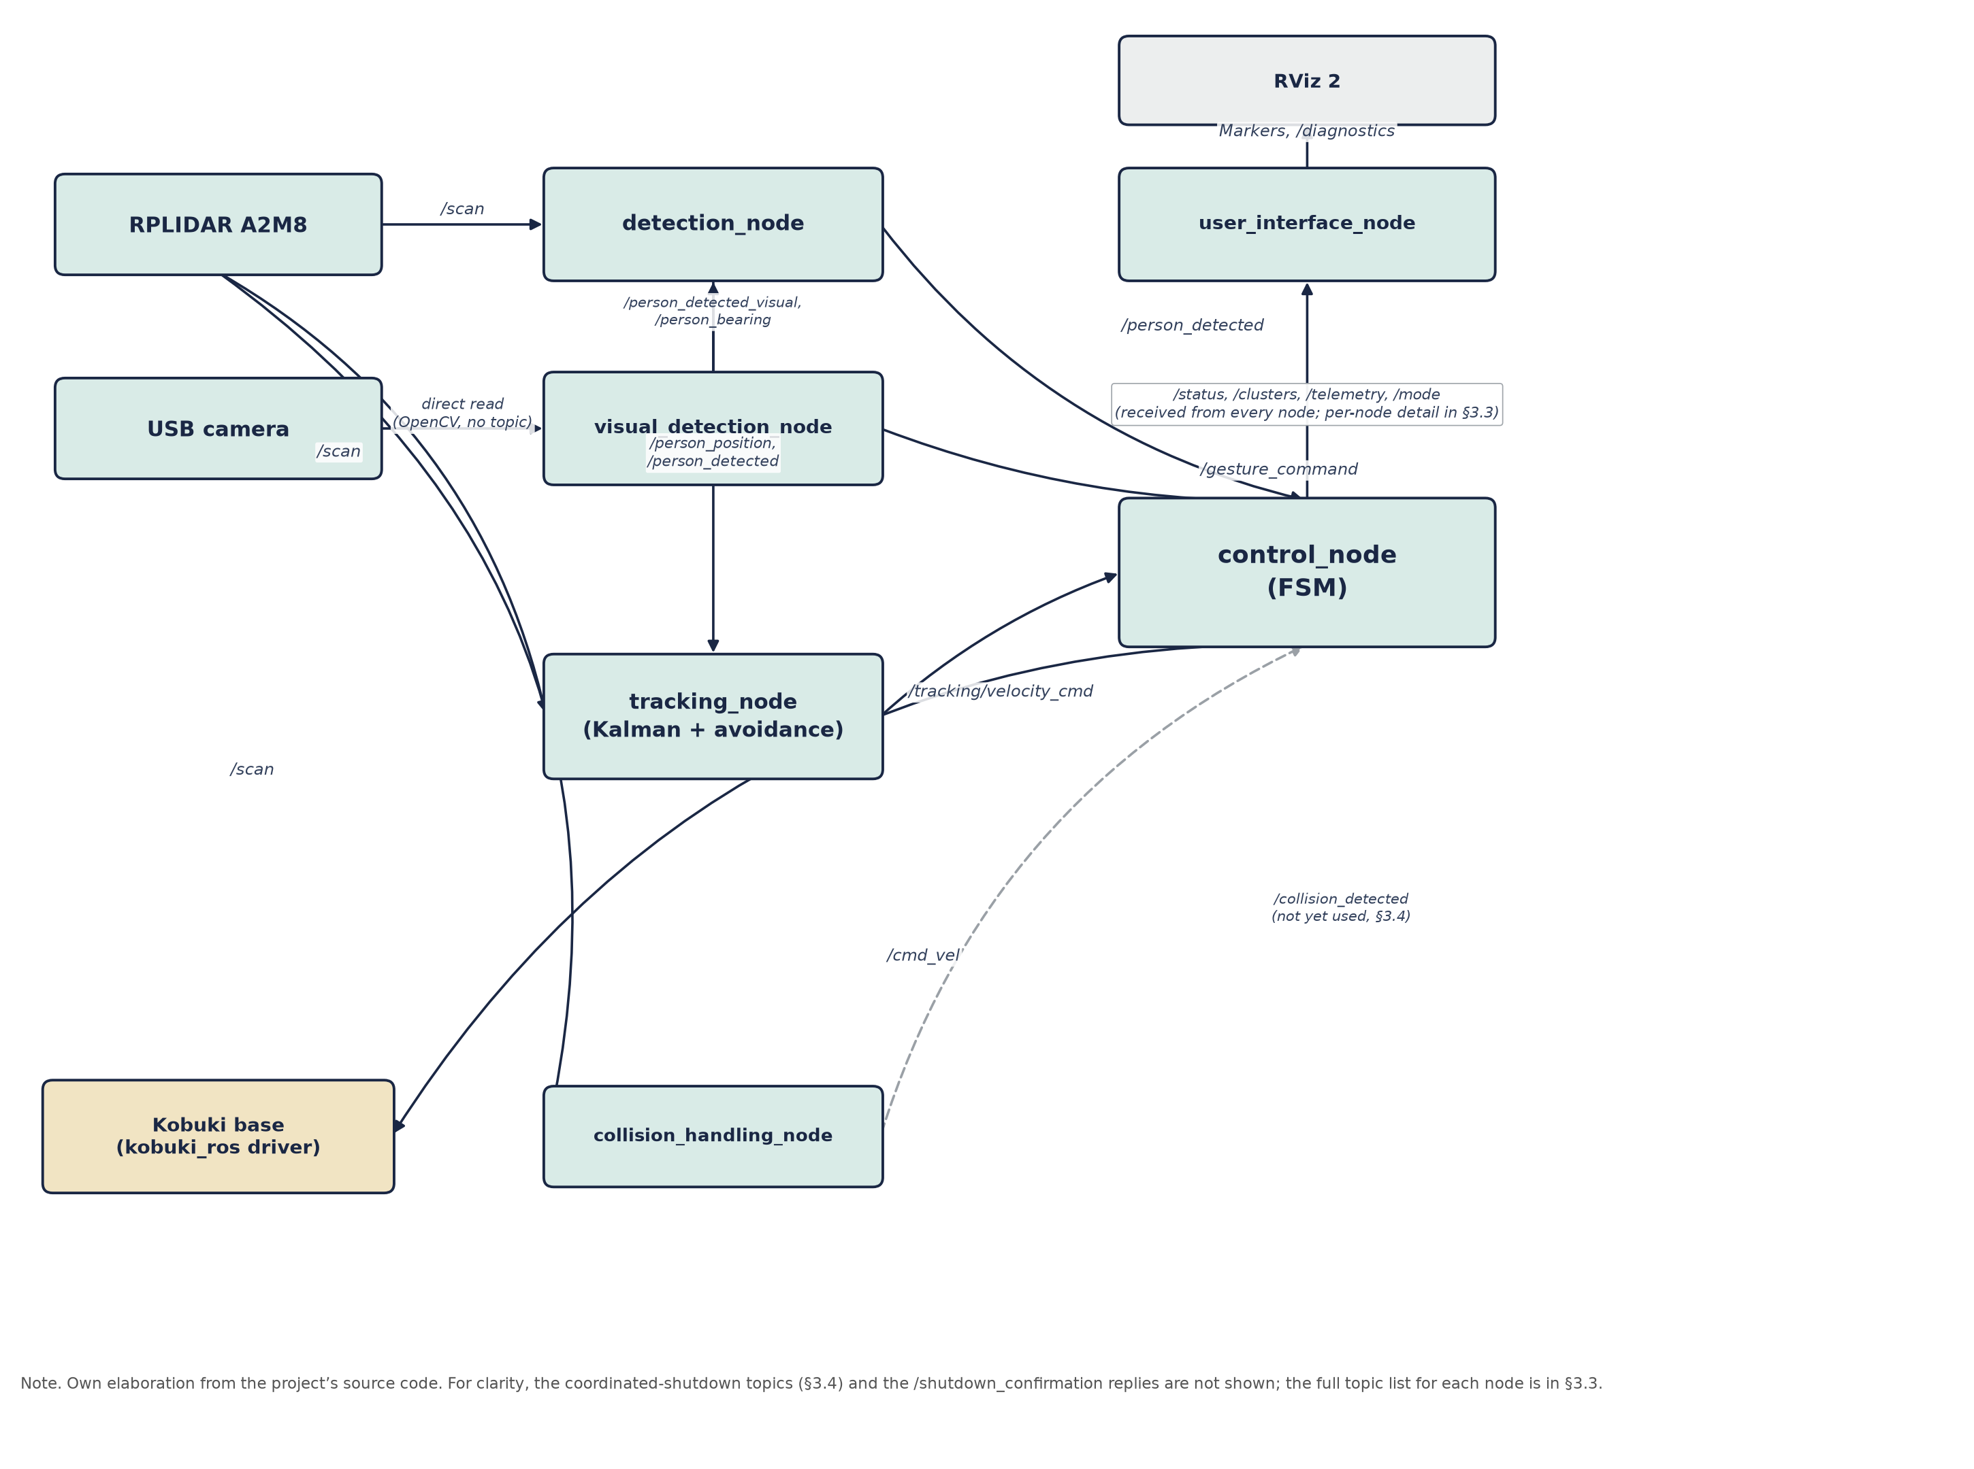
Note. Own elaboration from the project’s source code.
Figure 3.2
Real detection and tracking example (“straight-line” take, 22/07/2026).
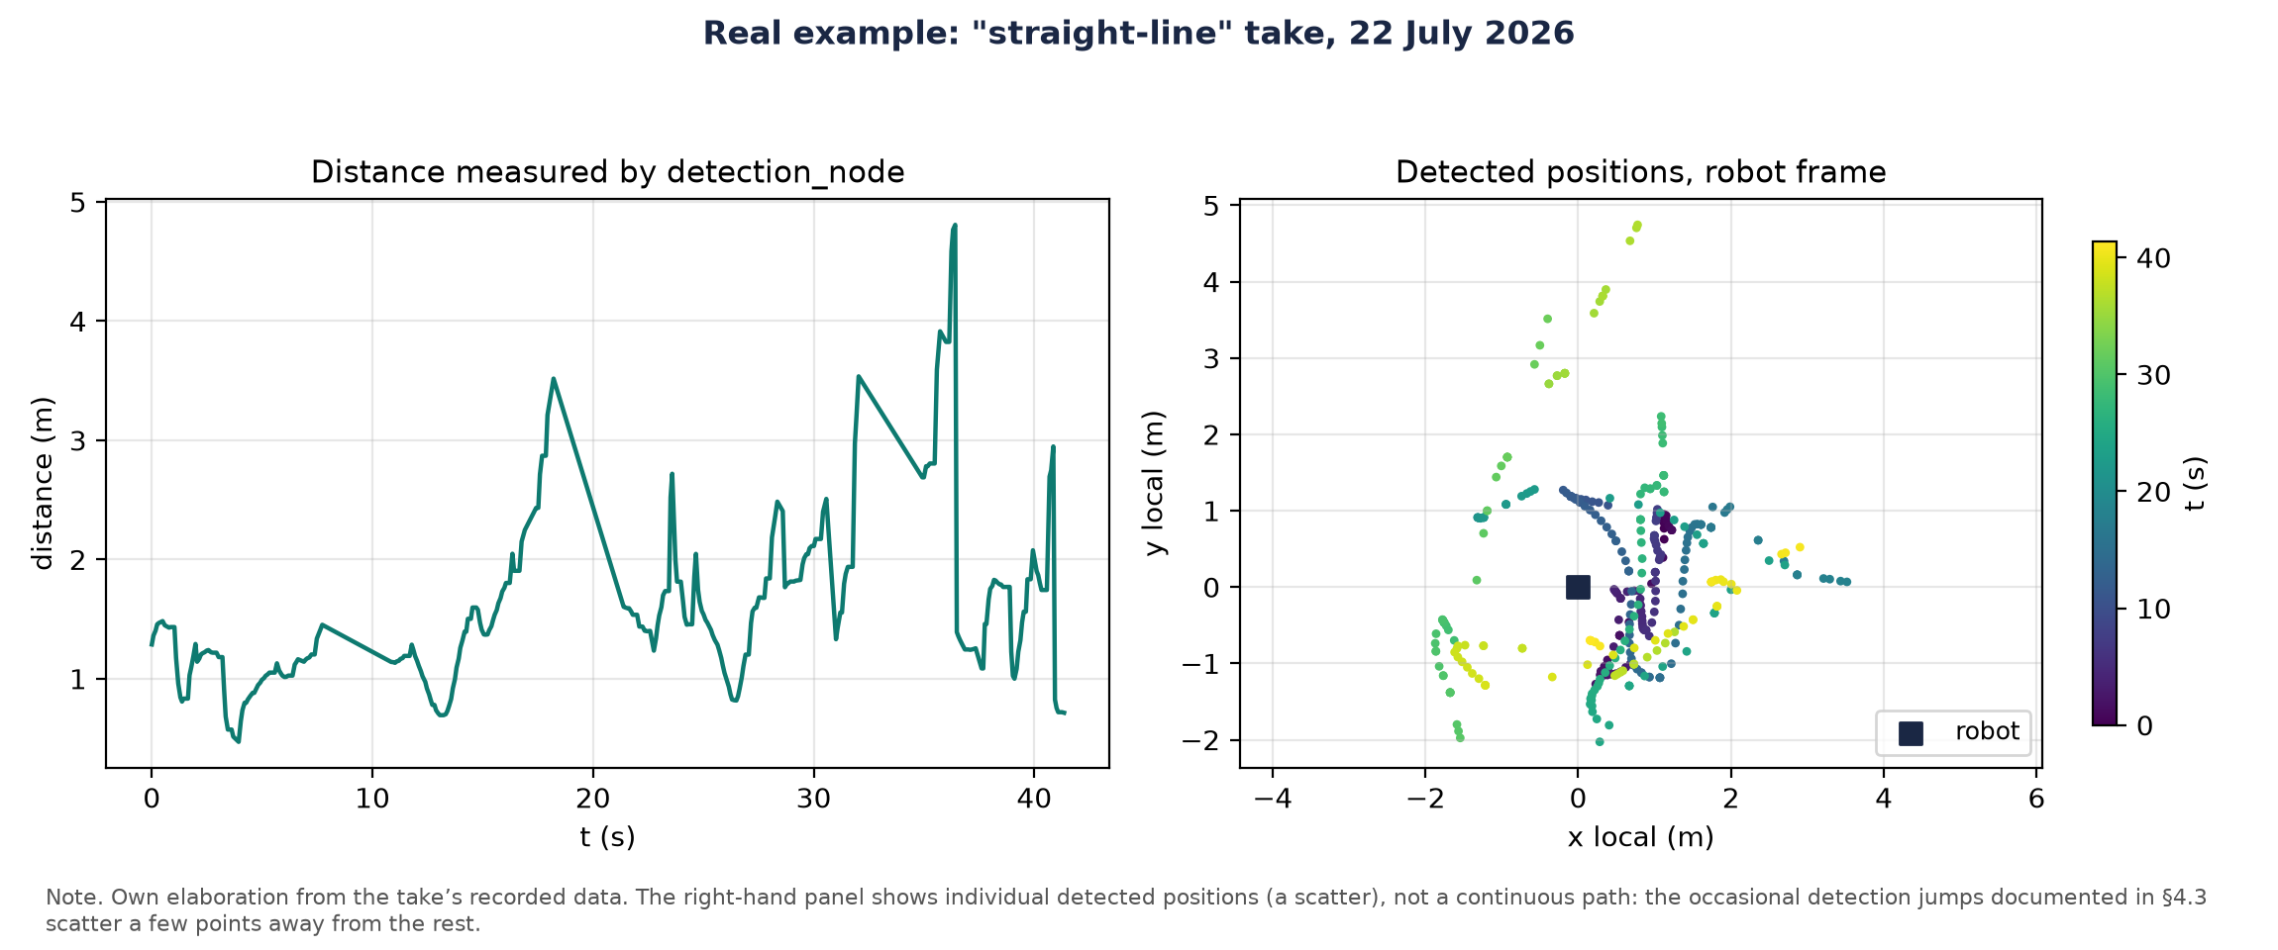
Note. Own elaboration from the take’s recorded data. The right-hand panel shows individual detected positions, not a continuous path (§4.3).

3.3 Description of Each Node

3.3.1 detection_node
Function: person detection using the LiDAR.
The subproblem is identifying, in each LiDAR scan, which points correspond to a pair of human legs and not to some other similarly-sized object (a chair leg, a column); out of a cloud of 300-400 points per scan, the node typically isolates 2 to 6 candidate clusters before looking for leg pairs.
The algorithm filters LiDAR noise by median, interpolates to increase angular resolution, and clusters points with DBSCAN (eps = 0.12 m, min_samples = 4). It then keeps the clusters that could be a leg (by size, radius and shape) and looks for pairs at a plausible distance.
As a fallback (Phase 2), without a valid leg pair the node uses visual_detection_node's bearing (MediaPipe) to pick the best-aligned LiDAR cluster and publishes its centroid. Without it, tracking stopped after 30 s without legs even if the camera saw the person. Validated without motion: 100% detection, bearing deviation ≈6°.
DBSCAN is reimplemented over scipy.spatial.cKDTree, and not over scikit-learn, because the NUC's Python version was not compatible with that library's compiled extension.
Configurable parameters: maximum detection distance (2.5 m, reduced from 6.0 m), DBSCAN neighborhood radius (0.12 m), leg cluster size (4-200 points) and camera timeout (1.0 s). It subscribes to /scan, /person_detected_visual, /person_bearing, and /system_shutdown; publishes /person_detected, /person_position, /detection/clusters, /clusters/general, /clusters/legs, and /detection/status.

3.3.2 visual_detection_node
Function: person detection and gesture recognition via camera.
The subproblem is twofold: recognizing two gestures from the person (start or stop tracking) and, when the LiDAR finds no valid leg pair, giving an approximate bearing so as not to lose them; for example, if the person turns and ends up side-on, the node can still see the shoulder and wrist even when the LiDAR can no longer tell their legs apart.
The node processes each frame with MediaPipe Pose to detect the human skeleton, instead of the original HOG detector, which needed the full body in frame, something impossible at the real tracking distance (~1 m).
Gestures are recognized from MediaPipe Pose body landmarks (not Hands): right hand raised above the shoulder starts tracking, left hand stops it. Each gesture requires several consecutive confirmation frames and a wait time between commands, to reduce false positives.
The node also computes the person's horizontal bearing from the midpoint between the shoulders, based on the camera's field of view, and publishes it for detection_node's fusion. It reads the camera directly via OpenCV, which is not a ROS topic; it only subscribes to /system_shutdown and publishes /person_detected_visual, /person_bearing, /gesture_command, and /camera/status.

3.3.3 tracking_node
Function: estimating the person's position and computing the velocity commands.
The subproblem is turning a noisy, intermittent position measurement into an estimated trajectory and safe velocity commands; for example, if detection_node loses the person for two or three scans, the Kalman filter keeps predicting their position from the estimated velocity instead of braking abruptly.
Applies a Kalman filter ([x, y, vx, vy, ax, ay], constant acceleration, §4.5) over detection_node's position, computing distance and angle to the person. Implements obstacle avoidance over the LiDAR's ±50° frontal sector: obstacles under 0.40 m trigger angular repulsion and reduce linear speed, and the robot stops if the person disappears for more than two seconds. Activated by the enable_tracking service, invoked by control_node.
Topics: subscribes to /person_position, /person_detected, /scan, and /system_shutdown; publishes /tracking/velocity_cmd, /expected_person_position, /tracking/status, and /follower/telemetry.

3.3.4 control_node
Function: the system's central finite-state machine.
The subproblem is arbitrating, at every instant, which of the possible velocity sources (tracking, homing navigation, teleoperation) controls the base, so that two contradictory commands never arrive at once; for example, on detecting the “roof” gesture, the node stops relaying tracking_node’s velocity and starts relaying Nav2’s.
Implements the state machine of Figure 3.3: IDLE (waiting for an authorized person), TRACKING (relays tracking_node's velocities), HOMING (relays Nav2's velocity toward the “home” pose after the “roof” gesture, §5.8), MANUAL (keyboard teleoperation) and SHUTDOWN (coordinated shutdown). With the camera enabled, starting tracking requires the gesture; otherwise it starts automatically.
Figure 3.3
control_node's finite-state machine.
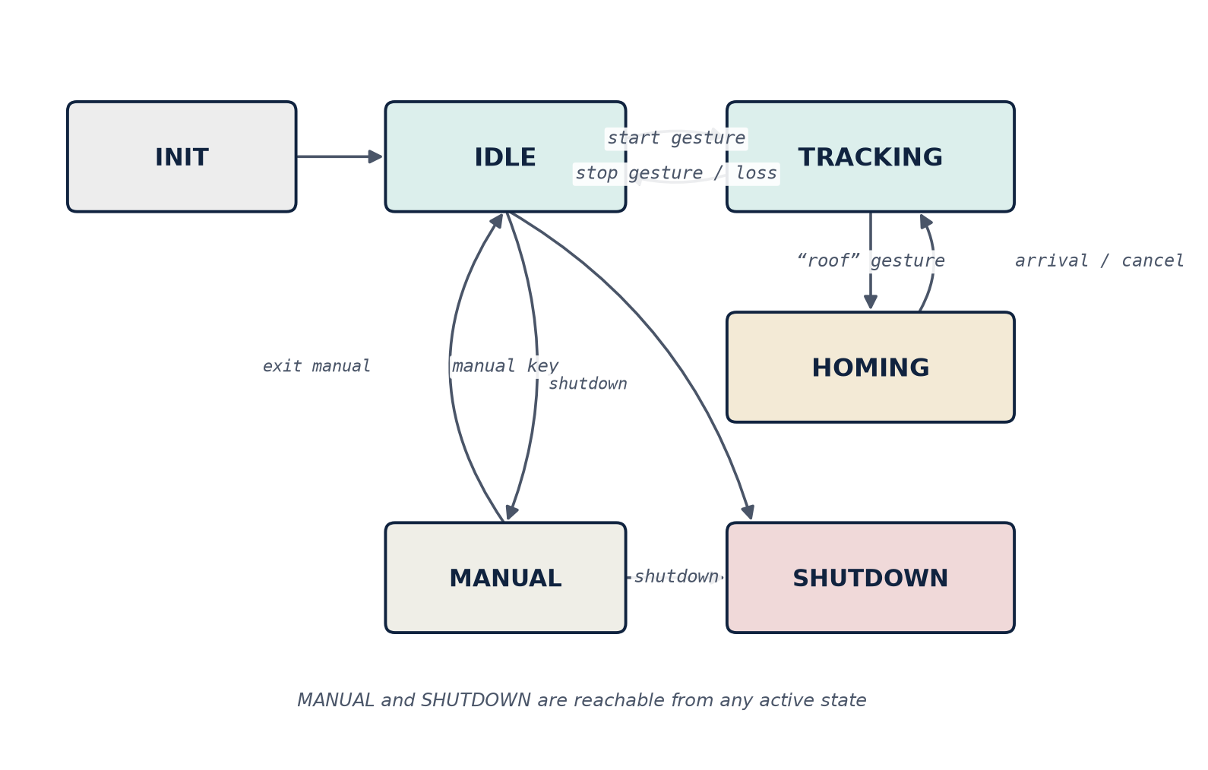
Note. Own elaboration from the project’s source code.
Topics: subscribes to /person_detected, /shutdown_confirmation, /tracking/velocity_cmd, and /gesture_command; publishes /cmd_vel (the real velocity sent to the base), /system_shutdown, /control/mode, /control/teleop_status, and /control/state.

3.3.5 collision_handling_node
Function: monitoring for imminent collisions, independently of the rest of the system.
Monitors the minimum distance to the nearest obstacle and publishes a collision-detected signal when any LiDAR scan point is under 0.4 m. control_node does not yet react to this signal; its integration is planned alongside Nav2.
Topics: subscribes to /scan; publishes /collision_detected and /collision_handling/status.

3.3.6 user_interface_node
Function: real-time visualization of the system's state, with no control logic of its own.
Takes care of real-time visualization: launches RViz 2 with the package configuration, publishes markers (estimated person position, LiDAR clusters, robot marker) and a periodic diagnostic status.
RViz 2 is ROS 2’s general-purpose visualization tool, not part of the person_follower package: user_interface_node only sends it the data (markers and diagnostics) that RViz then displays. Topics: subscribes to /camera/status, /detection/status, /tracking/status, /person_detected, /clusters/general, /clusters/legs, /expected_person_position, /control/mode, and /control/teleop_status; publishes the RViz markers (position, clusters, robot, status) and /diagnostics.

3.3.7 slam_node (experimental)
A basic 2D SLAM developed specifically in Phase 1. In Phase 2 SLAM Toolbox replaced it, as it is more robust, closes loops and can save maps; the node stays disabled by default.
Topics: subscribes to /scan, /person_position, and /system_shutdown; publishes /map, /initialpose, and /person_marker.

3.4 Coordinated Shutdown Management
The system implements a coordinated shutdown to prevent the robot from being left with active velocities: control_node publishes a shutdown signal, subscribed nodes stop their activity and confirm the stop, and control_node waits for all confirmations before finishing.

3.5 Transform Tree (TF)
Figure 3.4 shows the transform tree. The base_footprint→laser transform is published statically, with a 180° rotation about Z, because the LiDAR is mounted inverted.
Figure 3.4
The system's transform tree (TF).
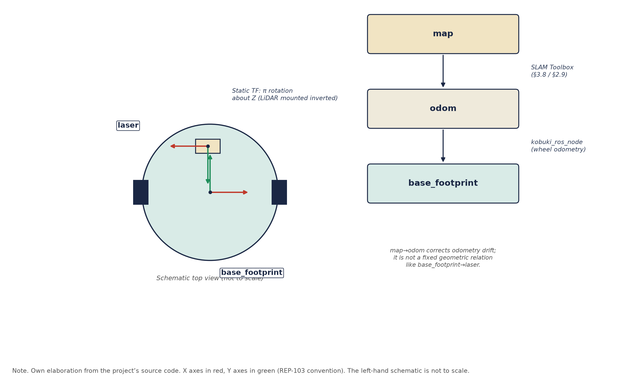
Note. Own elaboration from the project’s source code.

3.6 Configuration Parameters
All tunable parameters are in a common configuration file, so detection thresholds, safety distances and robot behaviors can be changed without recompiling. SLAM Toolbox uses a separate configuration file.

3.7 ROS 2 Package Dependencies
Figure 3.5 summarizes the dependencies of the person_follower package, both internal to the ROS 2 ecosystem and external.
Figure 3.5
person_follower package dependencies.
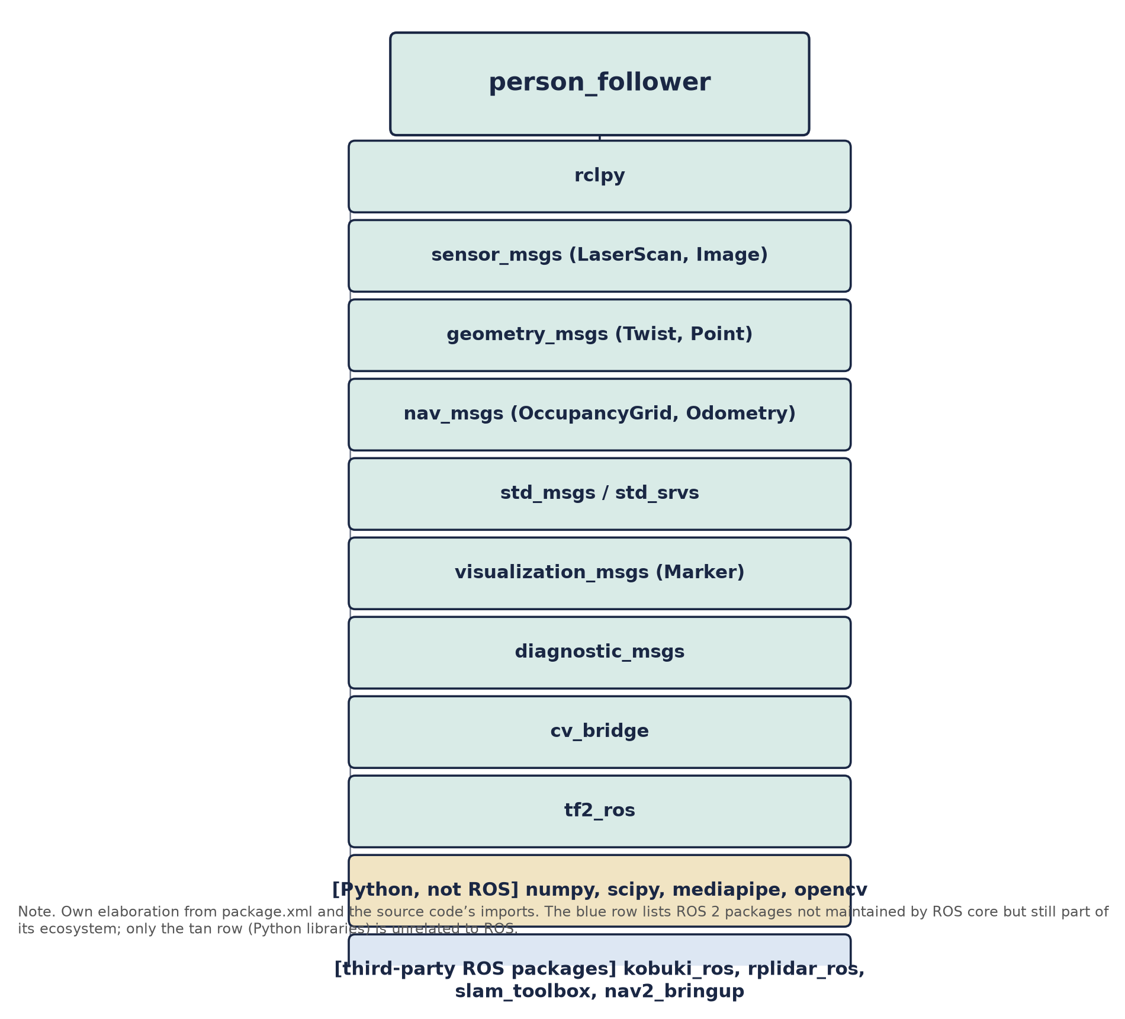
Note. Own elaboration from the project’s source code.

3.8 Nav2 Architecture (Phase 3)
Autonomous navigation is organized in four layers (Figure 3.6): sensors (LiDAR and odometry); localization, where map_server publishes the map and AMCL combines scan, odometry and map to estimate the pose (map-odom TF); the Nav2 core (planner_server, controller_server, behavior_server and bt_navigator, coordinated by a behavior tree); and the output, where controller_server drives the wheels.
Figure 3.6
Layered architecture of autonomous navigation with Nav2.
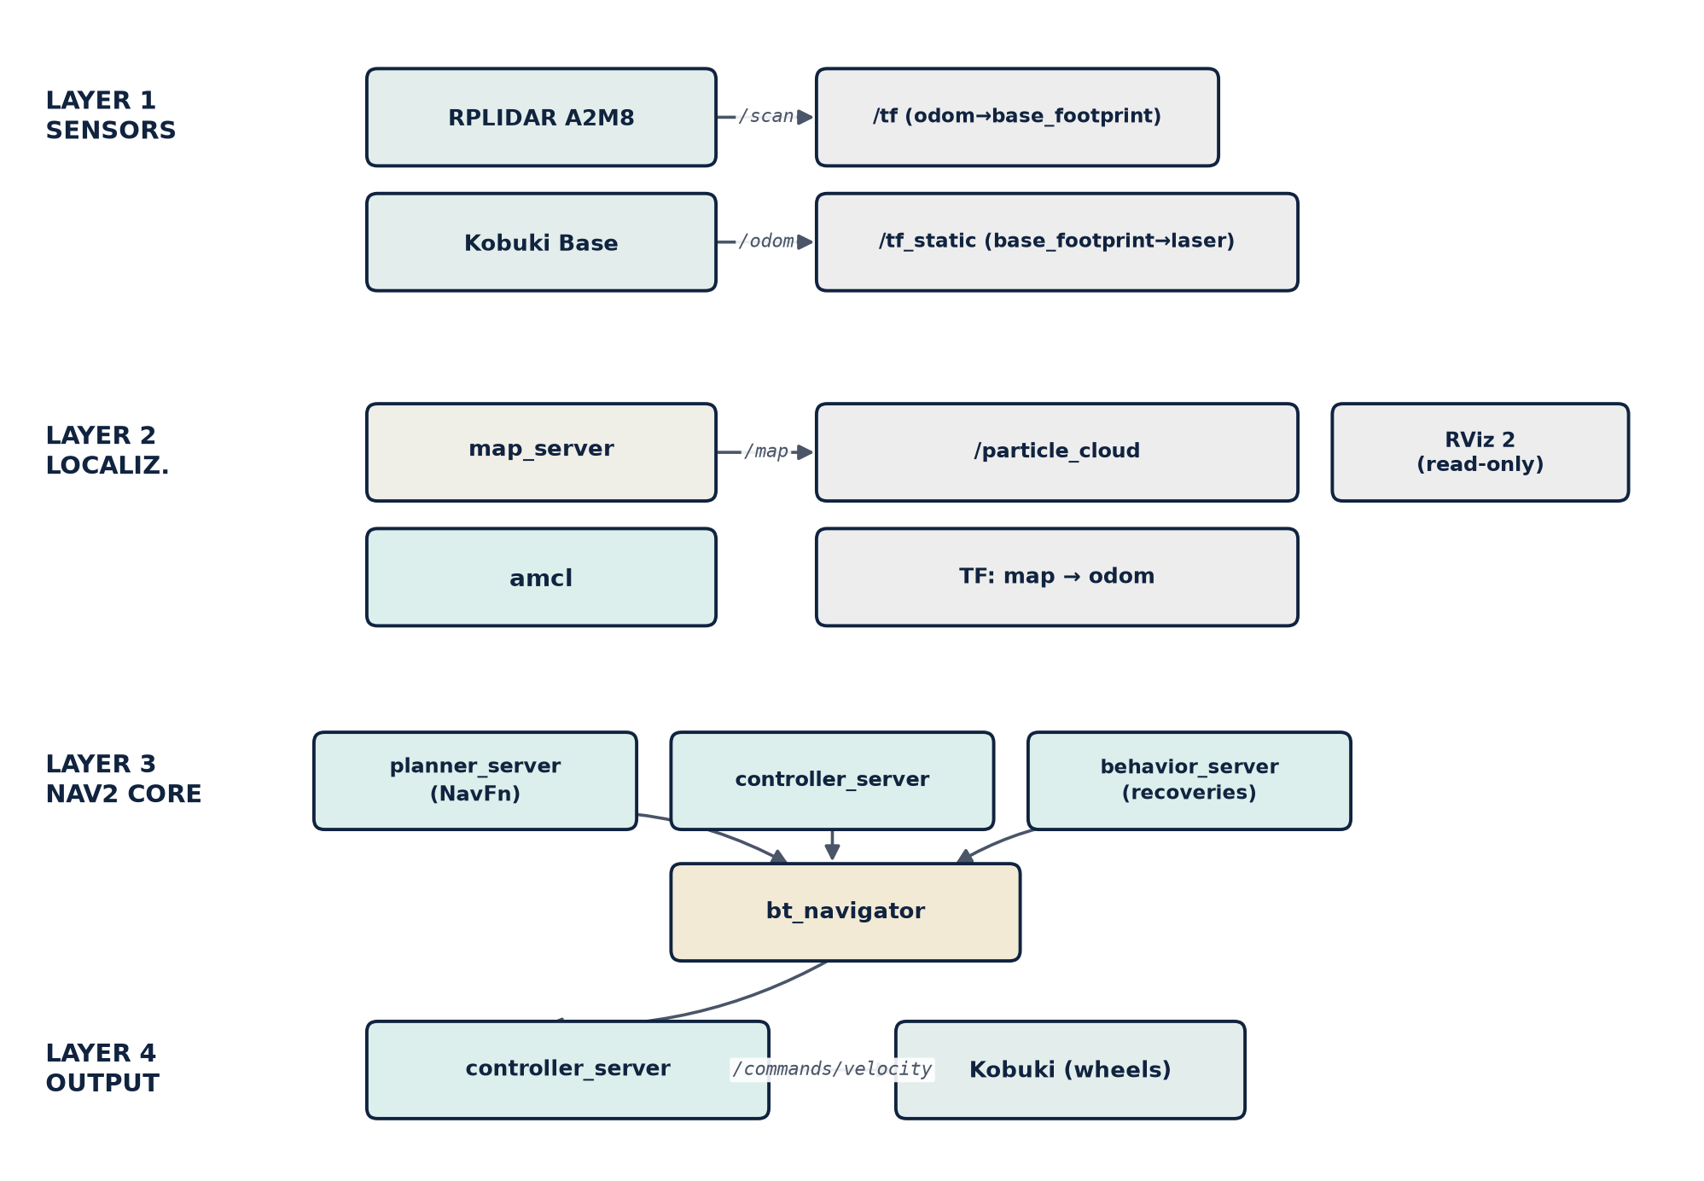
Note. Adapted from the Nav2 architecture described in Macenski et al. (2020).
This architecture was validated in stages: a first test confirmed sensors and localization, and a later one also covered the Nav2 core and the output. That test reached six of seven navigation goals, including avoidance of an unmapped real obstacle.

Chapter 4 — Implementation

4.1 Introduction and Scope
Chapter 3 shows the layout of nodes and topics. This chapter gets into the code: how each node works inside and why it was left that way.
Not all code files are running: the install script registers seven nodes as executables (§4.2), and several directories keep unregistered earlier versions. Only the code that actually runs is described here; §4.11 explains the legacy code.

4.2 Package Structure and Configuration Management
The package is of type ament_python, with one directory per node, and registers seven executables: control_node, visual_detection_node, detection_node, tracking_node, user_interface_node, collision_handling_node, and slam_node.
Each node's adjustable parameters are in a single configuration file, with one section per node, which the launch files load, so thresholds can be changed without recompiling. Each parameter has a comment justifying it and, often, the date and reason for its last change.
The main launch file starts five nodes: control_node, tracking_node, visual_detection_node, detection_node and user_interface_node. collision_handling_node and slam_node are left out: the former because control_node does not yet react to its signal (§3.3.5), and the latter because it is disabled (replaced by SLAM Toolbox, Phase 2).

4.3 detection_node — Clustering, Leg Features, and Temporal Filtering

In-house DBSCAN on a Nearest-Neighbour Tree
This node's DBSCAN is reimplemented over scipy's cKDTree and not over scikit-learn, because it was not compatible with the NUC's Python version (§3.3.1). It follows the usual semantics: a point is a core point if it has enough neighbors within a radius, with radius-based neighbor queries and breadth-first expansion. The computational cost is negligible for the hundreds of points in a filtered scan. The neighborhood radius (0.12 m) and the minimum number of neighbors (4) were calibrated to the RPLIDAR A2M8's real angular resolution.

Multi-feature Geometric Leg Filter
The node extracts eight features per cluster (size, radius, spread, width, height, aspect ratio, circularity, compactness) and applies six sequential filters, combining the original inherited filter with additional features to reduce false positives (furniture legs) and false negatives (occluded legs). Two thresholds were corrected after confirming they rejected real legs.
Leg pairing is a greedy nearest-neighbor algorithm: for each unpaired cluster, the closest one within a coherent range (0.05-0.35 m) is sought and combined into a candidate whose centroid is the estimated position. No global optimization (Hungarian assignment) is used, given the low number of clusters per scan.

Temporal Continuity and Confirmation Filtering
Three temporal filtering mechanisms guard against false positives: temporal persistence (a detection must hold for several scans to be confirmed, and fail as many to be lost); a cumulative-drift filter, discarding candidates whose distance from the oldest confirmed position exceeds the plausible displacement; and a consistency confirmation, stricter for the camera fallback (always requires confirmation).
The fusion fallback: without a valid leg pair, the node computes the expected angle in the laser frame from the camera bearing, picks the cluster with the smallest angular deviation, and requires repetition over several scans before publishing it. This confirmation is independent from that of leg pairs, since a single cluster is a weaker signal.
The node flips the sign of the coordinates right before publishing, at the boundary between the laser's raw frame (front ≈π radians) and tracking_node's standard convention (front on the positive x axis). Keeping the rest of the logic in the raw frame and flipping only on publish avoids rewriting all the filtering, at the cost of reading internal variables in the raw frame.

4.4 visual_detection_node — Dual Detection and Gesture Recognition
The node supports two interchangeable detectors: MediaPipe Pose if available, or HOG as an automatic fallback (resolved via import exception handling). Without MediaPipe there are no landmarks, so gestures are unavailable in HOG mode. HOG, inherited from Phase 1 and replaced as primary by MediaPipe Pose (§3.3.2, §2.4), is kept as a fallback.
Video capture runs in a thread independent of the ROS 2 executor, discarding stale buffered frames and always processing the most recent one. Publishing is capped to a target rate, measuring actual processing time to adjust the wait.
Gesture recognition and bearing computation reuse the same MediaPipe Pose landmarks (shoulders, wrists, hips). The start gesture triggers when the right wrist rises above the right shoulder, and stop with the left; the decision margin scales with torso size, not fixed in pixels, and each gesture requires confirmation over several frames plus a wait between commands. The bearing is computed from the shoulder midpoint, published only if both exceed the minimum visibility.

4.5 tracking_node — Kalman Filter, PD Control, and Obstacle Avoidance
Along with detection_node, it is the node with the most documented iterations. The active version replaces an earlier, simpler design without an acceleration model, kept as legacy code (§4.11).

Six-state Kalman Filter with a Constant-Acceleration Model
The filter keeps a six-dimensional state (position, velocity, acceleration), versus four in the inherited design, with observation measuring only position. The transition matrix implements constant acceleration, with process noise correlated by powers of the time step; the correction uses Joseph's form, costlier but numerically more stable.

Mahalanobis Gate with Streak-based Confirmation
Each observation goes through a Mahalanobis gate against the 95% chi-squared threshold (2 d.o.f.): it is only rejected if it exceeds that threshold by several times, and if several consecutive observations fall outside it, the filter re-anchors to the latest one, assuming a real reappearance. An isolated observation is ignored; a sustained streak is treated as a legitimate reappearance, the same confirmation pattern used by detection_node's continuity mechanisms (§4.3).

Angular Velocity Controller
Angular velocity is computed in five steps: (1) PD with a ±8° dead zone; (2) coupling with linear speed, reducing turning at high speed; (3) close-range attenuation, from zero to full value based on the reference distance; (4) soft start over the first second and a half; and (5) a per-cycle change limit, guarding against a large real error or a one-off detection jump.
Linear speed follows a non-linear ramp based on distance to the person, smoother than a linear relation near the tracking reference distance, avoiding abrupt starts when the person moves slightly away from that distance.

Reactive Obstacle Avoidance (not a Real Dynamic Window Approach)
The original documentation called this block Kalman + DWA, but tracking_node does not have a real DWA, which would simulate trajectories in velocity space (§2.8). That DWA exists in a separate file that is not registered (§4.11). The active mechanism is reactive, repulsion-field style: for each point in the ±50° frontal sector within a threshold (0.40 m, raised from 0.35 m), a weight is accumulated that gives more importance to closer, more frontal obstacles, and the final angular adjustment is the weighted average.
Linear-velocity reduction factor, fixed on 22 July. Before, the formula never brought the velocity down to zero: it had a lower bound that in practice never triggered, pure dead code (Appendix B, §5.6). So the robot never fully braked against an obstacle that stayed in front of it, and that caused two light contacts. The current formula computes the factor from the real distance to the closest obstacle in the frontal sector: it is 1 (no braking) at the 0.40 m threshold, and drops to 0 (hard stop) at 0.25 m, with about 10 cm of margin between the two.
Go-around manoeuvre, added on 22 July. If the reduction factor stays below 0.5 for 1.5 s in a row, the robot treats this as being stuck in front of the obstacle: it makes a tight 1.5 s turn toward the side the reactive avoidance was already steering, then moves straight ahead for a short stretch at low speed. If the factor drops again during the manoeuvre, it is cancelled and the turn restarts. It is a way out of the deadlock instead of pushing forward indefinitely. It is a first version, not yet validated systematically (Chapter 5).
It is cheaper than a full DWA on purpose: it does not reason about kinematic constraints or look several steps ahead. That is enough for low-speed reactive avoidance, but it is a clear simplification compared with Nav2's DWA (§2.8-2.9). The architecture label has been corrected.

4.6 control_node — Finite-State Machine and Teleoperation
The state machine (INIT → IDLE ↔ TRACKING, with MANUAL and SHUTDOWN reachable from any active state) is a single class with the current state as a text string. Two mechanisms prevent erratic behavior: hysteresis on detection loss, waiting before returning to idle; and gesture-based authorization independent of detection (with the camera disabled, authorization is granted automatically).
Keyboard teleoperation runs on a separate thread reading input in unbuffered mode, to capture keys without blocking the ROS 2 executor, and disables itself if standard input is not an interactive terminal. This is needed because a leftover interrupt signal can remain in the buffer and be read as an unexpected signal when the system launches.

4.7 collision_handling_node
It is the simplest node: it applies a single distance threshold over the LiDAR scan's minimum, publishing the collision signal only on state changes. It is not included in the main launch and control_node does not yet subscribe to its signal (§4.2). It is infrastructure prepared for Nav2, which can react through its recovery behaviors.

4.8 user_interface_node
It implements no perception or control: it is a state aggregator. It subscribes to the status topics of the other nodes and republishes visualization markers for RViz 2 (estimated position, LiDAR clusters, robot marker), a text panel and a periodic diagnostic on mode changes. It also launches and closes RViz 2 in a coordinated way.

4.9 slam_node (experimental, disabled by default)
A minimal, custom 2D SLAM implementation: an in-memory occupancy grid, static TF between map and odometry, updated from the LiDAR and the person's position, without scan matching or loop closure: an occupancy accumulator, not real SLAM. SLAM Toolbox replaced it in Phase 2 (§2.9), and it is kept disabled as a historical reference.

4.10 Deployment: Building and Syncing with the Robot
The package is built on the NUC with symlinks to the source files, letting the executor pick up changes by relaunching the node, without recompiling after every edit. A sync script automates copying the most-modified files (detection, tracking, configuration); the rest requires manual copying, a real limitation to keep in mind for future extensions.

4.11 Code Not Registered in the Package
Several directories keep more than one complete node class, of which only one is registered: the control node keeps two earlier versions; the tracking node keeps a real DWA implementation (velocity-space search and RViz trajectory visualization), not running; and the user-interface node keeps an unregistered earlier version.
None of these files is imported by another module: it is not dead code, but earlier versions of the same class kept in the working tree. The real DWA matters because the documentation kept saying that tracking_node used it, when the active node uses the reactive controller of §4.5. That was confusing, and it is worth cleaning up before the final delivery.

Chapter 5 — Results and Evaluation
The data in this chapter comes from the tests at UJI's robotics lab, up to the final session on 23 September 2026 (§5.8). Several scenarios have few samples, which is explained in §5.9. What falls outside the scope of this thesis is in §5.10.

5.1 Validation Methodology
Each take is recorded on the NUC as a ROS 2 bag, converted to tabular format and analyzed externally, producing metrics and four figures (distance, angle and speed over time, and trajectory). Standard metrics: distance error (MAE/RMS), mean angular error, peak speeds, % detection and losses.

5.2 Experimental Setup
- Robot: TurtleBot 2 on a Kobuki base, with an onboard compute unit running ROS 2 Jazzy.
- Sensors: RPLIDAR A2M8 LiDAR and an RGB camera. The camera changed midway through the validation campaign (§1.3): the no-motion fusion take (25/06) and the three takes from 08/07 (§5.4) were recorded with the original Logitech C270; all takes from 09/07 onward (§5.5, §5.6, and §5.7) were already recorded with the SPCA2650 that replaced it.
- Environment: UJI's robotics lab, indoors, tiled floor.
- Target tracking distance: 1.50 m in the 25 June take; 1.00 m from the 8 July takes onward, after a parameter adjustment between sessions.
- Tracking activation: via camera gesture under normal conditions; the 8 July takes used a manual activation mechanism because the gesture was not reliable with that session's camera framing.

5.3 Result 1 — Sensor Fusion, No Motion (25 June 2026)
First validation of the LiDAR-camera fusion fallback mechanism, with the robot's base inhibited so the detection mechanism could be tested safely before validating it in motion.
Table 5.1
Fusion without motion, 25/06
Metric | Value
Duration | 23.5 s (285 samples)
Target distance | 1.50 m
Distance error (MAE / RMS) | 0.627 m / 0.733 m
Min / max distance | 1.27 m / 3.41 m
% of time with person detected | 100.0%
Number of detection losses | 0
Camera bearing vs. chosen cluster deviation | ≈ 6°
With the fusion mechanism active, detection was continuous throughout the whole take, even though the LiDAR alone could not reliably tell legs apart in this configuration, which was the original motivation for the fallback mechanism (§3.3.1, §2.5). The mean angular error is not representative in this take: with the base inhibited, angular velocity never corrects orientation toward the person, so this figure measures the lack of motion rather than a detection failure.
Figure 5.1
Robot-to-person distance over time, no-motion fusion take (25/06/2026).

Note. Own elaboration from the recorded data of the take.

5.4 Result 2 — Progression of In-motion Continuity Fixes (8 July 2026)
First tracking test with the robot actually moving. The initial take revealed detection jumps and near-permanent angular saturation; the next two takes verify each fix separately (Appendix B).
Table 5.2
Continuity corrections, 08/07
Take | Duration | % detection | Losses | MAE dist. | RMS dist. | Jumps >0.8 m | wz saturation
Original (unfixed) | 759.8 s | 32.3% | 79 | 0.519 m | 0.935 m | 3.5% | 95.7%
+ continuity filter | 249.0 s | 71.7% | 43 | 0.534 m | 0.725 m | 2.2% | 99.3%
+ Mahalanobis and wz limit | 53.1 s | 82.6% | 13 | 0.491 m | 0.609 m | 0.7% | 86.9%
The jump and saturation figures were recalculated on 21 July with the standard analysis pipeline over the three original logs; the jump percentage reproduced exactly in two of the three takes and came out somewhat lower in the third, a minor difference attributable to reconstructing a previously ad-hoc methodology.
The three chained fixes clearly reduced implausible position jumps and increased detection: fewer jumps yield a more stable Kalman filter. Angular saturation, however, does not improve consistently, because the fixes target detection continuity and not the angular controller's gain. The fix that does reduce it (proximity attenuation, §4.5) was added later, on July 15.
Figure 5.2
Robot-to-person distance over time, take with all three continuity fixes applied.

Note. Own elaboration from the recorded data of the take.
Figure 5.3
Linear and angular velocity over time, same take.

Note. Own elaboration from the recorded data of the take.
Figure 5.4
Robot trajectory (odometry), same take.

Note. Own elaboration from the recorded data of the take.

5.5 Result 3 — Per-scenario Repetitions with the System Stabilized (22 July 2026)
With the July 21 fixes already in production, two to three takes were repeated for five collision-free validation scenarios: straight line, curve, short distance, stop, and occlusion.
Table 5.3
Scenarios with the stabilized system, 22/07
Scenario | Duration | MAE dist. | Mean ang. | % detec. | Losses | Jumps >0.8 m | Stable sat.
Straight (contaminated) | 41.4 s | 0.626 m | 62.0° | 76.2% | 7 | 6.8% | 13.8%
Straight (clean) | 25.9 s | 0.420 m | 26.5° | 100% | 0 | 2.3% | 1.8%
Curve #1 | 33.5 s | 0.794 m | 14.5° | 100% | 0 | 2.8% | 6.8%
Curve #2 (short) | 12.2 s | 0.759 m | 23.7° | 97.1% | 1 | 2.0% | 20.8%
Curve #3 | 14.3 s | 0.976 m | 6.2° | 100% | 0 | 0.9% | 0.0%
Stop | 36.5 s | 0.326 m | 5.9° | 100% | 0 | 0.0% | 0.0%
Short #1 (min. 0.15 m) | 32.5 s | 0.443 m | 32.8° | 100% | 0 | 2.0% | 25.1%
Short #2 (short, min. 0.42 m) | 8.4 s | 0.628 m | 4.9° | 98.8% | 1 | 0.9% | 0.0%
Short #3 (min. 0.02 m) | 18.7 s | 0.508 m | 46.8° | 100% | 0 | 1.2% | 28.6%
Occlusion | 30.6 s | 0.678 m | 16.2° | 100% | 0 | 2.5% | 1.5%
The first straight-line take was contaminated by a residual tracking state (the oscillation already documented on June 17); it was not repeated after de-authorizing tracking before each take. The short durations of curve #2 and short #2 stem from the gesture taking time to arrive; short #3 reached 0.02 m, with expected saturation. Occlusion caused no real loss, thanks to the Kalman filter and the single-leg fallback.

5.6 Result 4 — Obstacle Scenario: from First Contacts to Contact-free Avoidance (22–23 July 2026)
After the two real contacts described in Appendix B (21 July session), the obstacle scenario was retried with the safety threshold increased. Seven takes were carried out over two sessions, with two intermediate code changes.
Table 5.4
Obstacle, 22–23/07
Take | Configuration | Result
Obstacle v3 (furniture) | Safety threshold raised, linear reduction factor unfixed | Light contact — the reduction factor never reached zero, the robot “dragged” without fully braking
Obstacle v4 (furniture) | Same | Light contact again, same pattern
Obstacle v5 (furniture) | Reduction factor fixed: real ramp to zero between the warning and stop thresholds | No contact — much briefer encounter
Obstacle v6 (furniture + chair) | Same | No contact — the chair did not trigger avoidance in this take
Obstacle v7 (furniture + chair) | + go-around manoeuvre (tight turn and short advance) | No contact — manoeuvre triggered four times, completed successfully in all cases except one correct safety abort
Obstacle v8 (furniture + chair) | Same | Furniture correctly avoided; direct contact with the chair, not detected at all by the LiDAR
Obstacle v9 (furniture, 23/07) | No code changes from v7/v8 | No contact — second clean repetition of the fix, confirming the result in a different session
The fault was in the formula: the reduction factor never dropped below 0.4 because the lower bound never applied (dead code). The robot saw the obstacle and still did not fully stop, which is why it grazed it twice. The fix based the factor on the actual minimum distance in the frontal sector, with a hard stop past a second threshold, and the go-around maneuver was added.
In take v8 the robot hit the chair, the fifth contact so far. This was expected: the LiDAR scans at about 47 cm and does not see the thin legs of a chair. The test was not repeated until another sensor was available, either the available RGB-D camera or a second LiDAR at a different height.

5.7 Result 5 — Nav2: Localization and Autonomous Navigation (27 July 2026)
First real test of the complete Nav2 stack (specific objective 3). AMCL localization seemed to freeze after its first update. The problem was that the very short test commands were not arriving in time because of node-discovery latency; with longer commands it converged without trouble.
The full navigation phase was then tested for the first time, with seven goals sent from the RViz interface:
Table 5.5
Nav2 navigation, 27/07
Goal | Approx. distance | Result
1 | ≈ 3.7 m | Success
2 | ≈ 5.9 m | Success
3 (real unmapped obstacle) | ≈ 5.3 m | Success — detected and avoided by the local costmap
4 | ≈ 8.0 m | Success
5 | ≈ 8.1 m | Success
6 (goal change mid-path) | ≈ 0.6 m | Failure — automatically recovered by the lifecycle manager in about 2 s
7 (after recovery) | ≈ 3.6 m | Success
Six of seven goals were completed (86%), including two long ~8 m routes and one with avoidance of a real obstacle not present in the map, dodged via the local costmap. The single failure self-recovered through Nav2's lifecycle manager, without recurring. During the session it was noticed that the saved map did not match the real space well. It was recorded again and validated before replacing it, so all the results are already with the new map.

5.8 Result 6 — “Home” Gesture: Integrating Tracking and Navigation (23 September 2026)
Final lab session. The person makes the “roof” gesture (both hands joined above the head) and the robot stops following. It then returns on its own, via Nav2, to a predefined “home” pose. This is the first time tracking and navigation work in a single system. control_node decides which velocity source reaches the base (§3.3.4, §4.6).
Table 5.6
Metrics of the “home” gesture, 23/09
Metric | Value
Home-return attempts completed | 9 of 11 (82%)
Time from gesture to home | 15.5 s on average (11-21 s)
Arrival error | 0.27 m / 8° on average (Nav2 tolerance: 0.25 m / 14°)
Cancellation with the left hand | Confirmed by Nav2 in 20 ms, ~7 cm of travel
Gesture false positives | 0 in ~4 min of free gesturing
Roof gesture recognized from behind | 2 of 2 (slower: the head hides one wrist)
The two failures were not caused by the gesture or the state machine. Localization (AMCL, σ≈0.5 m) placed the robot inside the safety zone of a mapped obstacle, and from there the planner found no valid route. The robot returned to rest safely. This is a first result: 11 attempts in a single session (see §5.9).

5.9 Limitations of the Current Results
- Small sample. Several rows come from a single take, so there is no measure of variability between equivalent tests. The stop and occlusion tests have only one repetition at the close of this chapter.
- Durations and activation gesture. The takes in §5.4 differ a lot in duration, so the figures are proportions within each take, not normalized values. Also, the 8 July takes were started with a manual mechanism and not with the real gesture, so objective 1 only appears in the takes after 9 July.
- Nav2 has a single session, with no repetitions. So it is not possible to tell whether what is observed is a pattern or a one-off event. The exact cause of the single failure has also not been examined in depth.
- Objective 5: only a first step, with a limited sample. The “home” gesture (§5.8) brings tracking and navigation together for the first time: 9 of 11 home-return attempts completed in a single session (11 attempts). The 2 failures came from localization (AMCL, σ≈0.5 m), which left the robot next to a mapped obstacle with no room for the planner to trace a route, and not from the gesture or the state machine. Guidance to multiple destinations, which would be the full scope of the objective, remains as future work (§5.10).
- Shared compute resources. The NUC runs the LiDAR, the camera with MediaPipe, tracking, SLAM, Nav2 and the diagnostics interface all at once. In the early phases this caused disconnections and port conflicts, and the code had to be optimized considerably (duplicate ports, publication rates, a simpler detection pipeline; Appendix B). With everything active, the final measured load is ~30% per core (4 cores), with no saturation. What has not been checked is whether a momentary spike contributed to the two localization failures.

5.10 Future Work
Four lines of future work remain, beyond the scope of this thesis: guiding the robot to several destinations (a gesture or a QR code per destination, which would complete objective 5); a departure manoeuvre when localization leaves the robot next to an obstacle, before requesting a route from Nav2; repeating the stop and occlusion tests with more samples; and testing the system with more people, environments and lighting conditions.

Chapter 6 — Conclusions
Four of the five specific objectives are complete and validated on the real robot: gesture-based interaction, SLAM-based mapping, Nav2 navigation, and LiDAR-camera fusion. The fifth, guiding the person to several destinations, has a first step validated with the “home” gesture (9 of 11 return trips, 0.27 m mean arrival error) and remains open for a multi-destination version (§5.10). The exploratory QR-code objective was not tested.
This thesis does not contribute a new algorithm; its contribution is making detection, tracking, navigation, and gestures work together on a single robot with limited resources, with control_node deciding at each moment which source commands the base. The results in Chapter 5 show the system works under the conditions tested; the sample limitations detailed in §5.9 mark the boundary of this validation.
Taken together, the six validation sessions in Chapter 5 —from the first no-motion test to the final integration with the “home” gesture— show a clear progression: every fix documented in Appendix B resolved a concrete problem, found on the real robot rather than in simulation. That is, ultimately, the main lesson of this thesis: on a robot with limited resources, carefully integrating already-known pieces takes as much work as building a new one, and is just as valid a contribution in engineering terms.

References
Bazarevsky, V., Grishchenko, I., Raveendran, K., Zhu, T., Zhang, F., & Grundmann, M. (2020). BlazePose: On-device real-time body pose tracking [Preprint]. arXiv. https://doi.org/10.48550/arXiv.2006.10204
Bellotto, N., & Hu, H. (2010). Computationally efficient solutions for tracking people with a mobile robot: An experimental evaluation of Bayesian filters. Autonomous Robots, 28(4), 425–438. https://doi.org/10.1007/s10514-009-9167-2
Cha, D., & Chung, W. (2020). Human-leg detection in 3D feature space for a person-following mobile robot using 2D LiDARs. International Journal of Precision Engineering and Manufacturing, 21(7), 1299–1307. https://doi.org/10.1007/s12541-020-00343-7
Fox, D., Burgard, W., & Thrun, S. (1997). The dynamic window approach to collision avoidance. IEEE Robotics & Automation Magazine, 4(1), 23–33. https://doi.org/10.1109/100.580977
Grishchenko, I., Bazarevsky, V., Zanfir, A., Bazavan, E. G., Zanfir, M., Yee, R., Raveendran, K., Zhdanovich, M., Grundmann, M., & Sminchisescu, C. (2022). BlazePose GHUM holistic: Real-time 3D human landmarks and pose estimation [Preprint]. arXiv. https://doi.org/10.48550/arXiv.2206.11678
Guerrero-Higueras, Á. M., Álvarez-Aparicio, C., Calvo Olivera, M. C., Rodríguez-Lera, F. J., Fernández-Llamas, C., Martín Rico, F., & Matellán, V. (2019). Tracking people in a mobile robot from 2D LIDAR scans using full convolutional neural networks for security in cluttered environments. Frontiers in Neurorobotics, 12, Article 85. https://doi.org/10.3389/fnbot.2018.00085
Kitamoto, S., Hiroi, Y., Miyawaki, K., & Ito, A. (2025). Robust human tracking using a 3D LiDAR and point cloud projection for human-following robots. Sensors, 25(6), Article 1754. https://doi.org/10.3390/s25061754
Li, Z., Kou, D., Wang, Y., Li, W., Dong, Z., & Zhang, L. (2026). Auto-Follower: A person-following system for urban Ackermann human–machine collaborative robotics. ACM Transactions on Autonomous and Adaptive Systems, Article 3787977. https://doi.org/10.1145/3787977
Macenski, S., Foote, T., Gerkey, B., Lalancette, C., & Woodall, W. (2022). Robot Operating System 2: Design, architecture, and uses in the wild. Science Robotics, 7(66), Article eabm6074. https://doi.org/10.1126/scirobotics.abm6074
Macenski, S., & Jambrecic, I. (2021). SLAM Toolbox: SLAM for the dynamic world. Journal of Open Source Software, 6(61), Article 2783. https://doi.org/10.21105/joss.02783
Macenski, S., Martín, F., White, R., & Clavero, J. G. (2020). The Marathon 2: A navigation system. In 2020 IEEE/RSJ International Conference on Intelligent Robots and Systems (IROS) (pp. 2718–2725). https://doi.org/10.1109/IROS45743.2020.9341207
Macenski, S., Moore, T., Lu, D. V., Merzlyakov, A., & Ferguson, M. (2023). From the desks of ROS maintainers: A survey of modern & capable mobile robotics algorithms in the robot operating system 2. Robotics and Autonomous Systems, 168, Article 104493. https://doi.org/10.1016/j.robot.2023.104493
Minase, Y., & Tanaka, K. (2026). A dual-stream transformer architecture for illumination-invariant TIR-LiDAR person tracking [Preprint]. arXiv. https://doi.org/10.48550/arXiv.2604.00363
Sarmento, J., Neves dos Santos, F., Silva Aguiar, A., Filipe, V., & Valente, A. (2024). Fusion of time-of-flight based sensors with monocular cameras for a robotic person follower. Journal of Intelligent & Robotic Systems, 110(1), Article 30. https://doi.org/10.1007/s10846-023-02037-4
Schulz, D., Burgard, W., Fox, D., & Cremers, A. B. (2003). People tracking with mobile robots using sample-based joint probabilistic data association filters. The International Journal of Robotics Research, 22(2), 99–116. https://doi.org/10.1177/0278364903022002002
Urrea, C., & Agramonte, R. (2021). Kalman filter: Historical overview and review of its use in robotics 60 years after its creation. Journal of Sensors, 2021, Article 9674015. https://doi.org/10.1155/2021/9674015
Wang, X., Shen, H., Yu, H., Guo, J., & Wei, X. (2022). Hand and arm gesture-based human-robot interaction: A review. In Proceedings of the 6th International Conference on Algorithms, Computing and Systems (pp. 1–7). Association for Computing Machinery. https://doi.org/10.1145/3564982.3564996
Yao, H., Peng, J., Liao, Z., Zhao, R., & Dai, H. (2023). Leg detection for socially assistive robots: Differentiating multiple targets with 2D LiDAR. In F. Sun, Q. Meng, Z. Fu, & B. Fang (Eds.), Cognitive systems and information processing (Communications in Computer and Information Science, pp. 87–103). Springer Nature Singapore. https://doi.org/10.1007/978-981-99-8018-5_7
Zhang, G., Su, J., Zhang, S., Qi, J., Hou, Z., & Lin, Q. (2025). Research on deep learning-based human–robot static/dynamic gesture-driven control framework. Sensors, 25(23), Article 7203. https://doi.org/10.3390/s25237203

Appendix A — Use of Artificial Intelligence Tools

A.1 Declaration of Use
This thesis uses artificial intelligence tools as technical support, much as one would use an advanced search engine or an automated documentation tool.
Many universities already accept that these tools help with learning and productivity, provided the student retains intellectual authorship: understanding the problem, design decisions, experimental validation and interpretation of results.

A.2 Tools Used

A.2.1 Conversational AI assistant (Claude, Anthropic)
The main use was diagnosing ROS 2 errors: compilation errors (ament_cmake, find_packages()); log analysis to distinguish the LiDAR's and the Kobuki base's serial ports; queries about ROS 2 interfaces; and code review, identifying an unintended double subscription in the tracking node.
In addition, in the final writing phase the assistant was used to rephrase and trim paragraphs in several chapters of the report, in order to fit the page limit and improve readability. The author reviewed and validated every change. The design decisions (architecture, algorithms and parameters), the robot tests, the experimental data, their interpretation and the conclusions are the author's responsibility.

A.2.2 Code autocompletion tools
During development, IDE autocompletion (Visual Studio Code with Pylance) was used to speed up repetitive ROS 2 code, such as declaring parameters or creating publishers and subscribers.

A.2.3 Search engines and documentation
The official documentation for ROS 2, SLAM Toolbox, Nav2, and MediaPipe was routinely used as a technical reference during development.

A.3 Reflection on the Ethical Use of Artificial Intelligence
Every change suggested by the assistant was tested on the robot before being kept. On one occasion it pointed out a double subscription in tracking_node that had not been noticed until then; it was analyzed and corrected. That has been the rule followed: include nothing that is not understood, declare the use transparently, and take responsibility for everything in the code.

A.4 Impact Estimate
Table A.1 summarizes, for the project's main tasks, the proportion developed by the author and the type of support received from artificial intelligence tools.
Table A.1
Work share and AI support by task
Task | % developed by the author | AI support
System architecture design | 100% | None
DBSCAN algorithm for leg detection | 100% | Debugging
Kalman filter in tracking_node | 100% | None
control_node state machine | 100% | None
Identifying package configuration errors | 60% | Diagnosis
Physical robot bring-up | 90% | Log diagnosis
Technical documentation (this chapter) | 90% | Rephrasing and trimming of paragraphs
Experiments and validation | 100% | None

Appendix B — Development Diary
This chapter tells the story of the project session by session, with its technical milestones and the fixes that came up along the way. Table B.1 gives the full timeline. Chapter 4 describes how each module ended up; here the focus is the process, with its back and forth. Phase 4 closed with the validation of the “home” gesture on 23 September 2026 (see also §5.8 and §5.10).
Table B.1
Development timeline.
Date | Phase | Milestone / fix
21 May | P1 | First session: fixed install/build errors, LiDAR/Kobuki device conflicts, SLAM Toolbox not activated (lifecycle), and MediaPipe/scikit-learn access without internet. Six nodes operational.
27 May | P1 | Second session: 4 fixes (ROS 2 API, residual signal, leg geometric filter); Kalman 4→6 states, Mahalanobis gate, angular PD control; C270 camera with HOG.
late May | P1 | Fixed jerky motion (hysteresis, Kalman prediction); first lab map. Phase 1 completed.
4-17 Jun | P2 | Detection continuity tuning; MediaPipe Pose replaces HOG (framing issue); start/stop gestures validated.
25 Jun | P2 | Camera bearing as disambiguator without a leg pair; DBSCAN reimplemented over scipy. 100% detection, no losses. Phase 2 completed.
8-9 Jul | P3 | First in-motion validation: jumps and angular saturation, fixed with continuity filter, Mahalanobis gate and angular limit (jumps: 1/8 → 1/140).
9-15 Jul | P3 | Gesture fixed (SPCA2650 camera); fixed uncontrolled turning and inverted PD control sign, verified against real odometry.
16-21 Jul | P3 | Chapters 5-6 written; fixed inverted avoidance sector; turn-detection gap reduced from 2-4 s to ~1.5 s.
22-23 Jul | P3 | Two light collisions (LiDAR blind spot, mis-referenced threshold); fixed speed reduction factor and added go-around maneuver: from 4 contacts to contact-free avoidance.
27 Jul | P3 | AMCL converges with longer commands (DDS latency); Nav2 reaches 6/7 goals, including avoidance of an unmapped obstacle. Phase 3 completed.
29 Jul | P3-P4 | Demo video recorded; 2 open limitations confirmed: avoidance does not distinguish person from obstacle, position jump after prolonged occlusion.
Aug-Sep | P4-P5 | Phase 4: closing the evaluation scenario and consolidating metrics. Phase 5: final thesis review, defense prep, and repository tagging.

