UNIVERSITAT JAUME I
Master's Degree in [master's programme name] — Master's Thesis
Development and Implementation of a Person-Following System on a Mobile Robot — Part 2 Extension
Master's Thesis Report
Author: Juan Muñoz Rovira
Supervisor: Enric Cervera
Academic Year 2025–2026

Note on the status of this document
This document brings together the seven chapters of the thesis's technical report, drawn from the content and data collected in the project repository, including the validation of the “home” gesture on 23 September 2026 (§7.8). Chapter 7 reflects the experimental validation as closed at the time of writing; lines of work beyond the scope of this thesis are recorded as future work in §7.10.

Table of Contents
Note on the status of this document 1
Table of Contents 2
Chapter 1 — Introduction and Problem Statement 4
1.1 Context and Motivation 4
1.2 Thesis Objectives 4
1.3 Scope and Limitations 5
1.4 Planning 5
1.5 Structure of the Report 5
Chapter 2 — System Architecture 7
2.1 Overview 7
2.2 Node and Topic Diagram 7
2.3 Description of Each Node 7
2.4 Coordinated Shutdown Management 9
2.5 Transform Tree (TF) 9
2.6 Configuration Parameters 10
2.7 ROS 2 Package Dependencies 10
2.8 Nav2 Architecture (Phase 3) 10
Chapter 3 — Use of Artificial Intelligence Tools 12
3.1 Declaration of Use 12
3.2 Tools Used 12
3.3 Reflection on the Ethical Use of Artificial Intelligence 12
3.4 Impact Estimate 12
Chapter 4 — Development Diary 14
Chapter 5 — State of the Art 14
5.1 Introduction and Scope of the Chapter 14
5.2 Person-Following Systems with Mobile Robots 14
5.3 Person Detection via 2D LiDAR (Leg Detection) 15
5.4 Vision-based Human Pose Estimation 15
5.5 LiDAR-camera Sensor Fusion for Robust Detection 16
5.6 Gesture-based Human–Robot Interaction 16
5.7 State Tracking: Bayesian Filters 16
5.8 Obstacle Avoidance and Motion Control 16
5.9 Mapping and Autonomous Navigation (SLAM and Nav2) 17
5.10 Synthesis: Positioning This Thesis Relative to the State of the Art 17
References 18
Chapter 6 — Implementation 19
6.1 Introduction and Scope 19
6.2 Package Structure and Configuration Management 19
6.3 detection_node — Clustering, Leg Features, and Temporal Filtering 19
6.4 visual_detection_node — Dual Detection and Gesture Recognition 20
6.5 tracking_node — Kalman Filter, PD Control, and Obstacle Avoidance 20
6.6 control_node — Finite-State Machine and Teleoperation 21
6.7 collision_handling_node 22
6.8 user_interface_node 22
6.9 slam_node (experimental, disabled by default) 22
6.10 Deployment: Building and Syncing with the Robot 22
6.11 Code Not Registered in the Package 22
Chapter 7 — Results and Evaluation 23
7.1 Validation Methodology 23
7.2 Experimental Setup 23
7.3 Result 1 — Sensor Fusion, No Motion (25 June 2026) 23
7.4 Result 2 — Progression of In-motion Continuity Fixes (8 July 2026) 24
7.5 Result 3 — Per-scenario Repetitions with the System Stabilized (22 July 2026) 26
7.6 Result 4 — Obstacle Scenario: from First Contacts to Contact-free Avoidance (22–23 July 2026) 26
7.7 Result 5 — Nav2: Localization and Autonomous Navigation (27 July 2026) 27
7.8 Result 6 — “Home” Gesture: Integrating Tracking and Navigation (23 September 2026) 28
7.9 Limitations of the Current Results 28
7.10 Future Work 29

Chapter 1 — Introduction and Problem Statement

1.1 Context and Motivation
Service robotics in indoor environments has grown steadily, driven by open-source software (ROS 2) and by low-cost sensors such as 2D LiDAR and RGB cameras.
This thesis extends a prior project that built a person-following system on a TurtleBot 2 (Kobuki base), able to detect and follow a person using an RPLIDAR A2M8 LiDAR and clustering (DBSCAN) over the leg pattern.
However, the original system had limitations that motivate this extension:
- No mapping: no map of the environment, which prevented any planned navigation.
- No global localization: if the person was lost, the robot could not orient itself.
- Limited interaction: no clear mechanism for the user to start and stop tracking.
- No camera integration: visual detection was not part of the control loop.

1.2 Thesis Objectives

General objective
To extend the person-following system into a mobile assistance platform capable of autonomous navigation, environment understanding, and communication with the user indoors.

Specific objectives
- Gestural interaction module. Start/stop tracking via gesture recognition with MediaPipe Pose (right hand raised to start, left hand to stop). After replacing the camera (Logitech C270 → SPCA2650) and adjusting the visibility threshold, both gestures triggered reliably in real tests. Objective completed.
- SLAM-based mapping. SLAM Toolbox was integrated with the LiDAR to build real-time maps of the lab, reused for localization and navigation. Objective completed.
- Autonomous navigation with Nav2. Scope: AMCL over a saved map and navigation to a target point. DDS latency failures on short commands were fixed with longer commands; navigation reached six of seven goals, including two ~8 m routes and avoidance of an unmapped obstacle. Objective completed.
- LiDAR-camera sensor fusion. The camera supplies the bearing when the LiDAR finds no valid leg pair. After a static validation (100% detection), in-motion tests revealed jumps and angular saturation, fixed with a continuity filter, a Mahalanobis gate and an angular speed limit, plus a corrected inverted sign in the PD control and the avoidance sector. Objective completed.
- User guidance. Implementation of escort behaviours toward predefined destinations in the building. First step validated on the real robot on 23 September 2026: the “home” gesture integrates tracking and navigation into a single system, with 9 of 11 home-return attempts completed (82%) and a 0.27 m mean arrival error (§7.8). Guidance to multiple destinations remains as future work (§7.10).
- Exploratory objective. Investigate the use of QR codes for automatic semantic room recognition. Objective pending as of this chapter's close.

1.3 Scope and Limitations
Development is carried out on the hardware available in the robotics lab at Universitat Jaume I:
- Robot: TurtleBot 2 on a Kobuki base.
- Onboard computing unit: Intel NUC with Ubuntu 24.04 LTS and ROS 2 Jazzy.
- Sensors: 2D LiDAR RPLIDAR A2M8 (12 m range, 10 Hz) and an RGB camera (Logitech C270 until replaced by an SPCA2650, prompted by gesture framing issues). An Orbbec Astra RGB-D camera is also considered, though its integration is still pending.
- Test environment: indoor facilities at Universitat Jaume I.
The following limitations are assumed:
- Navigation restricted to two dimensions (single floor).
- Person detection limited to the horizontal plane, at leg height, since that is the LiDAR's scanning plane.
- Communication between the control PC and the robot over the lab's WiFi network.

1.4 Planning
Development was organized into five phases, constrained by lab availability (limited sessions in June-July, none in August). Table 1.1 summarizes the status of each phase.
Phase | Description | Period | Status
1 | Definition, review of the prior system, and initial drafting | May 2026 | Completed
2 | Gestural interaction module, SLAM integration, and sensor fusion | June 2026 | Completed
3 | Full autonomous navigation with Nav2 | July 2026 | Completed
4 | Experimental validation at UJI's facilities | June–July 2026 | Completed
5 | Closing, final report, and defence | August–September 2026 | Ongoing
Validation tasks not completed within the available lab schedule are documented as future work in Chapter 7.

1.5 Structure of the Report
The rest of the report is organized as follows:
- Chapter 2 — System Architecture: nodes, topics and data flow.
- Chapter 3 — AI Tools: declaration of their use as development support.
- Chapter 4 — Development Diary: chronological log of technical progress.
- Chapter 5 — State of the Art: literature review connected to design decisions.
- Chapter 6 — Implementation: algorithms, control formulas and package structure.
- Chapter 7 — Results and Evaluation: analysis of the experimental validation data.

Chapter 2 — System Architecture

2.1 Overview
The system is organized as independent ROS 2 nodes, communicating only over the message bus (DDS). This decoupled architecture allows enabling or disabling nodes, replacing modules —e.g. the person detector— without rewriting the system, and running subsets during development.
The whole system is packaged under the ROS 2 package person_follower, of type ament_python.

2.2 Node and Topic Diagram
Figure 2.1 summarizes the data flow between the main nodes. Since Phase 2, visual_detection_node also publishes /person_bearing to detection_node: the sensor-fusion fallback of §2.3.1, active only when the LiDAR finds no valid leg pair.
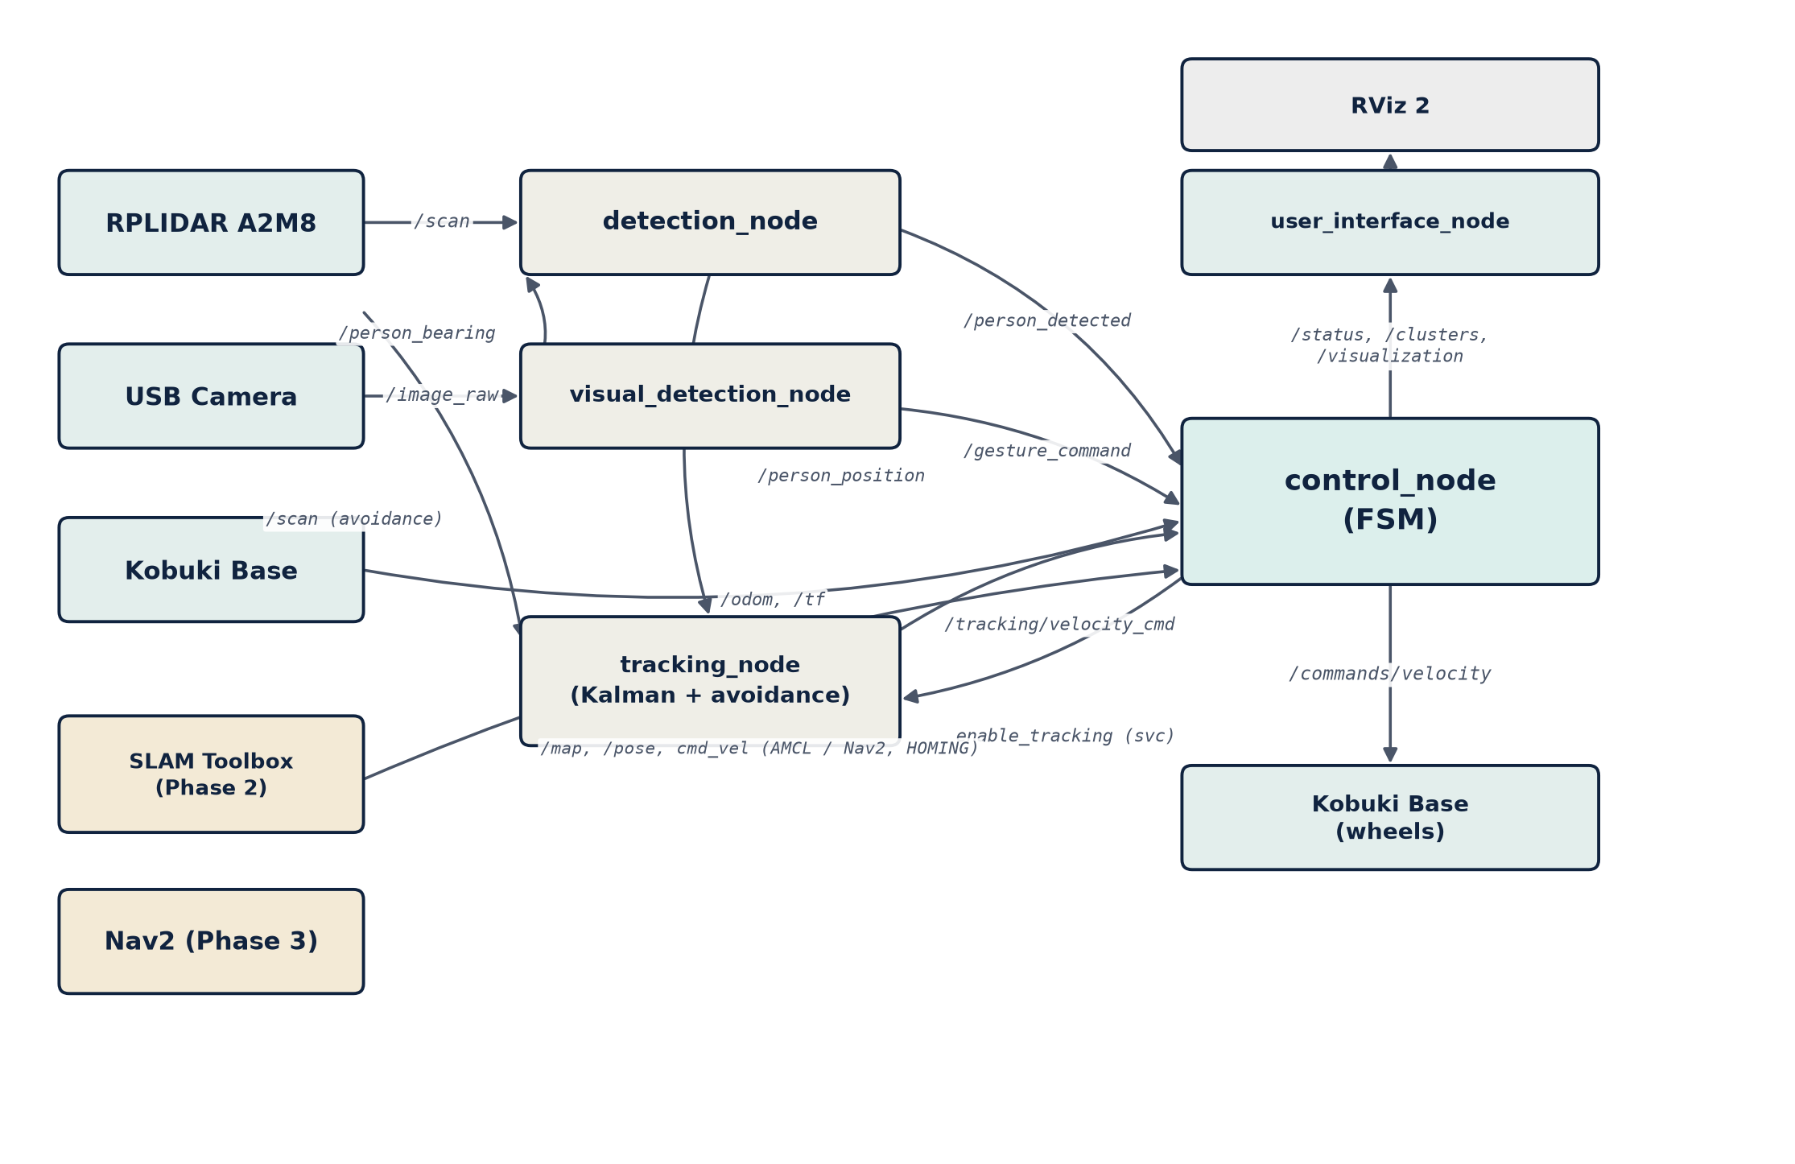

Figure 2.1 — Node and topic flow of the person_follower system.

2.3 Description of Each Node

2.3.1 detection_node
Function: person detection using the LiDAR.
The algorithm filters LiDAR noise by median, interpolates to increase angular resolution, and clusters points with DBSCAN (eps = 0.12 m, min_samples = 4). It then filters clusters compatible with a human leg (size, radius, shape) and searches for pairs at a coherent distance.
As a fallback (Phase 2), without a valid leg pair the node uses visual_detection_node's bearing (MediaPipe) to pick the best-aligned LiDAR cluster and publishes its centroid. Without it, tracking stopped after 30 s without legs even if the camera saw the person. Validated without motion: 100% detection, bearing deviation ≈6°.
DBSCAN is reimplemented over scipy.spatial.cKDTree, not scikit-learn, due to an incompatibility between the NUC's Python version and that library's compiled extension.
Configurable parameters: maximum detection distance (2.5 m, reduced from 6.0 m), DBSCAN neighborhood radius (0.12 m), leg cluster size (4-200 points) and camera timeout (1.0 s). It subscribes to /scan, /person_detected_visual and /person_bearing; publishes /person_detected, /person_position, /clusters/general and /clusters/legs.

2.3.2 visual_detection_node
Function: person detection and gesture recognition via camera.
The node processes each frame with MediaPipe Pose to detect the human skeleton, replacing the original HOG detector, which required the full body in frame —infeasible at the real tracking distance (~1 m).
Gestures are recognized from MediaPipe Pose body landmarks (not Hands): right hand raised above the shoulder starts tracking, left hand stops it. Each gesture requires several consecutive confirmation frames and a wait time between commands, to reduce false positives.
The node also computes the person's horizontal bearing from the midpoint between the shoulders, based on the camera's field of view, and publishes it for detection_node's fusion. It subscribes to /image_raw and publishes /person_detected_visual, /gesture_command, /person_bearing, /pose/keypoints and /camera/image_processed.

2.3.3 tracking_node
Function: estimating the person's position and computing the velocity commands.
Applies a Kalman filter ([x, y, vx, vy]) over detection_node's position, computing distance and angle to the person. Implements obstacle avoidance over the LiDAR's ±45° frontal sector: obstacles under 0.6 m trigger angular repulsion and reduce linear speed, and the robot stops if the person disappears for more than two seconds. Activated by the enable_tracking service, invoked by control_node.

2.3.4 control_node
Function: the system's central finite-state machine.
Implements the state machine of Figure 2.2: IDLE (waiting for an authorized person), TRACKING (relays tracking_node's velocities), HOMING (relays Nav2's velocity toward the “home” pose after the “roof” gesture, §7.8), MANUAL (keyboard teleoperation) and SHUTDOWN (coordinated shutdown). With the camera enabled, starting tracking requires the gesture; otherwise it starts automatically.
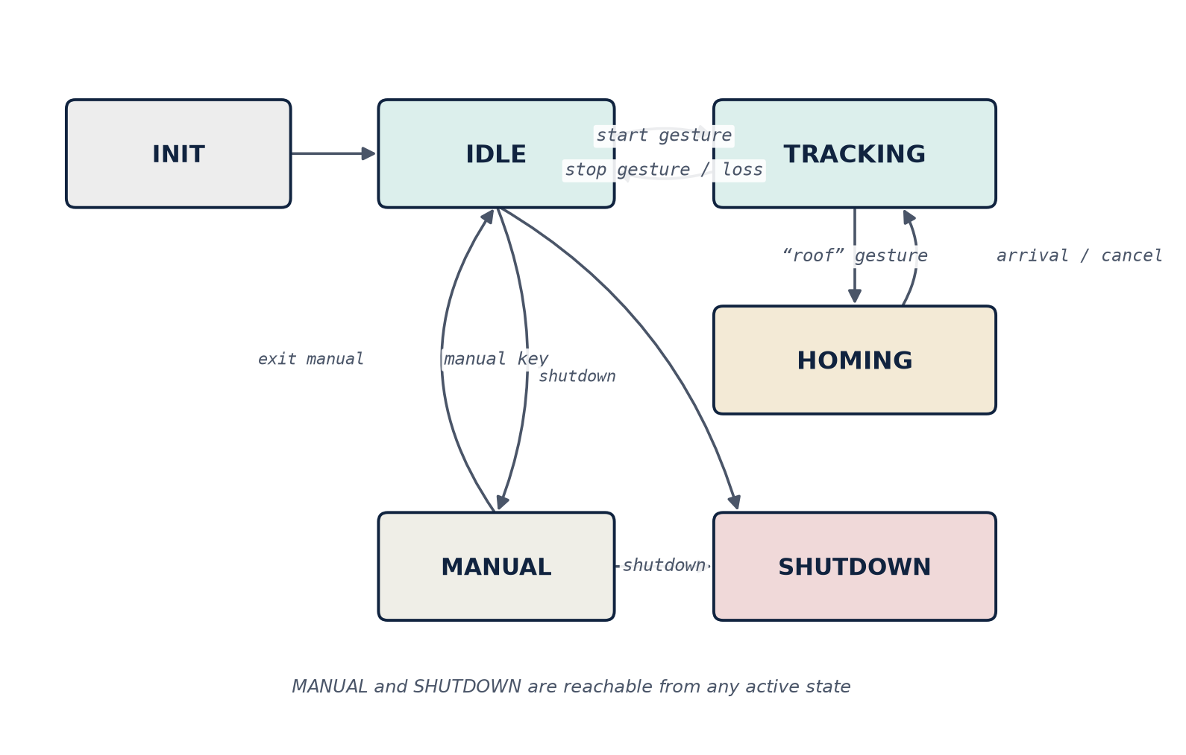
Figure 2.2 — control_node's finite-state machine.

2.3.5 collision_handling_node
Monitors the minimum distance to the nearest obstacle and publishes a collision-detected signal when any LiDAR scan point is under 0.4 m. control_node does not yet react to this signal; its integration is planned alongside Nav2.

2.3.6 user_interface_node
Handles real-time visualization: launches RViz 2 with the package configuration, publishes markers (estimated person position, LiDAR clusters, robot marker) and a periodic diagnostic status.

2.3.7 slam_node (experimental)
A minimal, custom 2D SLAM implementation, developed in Phase 1. Replaced in Phase 2 by SLAM Toolbox (greater robustness, loop closure and map serialization); kept disabled by default.

2.4 Coordinated Shutdown Management
The system implements a coordinated shutdown to prevent the robot from being left with active velocities: control_node publishes a shutdown signal, subscribed nodes stop their activity and confirm the stop, and control_node waits for all confirmations before finishing.

2.5 Transform Tree (TF)
Figure 2.3 shows the transform tree. The base_footprint→laser transform is published statically, with a 180° rotation about Z, because the LiDAR is mounted inverted.
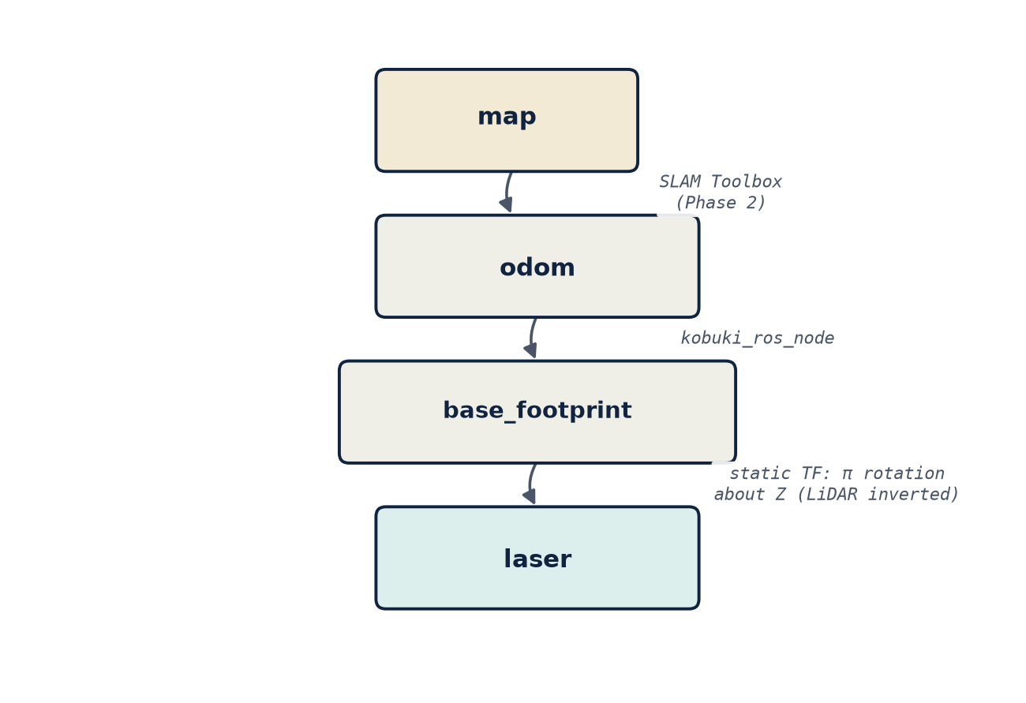
Figure 2.3 — The system's transform tree (TF).

2.6 Configuration Parameters
All tunable parameters are centralized in a common configuration file, allowing detection thresholds, safety distances and robot behaviors to be changed without recompiling. SLAM Toolbox uses a separate configuration file.

2.7 ROS 2 Package Dependencies
Figure 2.4 summarizes the dependencies of the person_follower package, both internal to the ROS 2 ecosystem and external.
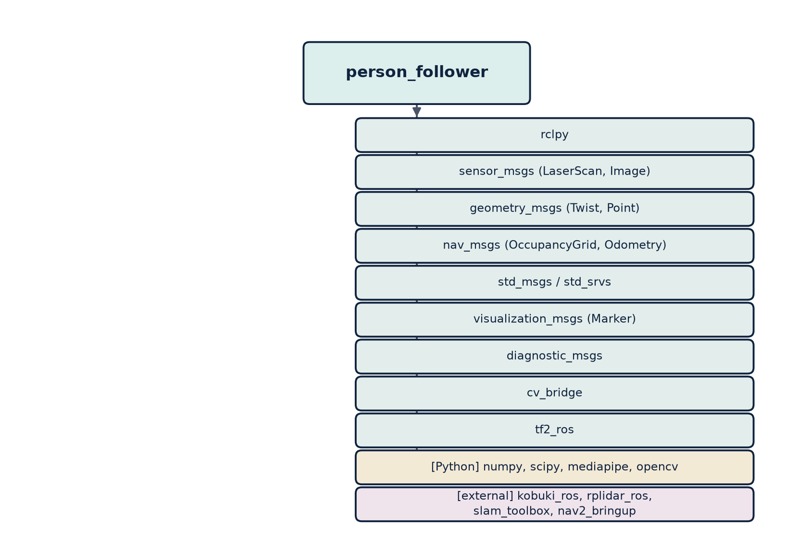
Figure 2.4 — person_follower package dependencies.

2.8 Nav2 Architecture (Phase 3)
Autonomous navigation is organized in four layers (Figure 2.5): sensors (LiDAR and odometry); localization, where map_server publishes the map and AMCL combines scan, odometry and map to estimate the pose (map-odom TF); the Nav2 core (planner_server, controller_server, behavior_server and bt_navigator, coordinated by a behavior tree); and the output, where controller_server drives the wheels.
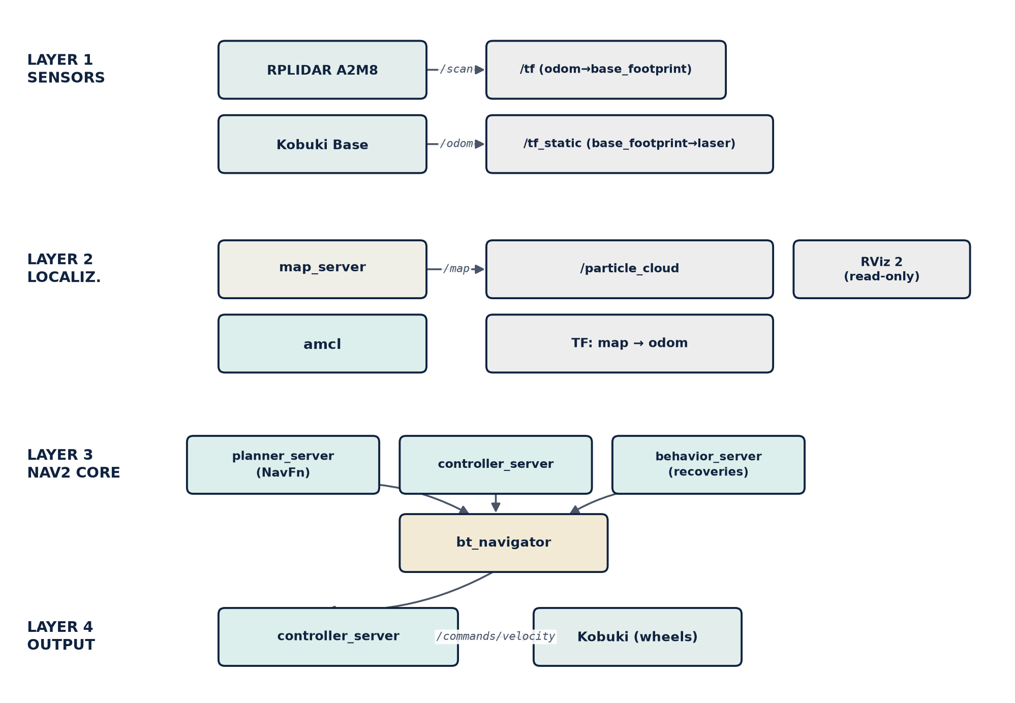

Figure 2.5 — Layered architecture of autonomous navigation with Nav2.
This architecture was validated incrementally: a first test confirmed sensors and localization, and a later test also validated the Nav2 core and the output, reaching six of seven navigation goals, including avoidance of an unmapped real obstacle.

Chapter 3 — Use of Artificial Intelligence Tools

3.1 Declaration of Use
This thesis uses artificial intelligence tools as complementary technical support, similar to an advanced search engine or an automated documentation tool.
This declaration is consistent with the guidelines of many universities, which recognize the value of these tools as a learning and productivity aid, provided the student retains intellectual authorship: understanding the problem, design decisions, experimental validation and interpretation of results.

3.2 Tools Used

3.2.1 Conversational AI assistant (Claude, Anthropic)
The main use was diagnosing ROS 2 errors: compilation errors (ament_cmake, find_packages()); log analysis to distinguish the LiDAR's and the Kobuki base's serial ports; queries about ROS 2 interfaces; and code review, identifying an unintended double subscription in the tracking node.
The assistant did not make system design decisions —architecture, algorithms or parameters—, did not run experimental tests or interpret results, and did not write the state of the art or the thesis conclusions.

3.2.2 Code autocompletion tools
During development, IDE autocompletion (Visual Studio Code with Pylance) was used to speed up repetitive ROS 2 code, such as declaring parameters or creating publishers and subscribers.

3.2.3 Search engines and documentation
The official documentation for ROS 2, SLAM Toolbox, Nav2, and MediaPipe was routinely used as a technical reference during development.

3.3 Reflection on the Ethical Use of Artificial Intelligence
Using AI in engineering raises questions of authorship and learning. The approach followed: never incorporate AI-generated code without understanding it, validating every change on the physical robot; take full authorial responsibility; transparently declare this use; and use the assistant as a learning tool.

3.4 Impact Estimate
Table 3.1 summarizes, for the project's main tasks, the proportion developed by the author and the type of support received from artificial intelligence tools.
Task | % developed by the author | AI support
System architecture design | 100% | None
DBSCAN algorithm for leg detection | 100% | Debugging
Kalman filter in tracking_node | 100% | None
control_node state machine | 100% | None
Identifying package configuration errors | 60% | Diagnosis
Physical robot bring-up | 90% | Log diagnosis
Technical documentation (this chapter) | 100% | None
Experiments and validation | 100% | None

Chapter 4 — Development Diary
This chapter summarizes, session by session, the project's technical milestones and fixes. Table 4.1 gives the full timeline; unlike Chapter 6 (each module's final state), this documents the iterative process. Phase 4 closed with the validation of the “home” gesture on 23 September 2026 (see also §7.8 and §7.10).
Table 4.1 — Development timeline.
Date | Phase | Milestone / fix
21 May | P1 | First session: fixed install/build errors, LiDAR/Kobuki device conflicts, SLAM Toolbox not activated (lifecycle), and MediaPipe/scikit-learn access without internet. Six nodes operational.
27 May | P1 | Second session: 4 fixes (ROS 2 API, residual signal, leg geometric filter); Kalman 4→6 states, Mahalanobis gate, angular PD control; C270 camera with HOG.
late May | P1 | Fixed jerky motion (hysteresis, Kalman prediction); first lab map. Phase 1 completed.
4-17 Jun | P2 | Detection continuity tuning; MediaPipe Pose replaces HOG (framing issue); start/stop gestures validated.
25 Jun | P2 | Camera bearing as disambiguator without a leg pair; DBSCAN reimplemented over scipy. 100% detection, no losses. Phase 2 completed.
8-9 Jul | P3 | First in-motion validation: jumps and angular saturation, fixed with continuity filter, Mahalanobis gate and angular limit (jumps: 1/8 → 1/140).
9-15 Jul | P3 | Gesture fixed (SPCA2650 camera); fixed uncontrolled turning and inverted PD control sign, verified against real odometry.
16-21 Jul | P3 | Chapters 5-6 written; fixed inverted avoidance sector; turn-detection gap reduced from 2-4 s to ~1.5 s.
22-23 Jul | P3 | Two light collisions (LiDAR blind spot, mis-referenced threshold); fixed speed reduction factor and added go-around maneuver: from 4 contacts to contact-free avoidance.
27 Jul | P3 | AMCL converges with longer commands (DDS latency); Nav2 reaches 6/7 goals, including avoidance of an unmapped obstacle. Phase 3 completed.
29 Jul | P3-P4 | Demo video recorded; 2 open limitations confirmed: avoidance does not distinguish person from obstacle, position jump after prolonged occlusion.
Aug-Sep | P4-P5 | Phase 4: closing the evaluation scenario and consolidating metrics. Phase 5: final thesis review, defense prep, and repository tagging.

Chapter 5 — State of the Art

5.1 Introduction and Scope of the Chapter
This chapter situates the design decisions of Chapter 2 —2D LiDAR detection, vision-based pose, sensor fusion, gestural interaction, Bayesian filters, obstacle avoidance and SLAM/Nav2— within the relevant prior work in each area, without aiming for an exhaustive review.

5.2 Person-Following Systems with Mobile Robots
Person-following is a classic service-robotics problem, combining perception, state estimation and motion control. Published approaches are typically grouped by their primary sensor:
- Pure LiDAR: exploits the environment's geometry and the leg pattern while walking. Most robust to varying lighting, but ambiguous against similarly-shaped objects (chair legs, columns).
- Vision-only: RGB or RGB-D cameras with detection or pose models to locate the person in the image. It provides rich semantic information (identity, gestures, body orientation), but is sensitive to occlusions, lighting, and a limited field of view.
- Multi-sensor fusion: combines LiDAR and camera, sometimes with time-of-flight or thermal sensors, to offset each modality's weaknesses. Sarmento et al. (2023) fuse time-of-flight with a monocular camera; Kitamoto et al. (2025) propose robust tracking with 3D LiDAR and point-cloud projection.
Robots in this family typically run on indoor differential bases —like this thesis's TurtleBot 2/Kobuki—, where perception dominates over kinematics; on outdoor Ackermann bases (Li et al., 2025) limited maneuverability adds constraints that do not apply here.
This thesis's system falls into the multi-sensor fusion category (LiDAR + camera), inheriting a clustering-based LiDAR detector from the project's initial phase and adding a visual fallback path in Phase 2 (§5.5).

5.3 Person Detection via 2D LiDAR (Leg Detection)
Detection from 2D scans at leg height is a well-established line: cluster segmentation, filtering by leg-compatible geometric features (size, radius, circularity, curvature), and pairing plausible candidates, optionally tracking their trajectory to distinguish gait from similar static objects.
Cha and Chung (2020) propose leg detection in a 3D feature space with 2D LiDAR for person-following robots; Yao et al. (2023) address differentiating multiple targets in multi-person scenarios. A recurring challenge is geometric ambiguity: chair/table legs, columns and other cylindrical objects can produce false positives, and partial occlusions —one leg blocking the other during a turn— break the pairing. Guerrero-Higueras et al. (2018) explore convolutional networks over raw 2D scans as an alternative to hand-crafted features, for robustness in cluttered environments.
This project's detection node (§2.3.1) follows the classic geometric-feature approach —DBSCAN clustering, filtering by size/radius, pairing by coherent distance— rather than deep-learning alternatives like Guerrero-Higueras et al. (2018), for simplicity without a dedicated GPU and to reuse the original system's already-validated detector. The geometric ambiguity described motivates the camera-based fallback of §5.5; the joint LiDAR-and-camera loss observed during turns —unresolved as of this chapter— is a concrete instance of the partial-occlusion problem described by Cha and Chung (2020) and Yao et al. (2023).

5.4 Vision-based Human Pose Estimation
BlazePose (Bazarevsky et al., 2020) is a lightweight convolutional network producing 33 body keypoints at >30 fps without a dedicated GPU, and underlies the MediaPipe Pose used in this project. Its GHUM Holistic extension (Grishchenko et al., 2022) adds 3D hand and face landmarks, though this thesis only needs shoulder and wrist landmarks for gestures and bearing.
Compared to HOG, used in the original version, landmark-based models have two advantages: they do not require the full body in frame —infeasible at the real tracking distance (~1 m)—, and they give semantically meaningful anatomical points (wrist, shoulder) directly usable for gestures and orientation, rather than a simple bounding box. This motivated replacing HOG with MediaPipe Pose (§2.3.2).

5.5 LiDAR-camera Sensor Fusion for Robust Detection
LiDAR-camera fusion is an active area: LiDAR offers precise but ambiguous geometry; the camera provides rich semantics but is sensitive to occlusion/lighting and gives no reliable monocular distance. Approaches range from 360° vision-LiDAR (Li et al., 2025) to deep fusion —Minase and Tanaka's (2026) transformer for LiDAR and thermal imagery—, confirming that fusion improves robustness over a single modality.
The design adopts a lighter scheme, without a depth camera: visual_detection_node computes an angular bearing from the shoulder midpoint (MediaPipe), and detection_node uses it only as a disambiguator when it finds no valid leg pair. This is an asymmetric late fusion: LiDAR remains the primary source of 2D position, and the camera only disambiguates when LiDAR geometry is insufficient.
This asymmetry is deliberate: it avoids relying on precise extrinsic camera-LiDAR calibration —only the horizontal field of view and a calibration sign are needed— at the cost of not leveraging the camera when the LiDAR does detect legs. Simultaneous loss during turns —both modalities share the same frontal blind spot— is a known limitation and remains open.

5.6 Gesture-based Human–Robot Interaction
Gesture recognition as an interaction channel is extensively reviewed (Wang et al., 2022). Within vision, the trend favors body landmarks over full-image classifiers —lighter, without large datasets: the gesture is a geometric rule over already-extracted points. Recent work with MediaPipe reports 94-96% success in gesture-driven tasks (Zhang et al., 2025).
The system follows this rule-based approach: two discrete gestures —right hand to start, left hand to stop—, defined as geometric conditions over MediaPipe Pose landmarks, with frame confirmation and inter-command waiting (§2.3.2). It is a deliberately minimal vocabulary, since interaction is limited to starting and stopping tracking.

5.7 State Tracking: Bayesian Filters
The family of Bayesian filters —Kalman, EKF, UKF, and particle filters— has been the standard approach in person-tracking with mobile robots for over two decades (Urrea and Agramonte, 2021). Bellotto and Hu (2010) show the UKF can match a particle filter's performance at much lower computational cost — relevant for embedded platforms like this project's, with no dedicated GPU and the CPU shared between LiDAR detection, MediaPipe, and the rest of the ROS 2 nodes.
The tracking node uses a linear, non-extended Kalman filter with state [x, y, vx, vy] (§2.3.3): the lightest option, appropriate because the motion and observation models are already linear, avoiding the cost of an EKF/UKF or particle filter, which would only add value if the observation model were non-linear.

5.8 Obstacle Avoidance and Motion Control
For converting the estimated position of a person into safe velocity commands, the reactive navigation literature's classic method is the Dynamic Window Approach (DWA; Fox, Burgard, and Thrun, 1997), which restricts the search to the robot's directly reachable velocity space, simulating short-term trajectories and selecting the one that avoids collisions. It is among the most widely adopted reactive avoidance methods indoors, and the one Nav2 (§5.9) uses as a standard local controller.
The tracking node implements avoidance inspired by the same idea —angular repulsion and speed reduction near obstacles (§2.3.3)—, simplified relative to full DWA: it does not simulate trajectories, applying a direct reactive rule over the frontal sector. Nav2 reserves full DWA for point-to-point navigation without active tracking.

5.9 Mapping and Autonomous Navigation (SLAM and Nav2)
For mapping, this thesis uses SLAM Toolbox (Macenski and Jambrecic, 2021), the reference implementation for ROS 2 (sync/async mapping, localization on a saved map, map merging). It replaced the custom basic SLAM implementation of Phase 1 (§2.3.7) in Phase 2, for greater robustness and loop closure.
For navigation, the project uses Nav2, successor to the ROS 1 stack (Macenski et al., 2020), separating global planning, local control and perception via behavior trees and lifecycle nodes (more in Macenski et al., 2023). This thesis's scope is a minimal demonstration —AMCL on a saved map and navigation to one goal—, limited relative to Nav2's full capabilities by the number of sessions available (§1.4).

5.10 Synthesis: Positioning This Thesis Relative to the State of the Art
The system introduces no individually novel method: each subsystem —clustering-based detection, MediaPipe Pose, late LiDAR-camera fusion, linear Kalman, reactive avoidance, SLAM Toolbox, Nav2— reuses established techniques. Its contribution lies in the concrete integration on a real, resource-constrained platform, and in the practical adaptations that integration requires:
- Reimplementing DBSCAN over scipy.cKDTree due to a scikit-learn incompatibility with the NUC's Python version (§2.3.1).
- A deliberately asymmetric LiDAR-camera fusion scheme with light calibration requirements, compared to the more symmetric or deep-learning-based fusion schemes in the recent literature (§5.5).
- The choice of a linear Kalman filter, not an EKF or UKF, exploiting the fact that this particular system's observation model is already linear (§5.7).
- A minimal gesture vocabulary (two gestures) strictly tailored to the need to start and stop tracking, rather than to general-purpose interaction (§5.6).
- A Nav2 scope trimmed to a minimal demonstration by real lab-time constraints, documented as such rather than presented as a limitation of the technique (§5.9, §1.4).
This perspective —pragmatic integration on a resource-constrained real platform, rather than isolated algorithmic innovation— frames the technical decisions detailed in Chapter 6 and the experimental results in Chapter 7, including the integration of tracking and navigation in the “home” gesture (§7.8): the contribution is not a new navigation algorithm, but the arbitration architecture that lets both subsystems safely share the same base.

References
- Bazarevsky, V., Grishchenko, I., Raveendran, K., Zhu, T., Zhang, F., and Grundmann, M. (2020). BlazePose: On-device Real-time Body Pose Tracking. arXiv:2006.10204.
- Bellotto, N., and Hu, H. (2010). Computationally efficient solutions for tracking people with a mobile robot: an experimental evaluation of Bayesian filters. Autonomous Robots, 28(4), 425-438.
- Cha, D., and Chung, W. (2020). Human-Leg Detection in 3D Feature Space for a Person-Following Mobile Robot Using 2D LiDARs. International Journal of Precision Engineering and Manufacturing.
- Fox, D., Burgard, W., and Thrun, S. (1997). The Dynamic Window Approach to Collision Avoidance. IEEE Robotics & Automation Magazine, 4(1), 23-33.
- Grishchenko, I., Bazarevsky, V., et al. (2022). BlazePose GHUM Holistic: Real-time 3D Human Landmarks and Pose Estimation. arXiv:2206.11678.
- Guerrero-Higueras, Á. M., Álvarez-Aparicio, C., Calvo Olivera, M. C., Rodríguez-Lera, F. J., Fernández-Llamas, C., Martín Rico, F., and Matellán, V. (2018). Tracking People in a Mobile Robot From 2D LIDAR Scans Using Full Convolutional Neural Networks for Security in Cluttered Environments. Frontiers in Neurorobotics, 12, 85.
- Kitamoto, S., Hiroi, Y., Miyawaki, K., and Ito, A. (2025). Robust Human Tracking Using a 3D LiDAR and Point Cloud Projection for Human-Following Robots. Sensors, 25(6), 1754.
- Li, Z., Kou, D., Wang, Y., Li, W., Dong, Z., and Zhang, L. (2025). Auto-Follower: A Person-Following System for Urban Ackermann Human–Machine Collaborative Robotics. ACM Transactions on Autonomous and Adaptive Systems.
- Macenski, S., and Jambrecic, I. (2021). SLAM Toolbox: SLAM for the dynamic world. Journal of Open Source Software, 6(61), 2783.
- Macenski, S., Martín, F., White, R., and Clavero, J. G. (2020). The Marathon 2: A Navigation System. IEEE/RSJ International Conference on Intelligent Robots and Systems (IROS). arXiv:2003.00368.
- Macenski, S., Moore, T., Lu, D. V., Merzlyakov, A., and Ferguson, M. (2023). From the desks of ROS maintainers: A survey of modern & capable mobile robotics algorithms in the robot operating system 2. Robotics and Autonomous Systems, 168, 104493.
- Minase, Y., and Tanaka, K. (2026). A Dual-Stream Transformer Architecture for Illumination-Invariant TIR-LiDAR Person Tracking. arXiv:2604.00363.
- Sarmento, J., Neves dos Santos, F., Silva Pinto de Aguiar, A., Filipe, V., and Valente, A. (2023). Fusion of Time-of-Flight Based Sensors with Monocular Cameras for a Robotic Person Follower. Journal of Intelligent & Robotic Systems.
- Schulz, D., Burgard, W., Fox, D., and Cremers, A. B. (2003). People Tracking with Mobile Robots Using Sample-Based Joint Probabilistic Data Association Filters. International Journal of Robotics Research, 22(2), 99-116.
- Urrea, C., and Agramonte, R. (2021). Kalman Filter: Historical Overview and Review of Its Use in Robotics 60 Years after Its Creation. Journal of Sensors, 2021, 9674015.
- Wang, X., Shen, H., Yu, H., Guo, J., and Wei, X. (2022). Hand and Arm Gesture-based Human-Robot Interaction: A Review. arXiv:2209.08229.
- Yao, H., Peng, J., Liao, Z., Zhao, R., and Dai, H. (2023). Leg Detection for Socially Assistive Robots: Differentiating Multiple Targets with 2D LiDAR. In: Proceedings ICCSIP 2023, Springer, LNCS.
- Zhang, G., Su, J., Zhang, S., Qi, J., Hou, Z., and Lin, Q. (2025). Research on Deep Learning-Based Human–Robot Static/Dynamic Gesture-Driven Control Framework. Sensors, 25(23), 7203.

Chapter 6 — Implementation

6.1 Introduction and Scope
Chapter 2 describes the architecture at the topology level: nodes, topics and general function. This chapter documents how each active node is implemented —algorithms, data structures, control formulas and code decisions— based on the real source code.
Not all code files are running: the install script registers seven nodes as executables (§6.2), and several directories keep unregistered earlier versions. This chapter documents the code actually running; §6.11 explains the legacy code.

6.2 Package Structure and Configuration Management
The package is of type ament_python, with one directory per node, and registers seven executables: control_node, visual_detection_node, detection_node, tracking_node, user_interface_node, collision_handling_node, and slam_node.
All of each node's adjustable parameters are centralized in a configuration file per node, loaded by the launch files, so thresholds can be changed without recompiling. Each parameter includes a comment justifying it and, often, the date and reason for its last change.
The main launch file starts five nodes: control_node, tracking_node, visual_detection_node, detection_node and user_interface_node. collision_handling_node and slam_node are left out: the former because control_node does not yet react to its signal (§2.3.5), and the latter because it is disabled (replaced by SLAM Toolbox, Phase 2).

6.3 detection_node — Clustering, Leg Features, and Temporal Filtering

In-house DBSCAN on a Nearest-Neighbour Tree
This node's DBSCAN is reimplemented over scipy's cKDTree, not scikit-learn, due to incompatibility with the NUC's Python version (§2.3.1). It follows the standard semantics —a point is a core point if it has a minimum number of neighbors within a radius—, with radius-based neighbor queries and breadth-first expansion; the computational cost is negligible for the hundreds of points in a filtered scan. Neighborhood radius (0.12 m) and minimum neighbors (4) are calibrated to the RPLIDAR A2M8's real angular resolution.

Multi-feature Geometric Leg Filter
The node extracts eight features per cluster (size, radius, spread, width, height, aspect ratio, circularity, compactness) and applies six sequential filters, combining the original inherited filter with additional features to reduce false positives (furniture legs) and false negatives (occluded legs). Two thresholds were corrected after confirming they rejected real legs.
Leg pairing is a greedy nearest-neighbor algorithm: for each unpaired cluster, the closest one within a coherent range (0.05-0.35 m) is sought and combined into a candidate whose centroid is the estimated position. No global optimization (Hungarian assignment) is used, given the low number of clusters per scan.

Temporal Continuity and Confirmation Filtering
Three temporal filtering mechanisms guard against false positives: temporal persistence (a detection must hold for several scans to be confirmed, and fail as many to be lost); a cumulative-drift filter, discarding candidates whose distance from the oldest confirmed position exceeds the plausible displacement; and a consistency confirmation, stricter for the camera fallback (always requires confirmation).
The fusion fallback: without a valid leg pair, the node computes the expected angle in the laser frame from the camera bearing, picks the cluster with the smallest angular deviation, and requires repetition over several scans before publishing it —independent confirmation from that of leg pairs, since a single cluster is a weaker signal.
The node flips the sign of the coordinates right before publishing, at the boundary between the laser's raw frame (front ≈π radians) and tracking_node's standard convention (front on the positive x axis). Keeping the rest of the logic in the raw frame and flipping only on publish avoids rewriting all the filtering, at the cost of reading internal variables in the raw frame.

6.4 visual_detection_node — Dual Detection and Gesture Recognition
The node supports two interchangeable detectors: MediaPipe Pose if available, or HOG as an automatic fallback (resolved via import exception handling). Without MediaPipe there are no landmarks, so gestures are unavailable in HOG mode. HOG, inherited from Phase 1 and replaced as primary by MediaPipe Pose (§2.3.2, §5.4), is kept as a fallback.
Video capture runs in a thread independent of the ROS 2 executor, discarding stale buffered frames and always processing the most recent one. Publishing is capped to a target rate, measuring actual processing time to adjust the wait.
Gesture recognition and bearing computation reuse the same MediaPipe Pose landmarks (shoulders, wrists, hips). The start gesture triggers when the right wrist rises above the right shoulder, and stop with the left; the decision margin scales with torso size, not fixed in pixels, and each gesture requires confirmation over several frames plus a wait between commands. The bearing is computed from the shoulder midpoint, published only if both exceed the minimum visibility.

6.5 tracking_node — Kalman Filter, PD Control, and Obstacle Avoidance
Along with detection_node, it is the node with the most documented iterations. The active version replaces an earlier, simpler design without an acceleration model, kept as legacy code (§6.11).

Six-state Kalman Filter with a Constant-Acceleration Model
The filter keeps a six-dimensional state (position, velocity, acceleration), versus four in the inherited design, with observation measuring only position. The transition matrix implements constant acceleration, with process noise correlated by powers of the time step; the correction uses Joseph's form, costlier but numerically more stable.

Mahalanobis Gate with Streak-based Confirmation
Each observation goes through a Mahalanobis gate against the 95% chi-squared threshold (2 d.o.f.): it is only rejected if it exceeds that threshold by several times, and if several consecutive observations fall outside it, the filter re-anchors to the latest one, assuming a real reappearance. An isolated observation is ignored; a sustained streak is treated as a legitimate reappearance, the same confirmation pattern used by detection_node's continuity mechanisms (§6.3).

Angular Velocity Controller
Angular velocity is computed in five steps: (1) PD with a ±8° dead zone; (2) coupling with linear speed, reducing turning at high speed; (3) close-range attenuation, from zero to full value based on the reference distance; (4) soft start over the first second and a half; and (5) a per-cycle change limit, guarding against a large real error or a one-off detection jump.
Linear speed follows a non-linear ramp based on distance to the person, smoother than a linear relation near the tracking reference distance, avoiding abrupt starts when the person moves slightly away from that distance.

Reactive Obstacle Avoidance (not a Real Dynamic Window Approach)
Although the original documentation labeled this block as Kalman + DWA, tracking_node does not implement a real DWA —simulating trajectories in velocity space (§5.8)—; that implementation exists in a separate, unregistered file (§6.11). The active mechanism is reactive, repulsion-field style: for each point in the ±50° frontal sector within a threshold (0.40 m, raised from 0.35 m), a weight is accumulated favoring closer, more frontal obstacles, with the final angular adjustment as a weighted average.
Linear-velocity reduction factor, fixed on 22 July. The original formula never actually reduced velocity to zero —a lower bound that was dead code (§4.3, §7.6)—, so the robot never fully braked against a sustained obstacle, causing two light contacts despite detecting it. The current formula uses the real minimum distance in the frontal sector: a ramp at 1.0 at the threshold, decreasing to a genuine 0.0 —hard stop— at a second, closer threshold (0.25 m), leaving ~10 cm of margin.
Go-around manoeuvre, added on 22 July. If the reduction factor stays below a threshold (0.5) for 1.5 s sustained, the node executes a tight 1.5 s turn in the direction already indicated, followed by a short straight advance at low speed; it aborts and restarts the turn if the factor drops again. This is the alternative to advancing indefinitely without resolving the deadlock; a first version, not yet validated systematically (Chapter 7).
It is deliberately cheaper than a full DWA, at the cost of not reasoning about kinematic constraints or multi-step lookahead: enough for low-speed reactive avoidance, but a real simplification versus Nav2's DWA (§5.8-5.9); the architecture label has been corrected.

6.6 control_node — Finite-State Machine and Teleoperation
The state machine (INIT → IDLE ↔ TRACKING, with MANUAL and SHUTDOWN reachable from any active state) is a single class with the current state as a text string. Two mechanisms prevent erratic behavior: hysteresis on detection loss, waiting before returning to idle; and gesture-based authorization independent of detection (with the camera disabled, authorization is granted automatically).
Keyboard teleoperation runs on a separate thread reading input in unbuffered mode, to capture keys without blocking the ROS 2 executor, and disables itself if standard input is not an interactive terminal —necessary because a leftover interrupt signal can remain in the buffer and be read as an unexpected signal when the system launches.

6.7 collision_handling_node
It is the simplest node: it applies a single distance threshold over the LiDAR scan's minimum, publishing the collision signal only on state changes. It is not included in the main launch and control_node does not yet subscribe to its signal (§6.2) —infrastructure prepared for Nav2, which can react via its recovery behaviors.

6.8 user_interface_node
It implements no perception or control: it is a state aggregator. It subscribes to the status topics of the other nodes and republishes visualization markers for RViz 2 (estimated position, LiDAR clusters, robot marker), a text panel and a periodic diagnostic on mode changes. It also launches and closes RViz 2 in a coordinated way.

6.9 slam_node (experimental, disabled by default)
A minimal, custom 2D SLAM implementation: an in-memory occupancy grid, static TF between map and odometry, updated from the LiDAR and the person's position, without scan matching or loop closure —an occupancy accumulator, not real SLAM. Replaced in Phase 2 by SLAM Toolbox (§5.9), kept disabled as a historical reference.

6.10 Deployment: Building and Syncing with the Robot
The package is built on the NUC with symlinks to the source files, letting the executor pick up changes by relaunching the node, without recompiling after every edit. A sync script automates copying the most-modified files (detection, tracking, configuration); the rest requires manual copying, a real limitation to keep in mind for future extensions.

6.11 Code Not Registered in the Package
Several directories keep more than one complete node class, of which only one is registered: the control node keeps two earlier versions; the tracking node keeps a real DWA implementation (velocity-space search and RViz trajectory visualization), not running; and the user-interface node keeps an unregistered earlier version.
None of these files is imported by another module: it is not dead code, but earlier versions of the same class kept in the working tree. The real-DWA case matters because it implements what the documentation kept describing as tracking_node's behavior, while the active node uses the reactive controller of §6.5 — a real source of confusion and a reasonable cleanup before final delivery.

Chapter 7 — Results and Evaluation
Note on this chapter's status: the data corresponds to validation completed at UJI's robotics lab, with the final session on 23 September 2026 (§7.8). Several scenarios have a reduced sample size, explicitly documented in §7.9; lines of work beyond the scope of this thesis are recorded in §7.10.

7.1 Validation Methodology
Each take is recorded on the NUC as a ROS 2 bag, converted to tabular format and analyzed externally, producing metrics and four figures (distance, angle and speed over time, and trajectory). Standard metrics: distance error (MAE/RMS), mean angular error, peak speeds, % detection and losses.

7.2 Experimental Setup
- Robot: TurtleBot 2 on a Kobuki base, with an onboard compute unit running ROS 2 Jazzy.
- Sensors: RPLIDAR A2M8 LiDAR and an RGB camera. The camera changed midway through the validation campaign (§1.3): the no-motion fusion take (25/06) and the three takes from 08/07 (§7.4) were recorded with the original Logitech C270; all takes from 09/07 onward (§7.5, 7.6, and 7.7) were already recorded with the SPCA2650 that replaced it.
- Environment: UJI's robotics lab, indoors, tiled floor.
- Target tracking distance: 1.50 m in the 25 June take; 1.00 m from the 8 July takes onward, after a parameter adjustment between sessions.
- Tracking activation: via camera gesture under normal conditions; the 8 July takes used a manual activation mechanism because the gesture was not reliable with that session's camera framing.

7.3 Result 1 — Sensor Fusion, No Motion (25 June 2026)
First validation of the LiDAR-camera fusion fallback mechanism, with the robot's base inhibited so the detection mechanism could be tested safely before validating it in motion.
Metric | Value
Duration | 23.5 s (285 samples)
Target distance | 1.50 m
Distance error (MAE / RMS) | 0.627 m / 0.733 m
Min / max distance | 1.27 m / 3.41 m
% of time with person detected | 100.0%
Number of detection losses | 0
Camera bearing vs. chosen cluster deviation | ≈ 6°
With the fusion mechanism active, detection was continuous throughout the whole take, even though the LiDAR alone could not reliably tell legs apart in this configuration —the fallback mechanism's original motivation (§2.3.1, §5.5). The mean angular error is not representative in this take: with the base inhibited, angular velocity never corrects orientation toward the person, so this figure measures the lack of motion rather than a detection failure.

Figure 7.1 — Robot-to-person distance over time, no-motion fusion take (25/06/2026).

Figure 7.2 — Robot trajectory (odometry), no-motion fusion take. The base remained stationary by design of the test.

7.4 Result 2 — Progression of In-motion Continuity Fixes (8 July 2026)
First tracking test with the robot actually moving. The initial take revealed detection jumps and near-permanent angular saturation; the next two takes verify each fix separately (§4.3).
Take | Duration | % detection | Losses | MAE dist. | RMS dist. | Jumps >0.8 m | wz saturation
Original (unfixed) | 759.8 s | 32.3% | 79 | 0.519 m | 0.935 m | 3.5% | 95.7%
+ continuity filter | 249.0 s | 71.7% | 43 | 0.534 m | 0.725 m | 2.2% | 99.3%
+ Mahalanobis and wz limit | 53.1 s | 82.6% | 13 | 0.491 m | 0.609 m | 0.7% | 86.9%
The jump and saturation figures were recalculated on 21 July with the standard analysis pipeline over the three original logs; the jump percentage reproduced exactly in two of the three takes and came out somewhat lower in the third, a minor difference attributable to reconstructing a previously ad-hoc methodology.
The three chained fixes clearly reduced implausible position jumps and increased detection: fewer jumps yield a more stable Kalman filter. Angular saturation, however, does not improve consistently —they target detection continuity, not the angular controller's gain; the fix that does reduce it (proximity attenuation, §6.5) was added later, on July 15.

Figure 7.3 — Robot-to-person distance over time, take with all three continuity fixes applied.

Figure 7.4 — Linear and angular velocity over time, same take.

Figure 7.5 — Robot trajectory (odometry), same take.

7.5 Result 3 — Per-scenario Repetitions with the System Stabilized (22 July 2026)
With the July 21 fixes already in production, two to three takes were repeated for five collision-free validation scenarios: straight line, curve, short distance, stop, and occlusion.
Scenario | Duration | MAE dist. | Mean ang. | % detec. | Losses | Jumps >0.8 m | Stable sat.
Straight (contaminated) | 41.4 s | 0.626 m | 62.0° | 76.2% | 7 | 6.8% | 13.8%
Straight (clean) | 25.9 s | 0.420 m | 26.5° | 100% | 0 | 2.3% | 1.8%
Curve #1 | 33.5 s | 0.794 m | 14.5° | 100% | 0 | 2.8% | 6.8%
Curve #2 (short) | 12.2 s | 0.759 m | 23.7° | 97.1% | 1 | 2.0% | 20.8%
Curve #3 | 14.3 s | 0.976 m | 6.2° | 100% | 0 | 0.9% | 0.0%
Stop | 36.5 s | 0.326 m | 5.9° | 100% | 0 | 0.0% | 0.0%
Short #1 (min. 0.15 m) | 32.5 s | 0.443 m | 32.8° | 100% | 0 | 2.0% | 25.1%
Short #2 (short, min. 0.42 m) | 8.4 s | 0.628 m | 4.9° | 98.8% | 1 | 0.9% | 0.0%
Short #3 (min. 0.02 m) | 18.7 s | 0.508 m | 46.8° | 100% | 0 | 1.2% | 28.6%
Occlusion | 30.6 s | 0.678 m | 16.2° | 100% | 0 | 2.5% | 1.5%
The first straight-line take was contaminated by a residual tracking state (the oscillation already documented on June 17); it was not repeated after de-authorizing tracking before each take. The short durations of curve #2 and short #2 stem from the gesture taking time to arrive; short #3 reached 0.02 m, with expected saturation. Occlusion caused no real loss, thanks to the Kalman filter and the single-leg fallback.

7.6 Result 4 — Obstacle Scenario: from First Contacts to Contact-free Avoidance (22–23 July 2026)
After the two real contacts described in §4.3 (21 July session), the obstacle scenario was retried with the safety threshold increased. Seven takes were carried out over two sessions, with two intermediate code changes.
Take | Configuration | Result
Obstacle v3 (furniture) | Safety threshold raised, linear reduction factor unfixed | Light contact — the reduction factor never reached zero, the robot “dragged” without fully braking
Obstacle v4 (furniture) | Same | Light contact again, same pattern
Obstacle v5 (furniture) | Reduction factor fixed: real ramp to zero between the warning and stop thresholds | No contact — much briefer encounter
Obstacle v6 (furniture + chair) | Same | No contact — the chair did not trigger avoidance in this take
Obstacle v7 (furniture + chair) | + go-around manoeuvre (tight turn and short advance) | No contact — manoeuvre triggered four times, completed successfully in all cases except one correct safety abort
Obstacle v8 (furniture + chair) | Same | Furniture correctly avoided; direct contact with the chair, not detected at all by the LiDAR
Obstacle v9 (furniture, 23/07) | No code changes from v7/v8 | No contact — second clean repetition of the fix, confirming the result in a different session
The central finding: the original reduction-factor formula never dropped below 0.4, due to a lower bound that was dead code —avoidance never braked fully, causing light contact despite detecting the obstacle. The fix based the factor on the actual minimum distance in the frontal sector, with a hard stop past a second threshold, and added the go-around maneuver.
The chair contact in take v8, a fifth cumulative real contact, confirmed an already-suspected limitation: the 2D LiDAR's height blind spot (~47 cm) means thin obstacles like a thin-legged chair are not detected at all. This scenario was not retried without mitigating it at the hardware level —an available RGB-D camera or a second LiDAR at a different height.

7.7 Result 5 — Nav2: Localization and Autonomous Navigation (27 July 2026)
First real test of the complete Nav2 stack (specific objective 3). AMCL localization, which had seemed to freeze after its first update, was resolved by determining that the very short test commands were not arriving in time due to node-discovery latency; with longer commands it converged normally.
The full navigation phase was then tested for the first time, with seven goals sent from the RViz interface:
Goal | Approx. distance | Result
1 | ≈ 3.7 m | Success
2 | ≈ 5.9 m | Success
3 (real unmapped obstacle) | ≈ 5.3 m | Success — detected and avoided by the local costmap
4 | ≈ 8.0 m | Success
5 | ≈ 8.1 m | Success
6 (goal change mid-path) | ≈ 0.6 m | Failure — automatically recovered by the lifecycle manager in about 2 s
7 (after recovery) | ≈ 3.6 m | Success
Six of seven goals were completed (86%), including two long ~8 m routes and one with avoidance of a real obstacle not present in the map, dodged via the local costmap. The single failure self-recovered through Nav2's lifecycle manager, without recurring. During the session the saved map was found not to reflect the real space well; it was re-recorded and validated before replacing it —all results already correspond to the new map.

7.8 Result 6 — “Home” Gesture: Integrating Tracking and Navigation (23 September 2026)
Final lab session. With a gesture (“roof”: both hands joined above the head), the user orders the robot to stop following and return autonomously, via Nav2, to a predefined “home” pose — the first integration of tracking and navigation into a single system, with control_node arbitrating which velocity source reaches the base (§2.3.4, §6.6).
Metric | Value
Home-return attempts completed | 9 of 11 (82%)
Time from gesture to home | 15.5 s on average (11-21 s)
Arrival error | 0.27 m / 8° on average (Nav2 tolerance: 0.25 m / 14°)
Cancellation with the left hand | Confirmed by Nav2 in 20 ms, ~7 cm of travel
Gesture false positives | 0 in ~4 min of free gesturing
Roof gesture recognized from behind | 2 of 2 (slower: the head hides one wrist)
The 2 failures were not caused by the gesture or the state machine: localization (AMCL, σ≈0.5 m) placed the robot inside the safety zone of a mapped obstacle, and the planner found no valid route from there; the robot returned to idle safely. This is a first result, based on a sample of 11 attempts in a single session (see §7.9).

7.9 Limitations of the Current Results
- Limited sample size. Several rows in the tables above correspond to a single take, not an average of repetitions; there is not yet a measure of variance between equivalent tests for every scenario. The stop and occlusion scenarios, in particular, remain at a single repetition as this chapter closes.
- Non-directly-comparable durations. The takes in the §7.4 table have very different durations from each other, so the figures are proportions within each take, not values normalized to the same time or distance travelled.
- Under-represented activation gesture: the July 8 takes were activated with a manual mechanism, not the real gesture, so specific objective 1 is not represented there; it is represented in takes after July 9.
- No repetitions for Nav2. The autonomous-navigation result corresponds to a single session, with no repetitions to separate real variability from a one-off event; the exact cause of the single observed navigation failure has also not been investigated in depth.
- Objective 5, a first step validated with a limited sample. The “home” gesture (§7.8) integrates tracking and navigation for the first time: 9 of 11 home-return attempts completed in a single session (11 attempts). The 2 failures were caused by localization (AMCL, ±0.5 m) placing the robot next to a mapped obstacle, leaving the planner no room to trace a route — not a failure of the gesture or the state machine. Guidance to multiple destinations, the full scope of the objective, remains as future work (§7.10).
- Shared compute resources. The onboard NUC runs LiDAR, camera/MediaPipe, tracking, SLAM/Nav2, and the diagnostics interface at the same time; in early development phases this caused disconnections and port conflicts that forced aggressive code optimization (duplicate ports, publish rates, simplifying the detection pipeline — Chapter 4). With all nodes and Nav2 active at once, the final measured load is ~30% per core (4 cores), with no saturation; whether a transient load spike contributed to the 2 localization failures above has not been isolated.

7.10 Future Work
The following remain as lines of future work, beyond the scope of this thesis: extending guidance to multiple destinations (a gesture or a QR code per destination, the full objective 5); a pre-departure manoeuvre when localization places the robot next to an obstacle before requesting a route from Nav2; repeating the stop and occlusion scenarios with more samples; and evaluating the system with more people, environments, and lighting conditions.

