UNIVERSITAT JAUME I
Master's Degree in Intelligent Systems — Master's Thesis
Development and Implementation of a Person-Following System on a Mobile Robot — Part 2 Extension
Master's Thesis Report
Author: Juan Muñoz Rovira
Supervisor: Enric Cervera
Academic Year 2025–2026

Table of Contents
Table of Contents 2
Abstract 4
Chapter 1 — Introduction and Problem Statement 4
1.1 Context and Motivation 4
1.2 Platform, Sensors, and Software Tools 4
1.3 Thesis Objectives 5
1.4 Scope and Limitations 6
1.5 Planning 6
1.6 Cost Estimate 7
1.7 Structure of the Report 7
Chapter 2 — State of the Art 8
2.1 Introduction and Scope of the Chapter 8
2.2 Person-Following Systems with Mobile Robots 8
2.3 Person Detection via 2D LiDAR (Leg Detection) 8
2.4 Vision-based Human Pose Estimation 8
2.5 LiDAR-camera Sensor Fusion for Robust Detection 9
2.6 Gesture-based Human–Robot Interaction 9
2.7 State Tracking: Bayesian Filters 9
2.8 Obstacle Avoidance and Motion Control 10
2.9 Mapping and Autonomous Navigation (SLAM and Nav2) 10
2.10 Synthesis: What This Thesis Contributes 10
Chapter 3 — System Architecture 11
3.1 Introduction to ROS 2 and Overview 11
3.2 Node and Topic Diagram 11
3.3 Description of Each Node 13
3.4 Coordinated Shutdown Management 16
3.5 Transform Tree (TF) 16
3.6 Configuration Parameters 16
3.7 ROS 2 Package Dependencies 17
3.8 Nav2 Architecture (Phase 3) 17
Chapter 4 — Implementation 19
4.1 Introduction and Scope 19
4.2 Package Structure and Configuration Management 19
4.3 detection_node — Clustering, Leg Features, and Temporal Filtering 19
4.4 visual_detection_node — Dual Detection and Gesture Recognition 20
4.5 tracking_node — Kalman Filter, PD Control, and Obstacle Avoidance 20
4.6 control_node — Finite-State Machine and Teleoperation 21
4.7 collision_handling_node 22
4.8 user_interface_node 22
4.9 slam_node (experimental, disabled by default) 22
4.10 Deployment: Building and Syncing with the Robot 22
4.11 Code Not Registered in the Package 22
Chapter 5 — Results and Evaluation 23
5.1 Validation Methodology 23
5.2 Experimental Setup 23
5.3 Result 1 — Sensor Fusion, No Motion (25 June 2026) 23
5.4 Result 2 — Progression of In-motion Continuity Fixes (8 July 2026) 24
5.5 Result 3 — Per-scenario Repetitions with the System Stabilized (22 July 2026) 26
5.6 Result 4 — Obstacle Scenario: from First Contacts to Contact-free Avoidance (22–23 July 2026) 27
5.7 Result 5 — Nav2: Localization and Autonomous Navigation (27 July 2026) 27
5.8 Result 6 — “Home” Gesture: Integrating Tracking and Navigation (23 September 2026) 28
5.9 Limitations of the Current Results 29
5.10 Future Work 30
Chapter 6 — Conclusions 31
6.1 Fulfillment of the Objectives 31
6.2 Contributions 31
6.3 Lessons Learned 31
6.4 Limitations and Future Work 31
Bibliography 33
Appendix A — Use of Artificial Intelligence Tools 35
A.1 Declaration of Use 35
A.2 Tools Used 35
A.3 Reflection on the Ethical Use of Artificial Intelligence 35
A.4 Impact Estimate 36
Appendix B — Development Diary 37

Abstract
This Master's Thesis extends a person-following system previously developed on a TurtleBot 2 mobile robot by adding mapping, autonomous navigation and gesture-based interaction. The robot detects the person's legs with a 2D LiDAR, estimates their posture with computer vision (MediaPipe Pose) and keeps an estimate of their position with a Kalman filter. SLAM Toolbox builds the map of the lab and Nav2 navigates on it. A “return home” gesture brings tracking and navigation together in a single system: in the validation session, 9 of 11 returns were completed (82%), with a mean arrival error of 0.27 m. All tests were carried out with the real robot in the robotics lab at Universitat Jaume I, using a single onboard computer with limited resources.
Keywords: person-following; mobile robot; 2D LiDAR; SLAM; Nav2; sensor fusion; ROS 2.

Chapter 1 — Introduction and Problem Statement

1.1 Context and Motivation
This thesis continues a previous work in which a person-following system was developed for the TurtleBot 2 mobile robot (omixxxer, 2025). That system located the person from the measurements of a LiDAR sensor: it grouped the points with the DBSCAN algorithm (Ester et al., 1996) and searched the resulting groups for the characteristic pattern of two legs.
The starting system had several limitations, which motivate this extension:
- No mapping: the robot had no map of its environment, which ruled out any planned navigation.
- No global localization: the robot did not know its position in the building, so if it lost the person it had no reference to orient itself.
- Limited interaction: there was no clear mechanism to start and stop tracking.
- Camera not integrated: visual detection played no part in the control loop.

1.2 Platform, Sensors, and Software Tools
This section briefly describes the platform and the tools on which the work is built, to make the rest of the report easier to follow. The specific characteristics of the hardware used are detailed in Section 1.4.

Robotic Platform
The TurtleBot 2 is a low-cost, open-source research and teaching platform designed to work with ROS. It is built on the Kobuki mobile base by Yujin Robot: a differential-drive base with two independent drive wheels and caster wheels, fitted with wheel encoders and a gyroscope. From them it computes its own odometry, that is, an estimate of how far it has moved and turned. Several trays are stacked on the base to mount the sensors and the computer.
A LiDAR (Light Detection and Ranging) measures the distance to the objects around it with a laser beam. In a rotating 2D LiDAR, such as the Slamtec RPLIDAR A2M8 used in this work, the measuring unit spins 360° and, on each turn, returns a scan: a set of distances in a single horizontal plane. It has a range of about 12 m and spins at about 10 Hz. As it is mounted about 47 cm above the floor, its scan plane cuts people at leg height, which is what the detector exploits.

Software Tools
All the software is built on ROS 2 (Robot Operating System 2), a set of open-source libraries and tools that has become the de facto standard for programming robots (Macenski et al., 2022); its basic concepts are summarized in Section 3.1. On top of ROS 2, three third-party components handle the spatial part of the problem:
- SLAM Toolbox (Macenski & Jambrecic, 2021). SLAM (Simultaneous Localization and Mapping) is the problem of building the map of an unknown environment while estimating the robot's position within that same map. SLAM Toolbox solves it from the LiDAR scans and the odometry, and produces an occupancy map: a grid in which each cell indicates whether it is free, occupied or unexplored.
- Nav2 (Macenski et al., 2020), the ROS 2 navigation stack. Given a map and a destination, it computes a route, follows it while avoiding any obstacles it encounters, and applies recovery maneuvers when the robot gets stuck.
- AMCL (Adaptive Monte Carlo Localization), the localizer included in Nav2. It estimates the robot's position on an already built map with a particle filter: it keeps a set of position hypotheses and, with each scan, reinforces those that best explain what the LiDAR measures (Fox et al., 1999; Thrun et al., 2005).
For visual perception, MediaPipe Pose (Lugaresi et al., 2019; Bazarevsky et al., 2020) is used. It locates a series of body keypoints in each image (shoulders, elbows, wrists, hips…) and makes it possible to recognize simple gestures from their relative position.

1.3 Thesis Objectives

General objective
To extend the person-following system into a mobile assistance platform capable of autonomous navigation, environment understanding, and communication with the user indoors.

Specific objectives
- Gestural interaction module. Starting and stopping tracking with gestures recognized with MediaPipe Pose: right hand to start, left hand to stop and, in the last phase, the “home” gesture (both hands together above the head, forming a roof) to order a return to a predefined position. After replacing the camera (Logitech C270 with an SPCA2650) and adjusting the visibility threshold, the gestures were reliably recognized in real tests. Objective completed.
- SLAM-based mapping. Integrating SLAM Toolbox with LiDAR to build maps of the lab that are then reused for localization and navigation. Objective completed.
- Autonomous navigation with Nav2. Localizing the robot with AMCL on a saved map and navigating to a target point. Once a latency problem in DDS node discovery had been solved by making the test commands last longer, navigation reached six of seven goals, including two routes of about 8 m and the avoidance of an obstacle not present in the map. Objective completed.
- LiDAR-camera sensor fusion. Using the camera to provide the person's direction when the LiDAR does not identify a pair of legs. The no-motion validation gave 100% detection; in motion, position jumps and angular-velocity saturation appeared, made worse by the NUC's limited computing power. They were corrected with a continuity filter, a Mahalanobis gate and an angular-velocity limit, together with an inverted sign in the PD controller and in the avoidance sector. Objective completed.
- User guidance. Having the robot escort the person to predefined destinations in the building. The first step was validated on the real robot on 23 September 2026: with the “home” gesture, tracking and navigation work in a single system, with 9 of 11 returns completed (82%) and a mean arrival error of 0.27 m (Section 5.8). Guidance to several destinations remains as future work (Section 5.10).
- Exploratory objective. Using QR codes so that the robot can recognize rooms. Still pending.

1.4 Scope and Limitations
Development is carried out on the hardware available in the robotics lab at Universitat Jaume I:
- Robot: TurtleBot 2 on a Kobuki base.
- Onboard compute unit: Intel NUC, a compact low-power computer, running Ubuntu 24.04 LTS and ROS 2 Jazzy.
- Sensors: 2D LiDAR RPLIDAR A2M8 (12 m range, 10 Hz) and an RGB camera (Logitech C270 until replaced by an SPCA2650, prompted by gesture framing issues). An Orbbec Astra RGB-D camera is also an option, but its integration is still pending.
- Test environment: indoor facilities at Universitat Jaume I.
The following limitations are assumed:
- Navigation restricted to two dimensions (single floor).
- Person detection limited to the horizontal plane, at leg height, since that is the LiDAR's scanning plane.
- Communication between the control PC and the robot over the lab's WiFi network.

1.5 Planning
Development was organized into five phases, shaped by lab availability: limited sessions between May and July, no access in August and a final session in September. Table 1.1 summarizes each phase, its period, its status and the estimated effort in hours.
Table 1.1
Project phases

Phase | Description | Period | Status | Hours (est.)
1 | Definition, review of the prior system, and initial drafting | May 2026 | Completed | 50
2 | Gestural interaction module, SLAM integration, and sensor fusion | June 2026 | Completed | 80
3 | Full autonomous navigation with Nav2 | July 2026 | Completed | 50
4 | Experimental validation in the UJI lab and final integration (“home” gesture) | June–September 2026 | Completed | 80
5 | Closing, final report, and defence | August–October 2026 | Ongoing | 90
 | Estimated total |  |  | 350
Validation tasks not completed within the available schedule are documented as future work in Section 5.10.

1.6 Cost Estimate
Table 1.2 estimates the cost of the project. The hardware was already available in the UJI robotics lab and was not purchased for this thesis, so the table gives its approximate market value and the cost attributable to the project through depreciation, assuming a five-year service life and five months of use (May to September 2026), that is, 8.3% of its value. All the software used is open source. The personnel item is based on the official workload of the thesis, 14 ECTS credits: with the minimum equivalence of 25 hours per credit set by Royal Decree 1125/2003, this amounts to about 350 hours, distributed by phase as in Table 1.1. It is valued at €15/h, a reference cost for a junior engineer. The hours are an estimate consistent with the sessions documented in Appendix B, not an exact record.
Table 1.2
Project cost estimate.

Item | Market value | Cost attributed to the project
TurtleBot 2 (Kobuki base and frame) | ~€1,000 | ~€83
RPLIDAR A2M8 LiDAR | ~€385 | ~€32
Onboard compute unit (Intel NUC) | ~€400 | ~€33
RGB camera (Logitech C270 / SPCA2650) | ~€30 | ~€3
Software (ROS 2, SLAM Toolbox, Nav2, MediaPipe, OpenCV, Python) | €0 (open source) | €0
Personnel: development and writing (350 h × €15/h) | — | €5,250
Approximate total |  | ~€5,400

Chapter 2 — State of the Art

2.1 Introduction and Scope of the Chapter
This chapter places the design decisions described in Chapters 3 and 4 in context. For each area, the most relevant works are reviewed and the option chosen in this project is stated, together with the reason, without aiming at an exhaustive review.

2.2 Person-Following Systems with Mobile Robots
Person following is a classic service-robotics problem that combines perception, state estimation and motion control. LiDAR-only systems exploit the geometry of the legs and do not depend on lighting, but they can mistake chair legs or a narrow column for human legs. Camera-only systems obtain much more information (gestures, identity, body orientation), at the cost of being sensitive to occlusions, poor lighting and a limited field of view. Fusing both sensors seeks to combine their advantages: Sarmento et al. (2024) fuse time-of-flight sensors with a monocular camera, and Kitamoto et al. (2025) propose tracking based on a 3D LiDAR and point-cloud projection.
These robots usually move indoors on differential bases, like this thesis's TurtleBot 2, where the difficulty lies more in perception than in kinematics. On outdoor platforms with Ackermann steering (Li et al., 2026), the reduced maneuverability imposes additional constraints that do not arise here.
This thesis's system belongs to the multi-sensor fusion category (LiDAR and camera): it keeps the clustering-based LiDAR detector inherited from the previous work and adds, in Phase 2, a visual fallback path (Section 2.5).

2.3 Person Detection via 2D LiDAR (Leg Detection)
Detecting people from 2D scans taken at leg height is a well-established line of work. The usual procedure is to segment the scan into groups of points (clusters), filter them according to the characteristics of a leg (size, radius, circularity, curvature) and pair them two by two; optionally, their trajectory is tracked to tell a walking person from similar static objects.
Cha and Chung (2020) detect legs in a 3D feature space built from a 2D LiDAR, and Yao et al. (2023) address the differentiation between several targets. The recurring challenges are geometric ambiguity and partial occlusions. Guerrero-Higueras et al. (2019) propose convolutional networks on the scans as an alternative to hand-crafted features.
The detection node (Section 3.3.1) follows the classical approach—DBSCAN (Ester et al., 1996), filtering by size and radius, and pairing by distance—rather than a deep-learning alternative, because it needs no GPU and allows an already validated detector to be reused. Geometric ambiguity justifies the camera fallback (Section 2.5), and the simultaneous loss of both sensors during turns is a particular case of the partial-occlusion problem described by Cha and Chung (2020) and Yao et al. (2023).

2.4 Vision-based Human Pose Estimation
BlazePose (Bazarevsky et al., 2020) is a lightweight convolutional network that obtains 33 body keypoints at over 30 frames per second without a dedicated GPU, and it is the model on which MediaPipe Pose (Lugaresi et al., 2019), used in this project, is based. Its GHUM Holistic extension (Grishchenko et al., 2022) adds 3D hand and face points; this thesis only needs the shoulders, wrists and head to recognize gestures and estimate the person's direction, and the NUC's computing power would not have allowed a heavier model anyway.
Compared with the HOG detector (histograms of oriented gradients; Dalal & Triggs, 2005) used by the original version, keypoint-based models have two advantages. First, they do not need the whole body to appear in the frame, which is impossible at less than 1 m. Second, they provide anatomical points (wrist, shoulder) that can be used directly to recognize gestures and estimate orientation, instead of a simple bounding box. For this reason, HOG was replaced by MediaPipe Pose (Section 3.3.2).

2.5 LiDAR-camera Sensor Fusion for Robust Detection
LiDAR-camera fusion is an active research area. The LiDAR provides precise but ambiguous geometry; the camera provides semantic information, but it is sensitive to occlusions and lighting and, if monocular, does not give a reliable distance. The works reviewed range from 360° LiDAR vision (Li et al., 2026) to the transformer of Minase and Tanaka (2026) for LiDAR and thermal imaging; in both cases, fusion improves on the results of a single sensor.
This project uses a lighter scheme, without a depth camera: visual_detection_node computes the person's angular direction (bearing) from the midpoint of the shoulders detected by MediaPipe, and detection_node only uses it as a tie-breaker when it cannot find a valid pair of legs. This is a late, asymmetric fusion: the LiDAR remains the main source of 2D position and the camera only steps in when the geometry is not enough.
The asymmetry is deliberate: it avoids having to calibrate the camera precisely with respect to the LiDAR, since only the horizontal field of view and a calibration sign are needed. In return, the camera is not used when the LiDAR already sees the legs and, during turns, both sensors share the same frontal blind spot, so they can lose the person at the same time. This is a known limitation that this thesis does not solve.

2.6 Gesture-based Human–Robot Interaction
Gesture recognition for human–robot interaction has been widely reviewed (Wang et al., 2022). The current trend is to work with body keypoints rather than classifiers on the whole image: they are lighter and need no training dataset, because each gesture is defined as a geometric rule on points that the model already provides. Works based on MediaPipe report success rates of 94-96% in gesture-guided tasks (Zhang et al., 2025).
The system follows this rule-based approach with three gestures, defined as geometric conditions on the MediaPipe Pose keypoints: the raised right hand starts tracking, the left one stops it, and both hands together above the head (the “home” gesture) order the return to the starting position. Each gesture requires confirmation over several frames and a waiting time between commands (Section 3.3.2). The vocabulary is minimal on purpose, because the interaction is limited to those three commands.

2.7 State Tracking: Bayesian Filters
Bayesian filters (Kalman, EKF, UKF and particle filters) have been the usual approach to tracking people for more than two decades (Urrea & Agramonte, 2021). Bellotto and Hu (2010) show that the UKF can give results similar to those of a particle filter at a much lower computational cost, which matters on GPU-less platforms like the one in this project. Schulz et al. (2003) address the simultaneous tracking of several people from a mobile robot with sample-based data-association filters.
The tracking node uses a linear Kalman filter (Kalman, 1960) with state [x, y, vx, vy, ax, ay] and a constant-acceleration model (Sections 3.3.3 and 4.5). It is the lightest option and is sufficient because both the motion model and the observation model are linear: an EKF, a UKF or a particle filter would cost more and would only pay off if the observation were non-linear.

2.8 Obstacle Avoidance and Motion Control
The Dynamic Window Approach (DWA; Fox et al., 1997) searches for the best velocity command directly in the space of velocities the robot can reach, simulating the trajectory each candidate would produce over a short horizon. It is one of the most widely used obstacle-avoidance methods indoors, and Nav2 provides an implementation of it (DWB), which is the one configured in this project as the local controller (Section 2.9).
The tracking node avoids obstacles with a similar but simpler idea: it deviates the heading and reduces speed when it detects something nearby (Section 3.3.3). Since it does not simulate trajectories, it is a reactive rule on the frontal sector and not a full DWA, which is left to Nav2 during navigation.

2.9 Mapping and Autonomous Navigation (SLAM and Nav2)
For mapping, the system uses SLAM Toolbox (Macenski & Jambrecic, 2021), the reference tool in ROS 2, which supports synchronous and asynchronous mapping, localization on a saved map and map merging. In Phase 2 it replaced the basic SLAM developed in Phase 1 (Section 3.3.7), being more robust and able to close loops, that is, to correct the map when it recognizes an area already visited.
For navigation, the system uses Nav2 (Macenski et al., 2020), the successor of the ROS 1 navigation stack, which separates global planning, local control and perception, coordinated through behavior trees and nodes with a managed life cycle (lifecycle nodes); Macenski et al. (2023) review the available algorithms. This thesis uses only part of its capabilities—localization with AMCL on a saved map and navigation to a goal—since the number of lab sessions was limited (Section 1.5).

2.10 Synthesis: What This Thesis Contributes
All the techniques cited already existed; the work has consisted of making them run together on the NUC, whose limited computing power shapes many of the decisions. The most relevant decisions of this thesis are the following:
- DBSCAN reimplemented on scipy.cKDTree, because scikit-learn was not compatible with the Python version installed on the NUC (Section 3.3.1).
- A deliberately asymmetric LiDAR-camera fusion scheme with low calibration demands, unlike the symmetric or deep-learning-based schemes of the recent literature (Section 2.5).
- A linear Kalman filter instead of an EKF or a UKF, sufficient because the system's observation model is already linear (Section 2.7).
The main contribution lies in control_node, which decides at each moment who controls the base—tracking or Nav2—so that it never receives contradictory commands. This idea guides the decisions of Chapter 4 and explains the results of Chapter 5, in particular the integration of tracking and navigation through the “home” gesture (Section 5.8).

Chapter 3 — System Architecture

3.1 Introduction to ROS 2 and Overview
ROS 2 (Robot Operating System 2) is not an operating system in the strict sense but a middleware: a set of libraries, tools and conventions that makes it easier to build a robot's software from independent pieces (Macenski et al., 2022). Its basic concepts, used throughout this chapter, are the following:
- Node: a process that performs a specific task, such as reading a sensor, detecting people or computing velocities. A ROS 2 system is a graph of nodes that work together.
- Topic: a named communication channel (for example, /scan) on which a node publishes messages and other, subscribed nodes receive them. It is asynchronous many-to-many communication: the publisher does not need to know who is listening.
- Message: a typed data structure that travels over a topic, such as LaserScan (a LiDAR scan) or Twist (a linear and angular velocity).
- Service and action: request-response communications. A service is immediate (for example, enabling or disabling tracking); an action is designed for long tasks, reports progress and can be canceled (for example, navigating to a point).
- Transforms (TF): a system that keeps track of the geometric relationship between the different reference frames of the robot and its environment (Section 3.5).
- Package and launch file: the package groups the code, configuration and dependencies of an application; the launch file starts a set of nodes with their parameters in one go.
Underneath, nodes communicate through DDS (Data Distribution Service), a distributed-communication standard that lets them discover each other automatically, both within the same computer and across the network. The running system is inspected with RViz 2, the ROS 2 3D visualization tool, which shows the map, the LiDAR scans or the markers published by each node.
This thesis's system is organized as a set of independent ROS 2 nodes that communicate only through topics, services and actions. This separation makes it possible to enable or disable nodes, replace a module (for example, the person detector) without rewriting the rest, and launch only part of the system during development.
All the code is grouped into a single ROS 2 package, person_follower, of type ament_python (that is, written in Python), available in the project's public repository (Muñoz Rovira, 2026).

3.2 Node and Topic Diagram
Figure 3.1 shows the main nodes and the topics that connect them. It shows the path of the information: the LiDAR publishes its scans on /scan; detection_node turns them into a position of the person; tracking_node filters that position and computes a velocity; and control_node decides whether that velocity reaches the base. The camera contributes two pieces of data: the gestures, which go to control_node, and the approximate direction of the person (/person_bearing), which detection_node only uses as a fallback when the LiDAR cannot find a valid pair of legs (Section 3.3.1).
Figure 3.1
Node and topic graph of the person_follower system.
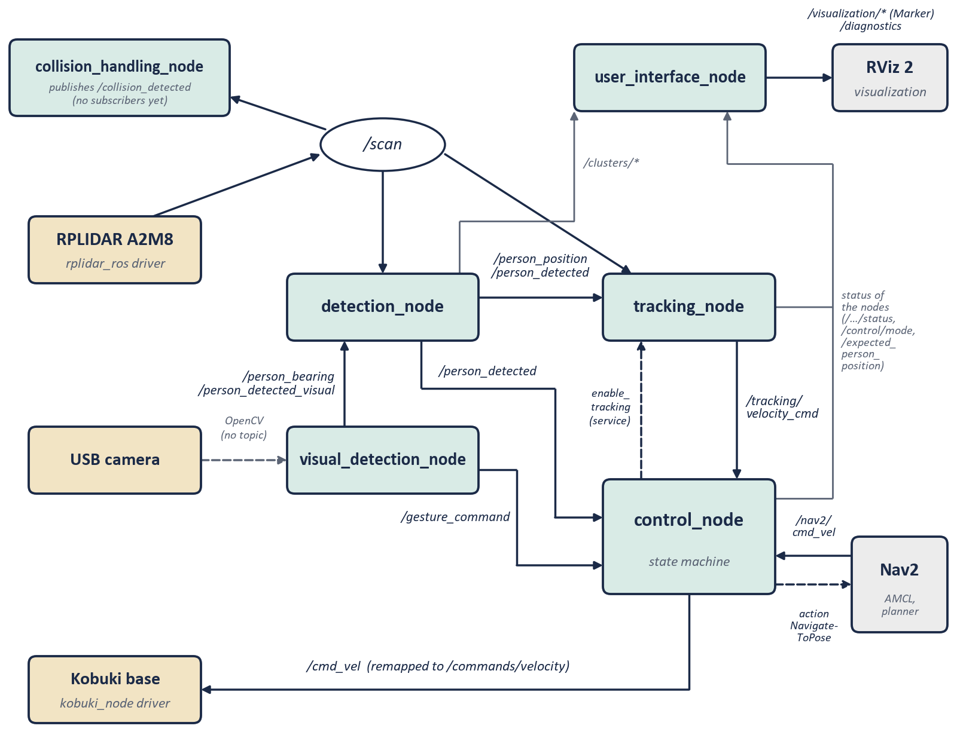
Note. Own elaboration from the project’s source code. In beige, the hardware with its driver; in gray, external tools from the ROS 2 ecosystem; in green, the package nodes. Dashed arrows indicate a service, an action or a read without a topic. The coordinated-shutdown topics are not shown (Section 3.4).
Figure 3.2 illustrates, with data from a real take, what detection_node and tracking_node produce: the distance to the person measured on each scan and the detected positions in the robot's reference frame.
Figure 3.2
Real detection and tracking example (“straight-line” take, 22/07/2026).
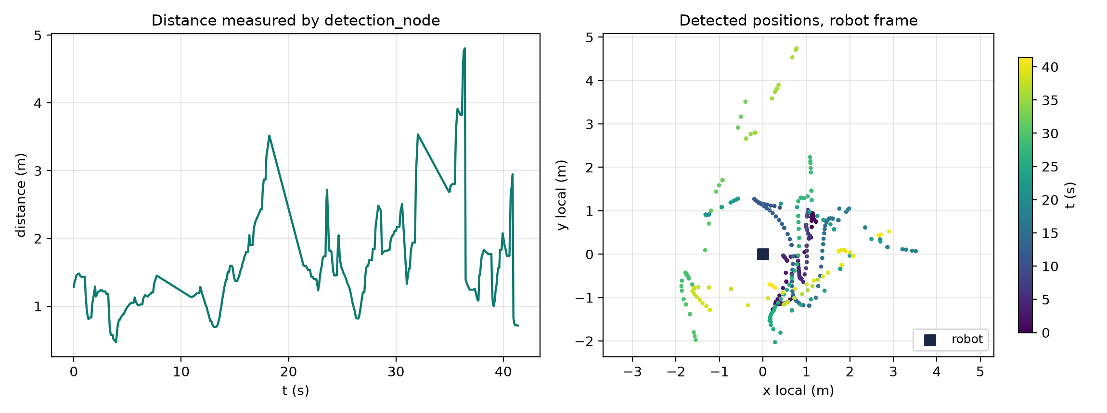
Note. Own elaboration from the take’s recorded data. The right-hand panel shows individual detected positions, not a continuous path (Section 4.3).

3.3 Description of Each Node

3.3.1 detection_node
Function: person detection using the LiDAR.
On each scan, the node must decide which points correspond to a pair of human legs and not to another object of similar size, such as a chair leg or a column. Out of the 300-400 points of a scan, it typically isolates between 2 and 6 candidate clusters before searching for pairs of legs.
To do so, it filters the LiDAR noise with a median filter, interpolates to increase the angular resolution and groups the points with DBSCAN (eps = 0.12 m; min_samples = 4). It then keeps the clusters compatible with a leg by size, radius and shape, and looks for pairs separated by a reasonable distance.
As a fallback (Phase 2), when it cannot find a valid pair of legs, the node uses the bearing from visual_detection_node to choose the LiDAR cluster best aligned with the person and publishes its centroid. Before this mechanism was added, tracking stopped after 30 s without legs even if the camera could still see the person. The no-motion validation gave 100% detection, with a bearing deviation of about 6°.
DBSCAN is reimplemented over scipy.spatial.cKDTree, and not over scikit-learn, because the NUC's Python version was not compatible with that library's compiled extension.
Configurable parameters: maximum detection distance (2.5 m, reduced from 6.0 m), DBSCAN neighborhood radius (0.12 m), leg cluster size (4-200 points) and camera timeout (1.0 s). It subscribes to /scan, /person_detected_visual, /person_bearing, and /system_shutdown; publishes /person_detected, /person_position, /detection/clusters, /clusters/general, /clusters/legs, and /detection/status.

3.3.2 visual_detection_node
Function: person detection and gesture recognition via camera.
This node has two functions: recognizing the gestures with which the person gives orders to the robot and, when the LiDAR cannot find a valid pair of legs, providing an approximate direction so as not to lose the person. For example, if the person turns sideways, the camera may still see their shoulder and wrist even though the LiDAR can no longer distinguish their legs.
Each frame is processed with MediaPipe Pose to obtain the person's skeleton, instead of the original HOG detector, which needed the whole body in the frame, something impossible at the real tracking distance (around 1 m).
Gestures are recognized from the MediaPipe Pose keypoints: the right hand raised above the shoulder starts tracking, the left one stops it, and both hands together above the head (the “home” gesture) order the return to the starting position. Each gesture requires several consecutive confirmation frames and a waiting time between commands, to reduce false positives.
The node also computes the person's horizontal bearing from the midpoint of the shoulders and the camera's field of view, and publishes it for fusion in detection_node. The camera is read directly with OpenCV, without going through a ROS topic. Topics: it subscribes to /system_shutdown and publishes /person_detected_visual, /person_bearing, /gesture_command, /camera/status and /shutdown_confirmation.

3.3.3 tracking_node
Function: estimating the person's position and computing the velocity commands.
This node turns a measured position, noisy and intermittent, into an estimated trajectory and safe velocity commands. For example, if detection_node loses the person for two or three scans, the Kalman filter keeps predicting their position from the estimated velocity, instead of braking abruptly.
It applies a Kalman filter (state [x, y, vx, vy, ax, ay] with constant acceleration; Section 4.5) to the position published by detection_node and computes the distance and angle to the person. It also avoids obstacles in the ±50° frontal sector of the LiDAR: if it detects an obstacle closer than 0.40 m, it deviates the turn and reduces the linear velocity; and it stops the robot if the person disappears for more than two seconds. It only acts when control_node enables it through the enable_tracking service.
Topics: subscribes to /person_position, /person_detected, /scan, and /system_shutdown; publishes /tracking/velocity_cmd, /expected_person_position, /tracking/status, and /follower/telemetry.

3.3.4 control_node
Function: the system's central finite-state machine.
This node arbitrates, at every instant, which of the possible velocity sources (tracking, navigation home or teleoperation) controls the base, so that it never receives two contradictory commands. For example, when it detects the “home” gesture, it stops forwarding the velocity from tracking_node and starts forwarding the one from Nav2.
It implements the state machine of Figure 3.3. After start-up (INIT), the system stays in IDLE, waiting for an authorized person. In TRACKING it forwards the velocities from tracking_node to the base; in HOMING it sends Nav2 the “home” goal through the NavigateToPose action and forwards the velocities Nav2 computes (Section 5.8); MANUAL allows the robot to be teleoperated from the keyboard; and SHUTDOWN coordinates the shutdown. With the camera enabled, starting tracking requires the gesture; without it, tracking starts automatically when the person is detected.
Figure 3.3
Finite-state machine of control_node.
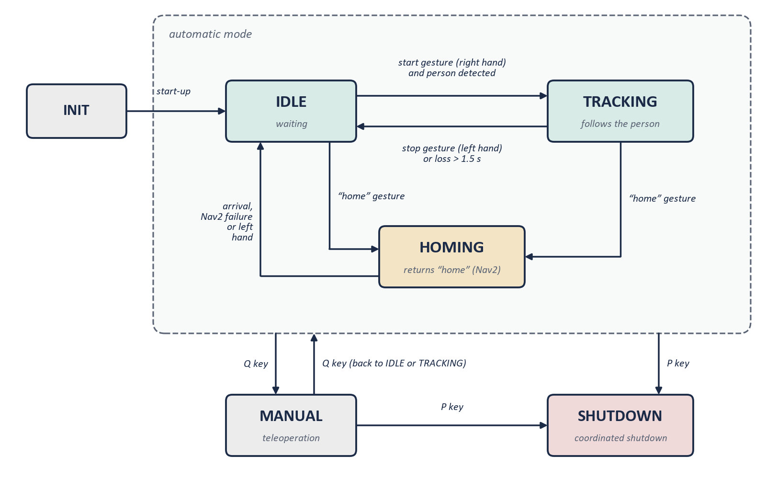
Note. Own elaboration from the project’s source code (control_node.py). The dashed box groups the states of the automatic mode; the Q and P keys act from any of them.
Topics: it subscribes to /person_detected, /gesture_command, /tracking/velocity_cmd, /nav2/cmd_vel (velocity computed by Nav2) and /shutdown_confirmation; it publishes /cmd_vel (the velocity that reaches the base, remapped to /commands/velocity), /system_shutdown, /control/mode, /control/teleop_status and /control/state. It also uses the enable_tracking service of tracking_node and the NavigateToPose action of Nav2.

3.3.5 collision_handling_node
Function: monitoring for imminent collisions, independently of the rest of the system.
It monitors the distance to the nearest obstacle and publishes a collision signal when any point of the scan is closer than 0.4 m. For now, control_node does not react to this signal; its integration remains as future work.
Topics: subscribes to /scan; publishes /collision_detected and /collision_handling/status.

3.3.6 user_interface_node
Function: real-time visualization of the system's state, with no control logic of its own.
It launches RViz 2 with the package configuration and sends it the information to be displayed: markers with the estimated position of the person, the LiDAR clusters and the robot, plus a periodic diagnostic status.
RViz 2 is not part of the person_follower package: it is the generic ROS 2 visualization tool. user_interface_node is the node that prepares and publishes the data (markers and diagnostics) that RViz 2 displays. Topics: it subscribes to /camera/status, /detection/status, /tracking/status, /person_detected, /clusters/general, /clusters/legs, /expected_person_position, /control/mode and /control/teleop_status; it publishes the /visualization/* markers and /diagnostics.

3.3.7 slam_node (experimental)
Basic 2D SLAM developed in Phase 1. In Phase 2 it was replaced by SLAM Toolbox, which is more robust and able to close loops and save maps; the node is kept, disabled by default.
Topics: subscribes to /scan, /person_position, and /system_shutdown; publishes /map, /initialpose, and /person_marker.

3.4 Coordinated Shutdown Management
The system implements a coordinated shutdown to prevent the robot from being left with active velocities: control_node publishes a shutdown signal, subscribed nodes stop their activity and confirm the stop, and control_node waits for all confirmations before finishing.

3.5 Transform Tree (TF)
Figure 3.4 shows the robot's reference frames and the transform tree that relates them. map is the fixed frame of the map; odom, the odometry frame, which is continuous but accumulates drift; base_footprint is attached to the robot, on the floor below its center, with the x axis pointing forward, the y axis to the left and the z axis up (REP-103 convention; Foote & Purvis, 2010); and laser is the LiDAR's measurement frame. The base_footprint→laser transform is static and is published with a 180° rotation about z, because the LiDAR is mounted rotated. The odom→base_footprint transform is published by the Kobuki driver from the wheel odometry, and map→odom is published by AMCL during navigation (or by SLAM Toolbox during mapping) to correct the accumulated drift.
Figure 3.4
Robot reference frames and transform (TF) tree.
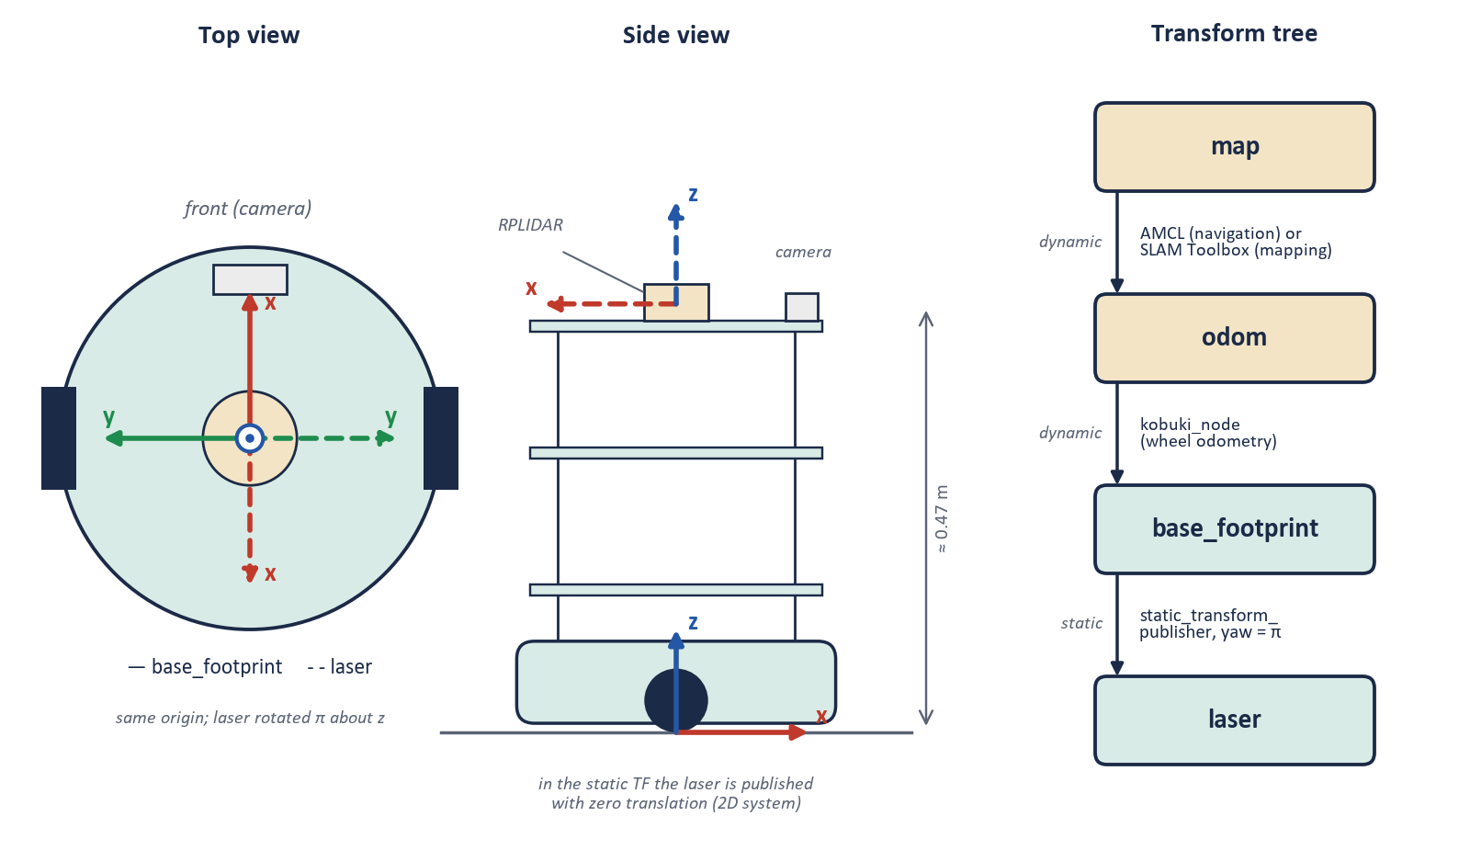
Note. Own elaboration from the project’s source code. x axis in red, y in green and z in blue (REP-103 convention); solid lines for base_footprint and dashed for laser. Not to scale.

3.6 Configuration Parameters
All the adjustable parameters are gathered in a common configuration file (config.yaml), so that thresholds, safety distances and behaviors can be changed without recompiling. SLAM Toolbox and Nav2 use their own configuration files.

3.7 ROS 2 Package Dependencies
Figure 3.5 summarizes the dependencies of the person_follower package, grouped into three levels. The first is the ROS 2 core: the rclpy client library and the standard message-interface packages, which the code imports directly. The second consists of other packages from the ROS 2 ecosystem, developed by third parties, which run alongside the system and with which it communicates through topics, services and actions: the Kobuki and LiDAR drivers, SLAM Toolbox, Nav2 and RViz 2. The third are Python libraries unrelated to ROS: numpy, scipy, OpenCV and MediaPipe.
Figure 3.5
Dependencies of the person_follower package.
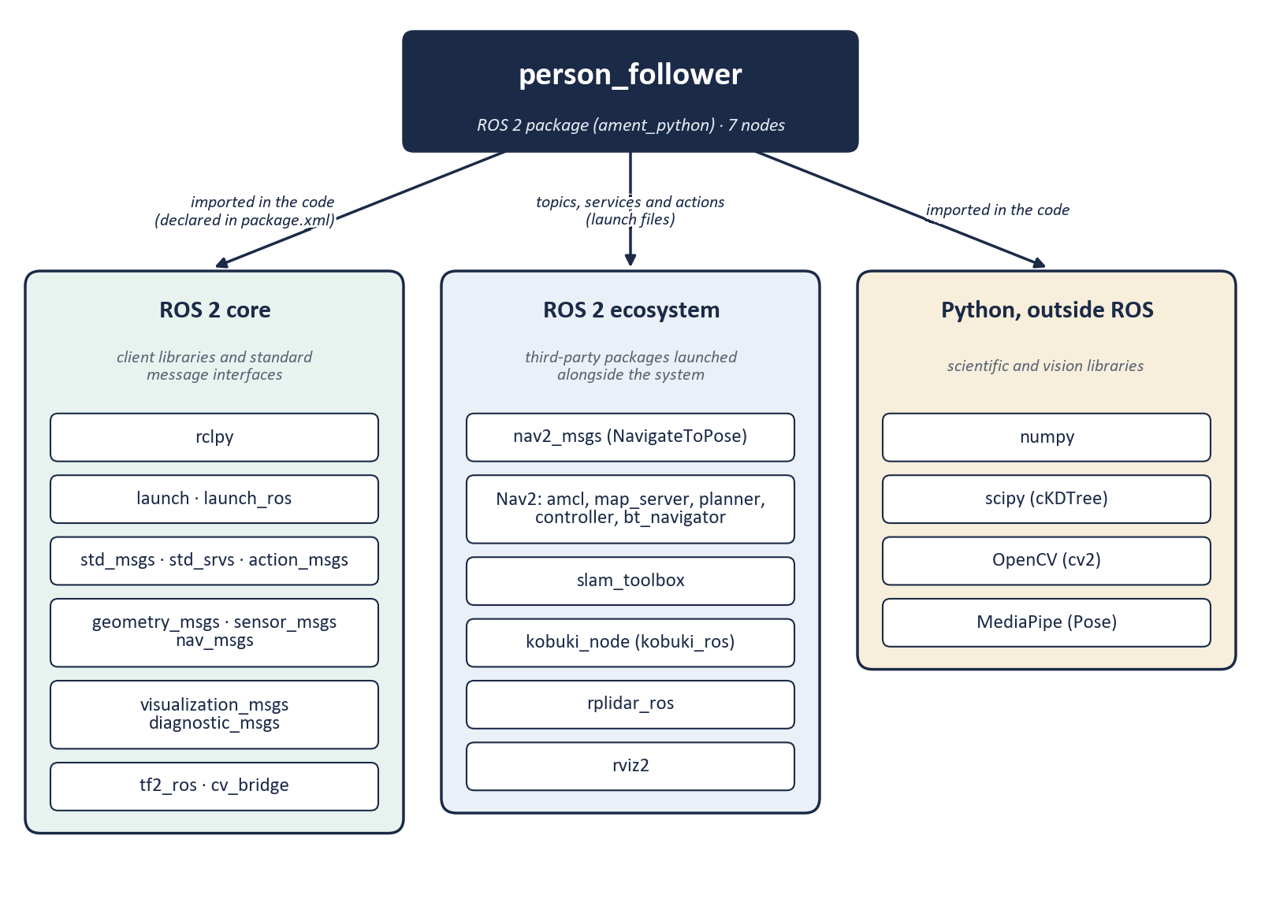
Note. Own elaboration from package.xml, the source code’s imports and the launch files.

3.8 Nav2 Architecture (Phase 3)
Autonomous navigation is organized in four layers (Figure 3.6). The first is the sensors: the LiDAR publishes /scan and the Kobuki its odometry. In the second, localization, map_server publishes the saved map and AMCL combines scan, odometry and map to estimate the robot's pose, which it expresses through the map→odom transform. The third is the Nav2 core: bt_navigator receives the goal and, following a behavior tree, assigns the global route to planner_server, its execution to controller_server (DWB controller) and the recovery maneuvers to behavior_server. In the fourth, the output, the velocity computed by controller_server does not go straight to the wheels: it is remapped to /nav2/cmd_vel and control_node only forwards it to the base in the HOMING state.
Figure 3.6
Layered architecture of autonomous navigation with Nav2.
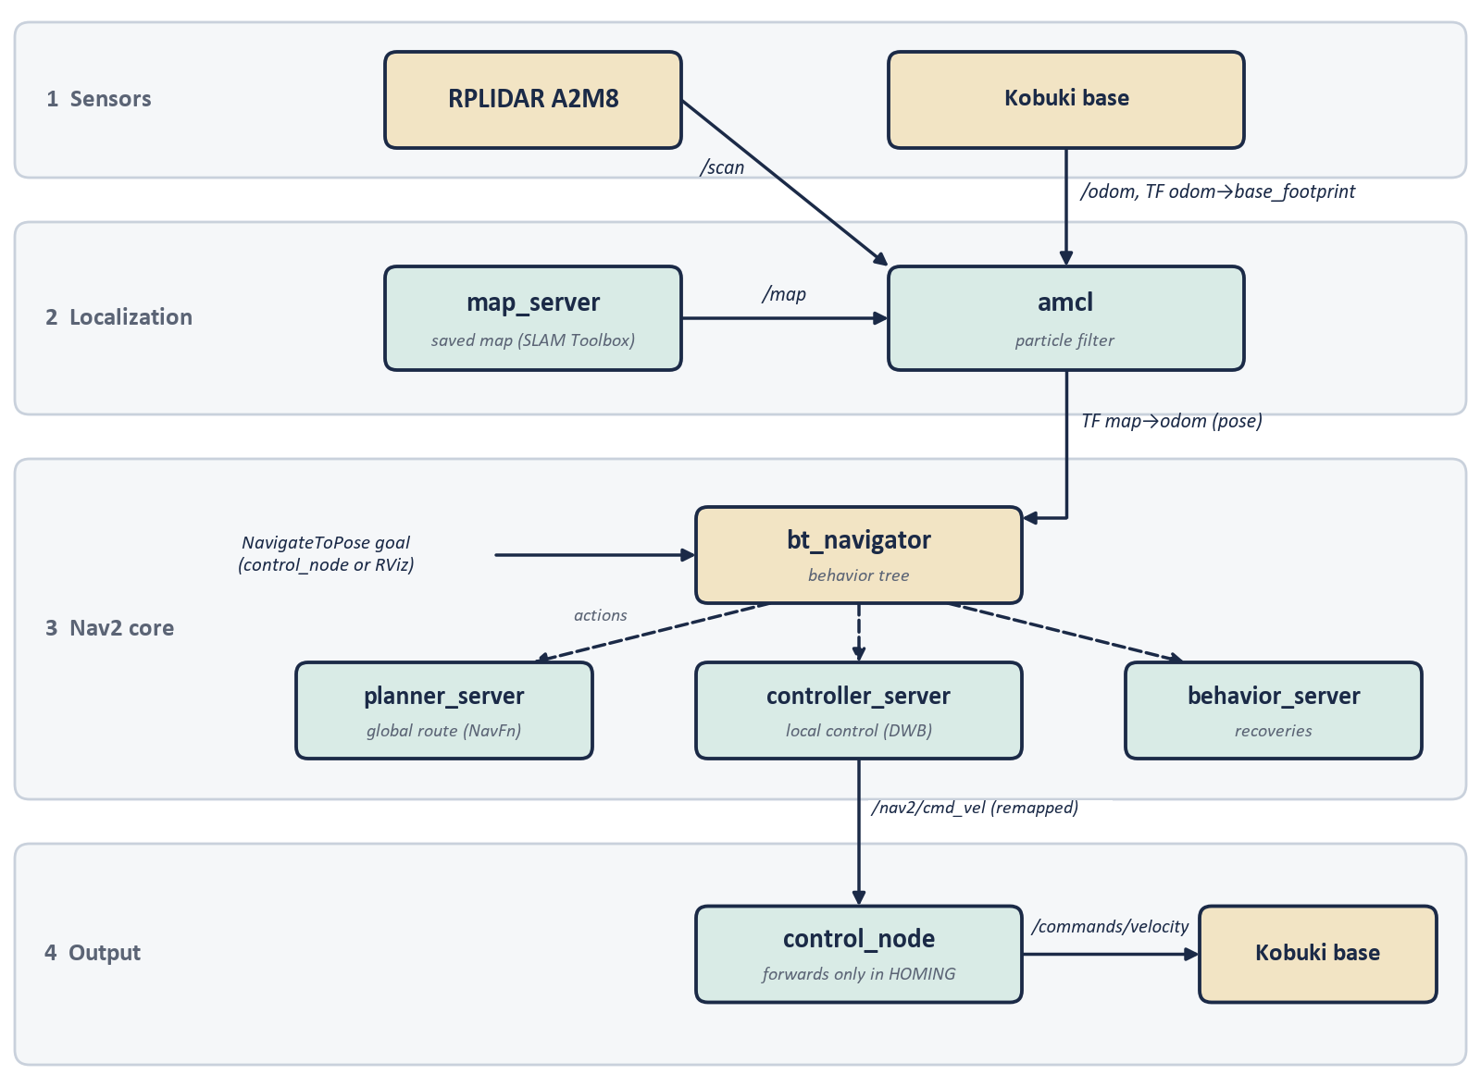
Note. Own elaboration, adapted from the Nav2 architecture described in Macenski et al. (2020) and from the project’s configuration.
This architecture was validated in parts: a first test confirmed the sensors and localization, and a later one the Nav2 core and the output. Overall, six of seven navigation goals were reached, including the avoidance of a real obstacle not present in the map (Section 5.7).

Chapter 4 — Implementation

4.1 Introduction and Scope
Chapter 3 presents the scheme of nodes and topics. This chapter describes how each node works internally and justifies the implementation decisions taken.
Not all the files in the repository are in use: the installation script registers seven nodes as executables (Section 4.2), and several directories keep earlier, unregistered versions. This chapter describes only the code that runs; Section 4.11 summarizes the rest.

4.2 Package Structure and Configuration Management
The package is of type ament_python, with one directory per node, and registers seven executables: control_node, visual_detection_node, detection_node, tracking_node, user_interface_node, collision_handling_node, and slam_node.
Each node's adjustable parameters are in a single configuration file, with one section per node, which the launch files load, so thresholds can be changed without recompiling. Each parameter has a comment justifying it and, often, the date and reason for its last change.
The main launch file starts five nodes: control_node, tracking_node, visual_detection_node, detection_node and user_interface_node. Left out are collision_handling_node, because control_node does not yet react to its signal (Section 3.3.5), and slam_node, disabled since SLAM Toolbox replaced it in Phase 2. For the “home” gesture, a second launch file (bringup_home.launch.py) adds Nav2 and the static transform of the LiDAR.

4.3 detection_node — Clustering, Leg Features, and Temporal Filtering

In-house DBSCAN on a Nearest-Neighbour Tree
This node's DBSCAN is reimplemented on scipy's cKDTree rather than on scikit-learn, which was not compatible with the NUC's Python version (Section 3.3.1). It keeps the original semantics of the algorithm (Ester et al., 1996): a point is a core point if it has enough neighbors within a radius, and clusters grow from the core points through radius queries and a breadth-first search. For the few hundred points of a filtered scan, the computational cost is negligible. The neighborhood radius (0.12 m) and the minimum number of neighbors (4) were calibrated to the real angular resolution of the RPLIDAR A2M8.

Multi-feature Geometric Leg Filter
The node extracts eight features from each cluster (size, radius, spread, width, height, aspect ratio, circularity and compactness) and applies six successive filters, which combine the inherited filter with new features to reduce both false positives (furniture legs) and false negatives (partially hidden legs). Two of the thresholds were corrected after finding that they rejected real legs.
Leg pairing is a greedy nearest-neighbor algorithm: for each unpaired cluster, the closest one within a consistent range (0.05-0.35 m) is sought and both are merged into a candidate whose centroid is the estimated position of the person. Global optimization (Hungarian assignment) is not used because the number of clusters per scan is low.

Temporal Continuity and Confirmation Filtering
Three temporal-filtering mechanisms protect against false positives: temporal persistence (a detection must hold for several scans to be confirmed, and fail for as many to be considered lost); an accumulated-drift filter, which discards candidates too far from the oldest confirmed position; and a stable confirmation, stricter in the camera fallback, which always requires it.
In the fusion fallback, when there is no valid pair of legs, the node transforms the camera bearing into the laser's reference frame, chooses the cluster with the smallest angular deviation and requires it to repeat over several scans before publishing it. This confirmation is independent of the one for pairs, because a single cluster is a weaker signal.
Just before publishing, the node inverts the sign of the coordinates to go from the raw laser frame, in which the front of the robot is at about π radians, to the standard convention used by tracking_node, with the front on the positive x axis. Keeping all the internal logic in the raw frame and inverting only when publishing avoids rewriting the filtering, at the cost of having to interpret the internal variables in that frame.

4.4 visual_detection_node — Dual Detection and Gesture Recognition
The node supports two interchangeable detectors: MediaPipe Pose, if installed, or HOG as an automatic fallback (the choice is made by catching the import error). Without MediaPipe there are no keypoints, so gestures are not available in HOG mode. HOG, inherited from Phase 1 and replaced as the main detector by MediaPipe Pose (Sections 2.4 and 3.3.2), is kept only as a fallback.
Video capture runs in a thread independent of the ROS 2 executor, which discards old frames from the buffer and always processes the most recent one. Publishing is limited to a target rate, measuring the processing time to adjust the wait.
Gesture recognition and bearing computation reuse the same MediaPipe Pose keypoints (shoulders, wrists, hips and nose). The start gesture fires when the right wrist rises above the right shoulder; the stop gesture, with the left hand; and the “home” gesture, when both wrists are together above the head. The margin is proportional to the torso height, not a fixed number of pixels, and each gesture requires confirmation over several frames and a waiting time between commands. The bearing is computed from the midpoint of the shoulders and is only published if both exceed the minimum visibility.

4.5 tracking_node — Kalman Filter, PD Control, and Obstacle Avoidance
Together with detection_node, it is the node with the most documented iterations. The active version replaces an earlier, simpler design without an acceleration model, which is kept as unregistered code (Section 4.11).

Six-state Kalman Filter with a Constant-Acceleration Model
The filter keeps a six-dimensional state (position, velocity and acceleration), compared with four in the inherited design, with an observation that measures position only. The transition matrix implements a constant-acceleration model, with process noise correlated according to the powers of the time step; the update uses the Joseph form, slightly more expensive but numerically more stable.

Mahalanobis Gate with Streak-based Confirmation
Each observation goes through a Mahalanobis gate, which compares it with the 95% chi-square threshold with 2 degrees of freedom: it is only rejected if it exceeds the threshold several times, and if several consecutive observations fall outside, the filter is reset on the last one, on the assumption that the person has really reappeared. Thus, an isolated observation is ignored and a sustained streak is treated as a legitimate reappearance, the same pattern followed by the continuity mechanisms of detection_node (Section 4.3).

Angular Velocity Controller
The angular velocity is computed in five steps: (1) PD control with a ±8° dead zone; (2) coupling with the linear velocity, which reduces turning at high speed; (3) attenuation at short distance, from zero to full value according to the reference distance; (4) a soft start during the first second and a half; and (5) a per-cycle rate limit, which protects against large errors or occasional detection jumps.
Linear speed follows a non-linear ramp based on distance to the person, smoother than a linear relation near the tracking reference distance, avoiding abrupt starts when the person moves slightly away from that distance.

Reactive Obstacle Avoidance
tracking_node does not implement a DWA proper, which would simulate trajectories in velocity space (Section 2.8); there is a DWA implementation in a separate file, which is not registered (Section 4.11). The active mechanism is reactive, of the repulsive-field type: each point of the ±50° frontal sector within a threshold (0.40 m, raised from 0.35 m) contributes a weight that grows the closer and more frontal it is, and the final angular adjustment is the weighted average of those contributions.
Linear-velocity reduction factor (fixed on 22 July). In the previous version, the formula never reduced the velocity to zero: it had a lower bound that in practice was never applied, so it was code with no effect (Appendix B and Section 5.6). As a result, the robot did not come to a stop in front of an obstacle that stayed ahead, which caused two light contacts. The current formula computes the factor from the real distance to the nearest obstacle in the frontal sector: it is 1 (no braking) at the 0.40 m threshold and drops to 0 (full stop) at 0.25 m, with a 15 cm margin between the two.
Detour maneuver (added on 22 July). If the reduction factor stays below 0.5 for 1.5 s in a row, the robot assumes it is blocked in front of the obstacle: it makes a tight turn for 1.5 s towards the side already indicated by the reactive avoidance and then moves straight ahead for a short stretch at low speed. If the factor drops again during the maneuver, the maneuver is canceled and the turn restarts. Its purpose is to get out of the blockage instead of staying stopped indefinitely. It is a first version, not yet systematically validated (Section 5.6).
This mechanism is deliberately cheaper than a full DWA: it does not take into account kinematic constraints or several future steps. It is enough for reactive avoidance at low speed, but it is a clear simplification compared with Nav2's DWB controller (Sections 2.8 and 2.9).

4.6 control_node — Finite-State Machine and Teleoperation
The state machine (Figure 3.3) is implemented in a single class that stores the current state as a text string. Two mechanisms prevent erratic behavior: hysteresis on detection loss, which waits 1.5 s before returning to IDLE, and gesture authorization independent of detection (with the camera disabled, authorization is granted automatically). The HOMING state sends the goal to Nav2 with its own action client, instead of Nav2's BasicNavigator utility, because the latter publishes a default initial pose that reset AMCL's localization. The robot returns to IDLE when it reaches home, when Nav2 reports a failure or when the person cancels with the left hand.
Keyboard teleoperation runs in a separate thread that reads the input character by character, without blocking the executor, and is disabled if standard input is not an interactive terminal. This check is necessary because, when the system is launched, an earlier Ctrl+C keypress may remain in the buffer and be interpreted as an unexpected command.

4.7 collision_handling_node
It is the simplest node: it applies a single distance threshold to the minimum of the scan and publishes the collision signal only when its state changes. It is not part of the main launch file, and control_node does not yet subscribe to its signal (Section 4.2). It remains as infrastructure for future integration, for example with Nav2's recovery behaviors.

4.8 user_interface_node
It implements neither perception nor control: it aggregates the status of the other nodes. It subscribes to their status topics and publishes visualization markers for RViz 2 (estimated position, LiDAR clusters and robot), a text panel and a periodic diagnostic when the mode changes. It also launches and closes RViz 2 in a coordinated way.

4.9 slam_node (experimental, disabled by default)
A minimal in-house 2D SLAM implementation: an in-memory occupancy grid and a static transform between map and odometry, updated from the LiDAR and the person's position, with no scan matching or loop closure. It is really an occupancy accumulator rather than a full SLAM. SLAM Toolbox replaced it in Phase 2 (Section 2.9), and it is kept disabled as a reference.

4.10 Deployment: Building and Syncing with the Robot
The package is built on the NUC with symbolic links to the source files, so relaunching a node is enough for it to pick up the changes, without rebuilding after each edit. A synchronization script automates copying the most frequently modified files (detection, tracking and configuration); the rest are copied by hand, a limitation to bear in mind for future extensions.

4.11 Code Not Registered in the Package
Several directories keep more than one complete node class, of which only one is registered: the control directory keeps two earlier versions; the tracking directory, a real DWA implementation (velocity-space search and trajectory visualization in RViz) that is not run; and the user-interface directory, an earlier version.
None of these files is imported by another module: this is not dead code inside the active nodes, but earlier versions kept in the working tree. The DWA case is relevant because part of the initial documentation stated that tracking_node used it, whereas the active node uses the reactive controller described in Section 4.5. It would be advisable to move these versions to a legacy-code directory to avoid confusion.

Chapter 5 — Results and Evaluation
The data in this chapter come from the tests carried out in the UJI lab, up to the final session on 23 September 2026 (Section 5.8). Some scenarios have few samples, which is discussed in Section 5.9; what falls outside the scope of the thesis is covered in Section 5.10.

5.1 Validation Methodology
Each take is recorded on the NUC as a ROS 2 log (rosbag), converted to tabular format and analyzed off the robot, producing metrics and four figures: distance, angle and velocity over time, and trajectory. The metrics are the distance error with respect to the target (mean absolute error, MAE, and root mean square error, RMS), the mean angular error, the maximum velocities, the percentage of time with the person detected and the number of losses.

5.2 Experimental Setup
- Robot: TurtleBot 2 on a Kobuki base, with an onboard compute unit running ROS 2 Jazzy.
- Sensors: RPLIDAR A2M8 LiDAR and RGB camera. The camera was changed midway through the validation campaign (Section 1.4): the no-motion fusion take (25/06) and the three takes of 08/07 (Section 5.4) were recorded with the original Logitech C270; all takes from 09/07 onwards (Sections 5.5, 5.6 and 5.7) were recorded with the SPCA2650 that replaced it.
- Environment: UJI's robotics lab, indoors, tiled floor.
- Target tracking distance: 1.50 m in the 25 June take; 1.00 m from the 8 July takes onward, after a parameter adjustment between sessions.
- Tracking activation: via camera gesture under normal conditions; the 8 July takes used a manual activation mechanism because the gesture was not reliable with that session's camera framing.

5.3 Result 1 — Sensor Fusion, No Motion (25 June 2026)
First validation of the LiDAR-camera fusion fallback, with the robot's base inhibited so that detection could be tested safely before doing so in motion.
Table 5.1
Fusion without motion, 25/06
Metric | Value
Duration | 23.5 s (285 samples)
Target distance | 1.50 m
Distance error (MAE / RMS) | 0.627 m / 0.733 m
Min / max distance | 1.27 m / 3.41 m
% of time with person detected | 100.0%
Number of detection losses | 0
Camera bearing vs. chosen cluster deviation | ≈ 6°
With the fusion mechanism active, detection was continuous throughout the take, even though the LiDAR alone could not reliably distinguish the legs in this configuration, which was precisely the motivation for the mechanism (Sections 2.5 and 3.3.1). The distance and angle errors are not representative in this test: with the base inhibited, the robot does not move to keep the target distance or correct its orientation.
Figure 5.1 plots that distance measured over the course of the take.
Figure 5.1
Robot-to-person distance over time, no-motion fusion take (25/06/2026).
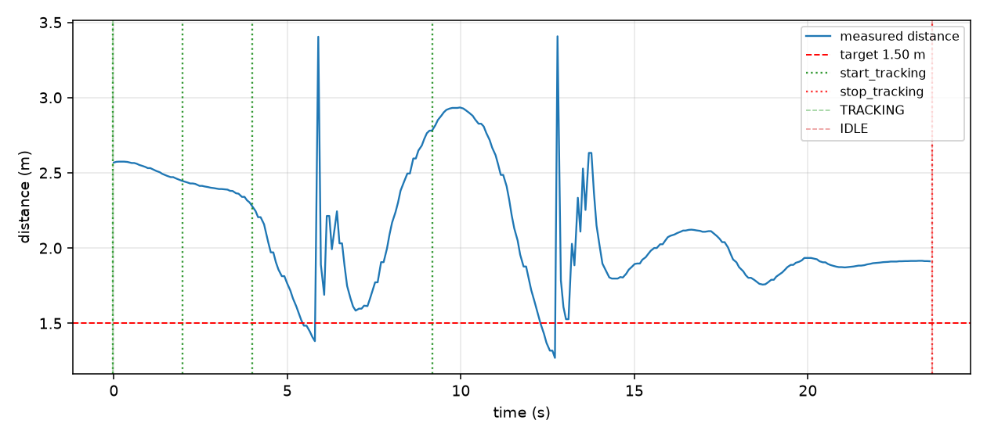
Note. Own elaboration from the recorded data of the take.

5.4 Result 2 — Progression of In-motion Continuity Fixes (8 July 2026)
First tracking test with the robot in motion. The initial take revealed detection jumps and almost permanent saturation of the angular velocity; the next two takes verify each correction separately (Appendix B).
Table 5.2
Continuity corrections, 08/07
Take | Duration | % detection | Losses | MAE dist. | RMS dist. | Jumps >0.8 m | wz saturation
Original (unfixed) | 759.8 s | 32.3% | 79 | 0.519 m | 0.935 m | 3.5% | 95.7%
+ continuity filter | 249.0 s | 71.7% | 43 | 0.534 m | 0.725 m | 2.2% | 99.3%
+ Mahalanobis and wz limit | 53.1 s | 82.6% | 13 | 0.491 m | 0.609 m | 0.7% | 86.9%
The jump and saturation figures were computed on 21 July by applying the standard analysis procedure to the three original logs. The jump percentage was reproduced exactly in two of the three takes and came out slightly lower in the third, a minor difference attributable to the initial methodology not yet being systematic.
The three chained adjustments clearly reduced the implausible position jumps and increased detection; with fewer jumps, the Kalman filter is more stable. Angular saturation, on the other hand, does not improve consistently, because the adjustments act on detection continuity and not on the gain of the angular controller. The adjustment that does reduce it, proximity attenuation (Section 4.5), was added later, on 15 July.
Figure 5.2 plots the distance measured in the take with all three fixes already applied.
Figure 5.2
Robot-to-person distance over time, take with all three continuity fixes applied.
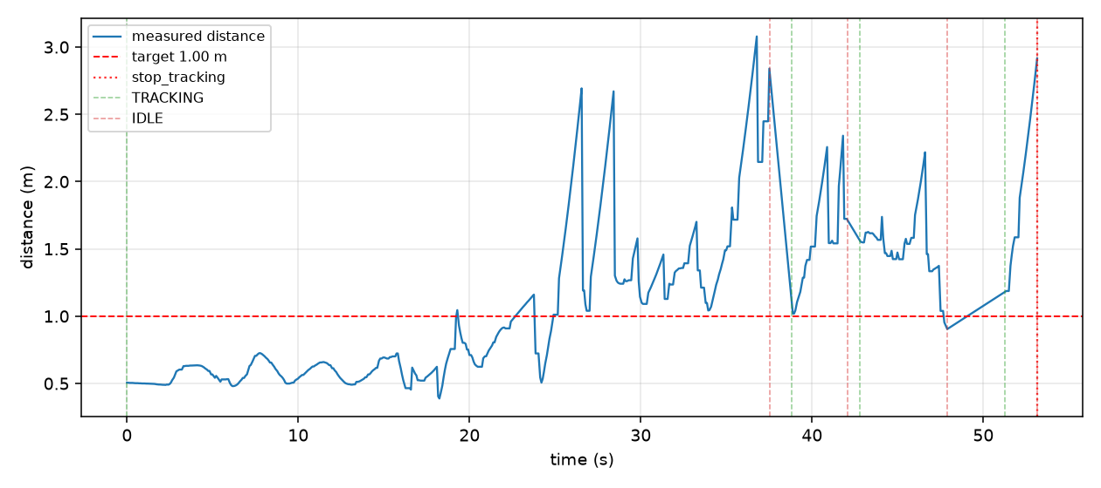
Note. Own elaboration from the recorded data of the take.
Figure 5.3 shows the linear and angular velocity for that same take.
Figure 5.3
Linear and angular velocity over time, same take.
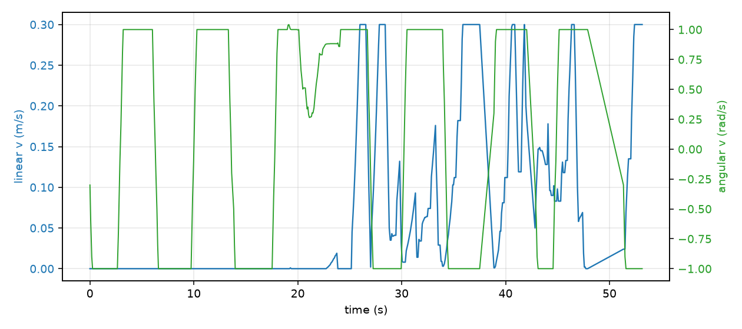
Note. Own elaboration from the recorded data of the take.
Figure 5.4 shows the resulting trajectory, from odometry.
Figure 5.4
Robot trajectory (odometry), same take.
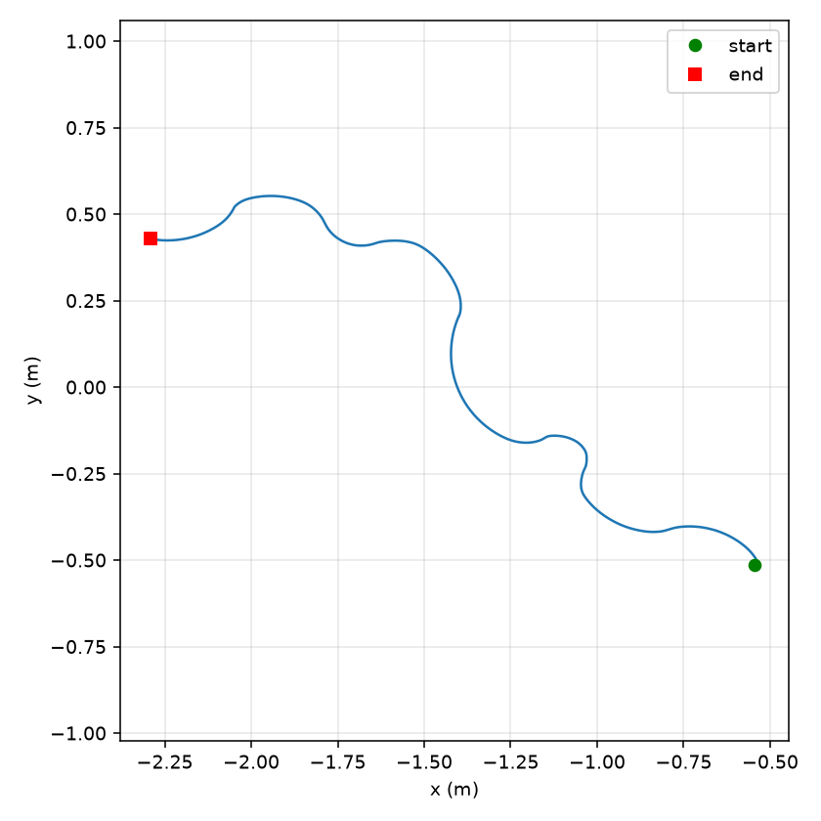
Note. Own elaboration from the recorded data of the take.

5.5 Result 3 — Per-scenario Repetitions with the System Stabilized (22 July 2026)
With the 21 July adjustments already in place, two to three takes were repeated for five scenarios without collision risk: straight line, curve, short distance, stop and occlusion.
Table 5.3
Scenarios with the stabilized system, 22/07
Scenario | Duration | MAE dist. | Mean ang. | % detec. | Losses | Jumps >0.8 m | Stable sat.
Straight (contaminated) | 41.4 s | 0.626 m | 62.0° | 76.2% | 7 | 6.8% | 13.8%
Straight (clean) | 25.9 s | 0.420 m | 26.5° | 100% | 0 | 2.3% | 1.8%
Curve #1 | 33.5 s | 0.794 m | 14.5° | 100% | 0 | 2.8% | 6.8%
Curve #2 (short) | 12.2 s | 0.759 m | 23.7° | 97.1% | 1 | 2.0% | 20.8%
Curve #3 | 14.3 s | 0.976 m | 6.2° | 100% | 0 | 0.9% | 0.0%
Stop | 36.5 s | 0.326 m | 5.9° | 100% | 0 | 0.0% | 0.0%
Short #1 (min. 0.15 m) | 32.5 s | 0.443 m | 32.8° | 100% | 0 | 2.0% | 25.1%
Short #2 (short, min. 0.42 m) | 8.4 s | 0.628 m | 4.9° | 98.8% | 1 | 0.9% | 0.0%
Short #3 (min. 0.02 m) | 18.7 s | 0.508 m | 46.8° | 100% | 0 | 1.2% | 28.6%
Occlusion | 30.6 s | 0.678 m | 16.2° | 100% | 0 | 2.5% | 1.5%
The first straight-line take was contaminated by a residual tracking state (the oscillation already documented on 17 June); the problem did not recur once tracking was de-authorized before each take. The short durations of curve #2 and short #2 are because the gesture took a while to be recognized; in short #3 the person came within 0.02 m of the robot, so saturation was to be expected. The occlusion did not cause any real loss thanks to the Kalman filter's prediction and the single-leg fallback.

5.6 Result 4 — Obstacle Scenario: from First Contacts to Contact-free Avoidance (22–23 July 2026)
After the two real contacts described in Appendix B (session of 21 July), the obstacle scenario was repeated with the safety threshold raised. Seven takes were carried out in two sessions, with two code changes in between (Table 5.4).
Table 5.4
Obstacle, 22–23/07
Take | Configuration | Result
Obstacle v3 (furniture) | Safety threshold raised, linear reduction factor unfixed | Light contact: the reduction factor never reached zero and the robot never fully braked
Obstacle v4 (furniture) | Same | Light contact again, same pattern
Obstacle v5 (furniture) | Reduction factor fixed: real ramp to zero between the warning and stop thresholds | No contact — much briefer encounter
Obstacle v6 (furniture + chair) | Same | No contact — the chair did not trigger avoidance in this take
Obstacle v7 (furniture + chair) | + go-around manoeuvre (tight turn and short advance) | No contact — manoeuvre triggered four times, completed successfully in all cases except one correct safety abort
Obstacle v8 (furniture + chair) | Same | Furniture correctly avoided; direct contact with the chair, not detected at all by the LiDAR
Obstacle v9 (furniture, 23/07) | No code changes from v7/v8 | No contact — second clean repetition of the fix, confirming the result in a different session
The fault was in the formula: the reduction factor never dropped below 0.4 because the lower bound was never applied. The robot detected the obstacle but did not stop completely, which is why it brushed against it twice. The fix computes the factor from the real minimum distance in the frontal sector, with a full stop beyond a second threshold, and was completed with the detour maneuver.
In take v8 the robot hit the chair, the fifth contact so far. This was to be expected: the LiDAR scans at a height of about 47 cm and does not see the thin legs of a chair. The test was not repeated, since it requires another sensor, either the available RGB-D camera or a second LiDAR at another height.

5.7 Result 5 — Nav2: Localization and Autonomous Navigation (27 July 2026)
First real test of the full Nav2 stack (specific objective 3). Initially, AMCL localization seemed to freeze after its first update. The cause was that the very short test commands ended before DDS completed node discovery; with longer commands, AMCL converged without problems.
Next, full navigation was tested for the first time, with seven goals sent from RViz (Table 5.5).
Table 5.5
Nav2 navigation, 27/07
Goal | Approx. distance | Result
1 | ≈ 3.7 m | Success
2 | ≈ 5.9 m | Success
3 (real unmapped obstacle) | ≈ 5.3 m | Success — detected and avoided by the local costmap
4 | ≈ 8.0 m | Success
5 | ≈ 8.1 m | Success
6 (goal change mid-path) | ≈ 0.6 m | Failure — automatically recovered by the lifecycle manager in about 2 s
7 (after recovery) | ≈ 3.6 m | Success
Six of the seven goals were completed (86%), including two long routes of about 8 m and one with a real obstacle not present in the map, which the local costmap detected and avoided. The single failure occurred when the goal was changed mid-route and was recovered automatically by Nav2's lifecycle manager, without recurring. During the session it was noticed that the saved map did not reflect the real space well, so it was recorded again and validated before replacing it; all the results correspond to the new map.

5.8 Result 6 — “Home” Gesture: Integrating Tracking and Navigation (23 September 2026)
Last lab session. The person makes the “home” gesture (both hands together above the head, forming a roof) and the robot stops following them to return on its own, with Nav2, to a predefined “home” position on the map. It is the first time tracking and navigation work within a single system, with control_node deciding which velocity reaches the base (Sections 3.3.4 and 4.6).
Table 5.6
“Home” gesture metrics, 23/09
Metric | Value
Home-return attempts completed | 9 of 11 (82%)
Time from gesture to home | 15.5 s on average (11-21 s)
Arrival error | 0.27 m / 8° on average (Nav2 tolerance: 0.25 m / 14°)
Cancellation with the left hand | Confirmed by Nav2 in 20 ms, ~7 cm of travel
Gesture false positives | 0 in ~4 min of free gesturing
“Home” gesture recognized from behind | 2 of 2 (slower: the head hides one wrist)
The two failures were not due to the gesture or to the state machine. Localization (AMCL, σ ≈ 0.5 m) placed the robot inside the safety zone around an obstacle on the map and, from there, the planner could not find a valid route; the robot returned safely to IDLE. Figure 5.5 shows the recorded trajectories on the lab map. This is a first result, with 11 attempts in a single session (Section 5.9).
Figure 5.5
Returns home with the “home” gesture on the lab map (23/09/2026).
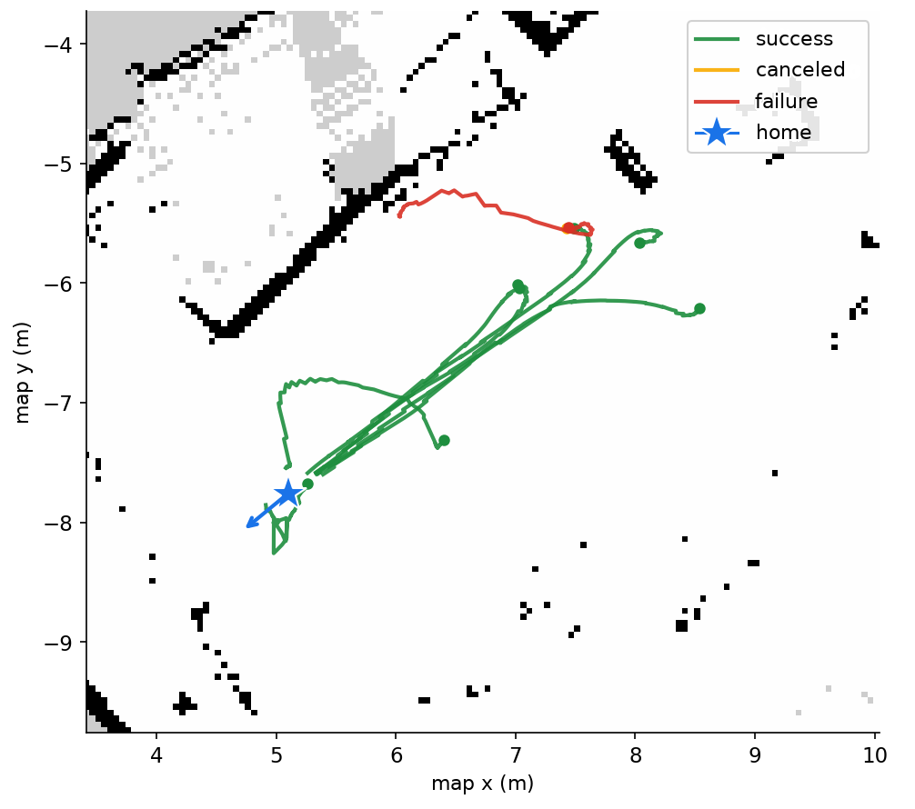
Note. Own elaboration from the session’s recorded data. The returns with a complete log are shown: seven completed, the intentional cancellation with the left hand and one of the two failures. The star marks the “home” position.

5.9 Limitations of the Current Results
- Small sample. Several rows come from a single take, so the variability between repetitions is not available. The stop and occlusion tests have only one repetition, because in that session attempts to record more takes saturated the NUC on several occasions.
- Durations and activation gesture. The takes in Section 5.4 have very different durations, so their figures are proportions within each take rather than normalized values. In addition, the 8 July takes were started with a manual mechanism rather than the real gesture, so objective 1 is only reflected in the takes after 9 July.
- Nav2, a single session. Without repetitions, it is not possible to tell whether what was observed is a pattern or a one-off event, and the cause of the single failure has not been analyzed in depth.
- Objective 5, only a first step. The “home” gesture (Section 5.8) integrates tracking and navigation for the first time, with 9 of 11 returns completed in a single session. The two failures were due to localization (AMCL, σ ≈ 0.5 m), which left the robot next to an obstacle on the map without room for the planner to plan a route, and not to the gesture or the state machine. Guidance to several destinations, which would complete the objective, remains as future work (Section 5.10).
- Shared computing resources. The NUC runs the LiDAR and camera drivers, MediaPipe, tracking, SLAM or Nav2 and the diagnostic interface at the same time. In the early phases this caused disconnections and port lock-ups, and the code had to be optimized (duplicate ports, publication rates and simpler detection processing; Appendix B). With the final configuration and everything running, the measured load is around 30% per core (4 cores), without saturation. It remains to be checked whether any occasional peak influenced the two localization failures.

5.10 Future Work
Following the work carried out, several further lines of work are proposed, beyond the scope of this thesis. One proposal would be guidance to several destinations, with one gesture or QR code per destination (preferable), which would complete objective 5. Another possibility would be building an exit maneuver for when localization leaves the robot next to an obstacle, before requesting the new route from Nav2. Also proposed are repeating the stop and occlusion tests with more samples, and evaluating the system with more people, environments and lighting conditions. Two further improvements already identified during development are added to these: incorporating the Orbbec Astra RGB-D camera, or a second LiDAR, to detect obstacles outside the scan plane (Section 5.6), and connecting the collision_handling_node signal to control_node (Section 3.3.5).

Chapter 6 — Conclusions

6.1 Fulfillment of the Objectives
Of the five specific objectives, four have been completed and validated on the real robot:
- Gestural interaction. Three gestures (start, stop and “home”) recognized with MediaPipe Pose, with no false positives in about four minutes of free gesturing (Section 5.8).
- Mapping. A map of the lab built with SLAM Toolbox and reused for localization and navigation; during the Nav2 validation it was re-recorded to correct discrepancies with the real space (Section 5.7).
- Autonomous navigation. Six of seven goals reached with Nav2, including the avoidance of an obstacle not present in the map (Section 5.7).
- LiDAR-camera fusion. Continuous detection in the no-motion test and, after the continuity corrections, an increase in in-motion detection from 32% to 83% (Section 5.4).
The fifth objective, user guidance, has a validated first step: the “home” gesture integrates tracking and navigation, with 9 of 11 returns completed and a mean arrival error of 0.27 m. Its extension to several destinations remains open. The exploratory objective of recognizing rooms with QR codes was not addressed.

6.2 Contributions
The contribution of this thesis is not a new algorithm but the integration of detection, tracking, navigation and gestures in a single robot with limited resources. The central element is control_node: by arbitrating at each moment which velocity source reaches the base, it lets tracking and Nav2 coexist without interfering and lets the user switch from one to the other with a gesture. In addition, there are specific design decisions, justified in Chapters 2 and 4: a DBSCAN reimplemented for the available hardware, an asymmetric LiDAR-camera fusion that avoids precise calibration, and a linear Kalman filter with a Mahalanobis gate that tolerates intermittent detections.

6.3 Lessons Learned
Development leaves several lessons. The first is the value of testing on the real robot: almost all the relevant errors—the inverted sign of the PD controller, the inverted avoidance sector, the reduction factor that never reached zero or the DDS node-discovery latency—only showed up in the lab and would hardly have appeared in simulation. The second is the importance of measuring: the recording and analysis procedure for each take (Section 5.1) made it possible to check the effect of each correction with figures rather than impressions. The third is that, on an onboard computer with limited resources, efficiency is a design constraint from the start: publication rates, the choice of lightweight models and the simplification of some algorithms shaped the system as much as the functional requirements themselves. Overall, carefully integrating known pieces has required an effort comparable to developing a new one, and it is an equally valid engineering contribution.

6.4 Limitations and Future Work
The limitations in Section 5.9 mark the scope of this validation: small samples, a single session for Nav2 and for the “home” gesture, and a single test environment. The most direct lines of continuation are to extend those tests, complete guidance to several destinations and improve the perception of obstacles outside the LiDAR plane (Section 5.10). With them, the system could evolve from a lab prototype into an assistance platform able to accompany people in a real building.

Bibliography
Bazarevsky, V., Grishchenko, I., Raveendran, K., Zhu, T., Zhang, F., & Grundmann, M. (2020). BlazePose: On-device real-time body pose tracking [Preprint]. arXiv. https://doi.org/10.48550/arXiv.2006.10204
Bellotto, N., & Hu, H. (2010). Computationally efficient solutions for tracking people with a mobile robot: An experimental evaluation of Bayesian filters. Autonomous Robots, 28(4), 425–438. https://doi.org/10.1007/s10514-009-9167-2
Cha, D., & Chung, W. (2020). Human-leg detection in 3D feature space for a person-following mobile robot using 2D LiDARs. International Journal of Precision Engineering and Manufacturing, 21(7), 1299–1307. https://doi.org/10.1007/s12541-020-00343-7
Dalal, N., & Triggs, B. (2005). Histograms of oriented gradients for human detection. In 2005 IEEE Computer Society Conference on Computer Vision and Pattern Recognition (CVPR'05) (Vol. 1, pp. 886–893). IEEE. https://doi.org/10.1109/CVPR.2005.177
Ester, M., Kriegel, H.-P., Sander, J., & Xu, X. (1996). A density-based algorithm for discovering clusters in large spatial databases with noise. In Proceedings of the Second International Conference on Knowledge Discovery and Data Mining (KDD-96) (pp. 226–231). AAAI Press.
Foote, T., & Purvis, M. (2010). REP 103: Standard units of measure and coordinate conventions. ROS Enhancement Proposals. https://www.ros.org/reps/rep-0103.html
Fox, D., Burgard, W., Dellaert, F., & Thrun, S. (1999). Monte Carlo localization: Efficient position estimation for mobile robots. In Proceedings of the Sixteenth National Conference on Artificial Intelligence (AAAI-99) (pp. 343–349). AAAI Press.
Fox, D., Burgard, W., & Thrun, S. (1997). The dynamic window approach to collision avoidance. IEEE Robotics & Automation Magazine, 4(1), 23–33. https://doi.org/10.1109/100.580977
Grishchenko, I., Bazarevsky, V., Zanfir, A., Bazavan, E. G., Zanfir, M., Yee, R., Raveendran, K., Zhdanovich, M., Grundmann, M., & Sminchisescu, C. (2022). BlazePose GHUM holistic: Real-time 3D human landmarks and pose estimation [Preprint]. arXiv. https://doi.org/10.48550/arXiv.2206.11678
Guerrero-Higueras, Á. M., Álvarez-Aparicio, C., Calvo Olivera, M. C., Rodríguez-Lera, F. J., Fernández-Llamas, C., Martín Rico, F., & Matellán, V. (2019). Tracking people in a mobile robot from 2D LIDAR scans using full convolutional neural networks for security in cluttered environments. Frontiers in Neurorobotics, 12, Article 85. https://doi.org/10.3389/fnbot.2018.00085
Kalman, R. E. (1960). A new approach to linear filtering and prediction problems. Journal of Basic Engineering, 82(1), 35–45. https://doi.org/10.1115/1.3662552
Kitamoto, S., Hiroi, Y., Miyawaki, K., & Ito, A. (2025). Robust human tracking using a 3D LiDAR and point cloud projection for human-following robots. Sensors, 25(6), Article 1754. https://doi.org/10.3390/s25061754
Li, Z., Kou, D., Wang, Y., Li, W., Dong, Z., & Zhang, L. (2026). Auto-Follower: A person-following system for urban Ackermann human–machine collaborative robotics. ACM Transactions on Autonomous and Adaptive Systems, Article 3787977. https://doi.org/10.1145/3787977
Lugaresi, C., Tang, J., Nash, H., McClanahan, C., Uboweja, E., Hays, M., Zhang, F., Chang, C.-L., Yong, M. G., Lee, J., Chang, W.-T., Hua, W., Georg, M., & Grundmann, M. (2019). MediaPipe: A framework for building perception pipelines [Preprint]. arXiv. https://doi.org/10.48550/arXiv.1906.08172
Macenski, S., Foote, T., Gerkey, B., Lalancette, C., & Woodall, W. (2022). Robot Operating System 2: Design, architecture, and uses in the wild. Science Robotics, 7(66), Article eabm6074. https://doi.org/10.1126/scirobotics.abm6074
Macenski, S., & Jambrecic, I. (2021). SLAM Toolbox: SLAM for the dynamic world. Journal of Open Source Software, 6(61), Article 2783. https://doi.org/10.21105/joss.02783
Macenski, S., Martín, F., White, R., & Clavero, J. G. (2020). The Marathon 2: A navigation system. In 2020 IEEE/RSJ International Conference on Intelligent Robots and Systems (IROS) (pp. 2718–2725). https://doi.org/10.1109/IROS45743.2020.9341207
Macenski, S., Moore, T., Lu, D. V., Merzlyakov, A., & Ferguson, M. (2023). From the desks of ROS maintainers: A survey of modern & capable mobile robotics algorithms in the robot operating system 2. Robotics and Autonomous Systems, 168, Article 104493. https://doi.org/10.1016/j.robot.2023.104493
Minase, Y., & Tanaka, K. (2026). A dual-stream transformer architecture for illumination-invariant TIR-LiDAR person tracking [Preprint]. arXiv. https://doi.org/10.48550/arXiv.2604.00363
Muñoz Rovira, J. (2026). person_follower: Sistema de seguimiento de personas y navegación autónoma para TurtleBot 2 (ROS 2) [person_follower: Person-following and autonomous navigation system for TurtleBot 2 (ROS 2)] [Computer software]. GitHub. https://github.com/juanitomuro1999/TFM_JUAN
omixxxer. (2025). TFM - Person Follower (ROS 2) [Computer software]. GitHub. https://github.com/omixxxer/TFM
Sarmento, J., Neves dos Santos, F., Silva Aguiar, A., Filipe, V., & Valente, A. (2024). Fusion of time-of-flight based sensors with monocular cameras for a robotic person follower. Journal of Intelligent & Robotic Systems, 110(1), Article 30. https://doi.org/10.1007/s10846-023-02037-4
Schulz, D., Burgard, W., Fox, D., & Cremers, A. B. (2003). People tracking with mobile robots using sample-based joint probabilistic data association filters. The International Journal of Robotics Research, 22(2), 99–116. https://doi.org/10.1177/0278364903022002002
Thrun, S., Burgard, W., & Fox, D. (2005). Probabilistic robotics. MIT Press.
Urrea, C., & Agramonte, R. (2021). Kalman filter: Historical overview and review of its use in robotics 60 years after its creation. Journal of Sensors, 2021, Article 9674015. https://doi.org/10.1155/2021/9674015
Wang, X., Shen, H., Yu, H., Guo, J., & Wei, X. (2022). Hand and arm gesture-based human-robot interaction: A review. In Proceedings of the 6th International Conference on Algorithms, Computing and Systems (pp. 1–7). Association for Computing Machinery. https://doi.org/10.1145/3564982.3564996
Yao, H., Peng, J., Liao, Z., Zhao, R., & Dai, H. (2023). Leg detection for socially assistive robots: Differentiating multiple targets with 2D LiDAR. In F. Sun, Q. Meng, Z. Fu, & B. Fang (Eds.), Cognitive systems and information processing (Communications in Computer and Information Science, pp. 87–103). Springer Nature Singapore. https://doi.org/10.1007/978-981-99-8018-5_7
Zhang, G., Su, J., Zhang, S., Qi, J., Hou, Z., & Lin, Q. (2025). Research on deep learning-based human–robot static/dynamic gesture-driven control framework. Sensors, 25(23), Article 7203. https://doi.org/10.3390/s25237203

Appendix A — Use of Artificial Intelligence Tools

A.1 Declaration of Use
Artificial intelligence tools have been used in the development of this thesis as technical support, much like an advanced search engine or an automatic documentation tool.
Many universities already accept that these tools help with learning and productivity, provided the student retains intellectual authorship: understanding the problem, design decisions, experimental validation and interpretation of results.

A.2 Tools Used

A.2.1 Conversational AI assistant (Claude, Anthropic)
The main use was diagnosing ROS 2 errors: compilation errors (ament_cmake, find_packages()); log analysis to distinguish the LiDAR's and the Kobuki base's serial ports; queries about ROS 2 interfaces; and code review, identifying an unintended double subscription in the tracking node.
In addition, in the final writing phase the assistant was used to rephrase and shorten paragraphs in several chapters, in order to fit the report to the page limit and improve its readability, and to propose a revision of the style towards a more formal register. It has also been used to produce the figures, both their design and their drawing: the architecture diagrams (Figures 3.1 and 3.3 to 3.6) were generated from the repository code and redrawn in this final phase, and the results plots (Figures 3.2 and 5.1 to 5.5) were generated with scripts written with its help from the recorded data of the takes, so that the data shown come entirely from the tests on the robot. The author has reviewed and validated every change. The design decisions (architecture, algorithms and parameters), the tests on the robot, the experimental data, their interpretation and the conclusions are the author's responsibility.

A.2.2 Code autocompletion tools
During development, IDE autocompletion (Visual Studio Code with Pylance) was used to speed up repetitive ROS 2 code, such as declaring parameters or creating publishers and subscribers.

A.2.3 Search engines and documentation
The official documentation for ROS 2, SLAM Toolbox, Nav2, and MediaPipe was routinely used as a technical reference during development.

A.3 Reflection on the Ethical Use of Artificial Intelligence
Every change suggested by the assistant was tested on the robot before being kept. On one occasion it pointed out a double subscription in tracking_node that had not been noticed until then; it was analyzed and corrected. That has been the rule followed: include nothing that is not understood, declare the use transparently, and take responsibility for everything in the code.

A.4 Impact Estimate
Table A.1 summarizes, for the project's main tasks, the proportion developed by the author and the type of support received from artificial intelligence tools.
Table A.1
Work share and AI support by task
Task | % developed by the author | AI support
System architecture design | 90% | None
DBSCAN algorithm for leg detection | 90% | Debugging
Kalman filter in tracking_node | 90% | None
control_node state machine | 90% | None
Identifying package configuration errors | 60% | Diagnosis
Physical robot bring-up | 90% | Log diagnosis
Writing of the report | 70% | Rephrasing and style revision
Preparation of the figures | 40% | Design and drawing from the code and the recorded data
Experiments and validation | 100% | None

Appendix B — Development Diary
This appendix records the evolution of the project session by session, with its technical milestones and the corrections that arose along the way. Table B.1 summarizes the full chronology. While Chapter 4 describes the final state of each module, this appendix documents the process that led to it. Phase 4 was closed with the validation of the “home” gesture on 23 September 2026 (Sections 5.8 and 5.10).
Table B.1
Development timeline.
Date | Phase | Milestone / fix
21 May | P1 | First session: fixed install/build errors, LiDAR/Kobuki device conflicts, SLAM Toolbox not activated (lifecycle), and MediaPipe/scikit-learn access without internet. Six nodes operational.
27 May | P1 | Second session: 4 fixes (ROS 2 API, residual signal, leg geometric filter); Kalman 4→6 states, Mahalanobis gate, angular PD control; C270 camera with HOG.
late May | P1 | Fixed jerky motion (hysteresis, Kalman prediction); first lab map. Phase 1 completed.
4-17 Jun | P2 | Detection continuity tuning; MediaPipe Pose replaces HOG (framing issue); start/stop gestures validated.
25 Jun | P2 | Camera bearing as disambiguator without a leg pair; DBSCAN reimplemented over scipy. 100% detection, no losses. Phase 2 completed.
8-9 Jul | P4 | First in-motion validation: jumps and angular saturation, fixed with continuity filter, Mahalanobis gate and angular limit (jumps: 1/8 → 1/140).
9-15 Jul | P4 | Gesture fixed (SPCA2650 camera); fixed uncontrolled turning and inverted PD control sign, verified against real odometry.
16-21 Jul | P4 | Writing of the results chapters; inverted avoidance sector fixed; detection gap when turning reduced from 2-4 s to ~1.5 s.
22-23 Jul | P4 | Two light collisions (LiDAR blind spot, mis-referenced threshold); fixed speed reduction factor and added go-around maneuver: from 4 contacts to contact-free avoidance.
27 Jul | P3 | AMCL converges with longer commands (DDS latency); Nav2 reaches 6/7 goals, including avoidance of an unmapped obstacle. Phase 3 completed.
29 Jul | P4 | Demo video recorded; 2 open limitations confirmed: avoidance does not distinguish person from obstacle, position jump after prolonged occlusion.
Aug-Oct | P5 | First draft of the report and consolidation of metrics (August, no lab access); polishing of the report (September-October) and preparation of the defense.
23 Sep | P4 | Last lab session: the “home” gesture integrates tracking and Nav2 (9 of 11 returns home, 0.27 m mean arrival error). Phase 4 completed.

