Juan Barrera
Professor Patrick Maher
Applied Data Mining
Assignment 3
Lines 19-66
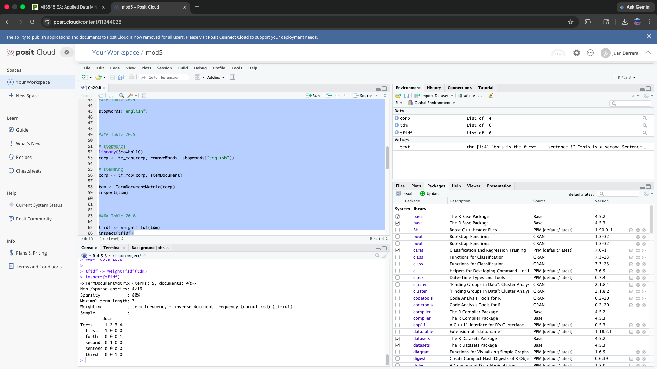

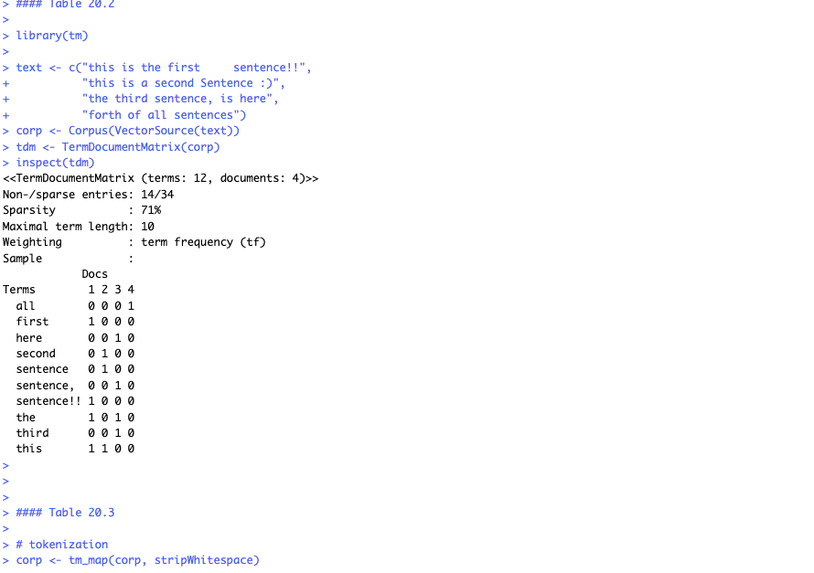

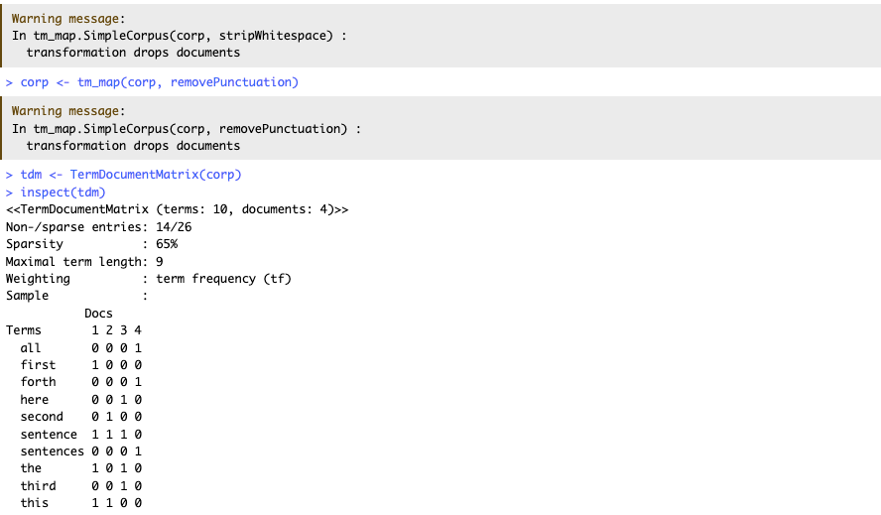

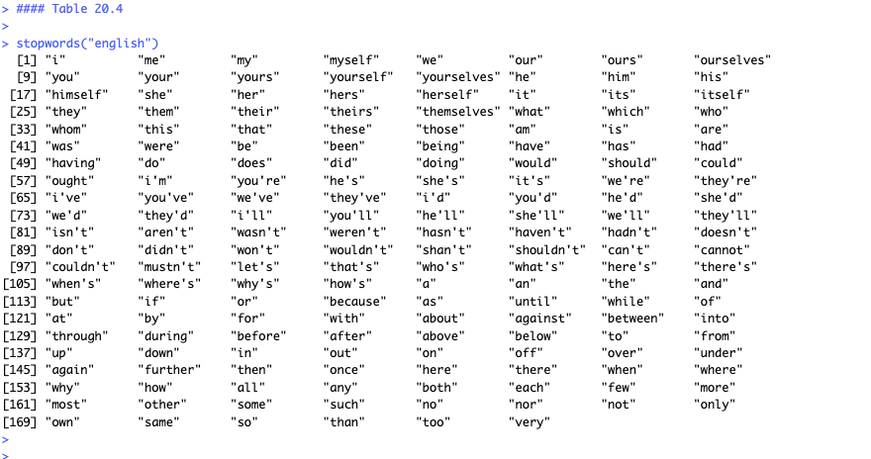

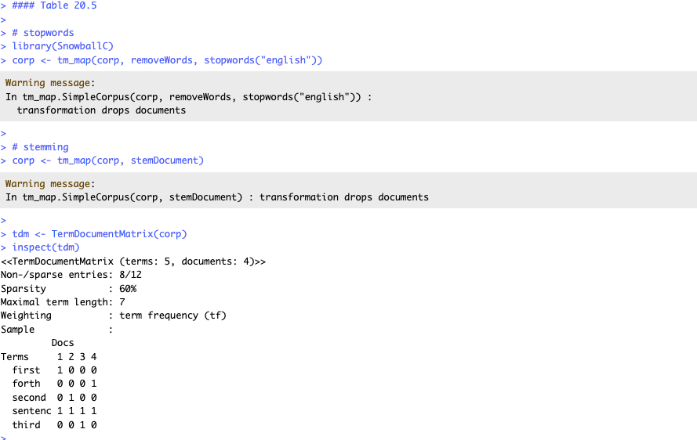

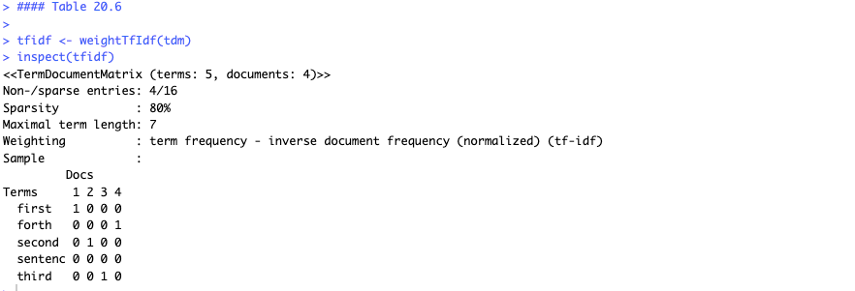

Explanation:
The data was first converted into a corpus and represented as a Term-Document Matrix (TDM), where rows correspond to terms and columns correspond to documents. The initial matrix included all words which appeared in the text but created multiple instances of the same word because of different punctuation and formatting. The process began with preprocessing steps which involved the elimination of all unnecessary spaces and punctuation marks.

The process standardized the text while reducing redundant elements which resulted in a decrease of unique terms and better document consistency. The researchers created a list of common English stopwords which included words like "the" and "is" and "and" because these words lack important meaning. The process of stemming resulted in the transformation of words to their fundamental roots which included the conversion of "sentence" and "sentences" to "sentenc" which made the dataset less complex.

The matrix received a TF-IDF (Term Frequency–Inverse Document Frequency) weighting system which was implemented as the final step. The method establishes greater value for words which are present in only one document while it grants lesser value to words which are found throughout all documents. Common terms such as "sentenc" received minimal or nonexistent weight while uncommon terms maintained greater value.

